Digital health literacy
Welcome to the Digital health literacy online training program.
The program will introduce to you to digital health resources to empower your community in managing their own health literacy. The focus of the resources training is My Health Record, the Australian Government-developed online portal offering every Australian a streamlined, digital approach to managing their health data and history.
This training package will also offer the skills needed to deliver digital health literacy training to your community, enabling them to make the most of the multitude of health resources available online, including My Health Record, and the many resources already available through libraries and beyond.

When you receive your training invitation

~~HERO-COLORS #20407F #FFF #FFF #FFF #FFF~~ ~~HERO-IMAGE 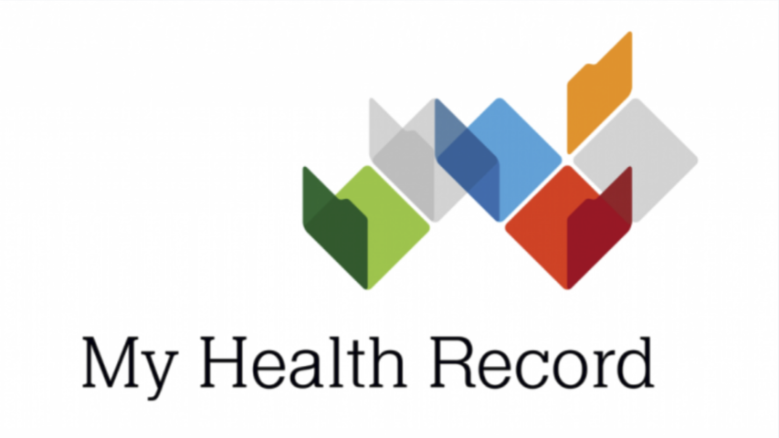~~ ~~HERO-SUBTITLE online training program~~

