Build a Steampunk LED
STEP 1: Assemble the top chassis plate
Insert long screws through the corner holes from the top.
Fasten each corner screw in place with a nut (use the wrench provided to tighten).

STEP 2: Add the large gear
Screw hole

Spacer

Push the small screw through the central hole in the gear (making sure the small spacer is in place), and then insert the screw through the hole indicated from the top. Secure loosely with a nut.

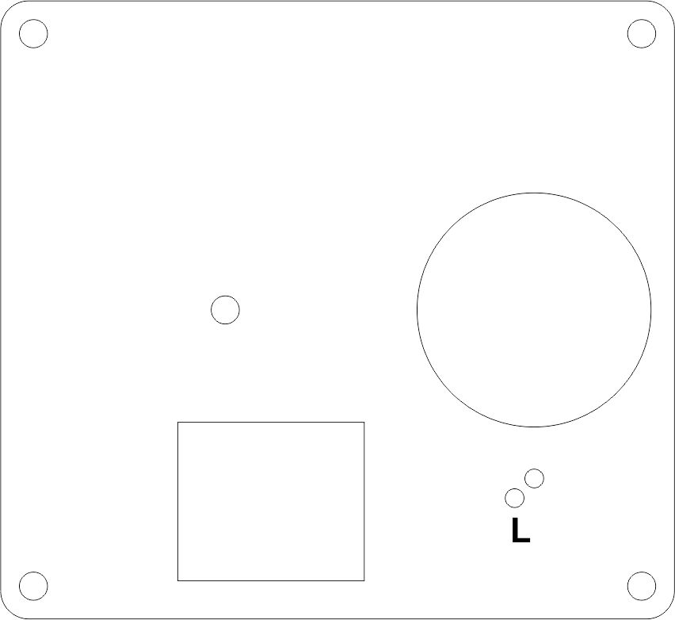
STEP 3: Attach the LED to the middle chassis plate
Lay out the plate as shown.
Insert the LED from this side, with the long leg going through the small hole marked with an ‘L’.

STEP 4 : Winding the Toroid
Find the small doughnut shaped toroid, and the 175mm length of twinned wire, and thread the wire through the centre of the toroid five times, keeping the wire flat and leaving about 2cm free at each end.
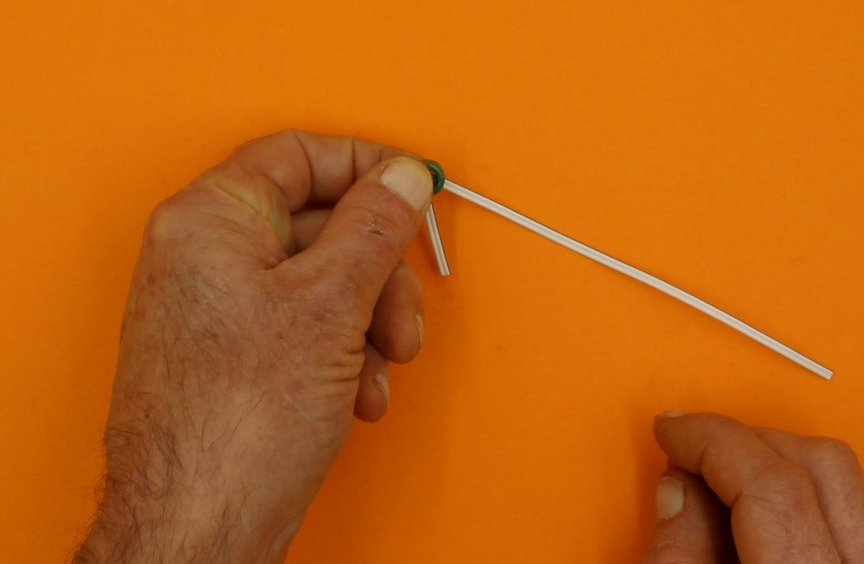
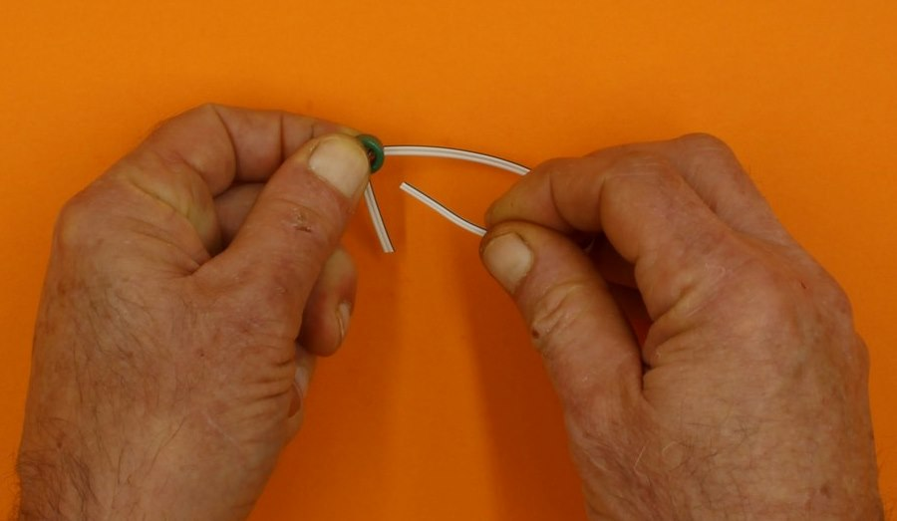

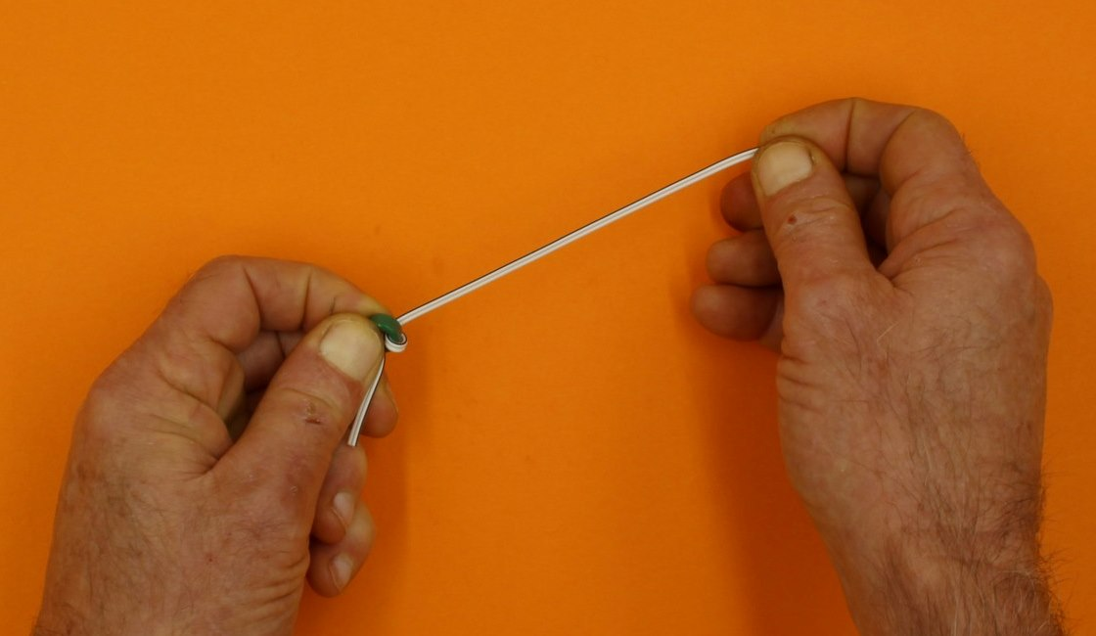
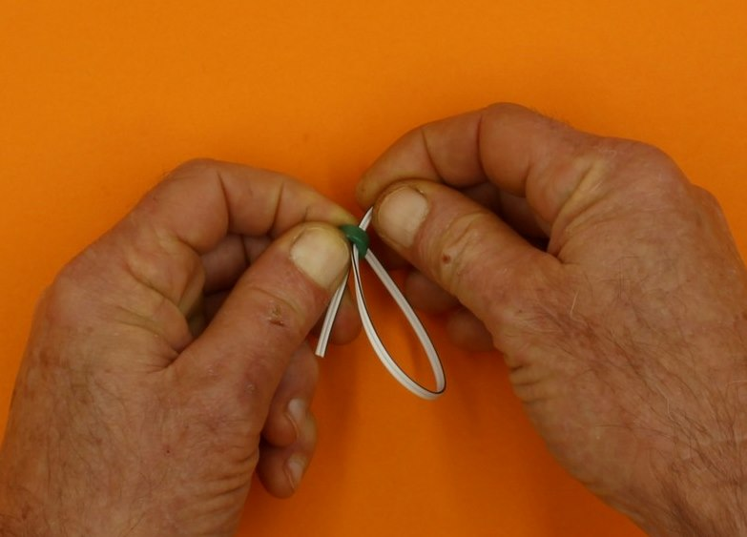

After looping through 5 or 6 times, separate the ends of the paired wires that protrude by grasping each wire separately, and pulling apart along the join. You should find that a pair of wires emerge from each side of the toroid when you hold it vertically.
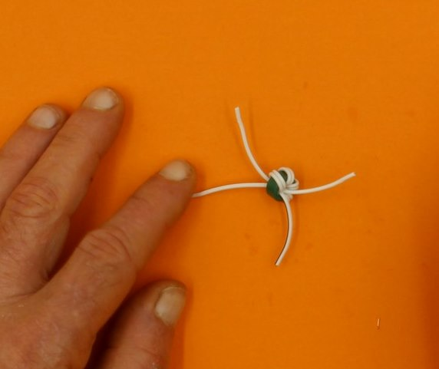
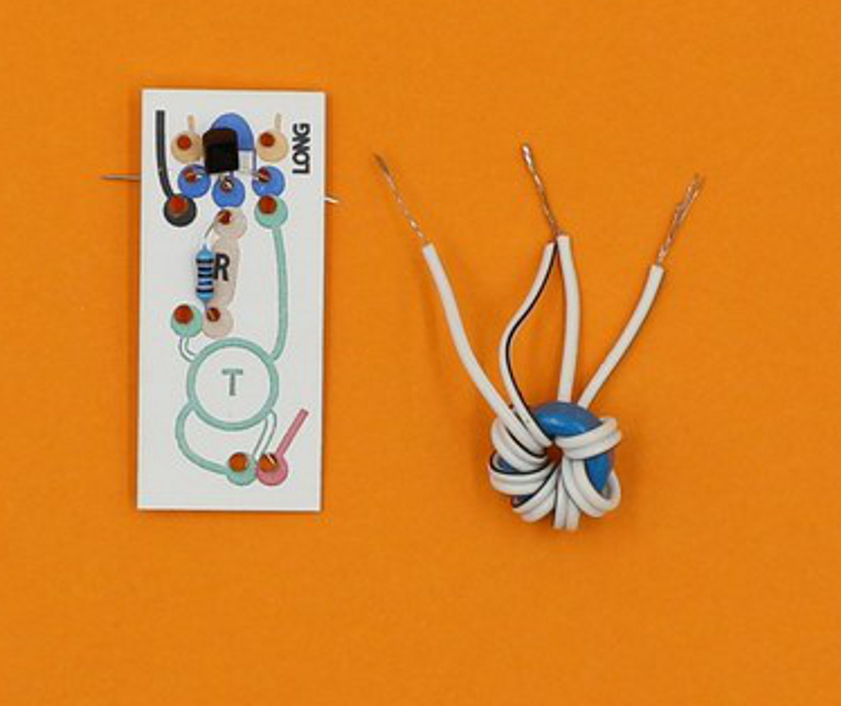

Now take the black wire from one side, and twist it together with the white wire from the other side.

STEP 5: Assemble the Joule Thief circuit

Insert the transistor legs through the 3 BLUE holes.

Next add the resistor (BROWN) and toroid (GREEN) as indicated, twisting the wires together at the back.

Finally attach the motor, red wire to the bottom of the toroid and black to the transistor.

STEP 6: Attach the LED to the Joule Thief circuit

Locate the LED legs through the ORANGE holes on the Joule Thief with the long leg through the marked hole. Twist the LED legs onto the existing pairs of wires at the back (3 wires finally twist together on each side).

Press the wooden cog on to the motor shaft and give the motor a sharp clockwise spin (like clicking your fingers) to confirm the circuit is working before continuing.

STEP 7: Joining the top two chassis parts
Slide the middle chassis plate on to the corner screws. As you wiggle it down, push the LED through the hole indicated. The toroid should fit into the rectangular hole.

STEP 7: Add the bottom chassis plate
Add 2 plywood spacers to each corner screw.
Slide the bottom plate on to the corner screws, placing the plywood retainer under the motor as you do.
Fix in place with a nut on each corner screw (you might need to press the assembly together firmly to do this).

STEP 8: Operation.
Spin the large gear.
Light the LED.
Smile with satisfaction.

