How does it work?
Virtual Reality
Virtual reality immerses users in the sights and sounds of impossible places, allowing them to interact with the virtual environment using a remote control.

What can I do with it?
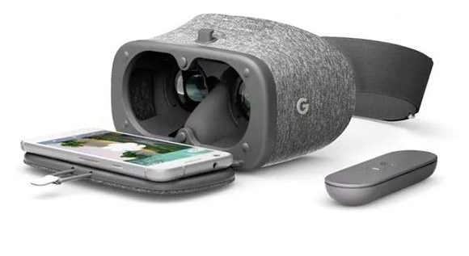
Different apps allow you to interact with music, immerse yourself in interactive stories or even explore the galaxy. Try one of the experiences and then share with your friends!

