Who’s Your Mob?

First Nations Family History

**Aboriginal and Torres Strait Islander Family History Resources**

**Who’s Your Mob?**

Learn about First Nations family history research with State Library’s *Who’s Your Mob?* video guides. See <https://www.slq.qld.gov.au/collections/family-history/whos-your-mob>

**Other useful resources**

**QLD Births, Deaths & Marriages**

<https://www.familyhistory.bdm.qld.gov.au>

**Tindale collection** - genealogical information on Aboriginal communities throughout Australia 1920 – 1930.

<https://www.slq.qld.gov.au/research-collections/family-history/aboriginal-and-torres-strait-islander-people/tindale>

**Margaret Laurie** - recorded many **Torres  Strait Islander** genealogies between 1964 and 1973

<https://www.slq.qld.gov.au/collections/family-history/whos-your-mob/margaret-lawrie-collection>

**TROVE** (newspapers, photographs, etc)

<https://trove.nla.gov.au>

**Centre for Indigenous Family History Studies**

<https://www.cifhs.com>

**QLD State Archives**

<https://www.archivessearch.qld.gov.au/>

**National Archives of Australia**

<https://recordsearch.naa.gov.au/>

**Community and Personal Histories**

Community and Personal Histories was established to assist Aboriginal and Torres Strait Islander peoples with finding **Queensland State Government records** about themselves and their families.

The Community and Personal Histories' team can help you use these records to research your family and personal history.

**See** <https://www.qld.gov.au/firstnations/cultural-awareness-heritage-arts/family-personal-history>

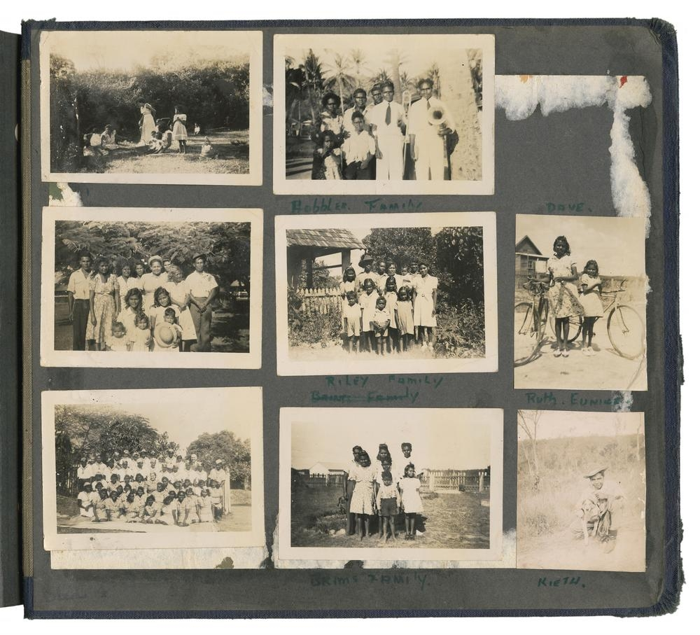

**WARNING**: **Aboriginal** and Torres Strait Islander people are **warned** that this handout contains images of **deceased persons**

**Cover Image State Library of Queensland, John Oxley Library, Ref (28187/1 28187-1v000r022)**

**Me**

Born ______/______/______

Place ____________________________

Married ____/____/____

Spouse __________________________

Name __________________________

Born ______/______/______

Place __________________________

Married ____/____/____

Place __________________________

Died ____/____/____

Siblings:

**Mother**

Name __________________________

Born ______/______/______

Place __________________________

Married ____/____/____

Place __________________________

Died ____/____/____

Siblings:

**Father**

**Grandmother**

Name __________________________

Born ______/______/______

Place __________________________

Married ____/____/____

Place __________________________

Died ____/____/____

Siblings:

**Grandfather**

Name __________________________

Born ______/______/______

Place __________________________

Married ____/____/____

Place __________________________

Died ____/____/____

Siblings:

**Grandmother**

Name __________________________

Born ______/______/______

Place __________________________

Married ____/____/____

Place __________________________

Died ____/____/____

Siblings:

**Grandfather**

Name __________________________

Born ______/______/______

Place __________________________

Married ____/____/____

Place __________________________

Died ____/____/____

Siblings:

**Great Grandmother**

Name ___________________________

Born ____/____/____ Place ____________________

Married ____/____/____ Place ____________________

Died ____/____/____ Place ____________________

Siblings:

**Great Grandfather**

Name ___________________________

Born ____/____/____ Place ____________________

Married ____/____/____ Place ____________________

Died ____/____/____ Place ____________________

Siblings:

**Great Grandmother**

Name ___________________________

Born ____/____/____ Place ____________________

Married ____/____/____ Place ____________________

Died ____/____/____ Place ____________________

Siblings:

**Great Grandfather**

Name ___________________________

Born ____/____/____ Place ____________________

Married ____/____/____ Place ____________________

Died ____/____/____ Place ____________________

Siblings:

**Great Grandmother**

Name ___________________________

Born ____/____/____ Place ____________________

Married ____/____/____ Place ____________________

Died ____/____/____ Place ____________________

Siblings:

**Great Grandfather**

Name ___________________________

Born ____/____/____ Place ____________________

Married ____/____/____ Place ____________________

Died ____/____/____ Place ____________________

Siblings:

**Great Grandmother**

Name ___________________________

Born ____/____/____ Place ____________________

Married ____/____/____ Place ____________________

Died ____/____/____ Place ____________________

Siblings:

**Great Grandfather**

Name ___________________________

Born ____/____/____ Place ____________________

Married ____/____/____ Place ____________________

Died ____/____/____ Place ____________________

Siblings:

**Name** __________________________________

­­­­­­­