DNA Weaving

Step 1
Start with a cylindrical object and add spokes. Here we used a toilet roll and paddle-pop sticks. You can use any size object with any number of spokes.

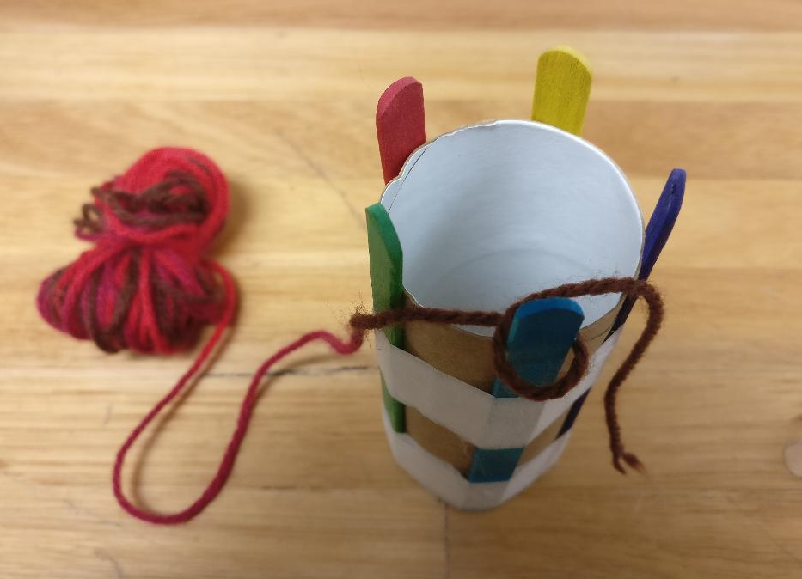
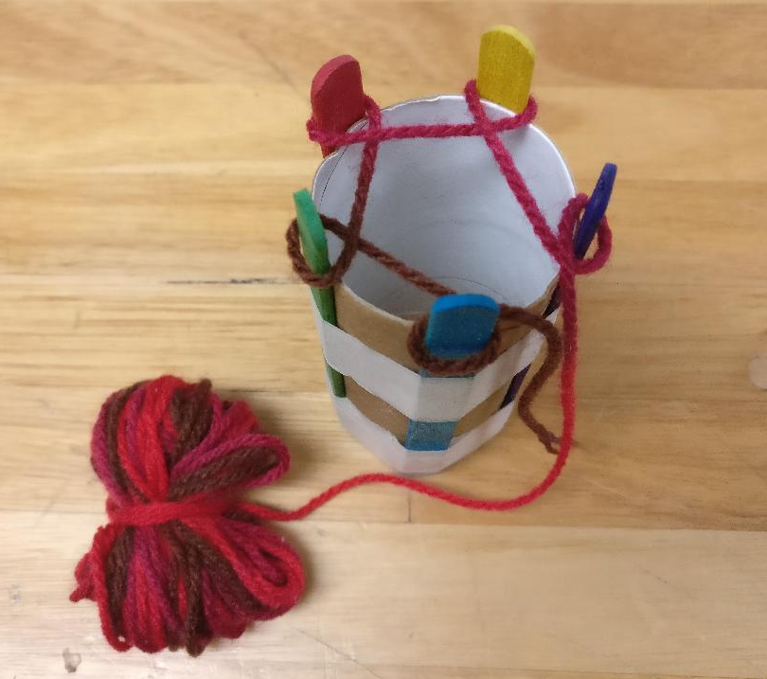

Step 2
Make a loop around one of the sticks. Repeat until you have made loops around all the sticks.

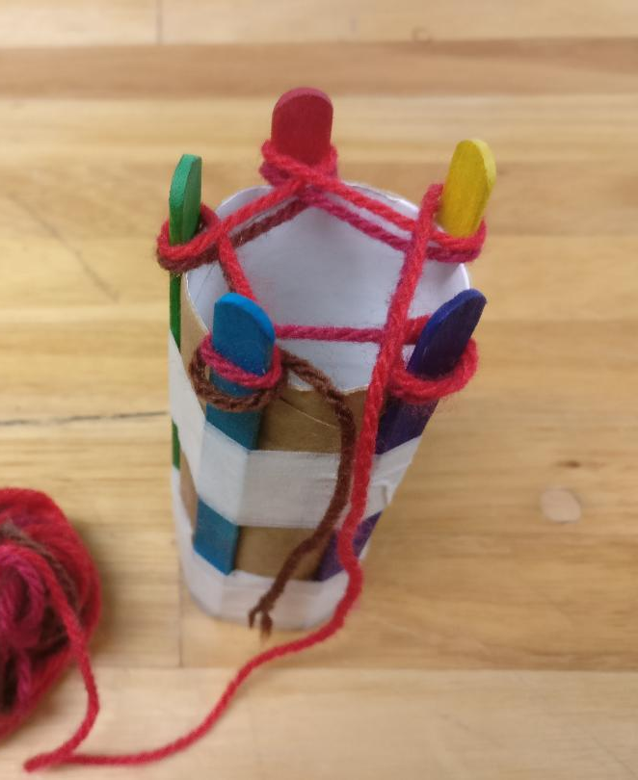

Step 4
Repeat for a second time on top of the first layer of loops. Try not to over tighten the loops, it will cause problems later.

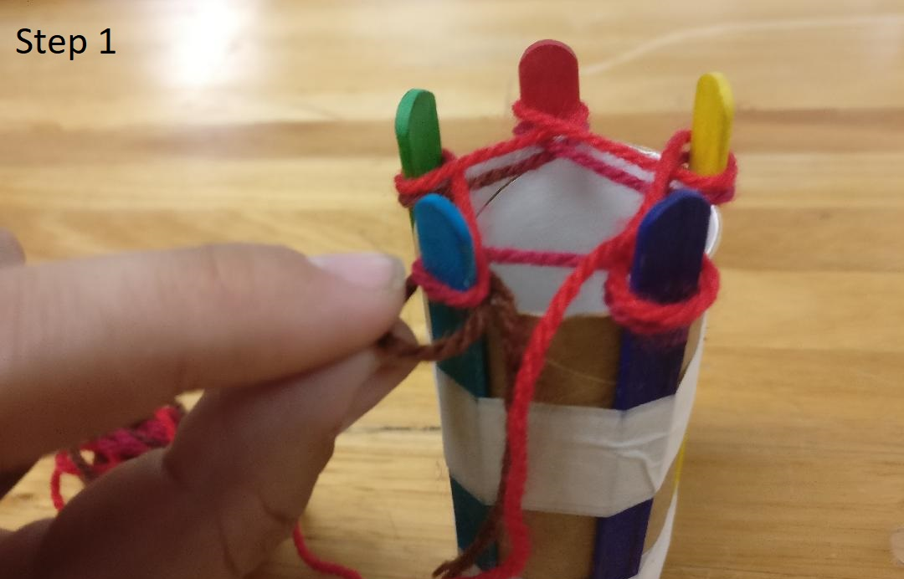

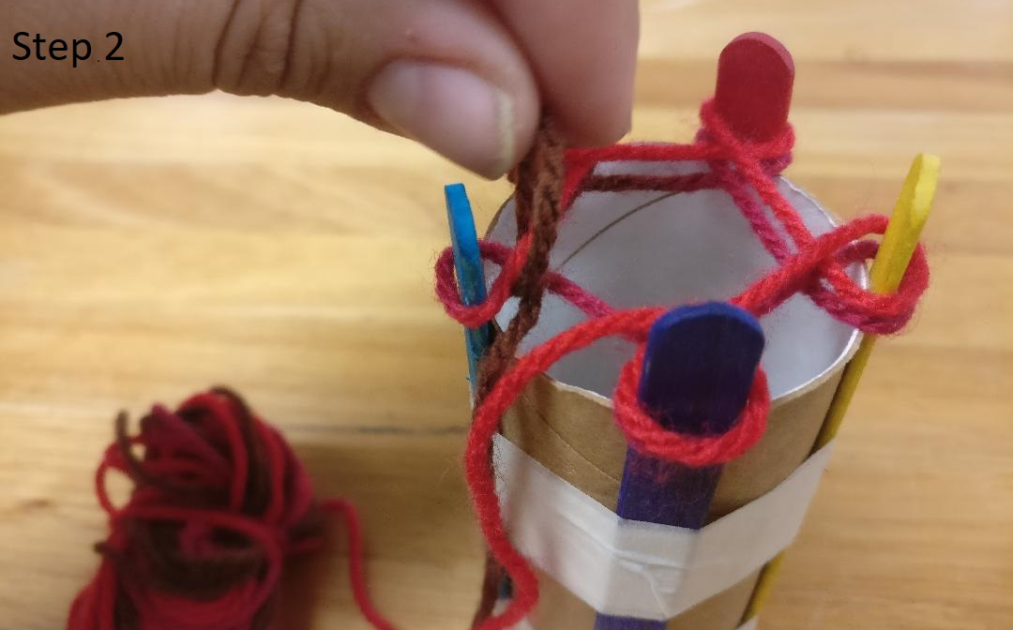

Step 5
Pull the lower loops (1) loose and flip it over the upper loop (2).

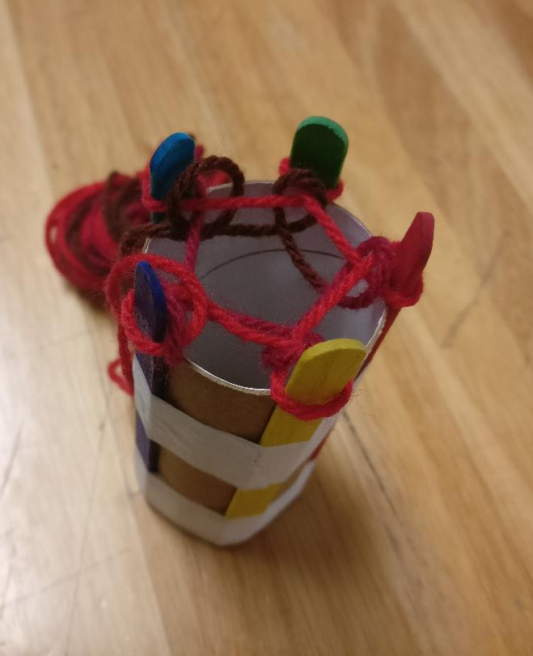

Step 6
Repeat for all sticks.

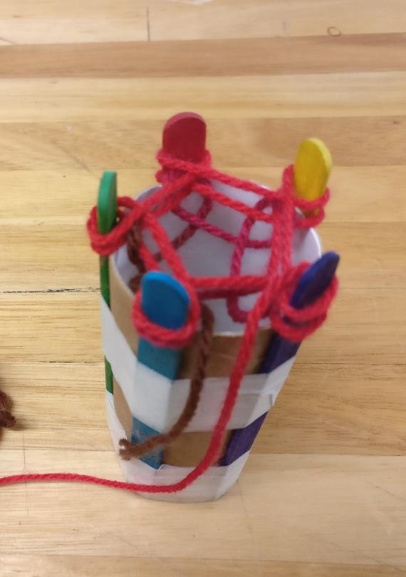

Step 7
Make another layer of loops around the sticks.

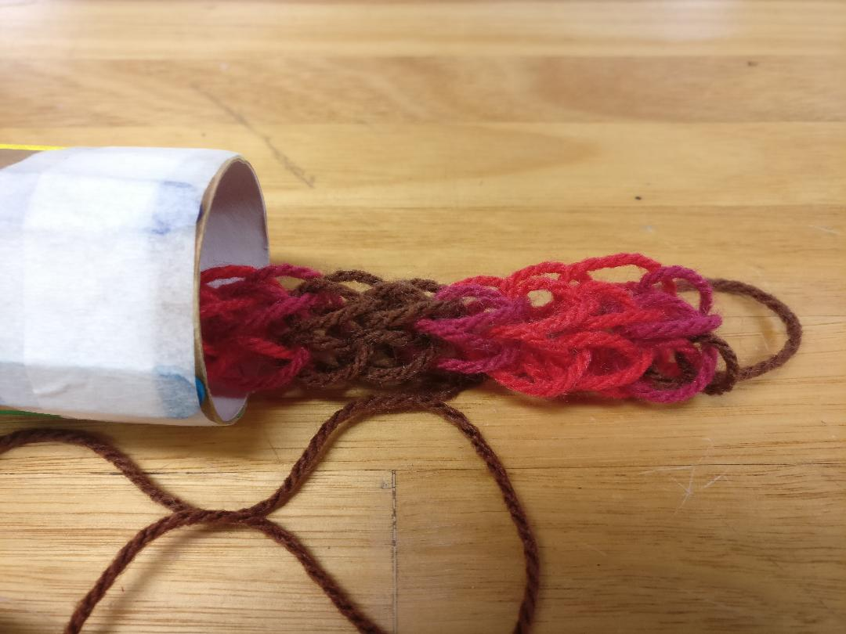

Step 8
Repeat steps 5 to 7 until you have used up all the wool or it's sufficiently long enough.

