**1,000,000 BC BCBC**

**NOW**

**2,000,000 BC**

**Hearths found**

**Evidence for use of fire**

**Twine and drills**

**3,000,000 BC**

**Earliest fossils of *Homo* sp**

***Homo* sp in Europe, China, Java**

**Evidence for use of stone tools**

13 Ways to

Start

a

Fire.

*Homo ignius.*

Modern humans have used fire for half the time they have existed, and gathered around managed campfires for at least the last 700,000 years.

Fire enabled humans to manage landscapes, make food more digestible (fueling increases in brain size) and promoted social interaction (possibly leading to language development)

Evidence of pierced shells and twine making from 120,000 years ago implies that the requirements for fire making (as well as mangement) were available, even though the devices have long turned to dust.

Preliminaries.

**Safety.**

Fire is a dangerous thing.

Avoid pain, disfigurement, property loss and potential bankrupting lawsuits by making sure you workspace is uncluttered and free from unexpected accelerants.

Prepare a hearth by scraping a hole in the ground or making a circle of rocks.

Have your fuel ready, but not too close.

Have a handy means of smothering the fire if things get out of control – a shovel, blanket, water or green branches.

**Tinder and fuel.**

You will need to have a bed of tinder waiting for any spark you produce. Charcloth, resting on a nest of well separated fibres of sisal rope, dry grass or shredded dry leaves works well.

Prepare the fire proper in your hearth, with small pieces of dry twig or stick surrounded by increasingly larger bits of wood. Building a central tipi of small sticks will give a ready receptacle for a blazing tinder ball.

Charcloth tinder

Charcloth is easily made in advance using scraps of pure cotton fabric (knitted material like an old t-shirt works best).

* Cut the rag into 5cm squares, and place loosely inside a tin with a close fitting lid (which could be made from alfoil)
* Punch a small hole in the centre of the lid with a nail
* Prepare a bed of hot coals a deep as the tin by feeding a wood fire and letting it die down, or light up a gas cooker.
* Place the tin of fabric pieces in the bed of coals (or on the gas flame), and wait until the smoke stops emerging from the hole in the lid (usually 5 -10 minutes, depending on the amount of fabric)
* Allow the fire to die down (or turn off the gas ring), and recover the tin from the fire when it is safe. Allow to cool fully
* Open the tin to find the cloth has turned to charcoal due to burning in a limited oxygen atmosphere.
* Keep the charcloth pieces dry in a zip lock bag.

1. The Fire Plough



* Prepare a softwood hearthboard about 60cm long by cutting a narrow v-shaped longitudinal groove down the centre.
* Find a hardwood friction stick about 30cm long and 1-2 cm diameter, and work one end to make a rounded point.
* Holding the hearthboard in place with you knees, rub the friction stick back and forth vigorously, for a very long time.
* A mound of sawdust will gradually form at the end of the groove, and eventually a smoking coal will be formed.
* Carefully transfer the glowing coal to your prepared tinder nest, and fan into life.

2. The Hand Drill

* Prepare the hearthboard by gouging a shallow socket to take the rounded end of the drill stick.
* Cut a narrow notch from the edge of the hearthboard to the centre of the socket so the sawdust has a place to collect.
* Twirl the hand drill rapidly between the palms for a very long time, exerting continual downward pressure, and jumping your hands to the top of the stick when required.
* When a coal forms which keeps smoking after you stop drilling, coax into life and transfer it to your tinder nest.

3. The Bow Drill



* Prepare a hearthboard as before by creating a depression to take the drill stick, and a notch to clear the sawdust. It helps to place something under the notch to allow easy transport of any coal you make.
* Attach twine or thin rope to the a bow about 90cm long, with enough slack to allow a twist around the drill stick as shown. Make sure the bow is on the opposite side to your foot.
* Apply downward pressure by pressing a socket board against the tapered top of the drill. Lubrication here will help.
* Press down, and run the bow back and forth rapidly to spin the drill. Keep going once smoke forms, until a smoking coal forms that you can transfer to the tinder.

4. The Pump Drill



* In this most advanced method of rubbing sticks together, the drill stick has a flywheel made from wood or stone firmly attached to maintain momentum.
* A push board with a central hole is slid over the drill stick, and attached by a cord which threads through a hole near the top of the drill.
* Wind the twine onto the drill by twisting it backwards, then pump down and up rhythmically (and repeatedly) to maintain a steady drilling speed.
* Use a hearthboard prepared as before, and look for a smoking coal to form

5. The Fire Piston

* A piston is made about 15 – 20cm long, with a notch in the end to take a piece of charcloth tinder, and a handle at the other end.
* The piston must make an airtight seal with the cylinder that receives it. Greased twine, or a rubber o-ring can be used to achieve this.
* When the charged piston is pushed forcefully into the cylinder, increasing pressure causes the air inside to heat up, and the charcloth ignites. Eventually.
* Because the pressures required are high, take care the cylinder is sturdy enough not to explode (acrylic is not recommended, wood or metal are better).

6. Flint and Steel

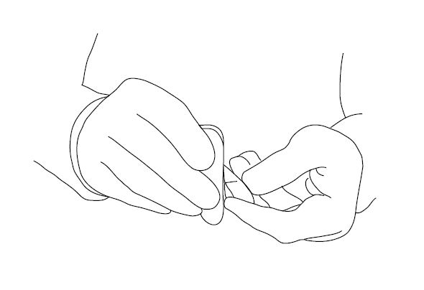

* Take a piece of hard steel (eg: an old file) in your dominant hand as shown
* Hold a piece of charcloth in your other hand, or otherwise have it ready to catch the sparks
* Hold a piece of hard stone (eg: quartz, flint, chert) firmly in your other hand, with a sharp edge outermost
* Strike the steel forcefully at the flint edge, on an angle of 20-30o  , repeatedly. Sparks are produced when you shave off piece of metal with sufficient energy.
* Keep trying until you can produce sparks consistently, and aim them to land on the charcloth. When lit, place this in the tinder nest, and coax into flame.

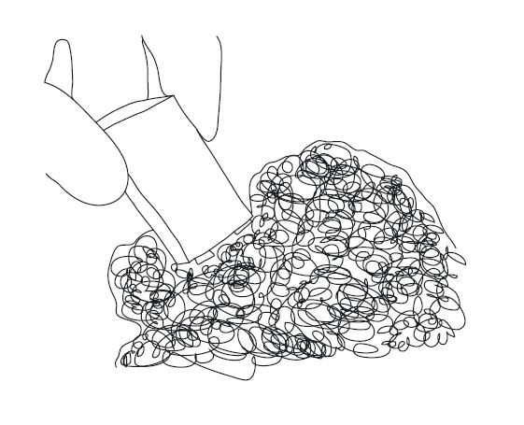7. 9V Battery and Steel Wool

* Resistance to an electric current passing through a wire will cause it to heat up.
* 9V is a high enough voltage to cause a thin wire to glow, and burn.
* Place some steel wool in your tinder nest, and touch both terminals of the battery to the wire.
* The wire will glow, and eventually burn, setting the tinder alight.
* Two 1.5V batteries joined in series (positive to negative) may also produce enough voltage for this to work

8. Battery and Gum Wrapper

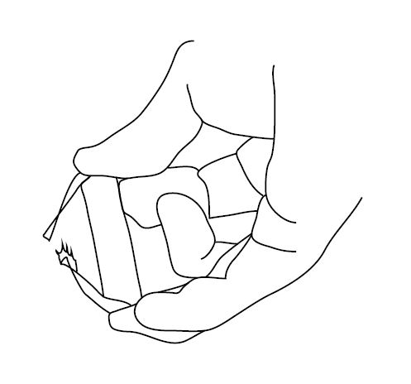

* Find a gum wrapper that comprises thin paper coated with aluminium foil.
* Tear off a piece of wrapper long enough to bridge the terminals of your battery, and give it a twist or two.
* Press the aluminium foil firmly onto the terminals of the battery
* The foil conducts a current, and heats up enough for the paper to burst into flames
* Note that dry skin is a good electrical insulator (so no fear of electrocution), but the flaming paper may burn you unless quickly placed into the tinder.

9. Torch Reflector and Sunlight

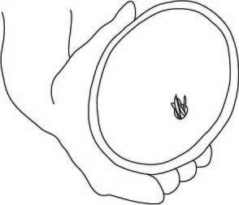

* A torch uses a reflector to collect the light from a bulb, and direct it outwards in a parallel beam. Incoming light will take the opposite path, and be concentrated by the reflector.
* Remove the reflector from a torch, and take out the bulb.
* Replace the bulb with some dry tinder, placing it in the same position as the bulb
* Aim the reflector towards the sun, and it will concentrate the solar radiation onto the tinder, causing it to burst into flames.

10: Polished Aluminum Can

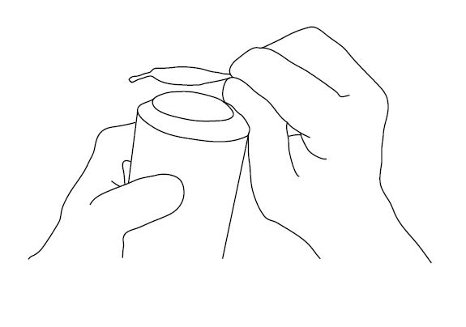

* The bottom of an aluminium can may be polished to a mirror shine using toothpaste, jewelers rouge, or even chocolate (given enough patience).
* Once polished, the concave can bottom acts like a mirror to concentrate the sun’s rays onto a focal point, where combustion can occur
* Aim the can at the sun, and move the tinder back and forth until the sunlight is focused into the smallest area. Hold it still, for as long as it takes for the tinder to catch alight
* Using black printed paper (which absorbs more energy) may make this happen faster

11. A Plastic Bottle Water Lens

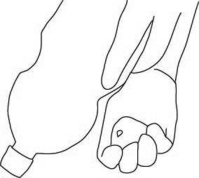

* Fill a clear plastic bottle with water, screw on the lid, and hold it bottom up.
* The curved top of the bottle can act as a lens to concentrate sunlight.
* Place some tinder on the ground, and move the bottle up and down until you see the smallest bright spot form on the tinder.
* Try changing the angle of the bottle to maximize this concentrating effect (about 20o off vertical is about right).
* Hold the bottle very still for an indefinite period of time until the tinder catches alight.

12: Clingwrap Water Lens



* Tear off a piece of clingwrap about 30cm square, and use it to line a container about 10cm deep.
* Pour water into the clingwrap, and pick up the loose ends, twisting them to make a plastic wrapped bubble of water.
* Twist around to make the bubble as round as possible, and then hold above your prepared tinder.
* The curved surface may act as a lens to concentrate sunlight on the tinder. Move it around to focus on the smallest possible spot.
* Hold very still, for an extended period of time, until the tinder catches alight, while avoiding water dripping from your leaky lens onto the tinder.

13. Chemical Combustion

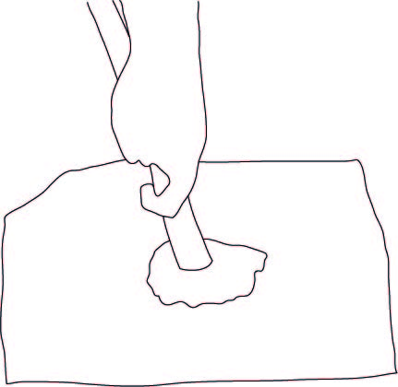

WARNING: Many of these methods produce irritating gases – for well ventilated areas only

* Recipe #1: grind potassium permanganate to a fine powder, and place about a teaspoon on your tinder. Add a couple of drops of glycerol, and stand back. After 30 – 60 seconds, spontaneous combustion will occur. Avoid breathing the purple gas produced.
* Recipe #2: on a flat surface, mix equal parts potassium permanganate and white sugar with a stick at least 30cm long. If combustion does not occur, grind some of the mixture under the end of your stick, but beware of leaping flames. Avoid the gas produced.

Not Advised: Stick and Volcano

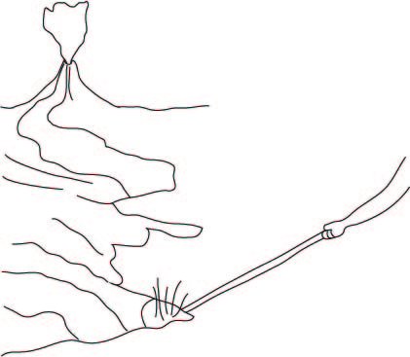

* Approach the boiling lava with caution (temperatures high enough to cause human combustion may be present).
* Avoid falling through thin crusts of solidified lave into the molten rock beneath.
* Using a stick at least 2m long, plunge one end into the glowing lava, and pause while it catches alight.
* Speedily vacate the area, and add burning stick to your tinder pile to start the fire.