**Digital Arts – Notes & Links**

* Digital and You <https://www.slq.qld.gov.au/discover/digital-and-you>

(App available for iPhone or Android)

* Be Connected <https://beconnected.esafety.gov.au/>

**Procreate** <https://procreate.com/>

See the Beginner series of videos. They are excellent.

<https://procreate.com/beginners-series>

**Android alternative**: Sketch Book, Clip Studio Paint

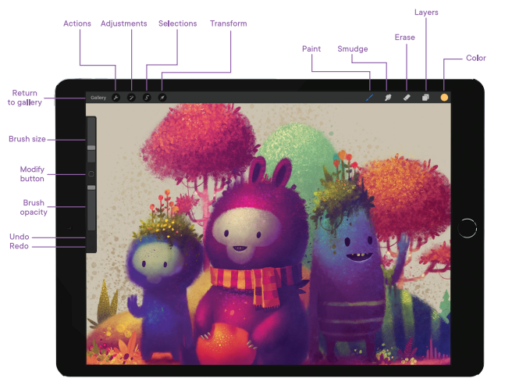

**Hand gestures:**

* Tap 2 fingers: Undo last
* Tap 3 fingers: Redo
* Scrub 3 fingers: clear screen
* Pinch to zoom or rotate.
* Press and hold a colour for eye dropper

**Apple pencil:**

* Draw and shade.

**Lines and shapes:**

Straight lines – manually draw a line and hold at the end point – it will automatically straighten the line

Shapes: rough draw the shape and hold down at the end. Touch the screen with your free hand to make it perfect

Colour drop: Drag the active colour into a closed shape to fill it with that colour.