Spirit of Grumpus 2021
Making Lampshades from Cardboard and Paper
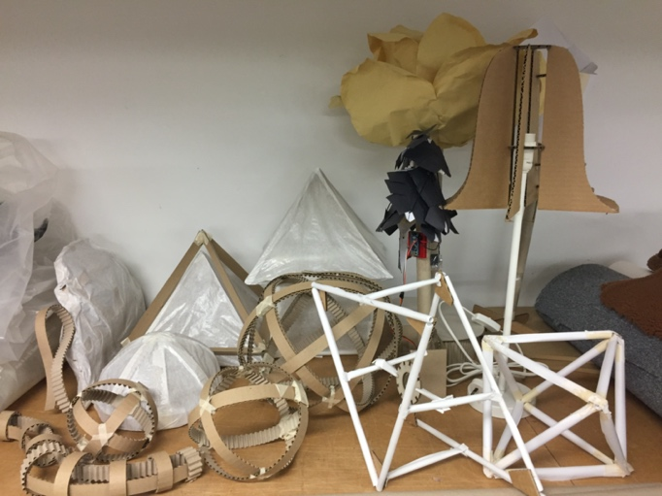 | 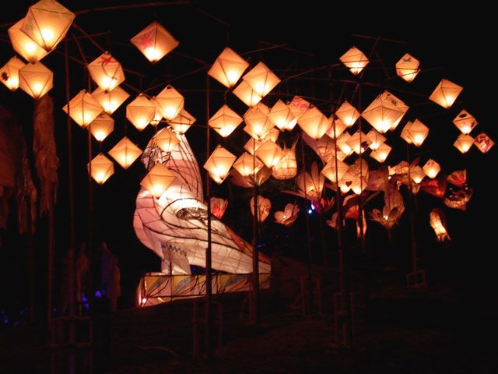
General tips for working with cardboard
Cardboard (and paper) are ubiquitous, cheap (or free), recyclable and versatile. They can be fashioned with basic tools, and joined with common, safe glues. Their ready availability and low cost also makes them ideal for iterative design. Like all materials, cardboard has unique properties that require specific techniques for best use.
- Corrugated cardboard (recovered from boxing) has a grain – it is strongest perpendicular to the corrugations. Cutting across corrugations will give a cleaner finished line than parallel, or even angled cuts. The chance of collapse (catastrophic folding) is greatest parallel to the corrugations, so (for example) vertical support elements will be strongest if the corrugations run vertically.
- Fold lines are stronger if the material is crushed, rather than scored. Scoring means only a single surface layer has to support all the strain, and rips can result. Use a rounded tool (maybe 5mm diameter), and pressure. Crush the INSIDE of the fold.
- Wet glues take a long time to dry, which means for forming the base shapes, masking tape or hot glue are good choices. The visibility of tape is a consideration and can become a design feature or coloured white with a posca pen, so it doesn’t show through.
- Many different grades of cardboard exist, from the very dense Kraft board (used to make the mounting washer for the lampshades), to single and double ply corrugated boards. They all have different thicknesses, and you need to allow for this when designing and constructing.
- Cardboard requires sealing before painting, for best effect. Shellac is quick to dry, cheap and available from hardware shops. Watered PVA can work too, but will take longer to dry, and can reduce strength. Polyurethane (water soluble variants are available) could also work.
- No name brand (not shiny) baking paper is used for skinning the lampshapes, an approximate 50:50 mix with PVA glue. Mess, drying time and storage needs to be considered for this stage in the process.

Specific tips for making lampshades (*NEED TO UPDATE THIS SECTION – RS)
Standard lampshade fittings mean some aspects of your design are already fixed.
- The lampshade has to attach to the stand, Mounting washers, laser-cut from 3.5mm Kraftboard, with a 28mm central hole, and 12x3mm slots for attachment are provided.
- The E14 bulbs used in these lamps have a diameter of 35mm, and have to fit inside your lampshade.
- The LED bulbs used have a very long life (and produce very little heat). This means you can design a lampshade that entirely encloses the mounting, as long as you remember to fit the washer and bulb before sealing everything up (and test that it works, too!). Most traditional shades have big holes top and bottom to allow for bulb-changing and heat dispersion, but you are not necessarily constrained by this.
- The final installation will be a garden of unearthly lights, so an entirely opaque lampshade (skinned with cardboard, for example) will not fit the design brief. A cardboard skin with artful piercing, or at least one window would. Even paper will allow light to be emitted, depending on thickness.
- Size and balance are a constraint – paying attention to symmetry will be rewarded through ease of construction.

The attachment washer is shown below: slots are 3mm wide.
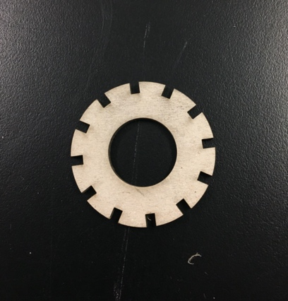

Construction techniques
By no means an exhaustive list, but these methods seem to work:

Using rolled paper as sticks, for straight edges
- Rolling the paper is a little tricky and time consuming
- Masking tape needs to match the paper, so the joins don’t show or be included in the design from the outset
- Simple shapes light well
- The baking paper skin sticks and stretches well on the curved edge
- Rolled sticks don’t work for curves as they are too rigid and just bend
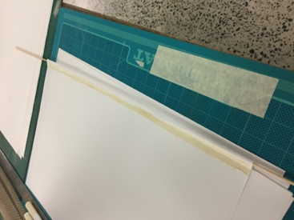 | 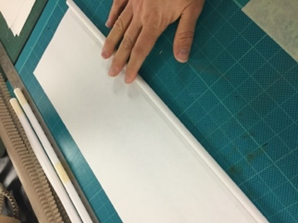 | 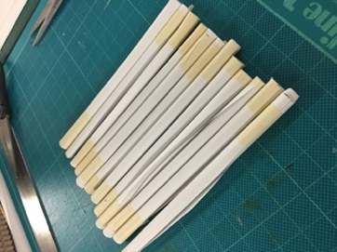 | 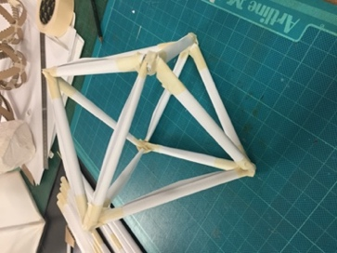
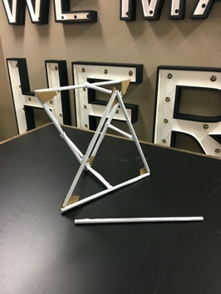 | 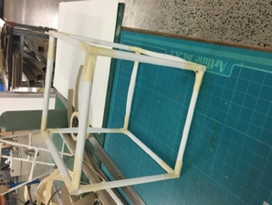 | 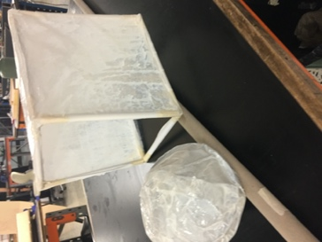 | 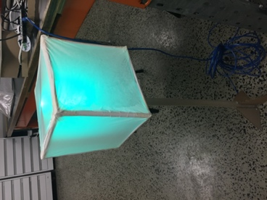

Corrugated Cardboard ribs, for curves
- Cutting the strips is time consuming and needs a good knife hand (perhaps this could be done on a machine prior to workshops)
- Masking tape needs to match the paper, so the joins don’t show or be included in the design from the outset, hot glue is perhaps a better choice for the corrugated cardboard
- The ribs are prominent and must become a design feature, they could also be thinned down as they are currently 20mm, the strength would just need to considered if this was the case
- The baking paper skin doesn’t stick and stretch as well on the corrugated side meaning it looks less schmick
- Need to consider size and strength of the material and double over if in larger sections

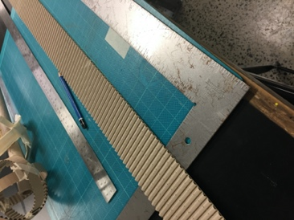 | 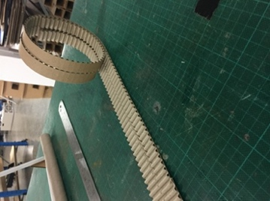 | 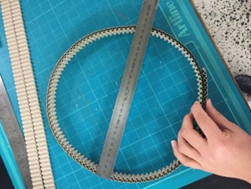 | 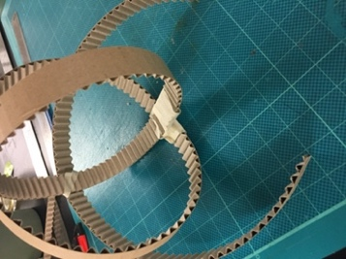
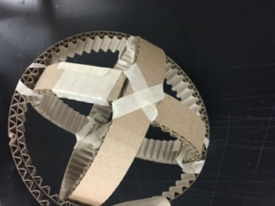 | 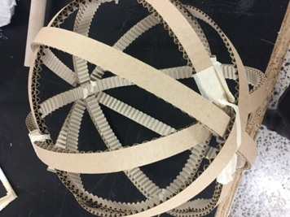 | 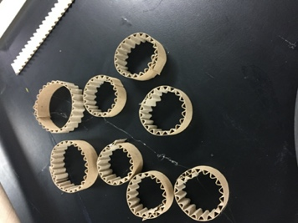 | 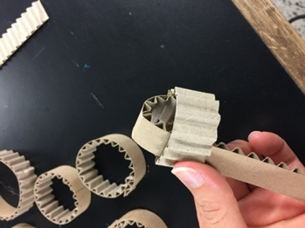
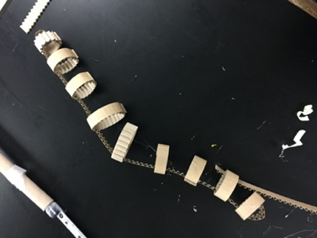 | 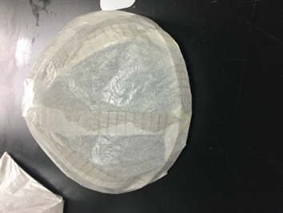 | 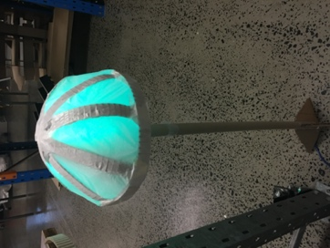 | 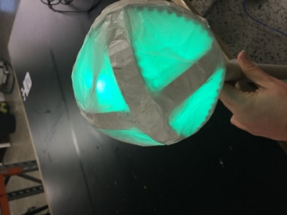

Corrugated Cardboard ribs, for straight edges
- Cutting the strips is time consuming and needs a good knife hand (perhaps this could be done on a machine prior to workshops)
- Masking tape needs to match the paper, so the joins don’t show or be included in the design from the outset, hot glue is perhaps a better choice for the corrugated cardboard
- The ribs are prominent and must become a design feature, they could also be thinned down as they are currently 20mm, the strength would just need to considered if this was the case
- The baking paper skin doesn’t stick and stretch as well on the corrugated side meaning it looks less schmick

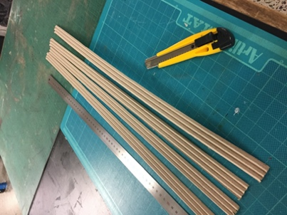 | 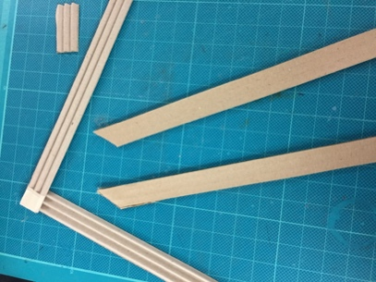 | 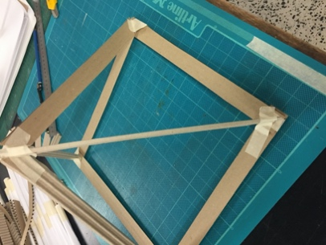 | 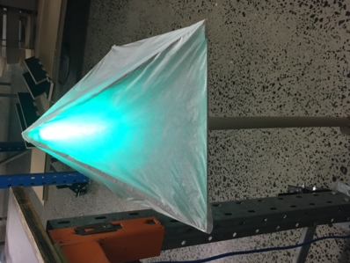
Single core cardboard ribs, which can be vertical or horizontal
- This method could be good for consistency between the large sculptures and the small sculptures (if this is important)
- Cutting ribs is time consuming and a bit tricky (would probably need machinery)
- The ribs are prominent and must become a design feature
- The baking paper skin hasn’t been tested on this prototype as yet
- the space around the globe would need to be bigger than shown
 | 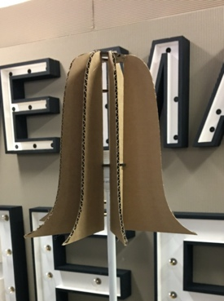 | 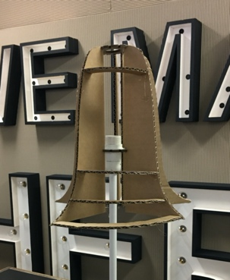

Paper screen style lantern

This method has not been tested yet

Origami inspired folded paper
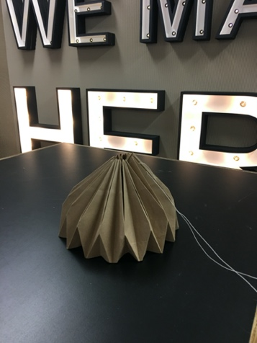
This design would need a support to hold it in place (most likely a circular ring attached to the washer),
which is not shown.

The thread seen is used to pull the flat , folded design into a circular shape, and would need to be secured in place to hold the shape.

Simple elements, repeated
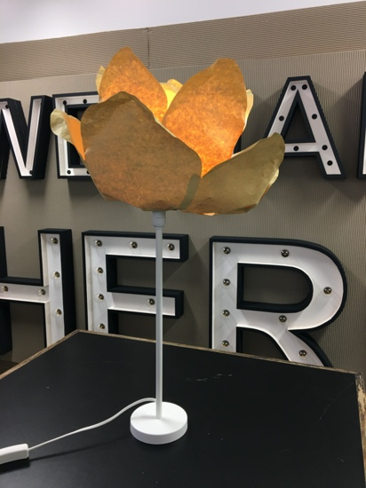
The petals were glued to a disc attached to the washer, and several layers are possible, as shown. Gluing along the overlap between petals helps maintain the shape.

This is probably the easiest naturalistic design to create, provided some thought is given to symmetry and overlap when figuring the size of the base of the petal that will attach to the support ring.

A mathematical approach (calculate the circumference, and divide evenly to find the base length) is possible, too.

