The city is under attack! A giant monster has risen from the sea to wreak havoc upon the populous. Gather your team and together, you must defend your cardboard metropolis from the onslaught of the… CARDBOARD KAIJU.

Cardboard Kaiju is a one vs many strategy game for 3 - 5 players. Players are split into teams, with one player acting as the Kaiju, and the rest acting as defenders. To win, the defenders must reduce the Kaiju’s deck to zero, forcing it to retreat back into the sea, before the kaiju destroys all buildings on the city map.

Each turn, a defender will strategise how best to counteract the Kaiju, choosing to either play a card from their hand, or placing a card into the support zone for their other defenders to utilise in the future. Then, the Kaiju will act, playing a card from their hand that can either damage the buildings in front of them, or limit the defender’s capabilities.

Be prepared though, as the Kaiju will get stronger as the game progresses. Every step up the rage track gives the Kaiju a bigger hand, or more actions each turn.

Will you save the city?

COMPONENTS
143 Cards (60 Defender, 75 Kaiju Cards, 8 ENRAGE Cards)
27 Buildings (9 Large, 18 Small)
1 City Map
1 ENRAGE + Support Board
1 Cardboard Kaiju
1 Enrage Marker
10 Shielding Markers
6 Six-sided dice (for marking building damage)

COMPONENTS EXPLAINED

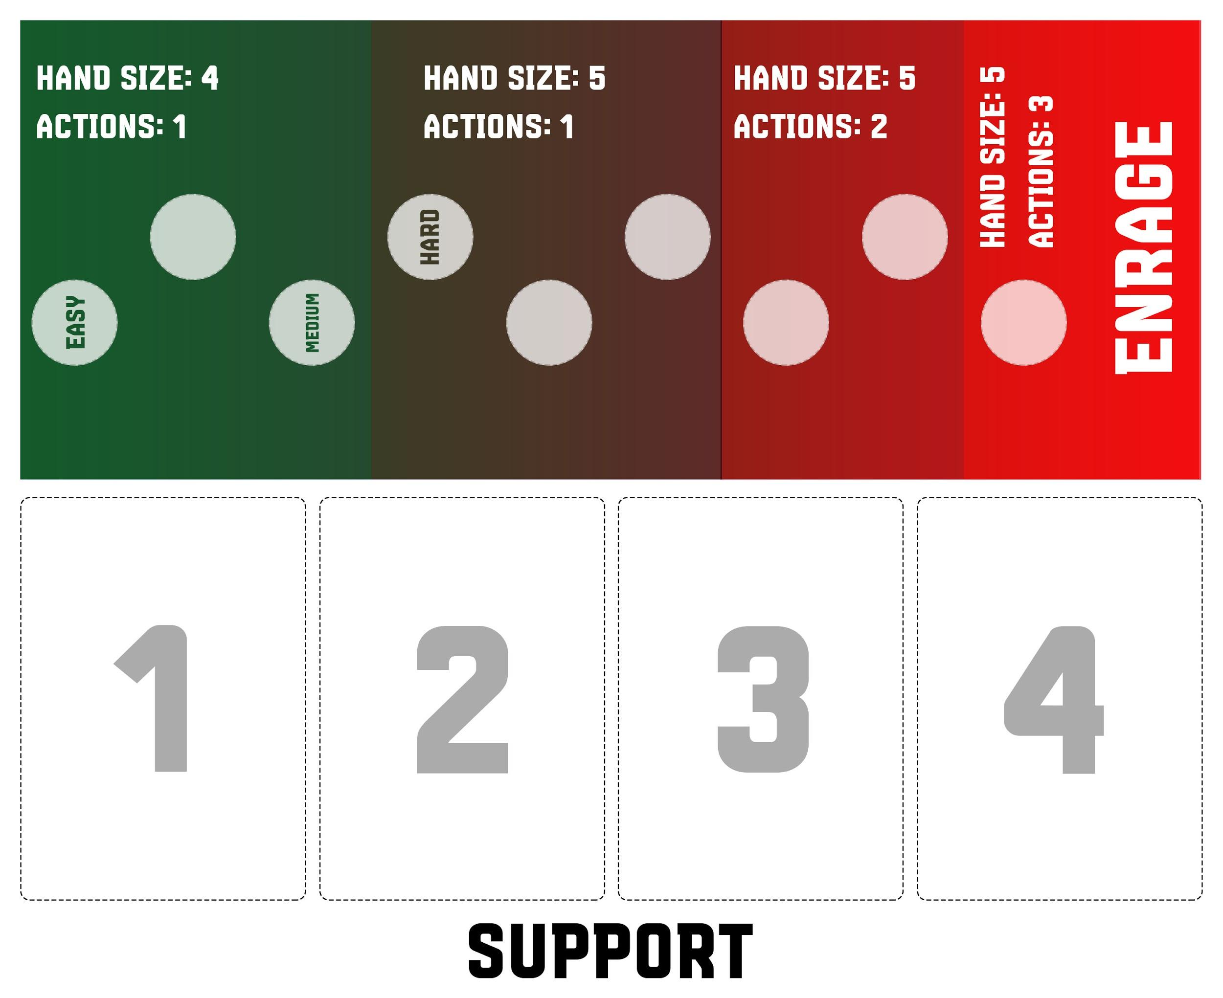
ENRAGE + Support Board
The ENRAGE + Support Board is used to track how enraged the Kaiju is, as well as acting as the support zone for defending players.

When setting up the game, place the enrage marker on a starting space that matches how difficult you want to make the game for the Defending players.

The City Map
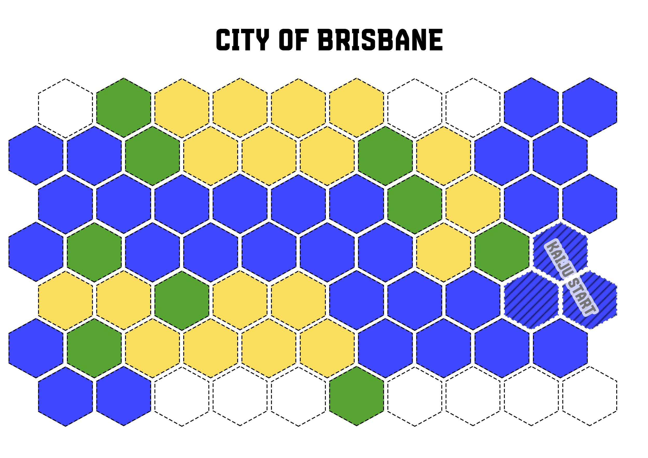Included in this game is map for Brisbane, Australia. The hexagon colors mean the following:
- Blue - Water. The Kaiju must keep at least one hex on a water space at all times
- Tan - Small Buildings. These buildings can take 3 points of damage before being destroyed.
- Green - Large Buildings.These buildings can take 6 points of damage before being destroyed.
- White - Unused Hexes. These spaces are not used during the game.

SETUP
- Lay out the City Map.
- Place the corresponding buildings on the City Map as indicated on the board, and the Kaiju on the KAIJU START spaces.
- Place the ENRAGE + Support Board on the table next to the city map.
- Place the Enrage Marker on a space, setting the difficulty of the game (the higher the space, the harder the game will be for the defenders).
- Shuffle the Kaiju Deck and set it in front of the Kaiju Player. The Kaiju player draws a number of cards equal to the Kaiju Hand Size indicated on the Enrage Board.
- Shuffle the Defender Deck (without the Enrage cards) and each Defending Player draws four cards.
- Select how many Enrage cards your game will use (we recommend six to begin with)
- Separate the Defender deck into a number of evenly sized piles equal to the number of Enrage cards you are using this game, and shuffle an Enrage card into each pile.
- Stack the piles back into a single deck and DO NOT shuffle it.
- You are ready to begin. The Kaiju player will go first.

WINNING THE GAME
If the Kaiju Player needs to draw a card and their are no cards left in the Kaiju deck, the Kaiju has grown weary and slinks back into the depths of the ocean. The Defending Players win.

If the Kaiju destroys the last building in the city, once the smoke settles, the Kaiju relishes the destruction around it and wins the game.

HOW TO PLAY
Each round will consist of a Defending Player performing one action, and then the Kaiju playing a card form their hand.

EXAMPLE
In a four-player game (three Defending players and one Kaiju Player), a game will flow as follows:

… -> Defender A -> Kaiju -> Defender B -> Kaiju -> Defender C -> Kaiju -> Defender A ->...

DEFENDING PLAYER TURN
A Defending Player can perform one of two actions:
PLAY A CARD
or
PLACE A CARD IN SUPPORT

Once the defending player has performed an action, they draw back up to their hand size of four.

Playing a card
Defending players can select a card from their hand, or a card in Support to play on their turn. To play it, they announce the card, resolve the text on the card, and then place the card into the Defender’s Discard Pile.

COMBO CARDS
Defender cards can be combined to perform a COMBO ability. To use a COMBO ability, when a card is resolving, the defending player may play any number of cards with the same name from their hand or the support zone to combine the effect of the cards (For instance, if a player plays an Assault 1 and an Assault 3 card on the same action, they do a total of 4 damage to the Kaiju).

DAMAGING THE KAIJU
If a Defending Player damages the Kaiju, discard a number of cards from the top of the Kaiju deck equal to the amount of damage dealt.

SHIELDING BUILDINGS
If a Defending Player plays a Shielding card, they place a shield marker on the chosen building (if a card allows for multiple shields to be applied, they must choose a different building for each shield). A building can never have more than one shield at a time.

Whenever any amount of damage would be applied to a building with a shield, instead, the shield marker is removed.

Placing a card in support
The key to the game is working as a team, and some cards, while good on their own, may be better played either later in the game, or as part of a combo. As an action, instead of playing a card, you can place a card into Support.

SUPPORT LIMIT
Support is dependant on how many players are with you, defending against the Kaiju. Because of this, Support can only hold a number of cards equal to the number of defending players. If a card would go into support, and there is no space for it, you must either discard the card moving into support, or discard a card from support.

ENRAGE Cards
If a player ever draws an ENRAGE card from the Defender Deck, the card is immediately resolved in the following order:
- The Kaiju immediately RAMPAGES, destroying every building adjacent to it
- The Enrage Track is increased by one (if this increase the Kaiju Player’s hand size, they draw up to their hand size)
- The ENRAGE Card is removed from the game
- The Defending player draws back up to their hand size

RUNNING OUT OF CARDS IN THE DEFENDER DECK
If the Defender Deck ever runs out of cards, resolve an ENRAGE, and shuffle the Defender Discard Pile to form a new deck.

KAIJU PLAYER TURN
On the Kaiju Player’s turn, they select a card from their hand to play. To play it, they announce the card, resolve the text on the card, and then place the card into the Kaiju’s Discard Pile.

Moving the Kaiju
Every time the Kaiju destroys a building, the Kaiju player may move the Kaiju any number of spaces. As the Kaiju is a creature of the sea, it MUST be placed so that it sits on at least one water space.

If the Kaiju begins its turn not touching a building, it must spend its entire turn moving into contact with a building.

Dealing Damage as the Kaiju
Some cards in the Kaiju deck will not be strong enough to destroy a whole building and other cards may deal more damage than a building needs to take before being destroyed.

IF NOT ENOUGH DAMAGE IS DEALT TO DESTROY THE BUILDING
Mark how much damage that building has taken. Future hits to that building will be added to that damage.

IF THERE IS STILL DAMAGE LEFT OVER AFTER THE BUILDING IS DESTROYED
You choose another building adjacent to the Kaiju, and the leftover damage is applied to that building. If there are no other buildings adjacent to the Kaiju, then the leftover damage is never applied.

FAQ
Can I combo with Assault cards when a Defending player uses a Coordinated Assault card?
Yes. When a Coordinated Assault card is played, all players may use all of their Assault cards at once.

When I play an Emergency Repairs card, can I place the building anywhere?
No. You can only place buildings where there is a building space indicated for that type of building.
If I’m the Kaiju and I start my turn with less cards than my hand size, do I draw up to my hand size before performing my actions?
No. The Kaiju player only draws at the end of their turn.

