Robotics and Coding Platforms (June 2016)

SparkFun RedBot Basic Kit $117.50

Description: Welcome the RedBot Basic Kit, a robotic development platform capable of teaching two motor robotics and sensor integration! This kit comes with our RedBot Mainboard, the Shadow Chassis, a handful of sensors, and everything required to get it moving.
The RedBot Mainboard is a modular robotic development platform that works with the Arduino IDE. The RedBot is a motor driver and Ardiuno combination with various headers and connections, eliminating the need to stack multiple shields to get desired functions all on one board. By simply connecting a USB mini-B cable, you can program it in the Arduino IDE using our example code, or your own.
The Shadow Chassis is an economical robot platform with a lot of versatility. It features two gearmotors with 65mm wheels and a caster. The chassis plates and mounts are cut from ABS plastic and utilize the Actobotics 0.77" and 1.50" hub patterns for sensors, controllers, power, etc. Simply snap each panel together and you’ll be able to attach everything in no time by simply snapping the parts together! The chassis does require some basic assembly but detailed instructions can be found in the Documents section below.
Rounding out the group are three Line Follower Sensors and one Accelerometer Sensor. The Line Follower sensor gives your robot the ability to detect lines or nearby objects using infrared light. The Accelerometer sensor provides bump and motion detection by measuring acceleration forces on the x, y, and z axes.
The RedBot Kit won’t be able to operate on Mars but it will definitely fuel your curiosity about robotics!
Note: This kit ships without batteries. You will need 4 AA batteries to get rollin'.
https://www.sparkfun.com/products/13166

SparkFun Inventor's Kit for RedBot A$165.81

Description: The SparkFun Inventor’s Kit for RedBot is a great way to get started with two motor robotics and sensor integration using the Arduino programming language. The SIK for RedBot includes everything you need to complete nine circuits that will teach you how to drive your RedBot, have it follow lines, control it remotely, and more. This kit doesn’t require previous programming or electronics experience but it is recommended that you possess an understanding of or desire to learn about robotics.
The SparkFun RedBot is a great way to get your feet wet in the world of robotics. However, once you have assembled your RedBot, you may be at a loss as to where to go from there. The on-line SIK for RedBot Digital Guide (in the Documents section below) contains step by step instructions of how to connect each circuit and assemble the kit into a full-fledged robot with all of the included parts. Full example code is provided and explained and even includes troubleshooting tips if something goes wrong. Once you’ve mastered each experiment, you can take what you’ve learned and apply it to creating your own robot platform.
The kit does not require any soldering and is recommended for anyone curious about robotics or if you have used the original SparkFun Inventor’s Kit and are looking for the next step in programming education.
https://www.sparkfun.com/products/12649
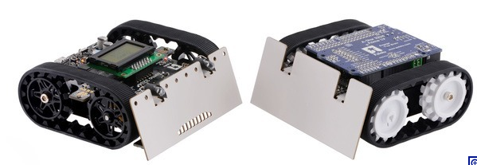
Pololu item #: 2510
Price: US$99.95
Top of Form
Bottom of Form

Zumo Robot for Arduino, v1.2 (Assembled with 75:1 HP Motors)
The Zumo robot for Arduino is an Arduino-controllable tracked robot platform that is less than 10 cm × 10 cm—small enough to qualify for Mini Sumo. It includes two micro metal gearmotors coupled to a pair of silicone tracks, a stainless steel bulldozer-style blade, an array of six infrared reflectance sensors for line following or edge detection, a buzzer for simple sounds and music, a 3-axis accelerometer, magnetometer, and gyro for detecting impacts and tracking orientation. Just add 4 AA batteries and an Arduino (or compatible controller) and you are ready to push! No soldering or assembly is required.
Pololu item #: 2509
Price: US$42.95
Top of Form
Bottom of Form

Zumo Robot Kit for Arduino, v1.2 (No Motors)
This kit contains most of the parts you need to build an Arduino-controlled Zumo robot. It consists of a Zumo Shield for Arduino, v1.2, a Zumo chassis kit, and a Zumo blade. You will also need a pair of micro metal gearmotors, four AA batteries, and an A-Star 32U4 Prime or Arduino to complete your Zumo robot (motors, batteries, and Arduino sold separately). This product is a kit; assembly (including soldering) is required.
https://www.pololu.com/category/169/zumo-robot-for-arduino
Pololu item #: 3124
Price: US$99.00
Top of Form
Bottom of Form

Zumo 32U4 Robot Kit (No Motors)
The Pololu Zumo 32U4 robot is a versatile tracked robot based on the Arduino-compatible ATmega32U4 MCU, and this kit contains most of the parts you need to build one—all you need to add are a pair of micro metal gearmotors and four AA batteries. It includes integrated dual motor drivers, an LCD, quadrature encoders, line sensors, side and front proximity sensors, and a full IMU. The assembled robot is less than 10 cm × 10 cm—small enough to qualify for Mini Sumo. This product is a kit; assembly (including soldering) is required.
Pololu item #: 3127
Price: US$149.95
Top of Form
Bottom of Form

Zumo 32U4 Robot (Assembled with 100:1 HP Motors)
The Pololu Zumo 32U4 robot is a versatile tracked robot based on the Arduino-compatible ATmega32U4 MCU. It includes two 100:1 HPmicro metal gearmotors along with integrated dual motor drivers, an LCD, quadrature encoders, line sensors, side and front proximity sensors for detecting objects, and a full IMU for detecting impacts and tracking orientation. The low-profile robot is less than 10 cm × 10 cm—small enough to qualify for Mini Sumo. No soldering or assembly is required; just add 4 AA batteries and a USB cable and your Zumo is ready for programming.

https://www.pololu.com/category/170/zumo-32u4-robot
Pololu item #: 975
Price: US$99.95
Top of Form
Bottom of Form

Pololu 3pi Robot
The Pololu 3pi robot is a complete, high-performance mobile platform featuring two micro metal gearmotors, five reflectance sensors, an 8×2 character LCD, a buzzer, and three user pushbuttons, all connected to a C-programmable ATmega328 microcontroller. Capable of speeds exceeding 3 feet per second, 3pi is a great first robot for ambitious beginners and a perfect second robot for those looking to move up from non-programmable or slower beginner robots.
Pololu item #: 2151
Price: US$149.95
Top of Form
Bottom of Form

Pololu m3pi Robot with mbed Socket
The Pololu m3pi robot consists of a 3pi robot base with a fully assembled m3pi expansion board as its second level. This expansion board enables the use of a powerful 32-bit mbed development board as the robot’s high-level controller, which offers significantly more processing power and free I/O lines than the 3pi’s built-in 8-bit AVR microcontroller. There are also sockets for Wixeland XBee wireless serial modules as well as prototyping space for additional sensors and electronics.

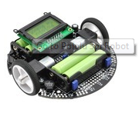
https://www.pololu.com/category/76/3pi-robot-and-accessories

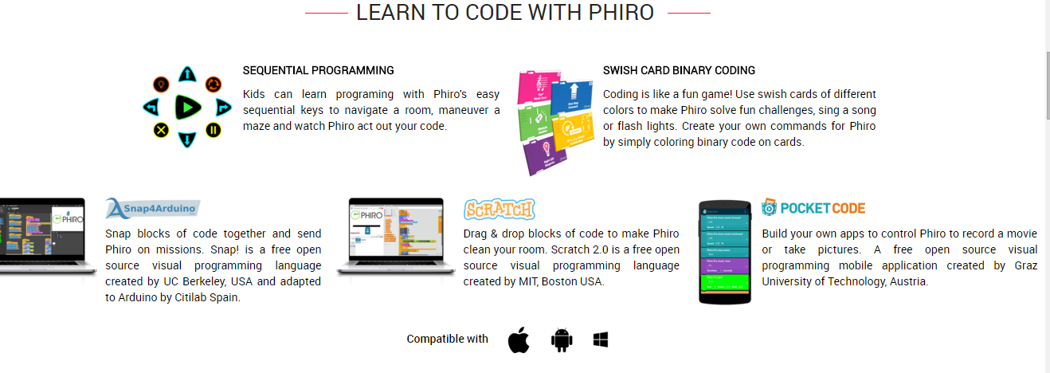
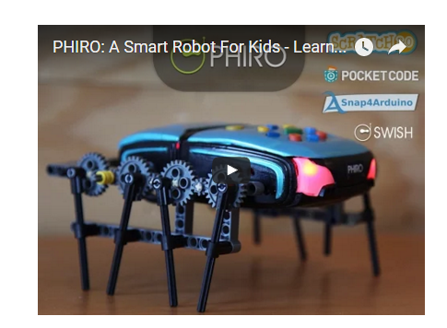LEGO compatable

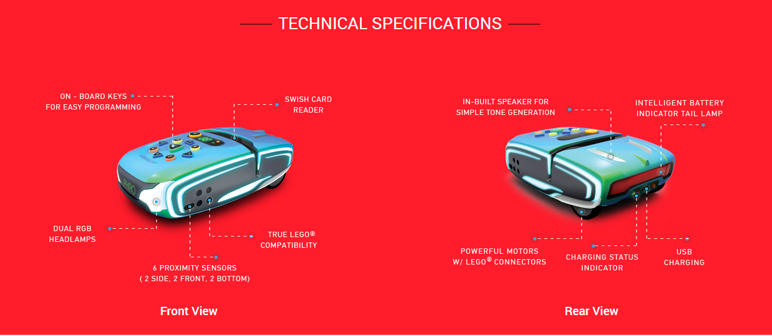

http://www.robotixedu.com/phiro.aspx
Sparki by Arcbotics US$159.95
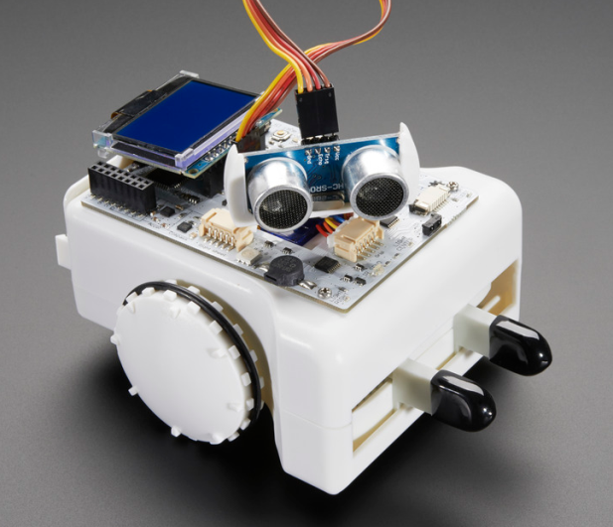
Sparki by Arcbotics is a new affordable, easy to use, and fun intro to programming, electronics, and robotics. It is geared towards kids elementary-age and above, educators looking for an easy intro to robotics, parents eager to find something affordable but educational and fun, DIY enthusiasts, and more. It is simple enough for beginners, while being feature-packed enough to be a must-have for pro-users. Sparki is your chance to have your very own robot, completely open source and available to do your bidding. Watch the ArcBotics video demoing Sparki.
The Story:
Sparki is ArcBotics’ answer to robotics in education. After ArcBotics' first successful Kickstarter for Hexy the Hexapod, a low-cost open-source Arduino robot designed to be an intro to advanced robotics, ArcBotics were approached by many who asked,"Is there anything for beginners?" When they looked around, they saw that other educational robots were mostly expensive, difficult to use, lacked features, or had closed designs. However, ArcBotics know that the interest in programming and robotics from people of all ages is enormous. So they thought, "why not design an adorable new robot that lets people of all ages enjoy robotics, while offering them a wide range of possibilities, and is – most of all – fun?"
The Robot
Sparki works out of the box with its remote control. To write your own programs, just plug it in via USB, install the custom-enhanced Arduino software and try any of the dozens of example programs. ArcBotics have programs for every sensor and actuator on Sparki:
- 1x Ultrasonic distance sensor (get distance from Sparki to walls/objects)
- 1x 3-Axis Accelerometer (pick-up detection, fall detection, hill climbing)
- 1x 3-Axis Magnetometer (sense the magnetic field around Sparki, coordinate with accelerometer to detect compass heading)
- 3x Light-sensing phototransistors (light following, darkness seeking)
- 5x Line-following and edge detection sensors (mazes, line follow, sumo)
- 1x 128×64 Graphic LCD
- 1x RGB LED (RGB = generate any color!)
- 1x Buzzer (beeping, booping, and musical tones!)
- 1x IR Transmitter (like your TV remote control)
- 1x IR Receiver (like your TV)
- 1x IR Remote control (lots of buttons to control Sparki with)
- 1x TTL Serial port for expansion (talk to an Arduino/Raspberry Pi)
- 1x Bluetooth Serial Module
- Powered by 4xAA batteries (rechargeable or alkaline)
- 2x Geared stepper motors (precise, measured movement down to millimeters/ sub-degrees)
- Marker holder for drawing
- And textured ABS plastic shell for your choice of decoration
Here are some of the things you’ll learn how to do with Sparki:
- Edge avoidance
- Line following
- Maze solving
- Wall avoidance
- Room navigation
- Object retrieval
- Follow/hide from light sources
- Shape drawing
- Computer input (make a keyboard/mouse using sensors)
- Games with other Sparkis
And more advanced concepts:
- PID Loops
- Pathfinding algorithms
- Signal Filtering
- Heuristics
The Programming:
Sparki’s code is available as Arduino code. All code is made for free to users and open-source.

https://www.adafruit.com/products/1715

OWI Robotic Arm Edge - Robot arm - OWI-535
PRODUCT ID: 548
US$49.95
Riding the wings of the award winning Robotic Arm Trainer, OWI has made robotic arm technology more affordable without compromising quality. With Robotic Arm Edge, command the gripper to open and close, wrist motion of 120 degrees, an extensive elbow range of 300 degrees, base rotation of 270 degrees, base motion of 180 degrees, vertical reach of 15 inches, horizontal reach of 12.6 inches, and lifting capacity of 100g. This is a pretty complicated arm to build, but we're happy with the quality and the arm. Many hackers and makers have used it with our Adafruit Motorshield. CHOKING HAZARD -- Small parts. Not for children. We only suggest this product for adults and/or kids with adult supervision.
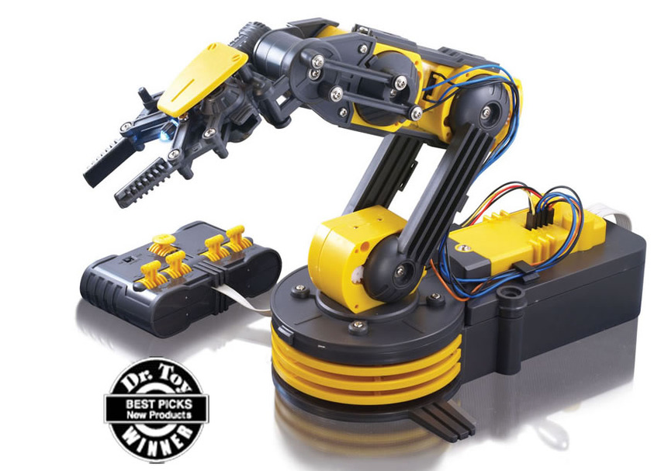
Some of the added features include a search light design on the gripper and a safety gear audible indicator is included on all five gear boxes to prevent any potential injury or gear breakage during operation. How does this equate to fun? Total command and visual manipulation using the 5s: five switch wired controller, five motors, and five joints. Night time play is possible and extended life on the gearbox to prolong your control and predictions of the robot’s behavior. 4xD Batteries Required (not included).
- Command the Robotic Arm Edge with for multiple movements and functions
- Robotic arm gripper opens and closes
- Movement includes radial wrist motion of 120°, an extensive elbow range of motion of 300°, base rotation of 270°, base motion of 180°
- No Soldering Required
https://www.adafruit.com/products/548

Boe-Bot US$124.95
This kit brings the excellent design and tutorials of Parallax to the Arduino world. Make your Arduino the onboard brain of a mobile robot and learn robotics, electronics, and programming with this versatile kit and its accompanying step-by-step lessons. The Board of Education Shield plugs into your own Arduino (not included) and mounts on the popular Boe-Bot robot chassis.
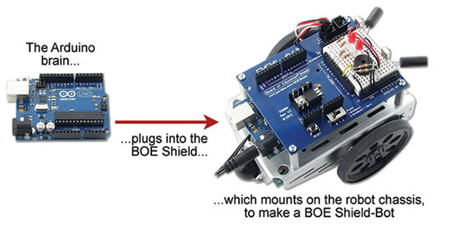
With this kit and your own Arduino module, you can follow the Robotics with the Board of Education Shield for Arduino lessons with over 40 hands-on activities.
- Learning to program your robot's Arduino Brain
- Calibrating the robot's continuous rotation servo motors
- Using lights and speakers for status indicators
- Assembling the robot
- Preprogrammed navigation
- Using touch-switches to navigate by contact with objects
- Using phototransistors to navigate by light
- Using non-contact infrared sensors to measure distance and avoid or follow objects
The original Robotics with the Boe-Bot text for the BASIC Stamp microcontroller has enjoyed worldwide popularity with teachers and hobbyists, and has been translated into seven languages. Author Andy Lindsay revised his work for the Arduino community, and Parallax Inc. is making it available as a free, online tutorial at http://learn.parallax.com/ShieldRobot.
Kit Contents:
- Board of Education Shield PCB
- High-quality aluminum robot chassis, continuous rotation servos, and wheels
- Boe-Boost Module
- All the electronic components and sensors needed for the Robotics activities
- All the assembly hardware needed (nuts, screws standoffs)
- Parallax Screwdriver
Please note: Arduino + USB cable not included! We suggest picking up an Uno + USB cable to complete the kit if you don't have one at home already.
https://www.adafruit.com/products/749

Adafruit 16-Channel 12-bit PWM/Servo Shield - I2C interface
PRODUCT ID: 1411
US$17.50

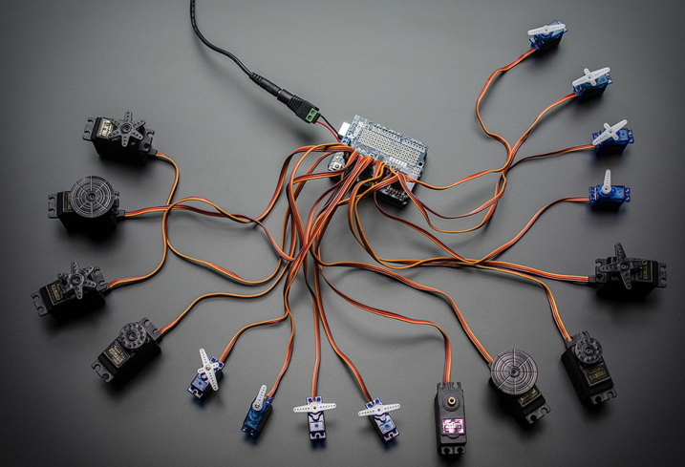
You want to make a cool Arduino robot, maybe a hexapod walker, or maybe just a piece of art with a lot of moving parts. Or maybe you want to drive a lot of LEDs with precise PWM output. Then you realize that the Arduino has only a few PWM outputs, and maybe those outputs are conflicting with another shield! What now? You could give up OR you could just get our handy PWM and Servo driver shield. It's just like our popular PWM/Servo Breakout but now Arduino-ready and works with any Arduino that uses shields: Uno, Leo, Mega, ADK, its all good.
When we saw this chip, we quickly realized what an excellent add-on this would be. Using only two I2C pins, control 16 free-running PWM outputs! You can even stack up 62 shields to control up to 992 PWM outputs (which we would really like to see since it would be glorious and like 4 feet tall) Because I2C is a shared bus you can also connect other I2C devices and sensors to the SCL/SDA pins as long as their addresses don't conflict (this shield has address 0x40)
- There's an I2C-controlled PWM driver with a built in clock. That means that, unlike the TLC5940 family, you do not need to continuously send it signal tying up your microcontroller, its completely free running!
- It is 5V compliant, which means you can control it from a 3.3V Arduino and still safely drive up to 6V outputs (this is good for when you want to control white or blue LEDs with 3.4+ forward voltages)
- 6 address select pins so you can stack up to 62 of these on a single i2c bus, a total of 992 outputs - that's a lot of servos or LEDs
- Adjustable frequency PWM up to about 1.6 KHz
- 12-bit resolution for each output - for servos, that means about 4us resolution at 60Hz update rate
- Configurable push-pull or open-drain output
We wrapped up this lovely chip into a shield with a couple nice extras
- Terminal block for power input (or you can use the 0.1" breakouts on the side)
- Reverse polarity protection on the terminal block input
- Green and red power-good LEDs
- 3 pin connectors in groups of 4 so you can plug in 16 servos at once (Servo plugs are slightly wider than 0.1" so you can only stack 4 next to each other on 0.1" header
- Stackable design. You'll need to pick up stacking headers and right angle 3x4 headers in order to stack on top of this shield without the servo connections getting in the way.
- A spot to place a big capacitor on the V+ line (in case you need it)
- 220 ohm series resistors on all the output lines to protect them, and to make driving LEDs trivial
- Solder jumpers for the 6 address select pins
- A lot of extra space remaining? Let's turn it into a prototyping area. You get a 5x20 proto area for any extra wiring you'd like to add
This product comes with a fully tested and assembled shield as well as 4 pieces of 3x4 male straight header (for servo/LED plugs), a 2-pin terminal block (for power) and a stick of 0.1" header so you can plug into an Arduino. A little light soldering will be required to assemble and customize the board by attaching the desired headers but it is a 15 minute task that even a beginner can do. If you want to use right-angle 3x4 headers, we also carry a 4 pack in the shop. Servos and Arduino not included - but we do sell tons of different servos in the shop so pick up a few while you're here!

https://www.adafruit.com/products/1411

Bee-Bot US$89.95

Bee-Bot is an exciting new robot designed for use by young children. This colorful, easy-to-operate, and friendly little robot is a perfect tool for teaching sequencing, estimation, problem-solving, and just having fun!!
- 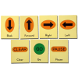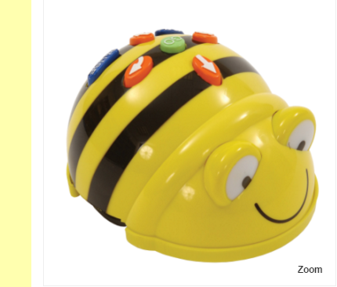

Command Cards
US$24.95
Sturdy construction and colorful design entice children to put Bee-Bot through its paces. Directional keys are used to enter up to 40 commands which send Bee-Bot forward, back, left, and right. Pressing the green GO button starts Bee-Bot on its way. Bee-Bot blinks and beeps at the conclusion of each command to allow children to follow Bee-Bot through the program they have entered and then confirms its completion with lights and sound. Children want to use Bee-Bot over and over and are inspired to enter ever more creative and complex command sequences.
Rechargeable Bee-Bot with USB Recharger Cable

https://www.bee-bot.us/bee-bot/bee-bot.html

Pro-Bot US$129.95

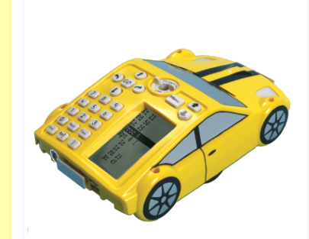
Pro-Bot is the latest in Logo technology. A turtle robot, cleverly disguised as a race car, Pro-Bot offers students an enticing, engaging, and hands-on experience with Logo programming as well as robotic controls.

Pro-Bot commands are entered via a set of arrow and number keys mounted on the back. Programs may also be written in Terrapin Logo 4.0 and downloaded to Pro-Bot. Conversely, Pro-Bot programs entered via the on-board keypad may be uploaded from Pro-Bot to Terrapin Logo for editing and storage. See Programming the Pro-Bot in the Terrapin Resources site for full information.
https://www.bee-bot.us/probot/pro-bot/probot.html
Pro-Bot is the latest in Logo technology. A turtle robot, cleverly disguised as a race car, Pro-Bot offers students an enticing, engaging, and hands-on experience with Logo programming as well as robotic controls. Pro-Bot commands are entered via a set of arrow and number keys mounted on the back. Plan a route for Pro-Bot and press the corresponding keypad controls. Press the GO button and send Pro-Bot on its way. Pro-Bot will follow the sequence of commands that were entered step by step.
Pro-Bot operates in two modes. As "big brother" to Bee-Bot, Pro-Bot can be operated in Bee-Bot mode using only the arrow keys and GO button. Each movement and turn defaults to a set amount. In Logo mode, arrow keys can be combined with the number buttons with distances entered for movement and degrees entered for turns. Students transition easily from one mode to another as their skills develop.
The built-in LCD screen makes on-board programming easy. As keys are pressed, the equivalent Logo command appears on the screen. When Pro-Bot is sent on its way with the GO button, each command in the sequence is highlighted on the LCD screen as it is executed. Programs can be edited and altered on the LCD screen using the edit keys without having to enter the entire program again.
Pro-Bot can hold a felt-tip pen in the built-in mechanism in the center, allowing it to draw as it moves, much like the Logo turtle on the screen. A simple PenUp/PenDown toggle makes it easy to turn drawing on and off and reinforces the same concepts for screen drawing.
Pro-Bot not only supports procedures that it can execute, but also has the capability for storing subprocedures that can be incorporated into a Pro-Bot program. Complex projects are made simple by developing and testing subprocedures and then incorporating them into a master program and sending Pro-Bot on its way.
In addition to moving and turning, Pro-Bot has several built-in sensors providing a strong grounding in robotics concepts. The front and rear bumpers are touch sensors. Pro-Bot also comes equipped with sound and light sensors. Having Pro-Bot respond differently to different states of its sensors is a programming challenge and provides an exciting robotic experience.
Pro-Bot runs on 3 AA batteries (included) and comes complete and ready to go in a convenient storage box. A user guide provides information on operating and caring for Pro-Bot and decorative decals can be used to customize it. Pro-Bot is a hands-on way to introduce Logo, a tool to encourage student collaboration, and an entry into the exciting world of robotics.

ROBOTC is a powerful C-based programming language with a Windows environment for writing and debugging programs, and the only programming language at this level that offers a comprehensive, real-time debugger. ROBOTC is a cross-platform solution that allows students to learn the type of c-based programming used in advanced education and professional applications.
US$17/year or $40 perpetual each seat or US$99 /$239 for small groups.

Benefits of using ROBOTC
- Uses the industry standard C-programming language. Additional language extensions specifically for robotic use.
- Modern Windows GUI with standard visual interface.
- The only solution with fully integrated software debugger allowing users to step line by line through program execution and analysis of all variables.
- Additional debugging tools allow the user to see the real time states of all motors and sensor. These are viewed as your program is running; not as a separate application!
- Single solution works for both VEX Cortex and VEX PIC. No need to purchase two different applications.
- Over 100 Sample Programs with extensive documentation so students and hobbyists can get started learning how to program
- Advanced source code editor with smart indenting, automatic code competition and a tabbed interface to allow multiple program to be open at the same time
- Free webinars, video tutorials, community forums, detailed help files, and curriculum provided by Carnegie Mellon’s Robotics Academy.
- ROBOTC skills easily transitions into use of professional tools used by engineers. Not a dead end skill for VEX only!
- ROBOTC has the same form and feel, often even the same command names, as professional tools used on other systems.

Read the WIRED Blog Network article:
The Best Programming Language for LEGO Mindstorms, Hands Down

At this site you will find:
- Comprehensive ROBOTC.net web support includes forums, how-to guides and links to global ROBOTC community
- Sample programs demonstrate both autonomous and user control phases of competition
- Companion CD Teaching ROBOTC for LEGO MINDSTORMS and Teaching ROBOTC for IFI VEX is available from CMU Robotics Academy.

ROBOTC Robot Virtual Worlds for VEX
No robot no problem! Save money and learn to program faster with a virtual VEX robot! (Our software supports the virtualization of Cortex and IQ robots.)
US$49/seat or US$149 for 6

Starter Kit with Sensors US$249.99

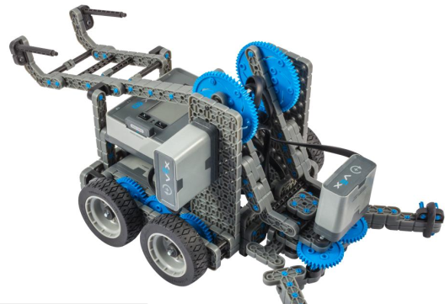 Model: 228-3080
- Manufactured by: VEX Robotics
The Starter Kit with Sensors is a focused introduction to STEM and sensor integration. Students can use the included Smart Sensors to program autonomous robots right out of the box. While the included Clawbot IQ instructions help students easily build their first robot, the intuitive snap-together parts mean the sky is the limit for their VEX IQ creations.
- Over 850 Structural & Motion Components
- 4 Smart Motors, 7 Sensors, Robot Brain & Batteries Included
- Storage Bin & Tray included for organized storage of all parts
http://store.robomatter.com/Shop-By-Robot/VEX-IQ-Robots/Bundles/Starter-Kit-With-Sensors

GIZMOS & GADGETS KIT
Little Bits Gizmos and Gadgets kit US$199.95

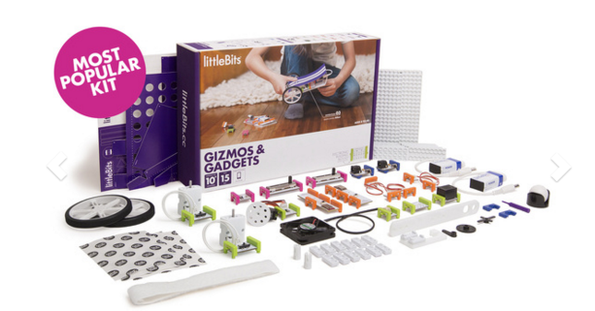

The Gizmos & Gadgets Kit is the ultimate invention toolbox. Motors, wheels, lights, switches, servos, buzzers, even the tools to build a remote control – snap it all together to spark creativity and fun. Want to invent a remote control racecar? Do it. Create an automatic bubble blowing device? Go for it! Make a wireless doorbell, a bumper ball game, even a mischief machine to scare the pants off friends and family. Start with step-by-step instructions for 12 inventions, then break out of the box and hack your world for fun.
Start inventing the minute you open the box. The Gizmos & Gadgets Kit comes with 15 electronic building blocks, a detailed instruction handbook, and all the accessories and tools you need to unleash the inventor within. Create, play, remix, then share your creations with the world. Need some inspiration? Check out the thousands of inventions on our community pages and the free littleBits app. Want to do even more? Explore the worlds of coding, electronic music, smart devices and more with additional littleBits Kits. Develop creativity and engineering skills as you reinvent the world around you.

http://littlebits.cc/shop/kits

Edison Robot - EdPack1 US$49

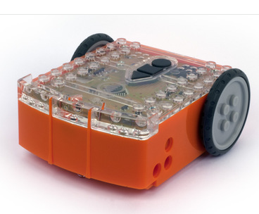

Edison is programmed using EdWare, an icon based graphical programming language. Programs are downloaded to Edison using the EdComm cable. The EdComm cable plugs into the computer's headphone jack and carries a pulsed audio signal to a high efficiency LED. The LED converts the pulsed audio signal into light that is received by Edison's line tracker phototransistor and loads the program into the processor.

Sensors and inputs
Obstacle detection: Infrared using 2 IR LEDs (front left and right) and IR receiver module (doubles as IR receiver)
Remote control: IR receiver module (38kHz) Edison can learn IR codes from most standard TV/DVD remote controls
Infrared data comms: IR receiver module (double as obstacle detection sensor and IR remote receiver)
Line tracker: Red LED and phototransistor (doubles as barcode reader and programming port)
Light sensors: 2 phototransistors (front left and right)
Sound sensor: Piezo transducer (doubles as sounder)

Outputs
Drive: Differential drive system
Infrared data comms: 2 infrared LEDs (double as obstacle detection sensor)
Sound: Piezo buzzer (doubles as sound sensor)
Lights: 2 red LEDs (Front left and right)

Processor
Freescale 8-bit MC9S08PA8VLC

Power
Battery: 4 x AAA (UM 4)
Edison has:
- infrared obstacle detectors (left and right)
- line tracking sensor
- light sensors (left and right)
- infrared receiver
- infrared transmitter
- piezo sounder
- sound sensor
- two motors with variable speeds
- left and right red LED lights
- and three control buttons
Edison can:
- navigate his way around by detecting obstacles to his left or right
- be controlled by a standard TV/DVD remote
- follow a line or stay within a boarder
- follow a flash light
- communicate with another Edison using infrared light - robot swarm anyone?!!
- play beeps and musical tunes
- respond to clapping and other loud sounds
- move in any direction through his differential drive system

EdWare is a free open source program that runs on Mac, Linux and Windows computers. To upload your program to Edison, the supplied EdComm data cable is simply connected between your computer’s headphone jack and Edison. Then press PLAY and let Edison do the rest!
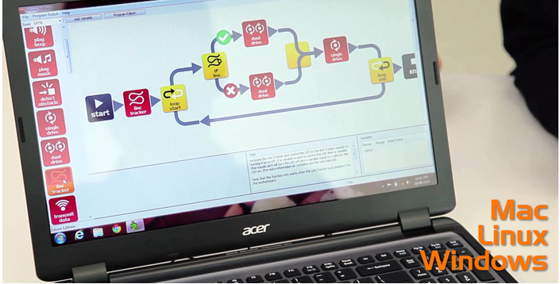
EdComm uses audio encoded data to transfer your program to Edison. This happens via your computer’s headphone socket, so no additional driver software is required to be installed.
All Robot Kits also come with Free Worldwide Shipping, Free Software and a Free Robot Activity Mat to download.

The Edison robot is an innovation from Microbric, an Australian company based in South Australia. Microbric has been providing educational products to schools since 2004.

http://meetedison.com/robots/

Robo Wunderkind Programmable Robot Kit
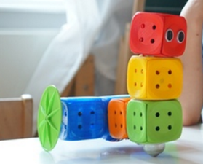
Robo Wunderkind is a set of blocks for building robots. By just snapping blocks together, even a five year old can build a robot. The LEGO-compatible kit connects to Android and iOS devices via Bluetooth. Kids can also use the app’s visual drag-and-drop interface to program it. Once children have mastered the basics of coding, they can move on to program their robot with Scratch, a programming language for kids developed at MIT.
Robo Wunderkind comes in three sets. Kickstarter prices start at $79. There is a sliding price scale depending on the cube quantity and complexity. The cubes’ colors relate to their function: red is a proximity sensor, blue is a motor, orange - the main controller, and so on. The most advanced set comes with a digital camera and a weather sensor.
https://www.kickstarter.com/projects/startrobo/robo-wunderkind-a-programmable-robot-for-kids-of-a

Makeblock Starter Robot Kit US$149.99

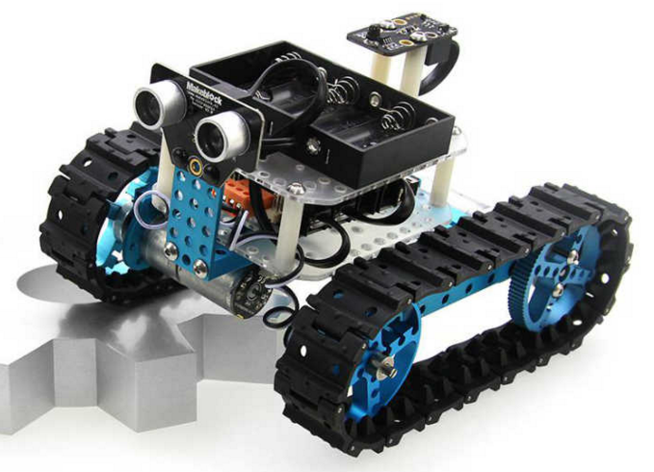
This robot kit is a great option for starting your innings at robotics. The Makeblock starter robot kit is a great way of learning robotics, Arduino programming as well as electronics. The kit comes with mechanical parts along with electronic modules. With this you can build a 3- wheel robot car or a robot tank. There are two versions of this kit an IR version and a Bluetooth version.
You can also make an ultrasonic obstacle-avoiding robot or an IR controlled robot with electric modules- ultrasonic sensor, Me Orion, IR receiver and IR remote controller. The electronic modules of Me series are very user friendly and are a great option to begin with. For building robots with this kit, you do not need to solder. The wiring is also not a big issue. The aluminum extrusion structure is another plus point.

http://www.makeblock.cc/starter-robot-kit/

ASURO

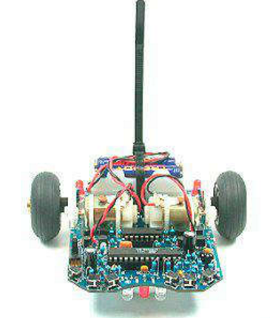
The mind behind this small mobile robot is the German aerospace center, DLR. The basic purpose of this robot is educating the beginners. It is easy to assemble even for a novice and is programmed in C. Standard parts are used excluding the PCB (Printed Circuit Board). The freeware equipment can be brought into use for programming.
This robot kit qualifies for use in school and university projects, for studies as well as adult education centers. It is a great way to introduce yourself to the processor-controlled hobby electronics. The tools that are used for making this robot are freeware for confidential use. The parts used for electronic development and software design are inexpensive. ASURO comes with 2 motors that are controlled independently and an Atmel AVR RISC-processor, 6 collision-detector buttons, 3 indicator LEDs, an IR-Interface and 2 odometer-sensors. The robot can be programmed and remote controlled by a PC.
It is very flexible and completely programmable in C. Assembly is easy for experienced electronic technicians and feasible for a novice. | 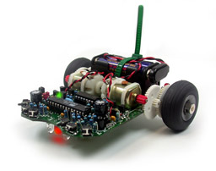
Except for the printed circuit boards (PCB) only standard parts are utilized and freeware tools can be used for programming. Therefore ASURO is exceptionally suitable as an introduction into processor-controlled hobby electronics, for projects in schools and universities, for studies and adult education centres. Special tools, which are freeware for private users, have been used for all electronic development phases and software design, proving that robots can be designed without expensive tools or machines.
http://www.arexx.nl/arexx.php?cmd=goto&cparam=p_asuro

mBot Robot Kit

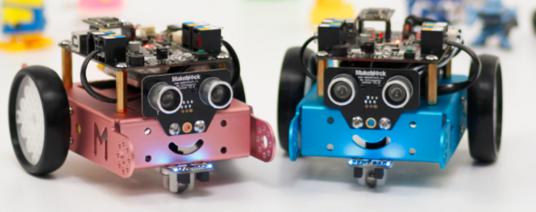
Age: 8+
Price: $74.99
Buy Now
Instead of a toy played by kids, mBot is a masterpiece created by kids. mBot is an educational robot which is easy to handle. The original intention of the design is to make it convenient for children to learn programming, Arduino, and robotics. To start with, kids have to assemble the robot by themselves. To make it possible, modular design simplifies the assembly so that it can be finished in 10 minutes. As for the software mBlock, users do not need to code, instead, they only have to drag the pattern to design a program. All these make it easier for kids to use and learn about robots. Particularly, the affordable price helps to realize the goal of “one robot per kid.”

http://www.makeblock.cc/mbot/

Barobo Linkbot US$499
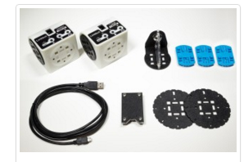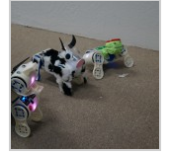
Recognizing that educators are working harder than ever to prepare eager learners for our technologically advanced world inspired Barobo to collaborate with award winning STEM educators to develop a CCSS and NGSS aligned click through curriculum. Teachers are free to monitor student progress as they interactively learn to program using industry standard Python and C/C++. Together students can persevere and collaborate through coding tasks that result in immediate feedback from a Linkbot, which fosters self-correction, reflection, and critical thinking skills. The teacher is free to rove through and monitor a classroom full of enthusiastic young programmers.

Simplify research by using the modular Linkbot for labs. It is easy to get started, Arduino-compatible, Raspberry Pi friendly, loaded with absolute encoding, accelerometer, Battery and ZigBee. All accessories can be easily interchanged with quick SnapConnector mounting surface technology. If specific parts are needed, they can be created from the library of open source hardware accessories for 3D printing. Linkbots can be programmed in Python and C/C++.
- Linkbots can be used with LabVIEW and NI myRIO hardware
- Pose teaching programs the Linkbots with your hands; no programming language knowledge is necessary
- Bump connect allows you to connect and control multiple modules without a computer

This package includes:
2x Linkbot-I
1x Z-Link Dongle
6x Snap Connector
4x Wheel
2x Caster
1x 2-Port USB Charger
3D Printing/Laser Cut Accessory Files
Content Updates

Catrobat Pocket Code app free

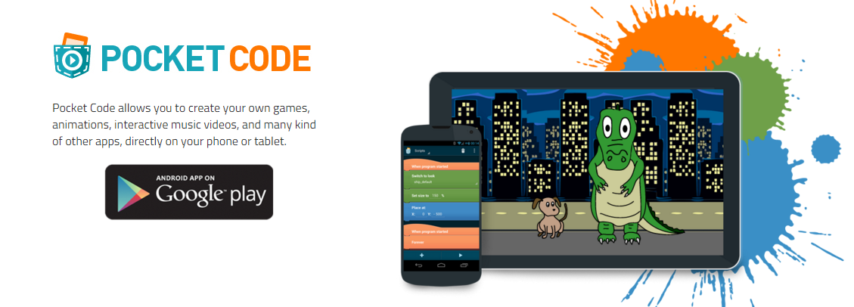

Ozobot

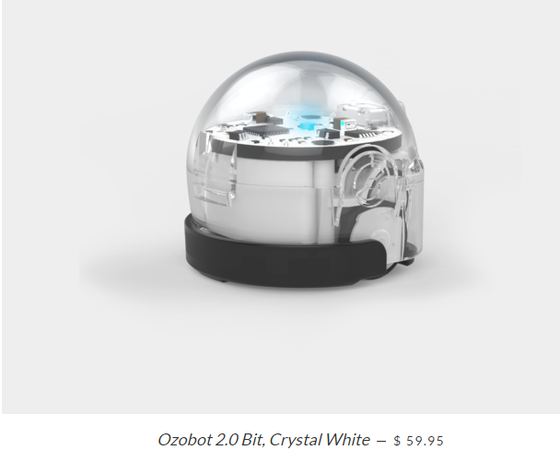

Starting with color markers, Ozobot takes kids on a fun and mesmerizing experience through creative drawing, problem solving and group challenges by coloring code commands in the form of basic color combinations.
Ozobot Bit’s ability to learn your programs, and then play them back is a big game changer to how young minds play and learn. OzoBlockly - a web-based visual editor - offers five step up modes from icon-based to loops, logic and equation blocks to appeal to young kids and even to challenge the seasoned programmers.

Hummingbird Duo Base Kit
Our Price: $159.00
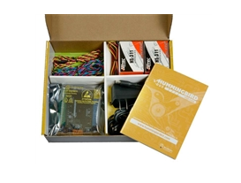

- One Hummingbird Duo controller
- Power supply, USB cable, terminal tool, snap-in stand-offs
- Red, orange, yellow, and green single-color LEDs
- Two tri-color LEDs
- Two hobby servos and one servo extension cable
- One light sensor, and one temperature sensor
- Program in everything from Scratch to Java!

Hummingbird Duo Controller Kit
Our Price: $89.00
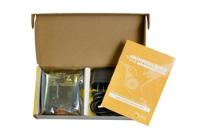

Contains assembled Hummingbird circuit board, USB cable, auxiliary power supply, snap-in standoffs, and terminal tool.
The Duo controller kit does not come with its own set of Hummingbird Duo kit parts like LEDs, motors, or sensors. Purchase the base, premium, or classroom kits for a complete robot-building package. Purchase the Hummingbird Duo controller kit if you want to:
- Upgrade an original Hummingbird kit: All original kit parts work with Duo.
- Use our datasheet to guide you as your create your own LEDs, motors, sensors, etc, to add to the kit.
- Use it as an Arduino with integrated motor/servo and connector shields.
- Purchase kit parts a la Carte to use with the Duo controller.
http://www.hummingbirdkit.com/

Crumble Controller
CRM 001

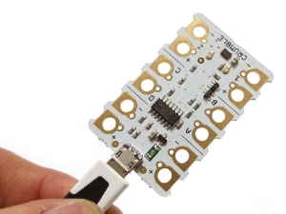£12.00 inc VAT £10.00 ex VAT

This truly game-changing device opens up countless possibilities for ‘embedded intelligence’ as required by the new national curriculum.
What makes it unique is the much lower cost than any comparable device (about the same as our IQ4 controller) and the ease of use.
Non-electronics specialists can use it right away BUT, at the same time, it offers unlimited potential for advanced users – including electronics professionals.
You simply create a programme on a computer screen by moving icons into the right position – e.g., to turn things on and off – and then plug in the Crumble. The programme is immediately transferred and turns Crumble into whatever you tell it to do. Drawing power from a very small battery, it might be applied to anything from turning LEDs on and off in smart clothing to driving and steering a robot.
Starter Pack also available. Please see HERE.
Please see sample use of Crumble controller in 'Product Video' tab below...

Download the FREE Software from Redfern Electronics. (External Link).
