Proposal
Part 1

Edit
Activity Summary
Indroduction to Fusion 360 CAD Program, and modelling up your phone and phone case.
Edit
Materials
Phone
Edit
Tools
Fusion 360
Laptops
measuring tools (Tape Measure, ruler, or vernier calliper)
Edit
Instructions
Rename the steps as you like, use italics or bold for emphasis
Edit
Step Zero:
Turn on Computer, log on using the password on the keyboard and open your web browser to create a Fusion 360 Account. The link is:
Edit
Step One:
Open Fusion 360 and follow Map around Fusion 360 to get an understanding

Step Two:
Click File and save. Name as my phone

Edit
Step Three:
In the tool bar click Assemble then Make a component. An assembly is an organisation of parts that make a whole product.

Edit

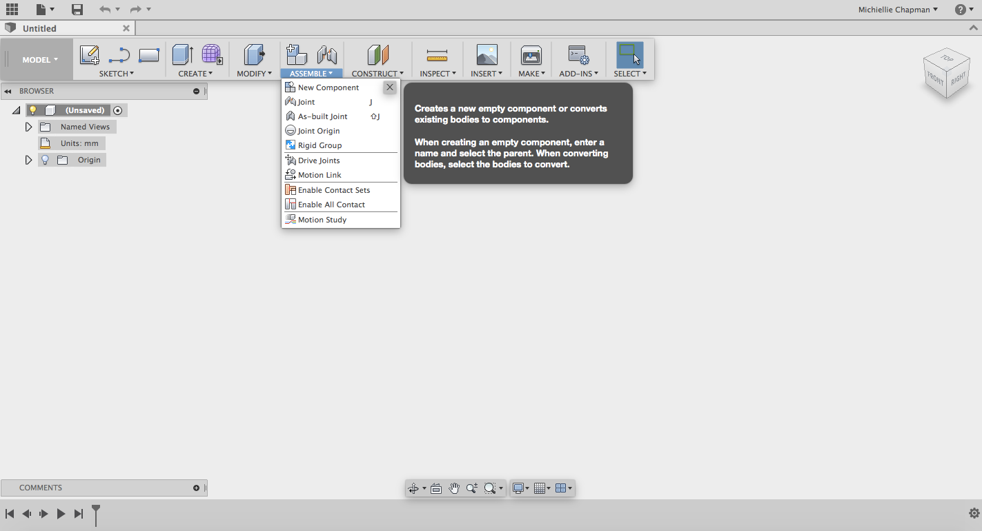

Step Four:
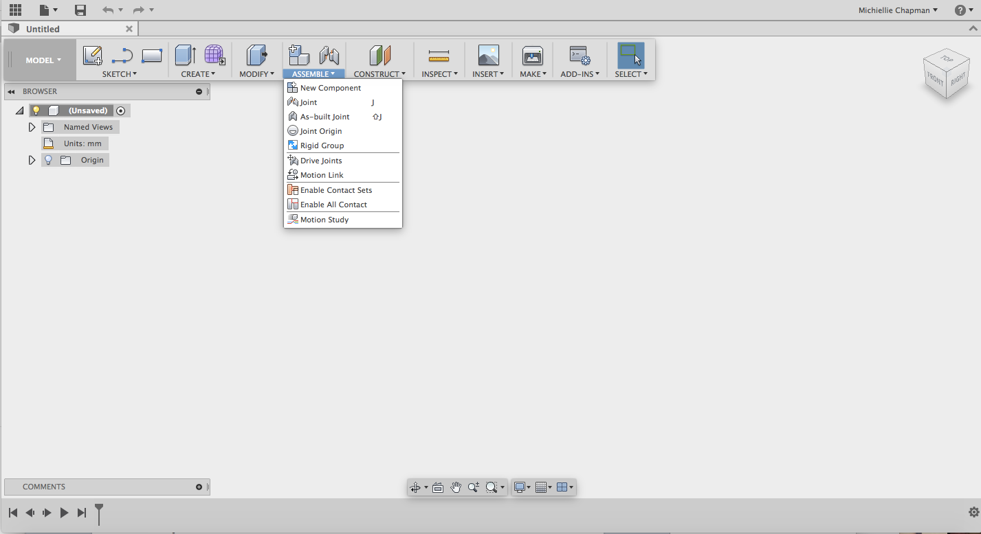
Click sketch then choose a plane to draw on, and draw a rectangle.
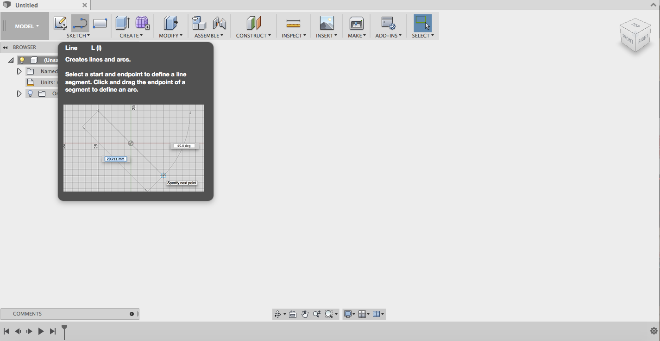
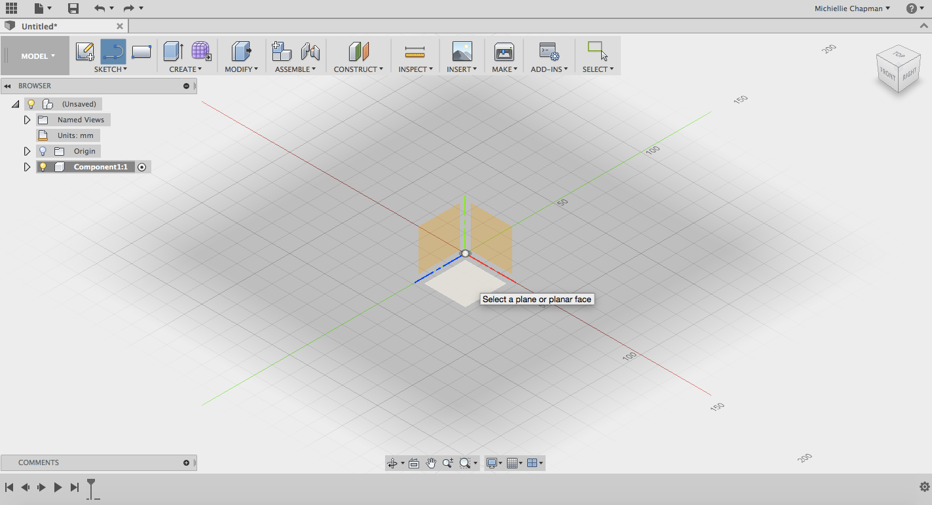
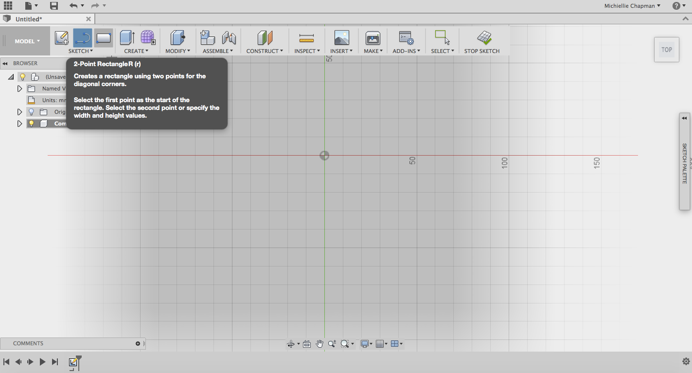
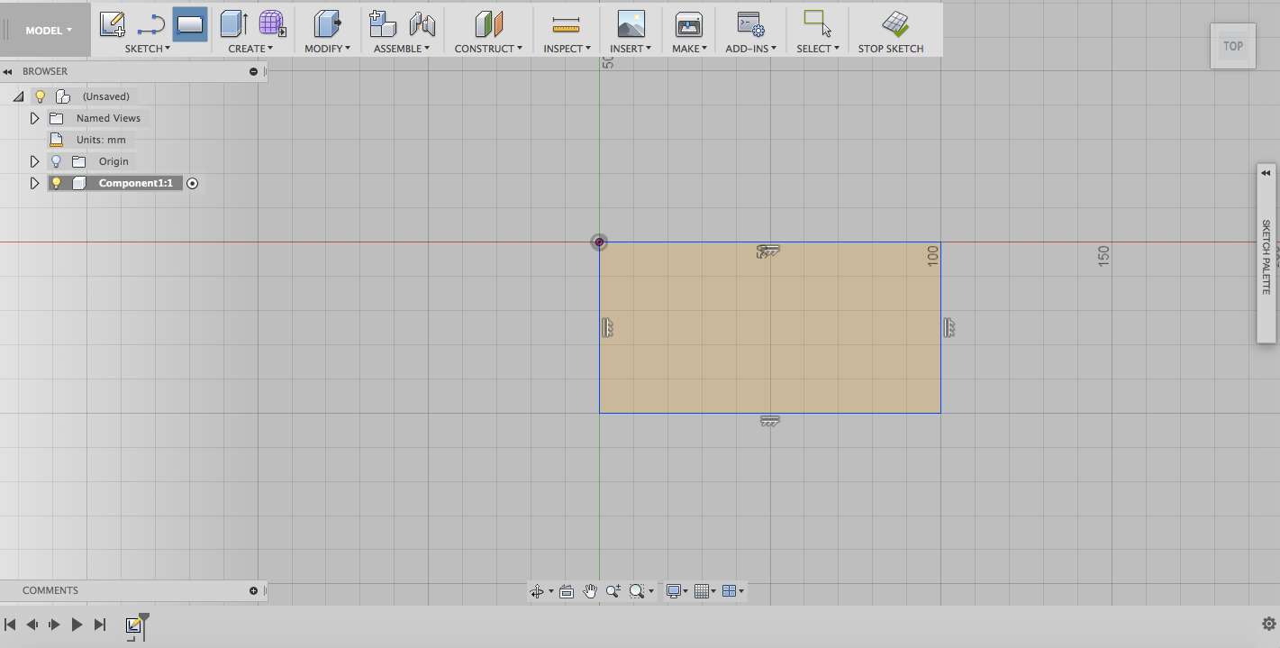

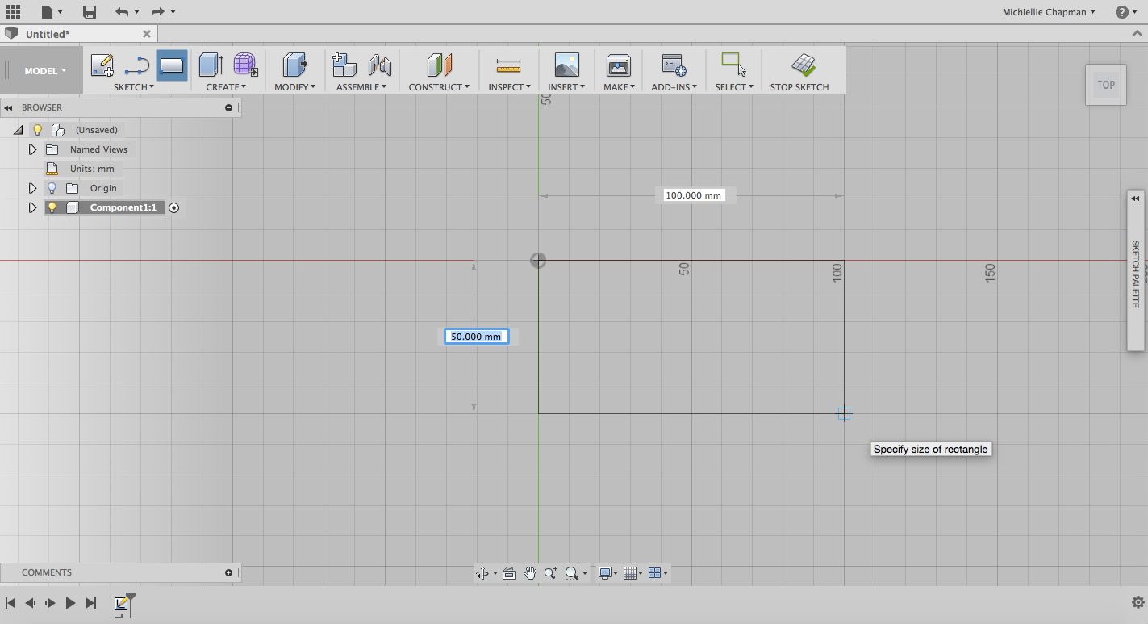

Step Five:
Delete some restraints from the rectangle and then change some parameters then click stop sketch.
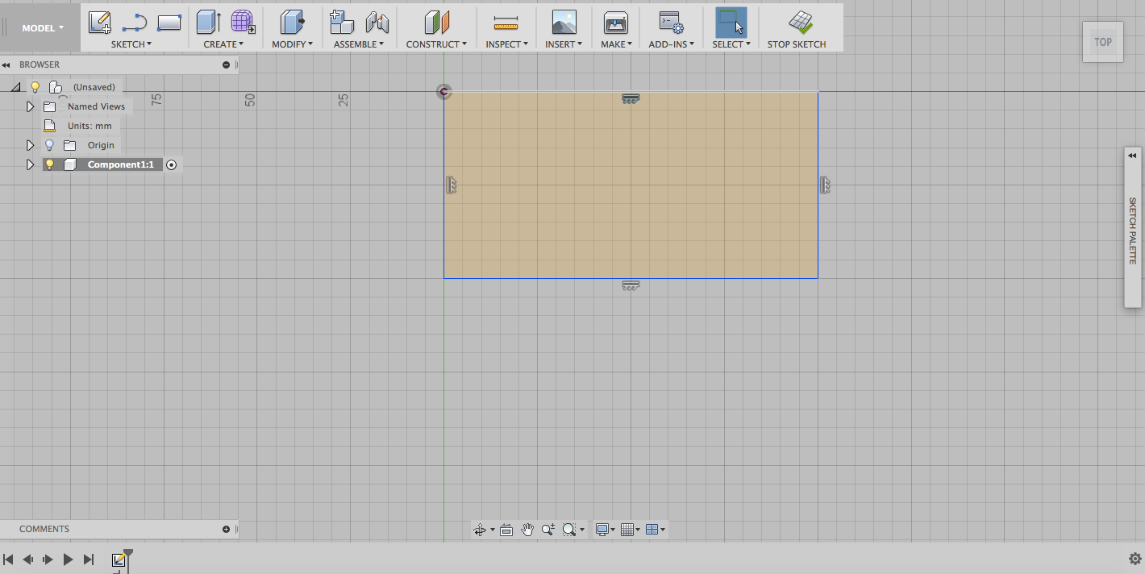
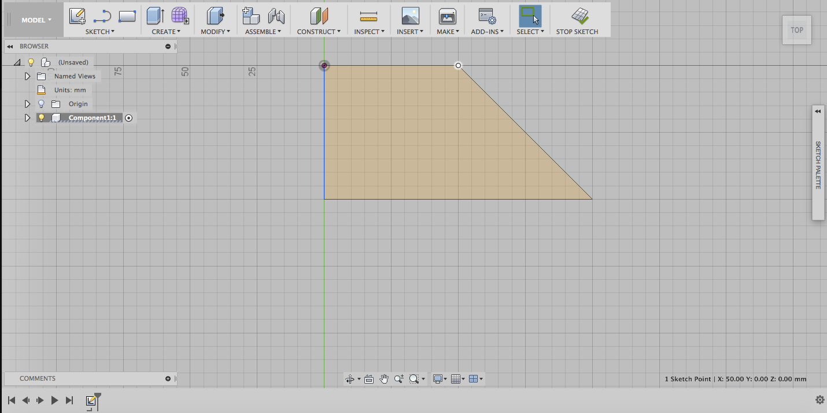
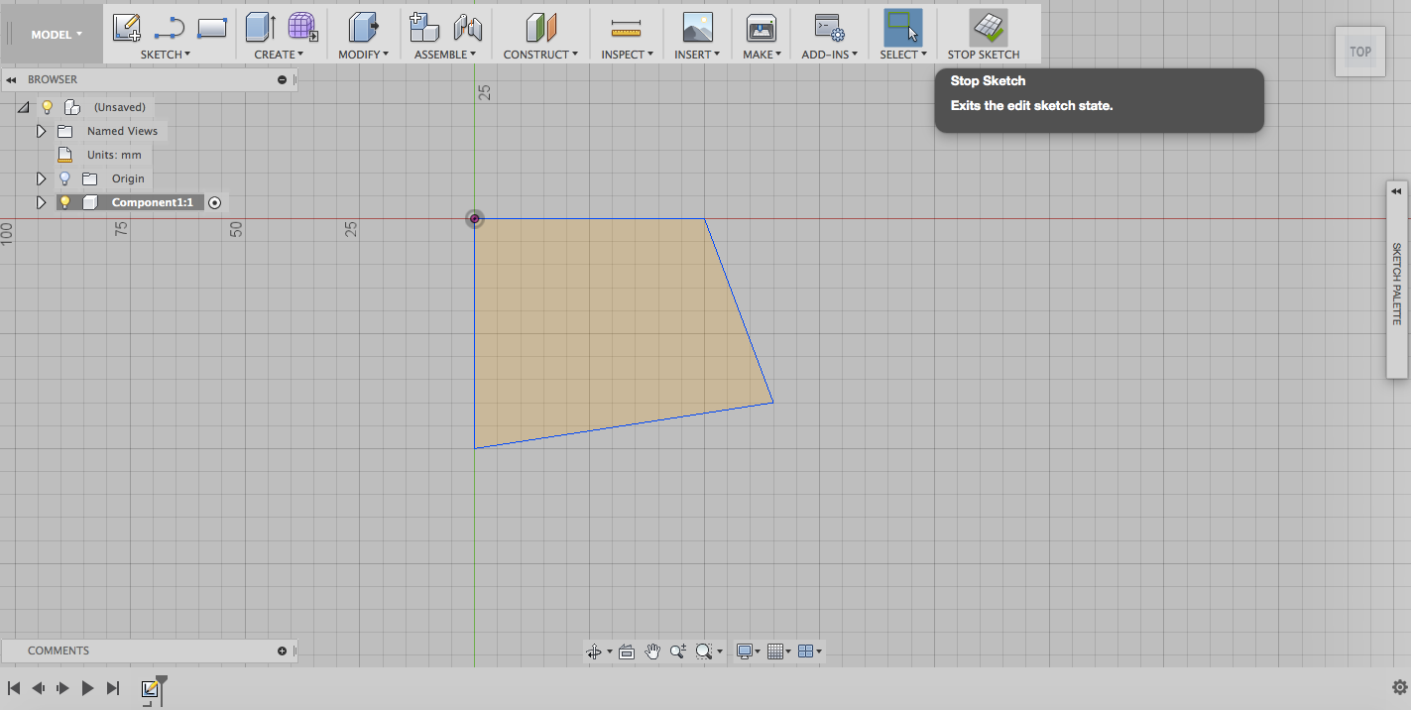

Step Six:
Now that you have done some exploring in Fusion, go to file and open a new design.

Step Seven:
Pull out your phone, and measure its length, width and depth (not including the camera) using the vernier calliper

Step Eight:
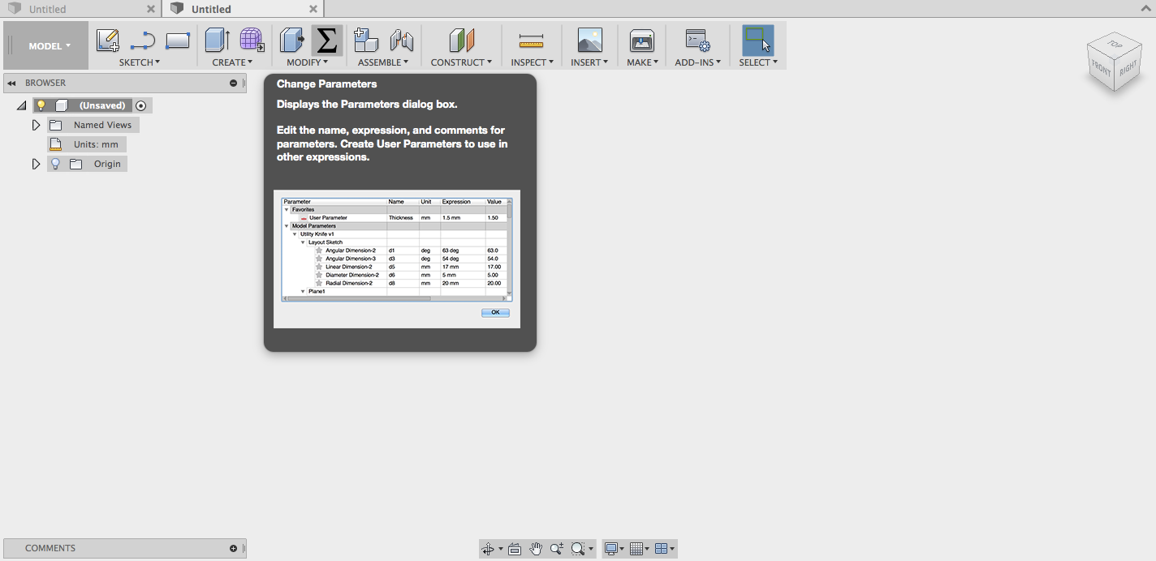
In your new design click parameters in the tool bar (it can sometimes be under Modify). When the window appears click the little green plus to enter new information. Then making sure the measurements are set to mm enter the length, width and depth of your phone into the table one by one. At the end select all the stars to make them all favourites.
Step Nine:
Click assembly, then new component.

Step Ten:
Now click sketch, centre point rectangle and the planes will appear. Click the bottom plane.
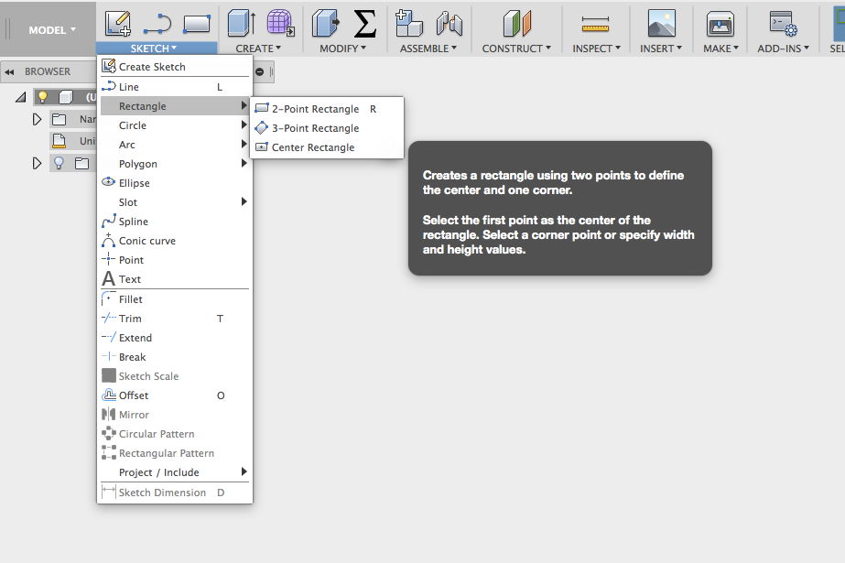

Step Eleven:
Begin drawing the rectangle from the origin. Before clicking to creating the rectangle two measurement boxes appear. In the width box write width and click enter. Then click tab which will take you to the length box. In this box type length then click enter and then enter again. Check that the rectangle cannot move then once done click stop sketch.
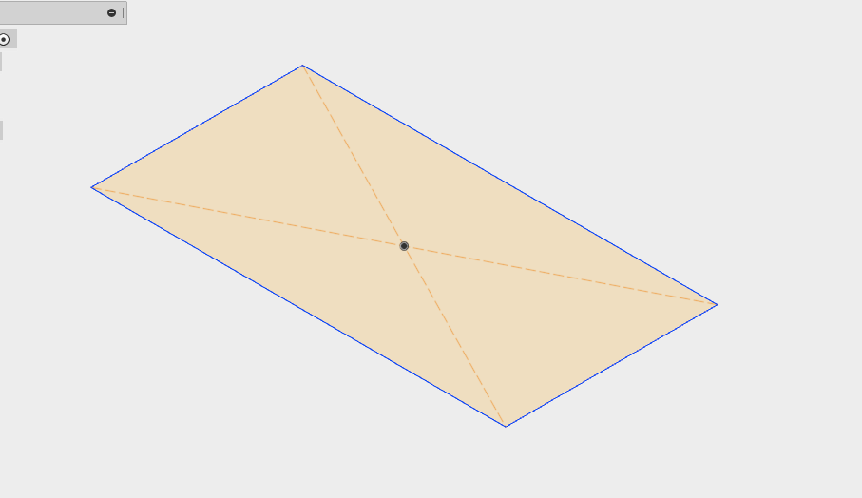
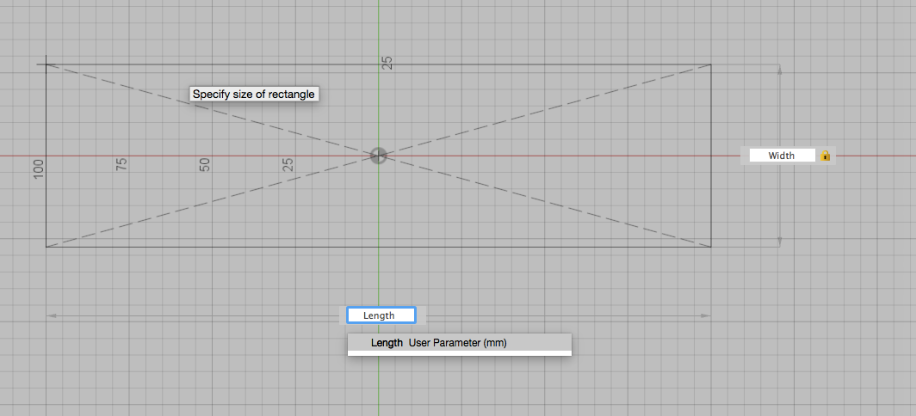
Step Twelve:
Click the rectangle the click create then extrude. A window will come up to the right. In the box next to distance type phone depth(or whatever you named your phone depth in parameters). A selection box asking if you want to assign the parameter phone depth will appear. Click on it then click ok.

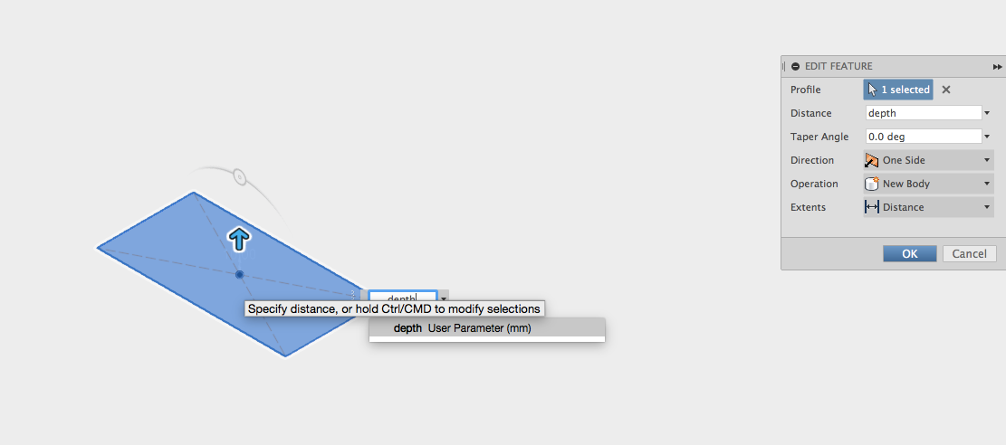
Step Thirteen:
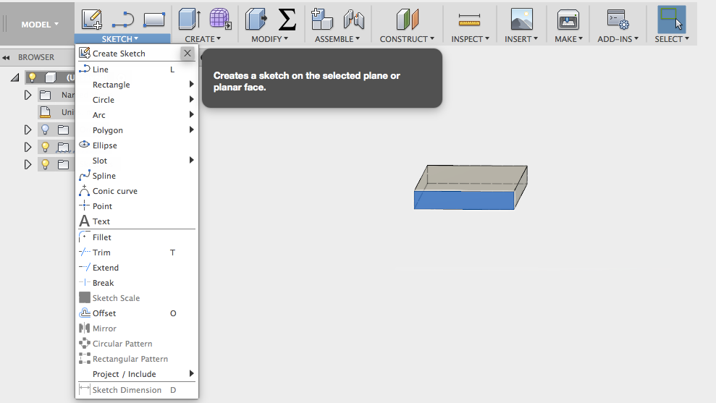
If your phone has a curve, using the vernier calliper measure the distance from the table to the thinest piece of phone If your phone doesn’t have a curve skip this step). Using these measurements click on the end face and click create a sketch. Now click arc/3 point arc. Using the 3 point arc click the left and right edges where you measured then click the bottom. Then click stop sketch.

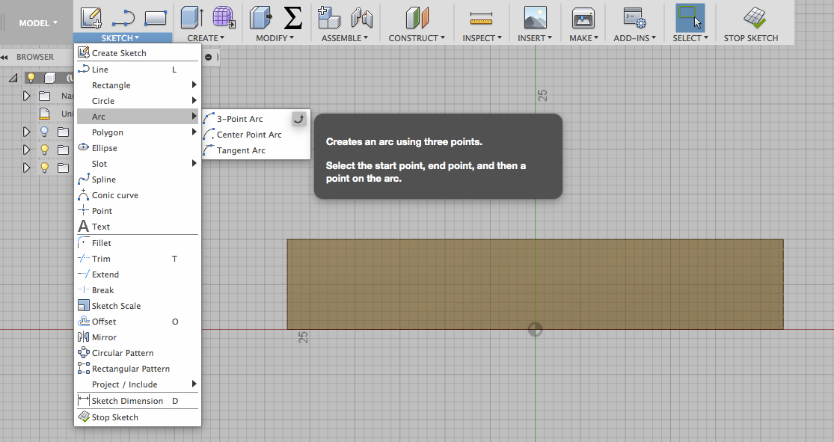
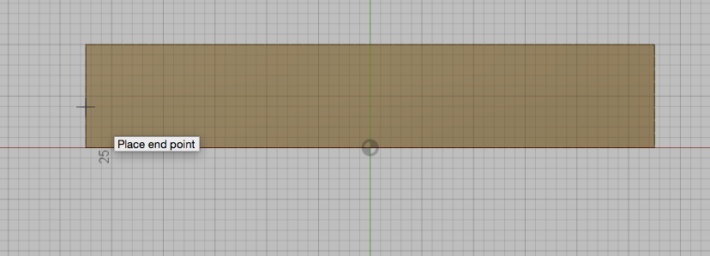
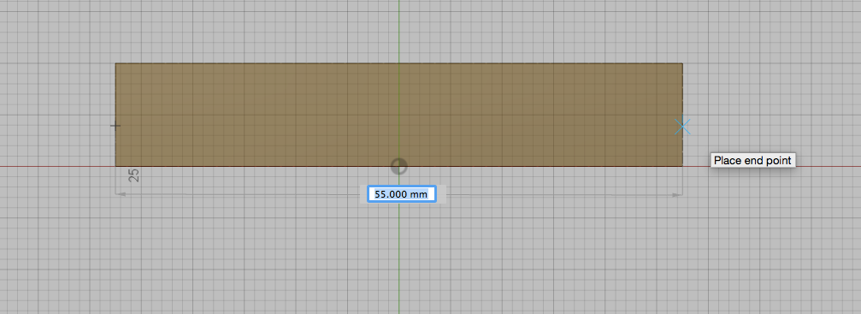

Step Fourteen:
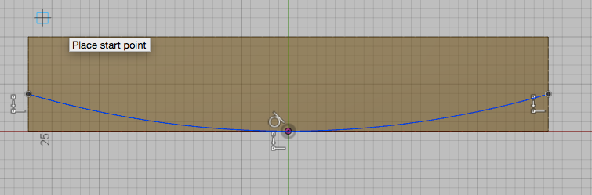
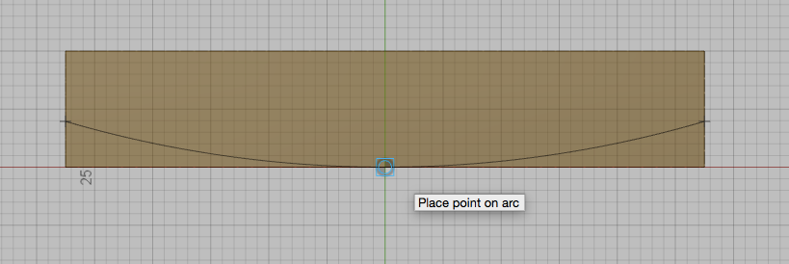
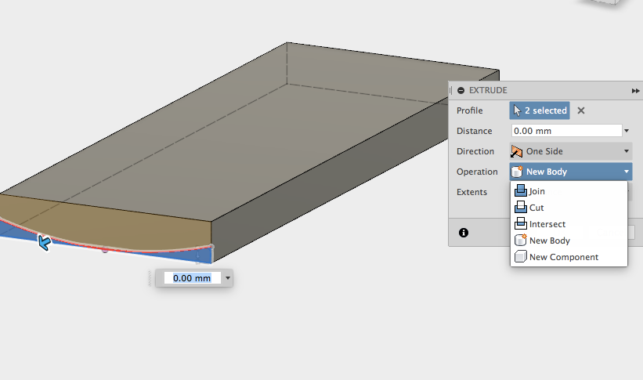
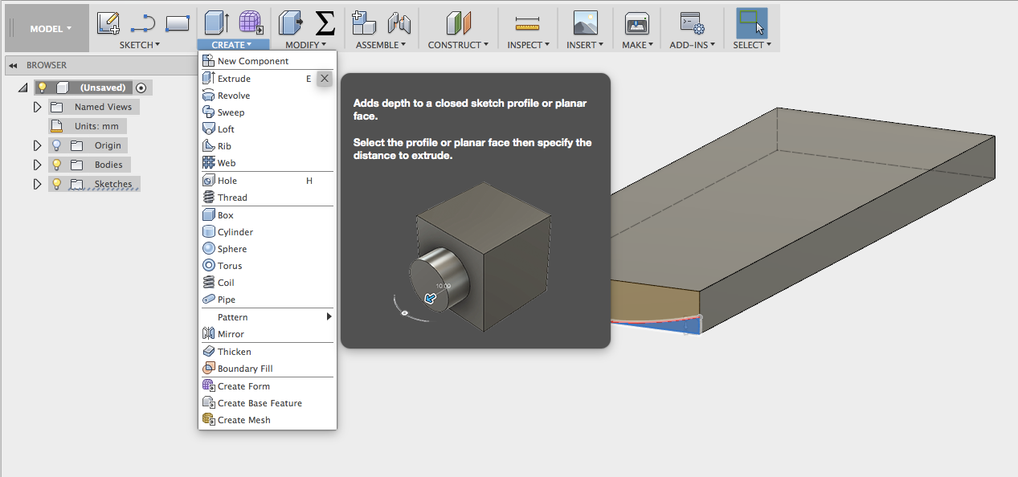
Now using the extrude tool click the bottom section that you just created on the edge face, then change the setting from new body to cut. Using the arrow on the screen change the direction of the cut to cut through the phone. Once this is done change the extent to all using the drop down arrow. Then click ok.
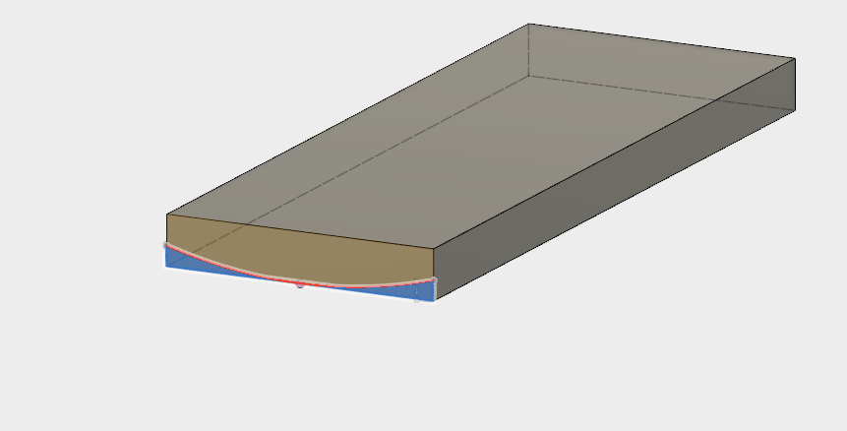
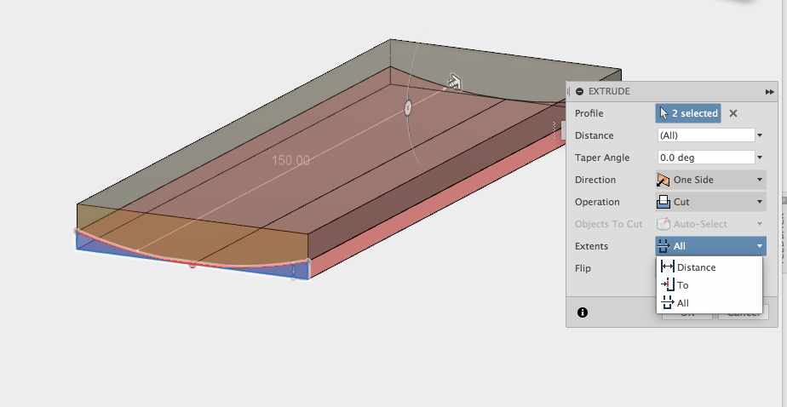

Step Fifteen:
Now click the top face and click create sketch. Then click sketch then offset. In the offset distance put -2mm. Then click ok and stop sketch.

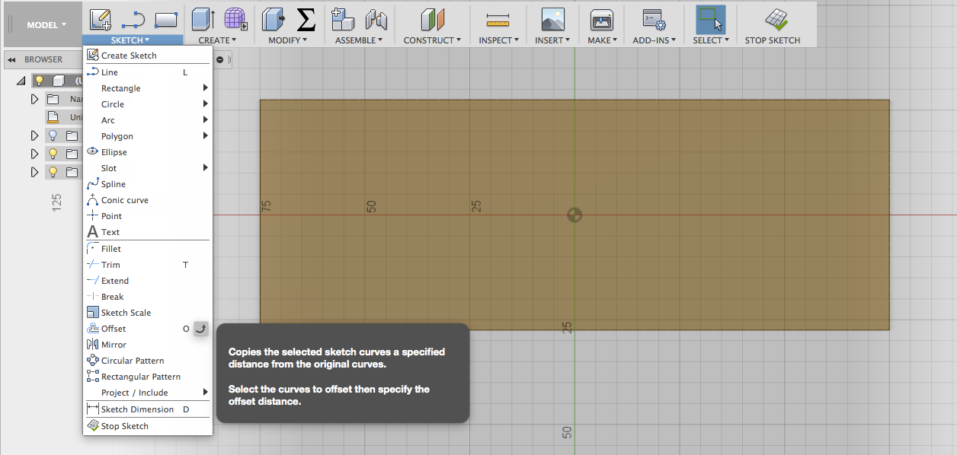
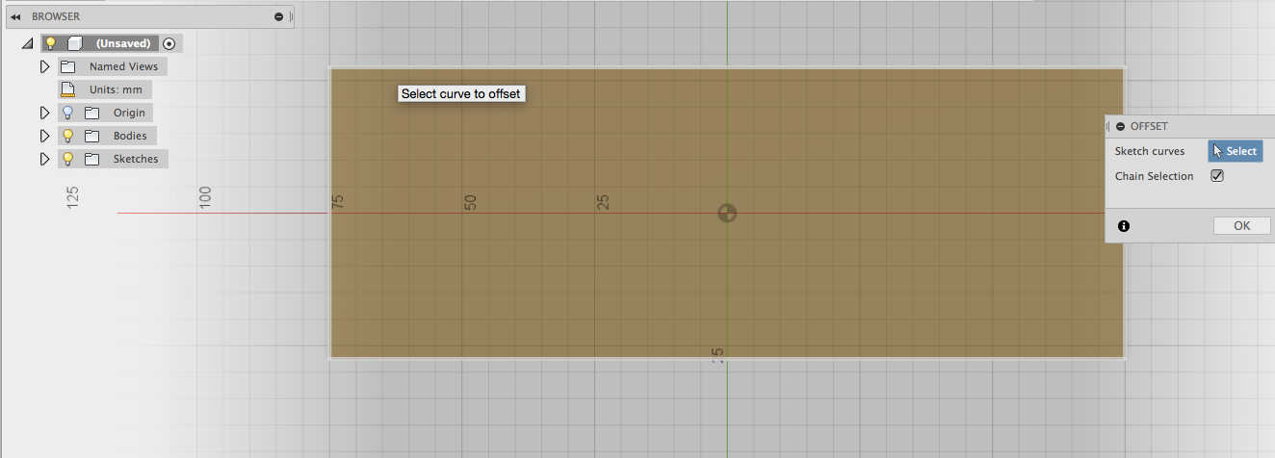
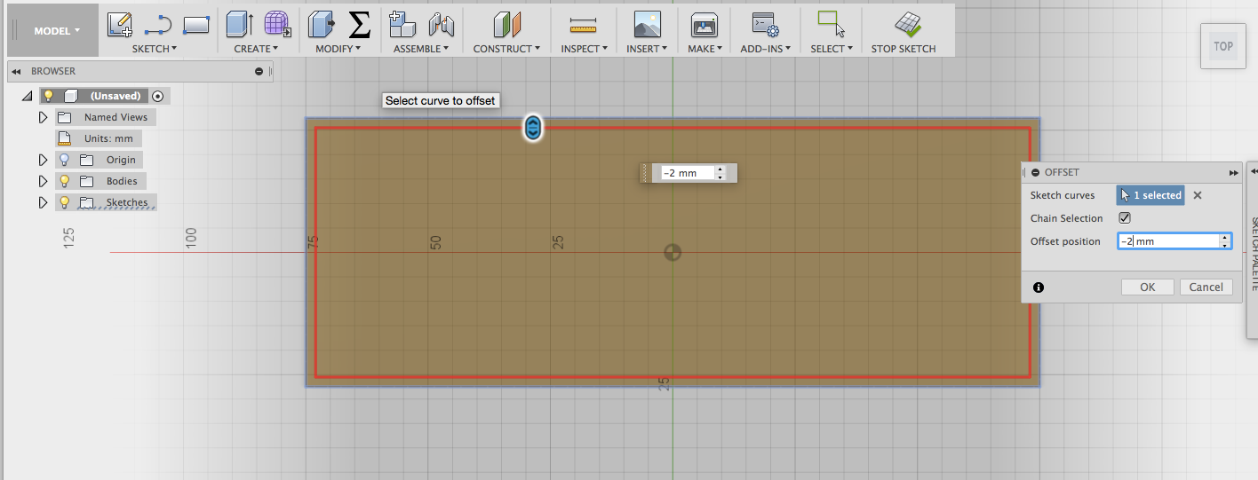
Step Sixteen:
Now click the inside rectangle and click extrude. In extrude change new body to cut then put the measurement in as -0.1mm. Now click ok. You have just created a phone screen.

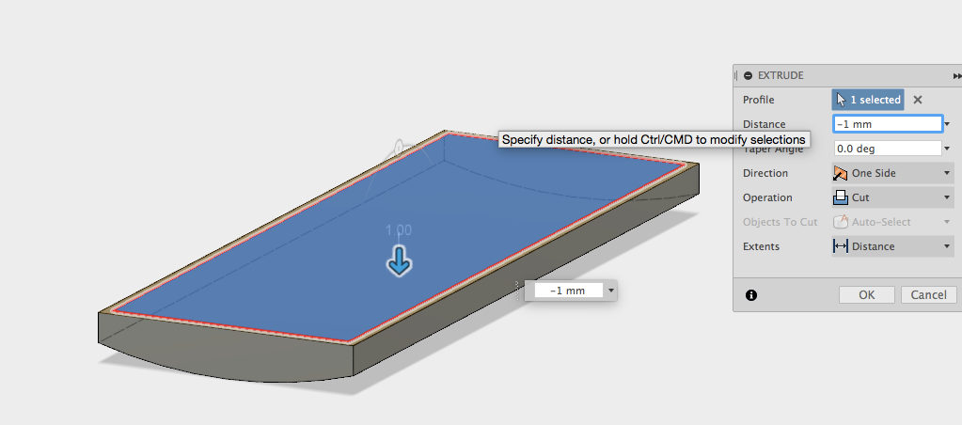
Step Seventeen:
Using the tree, enter back into the design history, click sketch then once in delete the offset constraint. You can now move the bottom line up to allow room for a button. click exit Sketch

Step Eighteen:
Click sketch, then centre point circle and draw. Once you are done click exit sketch.

Step Nineteen:
Click Extrude and click the circle, then extrude by 1mm.

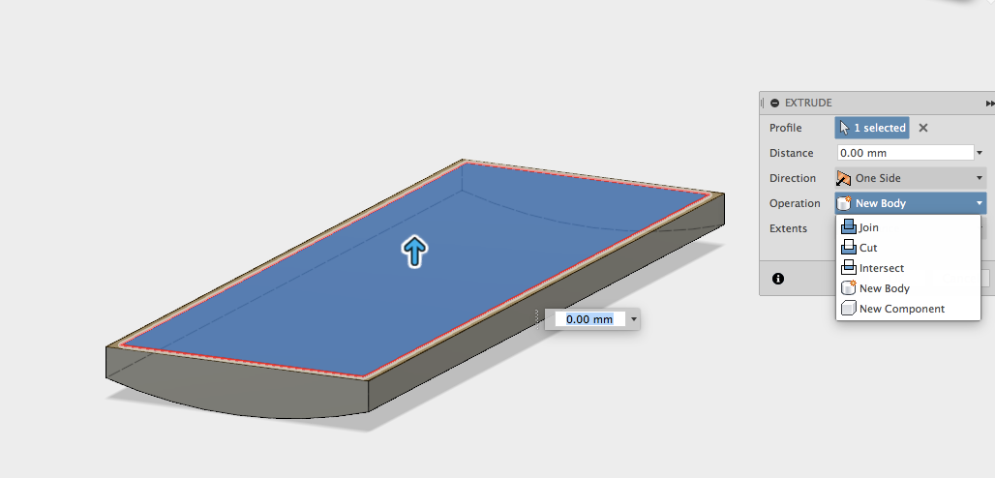
Step Seventeen:
Now using the keyboard click A, then the appearance window will appear. Make sure the bodies and component option is selected (this will allow you to cover whole components with an appearance). Select an appearance and drag it onto your phone. Now select the face selection (this will allow you to apply an appearance to faces only). Select an appearance and drag it to your phone screen.

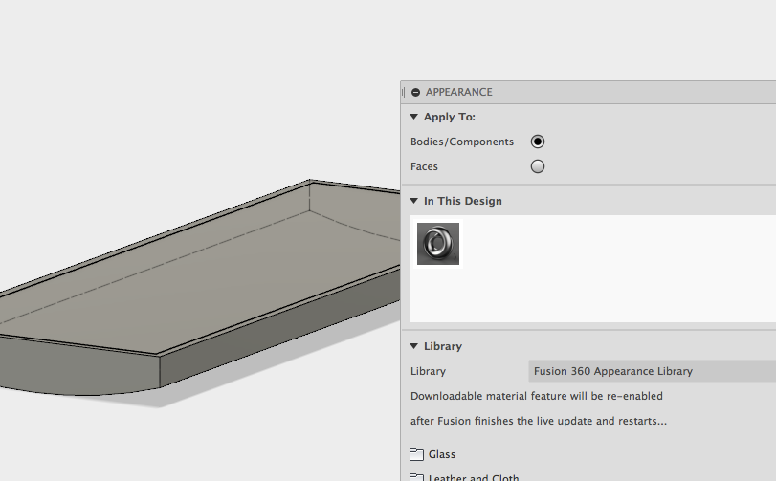
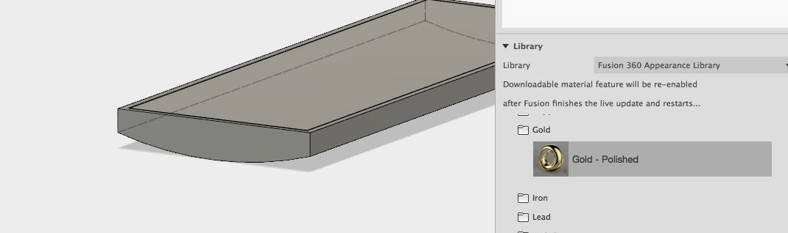
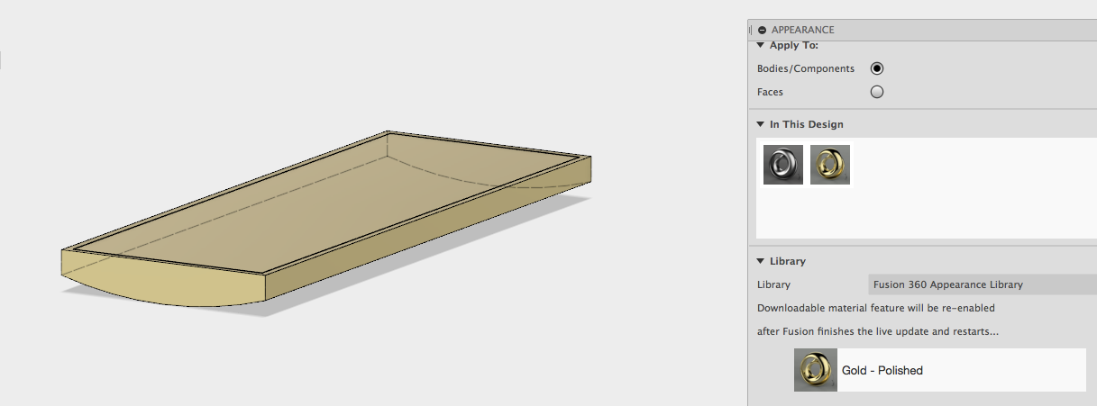

Step Fifteen:
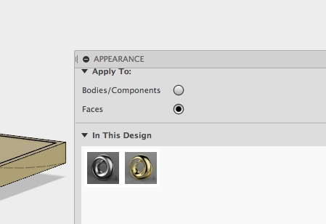
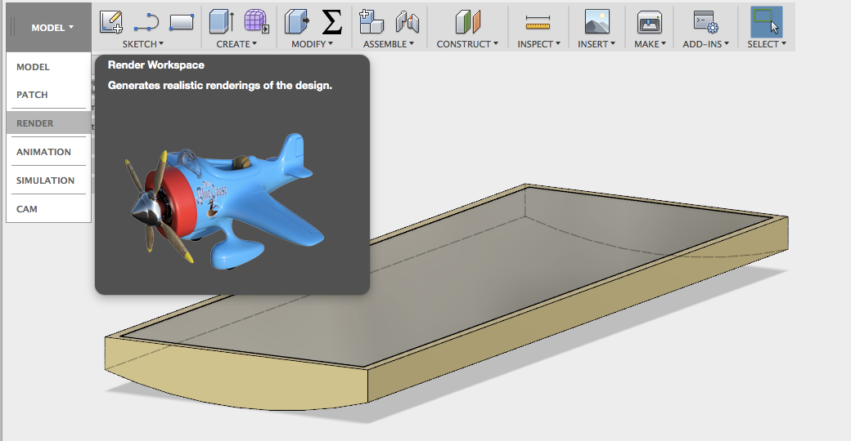
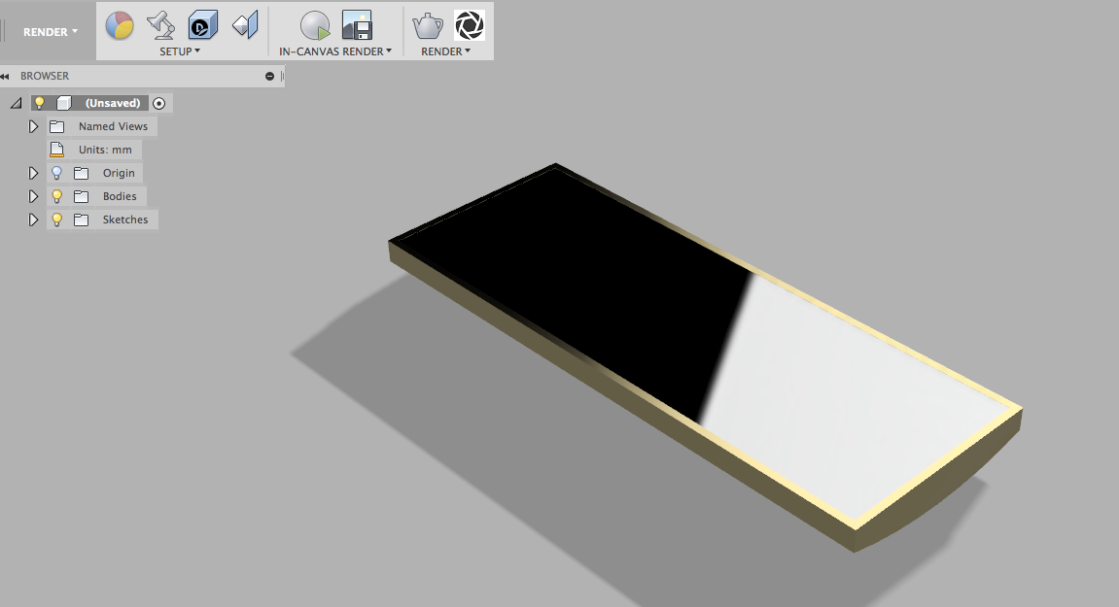
Click Model and a drop down menu will appear. Select Render. You have now created and rendered a basic phone.

Lexicon:
Body: the physically formed part of a model. A body is within a component
Components: A component is a part in the working model.
Assembly: The formation of many components to make a complete model.
Extrude: To pull a 2D sketch into a 3D form creating a body.
Sketch: A 2D drawing that can later be extruded 3 Dimensionally
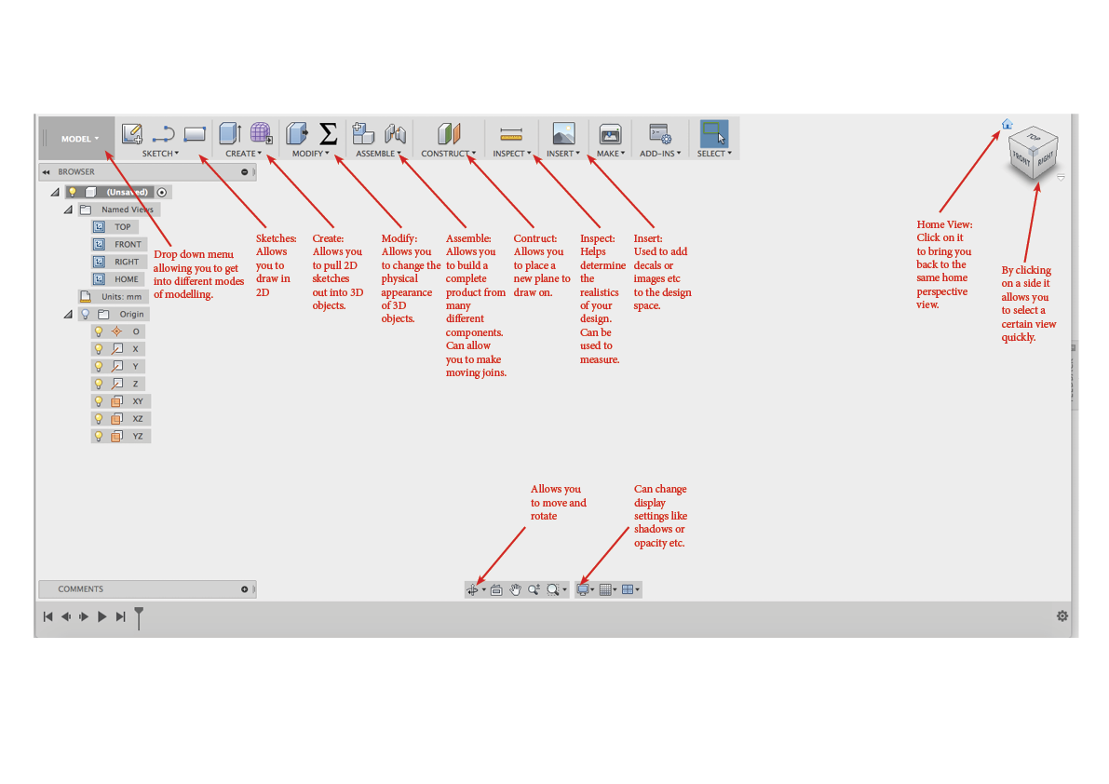
Plane: A invisible surface to sketch on which can exist on the bottom, front, back, right, left and top directions. Once the sketch is extruded to a body this allows you to see the body from a certain perspective accurately.
Parameters: The measurements that define the size of a shape.
Constraints: limitations that stop a sketch from changing (being moved or resized)

