THE EDGE, STATE LIBRARY QUEENSLAND
Grow and Sew
Kombucha
Grow clothes
using simple planet-friendly ingredients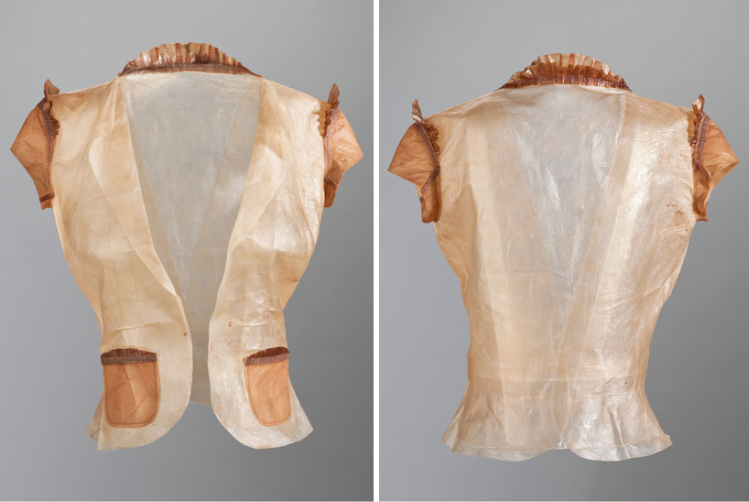
More Info
If you have any questions throughout the process, please email: what.the@edgeqld.org.au
Share
Don’t forget to share a photo of anything you make with us
https://www.instagram.com/slqedge/
https://twitter.com/SLQedge
https://www.facebook.com/theedgeqld
Caring for your Kombucha
Kombucha is produced by fermenting sweet tea using a symbiotic colony bacteria and yeast (or SCOBY). It is a lightly effervescent drink regarded by many as a functional food that assists in digestive health and liver detoxification. But The Edge is growing kombucha tea for an entirely different reason. Researchers, the most prominent of these being Suzanne Lee, have suggested the microbial cellulose pellicle produced by a kombucha culture can also be used as a clothing textile. Over the last several years, The Edge has been experimenting in growing kombucha and harvesting the cellulose pellicle as artificial or vegan leather.
The following instructions will take you through brewing the tea for your kombucha (its food), ongoing maintenance for your kombucha and harvesting and drying your samples.
Making the Kombucha Tea
The following recipe makes a 1L of Kombucha Tea. Scale up your quantities to make more.
Equipment
- Tub or tray with a lid you can cut a small breather hole in (~30mm diameter hole), able to hold 1L. The shallower the liquid the better the pellicle grows (so a bigger tray is better)
- 80mm x 80mm square of cloth
- Measuring jug, 500mL
- Stirring spoon
- Muslin bag
- Kettle or urn
- Spray bottle
- Scissors
- Washing tub
- Flat, smooth drying board – we use laminated table top/ kitchen cupboard melamine boards
- Scraper
- Storage container
- Washing up gloves (optional)
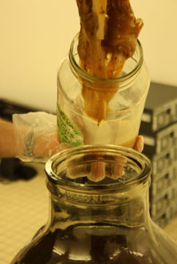
Consumables
- 6g of tea or 6 teabags
- PVC tape (electrical tape)
- 80 mm x 80 mm square of cotton
- 1L of tap water
- 100ml of soured (fermented) kombucha tea and a small cutting of scoby (mother)
- white vinegar
- coconut oil (optional)
- vaseline
- 1 cup of dry rice

Directions
- Wash your hands… properly- not just a social wash
- Thoroughly clean all utensils and receptacles using mild detergent and rinse
- Boil water and measure 500mL into your tub or tray
- Add 85g sugar stir til dissolved
- Measure out 6gm of tea and place in muslin (or organza) bag
- Add muslin bag of tea (or 6 teabags)
- Wash your hands again
- Cover tray/ tub with lid. Cover the breather hole in the lid with cloth square taped down around the edges with the PVC tape.
- Allow tea to steep until the brew cools to room temperature.
- Yep… wash those hands again
- Remove muslin bag (or teabags) and add 400ml of cold water to the brew
- Add a piece of the scoby or pellicle (40mm x 40mm you have cut from the larger mass with clean scissors).
- Add at least 100ml of the starter sample of fermented kombucha tea.
- Replace the lid
- Keep your kombucha in a place where it won’t get disturbed and out of direct light.
Caring for you Kombucha
Before doing anything with your brew, always wash your hands.
All going well, an opaque, jelly-like white pellicle or skin of microbial cellulose should start to form on the surface of your tea within 3-7 days. This will continue to thicken over 2-3 weeks until it takes on the texture and appearance of fresh, cleaned calamari tube.
The key to caring for your kombucha is making sure it doesn’t get infected with common mould. The brew is most susceptible to infection in the first week as the tea sours. Once your tea has soured and the pH has dropped to between 4 and 4.5 it’s difficult for an infection to take hold in your brew.
If you do observe a mould infection (furry grey, grey green or even orange patches growing on top of the brew) you can combat this by spraying infected patches with a 1:1 mixture of white vinegar and water.
Harvesting, preparing and drying your pellicle
After two to three weeks a good Kombucha brew will grow a pellicle that is about 1cm thick. This is the point at which we harvest our pellicles. Sometimes you will have a slow brew that will take a little longer. You might want to wear your washing up gloves for this part.
- Without spilling any of your precious brew, remove the pellicle from the container and place it in another tub for washing.
- Wash your pellicle in a mild detergent and rinse in clean water. Repeat this cycle until the pellicle has lost its sweet smell.
- Dyeing: Because the pellicle is composed of cellulose (the same as cotton), many fabric dyes will be effective in colouring your creation. Dyeing is best done after washing, and before oiling – just follow the instructions for the dye.
- Rubbing coconut oil into the pellicle at this stage (before it dries) will produce a more supple and leather-like product. For best results, spread the wet pellicle on a flat surface, and rub all over (both sides) with fingers dipped in coconut oil.
- Lightly grease your drying board (or mould) with Vaseline to prevent the pellicle from sticking as it dries.
- Spread the pellicle over the greased board or shaped mould and allow it to dry for 4 -7 days.
- The 1cm pellicle will shrink to a 1-2mm thickness as the water evaporates. The length and breadth of the drying sheet will not change appreciably.
- When you are satisfied that your pellicle has dried completely carefully remove it from the board or mould. You can use a scraper to help you remove a smooth sheet, or simply start at a corner and gently pick away until it lifts up, so you can grab it between your fingers, and pull gently.
- If the dry product is too sticky give your next batch a more thorough wash. If it’s too papery for your purpose try washing the next batch less. Thinner pellicles will tend to give a more brittle, papery product.
- Store your dry sheets of finished cellulose in an airtight container with a cup of dry rice to act as a desiccant. You can also put in an open container of bicarbonate of soda to absorb any lingering smells.
What about the leftover brew?
You have 2 options with the left over brew.
- Split the volume and use it to seed two new brews (maybe a friend would like one).
- Move the existing brew to a larger container and add more tea.
Just scale up the quantities to make a large volume of tea, but remember the more fermented tea you add to a new batch the less chance you have of getting a mould infection while you wait for you brew to sour.
You can experiment with other food sources for the kombucha culture, too – keep the amount of sugar the same, and try coffee, or green tea as a nutrient source. Soluble plant fertilizers will also work (and produce a white pellicle), but contamination tends to be more likely.
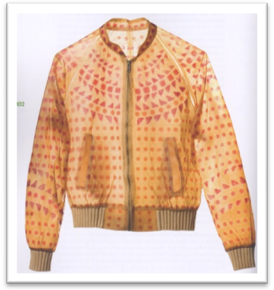
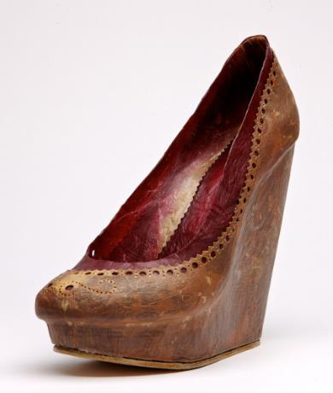
Fermentation facts
Kombucha is a community of bacteria and yeast that live in sweet tea. As the microbes ferment the tea, it becomes sour (acidic), and in this environment, the bacteria spin out little threads of cellulose. Although there are a few reasonable ideas, no-one’s been able to confirm exactly why they do it! The process also needs oxygen, which is one reason the cellulose mat forms on the surface of the liquid, and is also why we don’t tightly seal the container.
The cellulose mat, or pellicle, is formed by various members of the acetobacter family of bacteria, when they have a nice acidic environment. This environment is created by the fermentation process, which chiefly converts sugar to lactic acid and a small amount of alcohol in the process of creating energy to keep the micro-organisms alive and growing.
The “aceto” part of the bacteria’s name comes from the Latin name for vinegar. It is they who convert ethanol into acetic acid to make wine into vinegar, and during this process, they also happen to make a mat of cellulose on top. In a culture like Kombucha, the ethanol comes from the yeast fermenting the sugar; as well as providing the feed to make acetic acid, this also helps to keep out some contaminating micro-organisms.
People have been benefiting from microscopic bacteria factories for thousands of years, turning milk into cheese and yoghurt, and pickling fruit and vegetables. Yeast, a microscopic fungus, is perhaps an even better known tiny workforce, turning grape juice into wine, grain into beer, and making bread rise. Because these human-friendly microbes make themselves at home in the process, they are able to out-compete many of the microbes that make us ill, which is how fermentation makes food resistant to spoilage.
Sugar
SCOBY
Kombucha material analysis
Tea
When selecting materials for a design, it is important to understand their key physical properties and choose materials that are fit for purpose. Explore and record Kombucha’s key properties here.
 | Wet Kombucha | Dry Kombucha
Aesthetic Properties
Handle
Drape
Appearance
Functional Properties
Strength
Durability
Stain resistant
Water resistance
Chemical Properties
Effect of heat
Effect of light
Reaction to acids/alkalis
Reaction to bleach
Affinity for dyes
Comfort Properties
Absorbency
Breathability
Elasticity
Softness

