Cardboard Kaiju 2.0 Development

Initial thoughts of playthrough (12 September 2018) - Image of gameplay notes
- The game runs with very little input from players
- There is little strategy to the kaiju. It just moves to the most contact and there is really no need for a kaiju player in its current state
- The players have to survive past the Kajiu deck, but have very little interaction with the Kaiju deck -> This means the players can’t actually win the game, only lose it.
- The same can be said for the Kaiju player. The Kaiju does not interact too much with the players, as most of the player interaction is done via instant cards - something that th Kaiju player doesn’t have control over
- Players enjoy interacting with each other but don’t really get to interact with each other
- Player feedback during the playthrough reinforced these points to me
- Cards required a translation sheet to resolve (re: “Resolve the top card of the Kaiju deck as if it was yours”)
- Rulebook had multiple failures:
  - failed to indicate what happens when instants appear in the opening hand
  - failed to handle what happens when the player deck runs out
  - fails to set how damage is applied to buildings by the kaiju monster
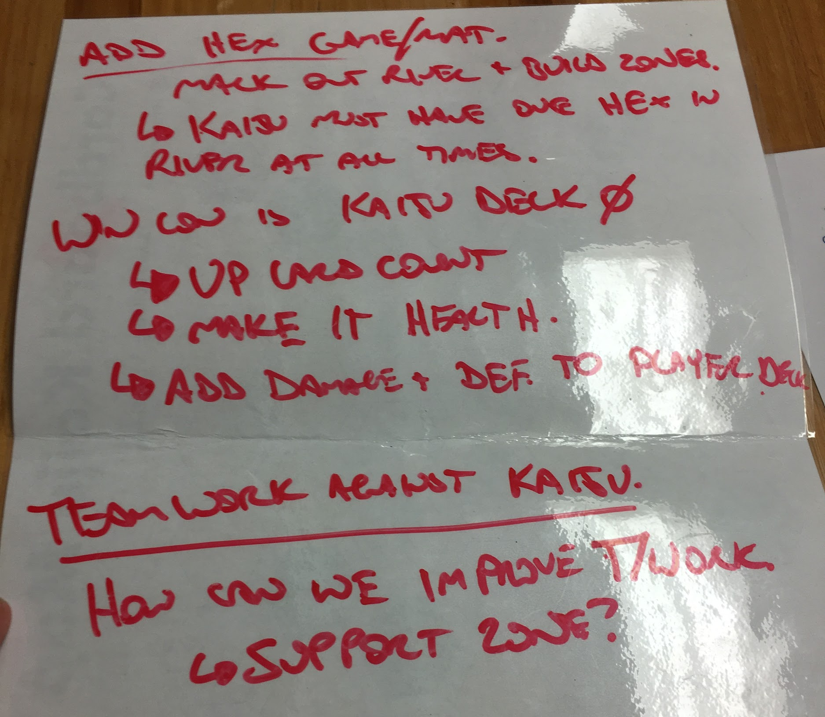

Playtest responses from Go Play (15 September 2018)

Timestamp | What was ONE thing you ENJOYED about the game. | What was ONE thing you DID NOT ENJOY about the game.
9/15/2018 11:30:39 | The card actions were interesting | The game was hard to understand initially
9/15/2018 11:52:37 | The tactile setup ... the miniatures | Not enough tactical options as a player
9/15/2018 11:53:50 | How interactive it is | Nothing this time
9/15/2018 12:21:56 | Tactical decisions, controlling kaiju where to go. | Buildings all die very quickly, most hits one shot nearly all buildings.

This feedback, while small, I believe reinforces the thoughts above that I found during the initial playthrough.

We need to focus on the following gameplay elements for development:
- Team Co-Operation
- Kaiju Strategy
- Clearer Ruleset and Card Information
- Add a way for players to actively win the game, instead of passively losing it

Proposed Improvements
The following improvements will be where I intend to take the game. During the development nights, I will push the students to come up with the similar solutions below.

Team Cooperation
Team Cooperation will be enhanced by introducing a Support Zone. Each Turn, a player may, instead of playing a card from their hand, they may place a card into the Support Zone for another player to use.

As to why this will be helpful, is cards will be put together to form combos. For instance, if a player plays 3x 1 Damage Cards, they could combine instead to do 5 damage.

To assist with this game mechanic, the player actions will be updated to say the following:
“Once per turn, a player may do one of the following:
1 - Play an action or combo action from their hand; or
2 - Place one action card from their hand into the support zone”

The Support Zone will be described in the rulebook as follows:
“Any action cards in the support zone count as being in every defender’s hand while it is in the support zone.”

Kaiju Strategy
Kaiju Strategy will be enhanced by introducing a limitation to the Kaiju’s movement. As shown on the game mat below, certain hexes on the game board will be labelled as River Tiles. The Kaiju, being a snake-like sea monster, will only be able to move and attack from the river. The Kaiju MUST HAVE at least one tile on the river at all times.

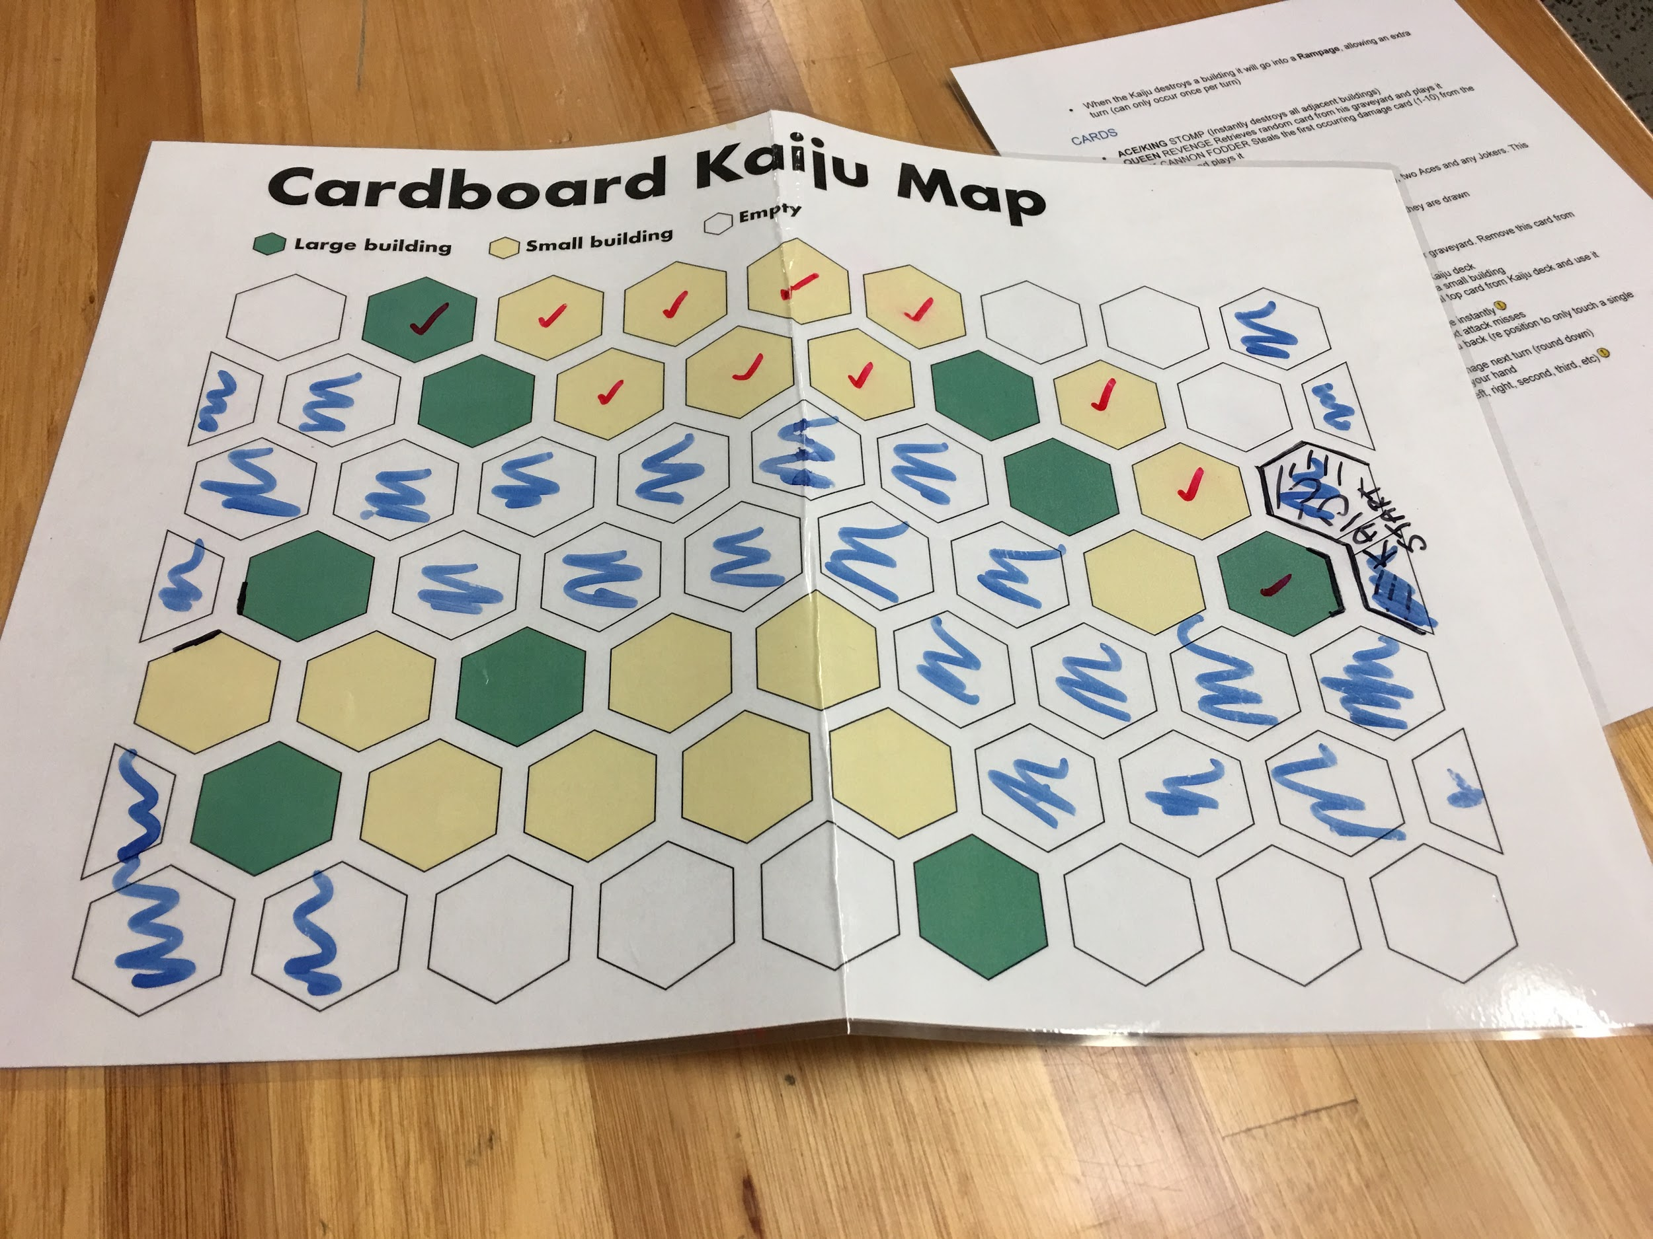

This gives the Kaiju player a strategic element to how they attack the river, while also limiting how much damage they can via the Rampage mechanic (which we will be keeping because it is badass)

Clearer Ruleset and Card Information
Cards will no longer be listed in relation to a Deck of standard playing cards. Instead, all cards will clearly say what they do and any cards referencing cards the other team’s cards will be removed. Players will not need to look up what a card does.

The cards will also have one of 3 card frames, artistic design used to identify the card. The three frames are: Kaiju Deck, Defender Deck, Instant Card (found in Defender Deck)

Players winning the Game
Players need to be able to win the game, not just run through the game and maybe lose. So the following major changes will be made to assist in the process of winning the game:

- The Kaiju Deck will be rebuilt. The Kaiju deck will now be enhanced in its damage and special abilities, as well as the amount of cards increased. This Deck will now act as the Kaiju’s health, meaning any damage done by the defenders will discard cards from the top of the Kaiju Deck.
- The Kaiju player will gain a hand. To give the Kaiju player a form of strategy to what they do, they will also draw a hand of 4 cards. These cards will not only include damage and special destruction abilities, but it will also have some form of defense or damage reduction to slow down the players, as well as “Gain extra action” cards to give this player a further edge
- Defender Deck will be rebuilt. The most notable change will be the inclusion of damage and defense cards. Damage cards will flip cards off the top of the Kaiju deck and reduce that deck (as it is now the Kaiju’s helath). The defender deck will now have targeted defense cards so that, rather than outright preventing the kaiju player from doing anything for a turn, they will instead be able to defend specific buildings from the Kaiju’s attacks, possibly directing the Kaiju into further traps.

