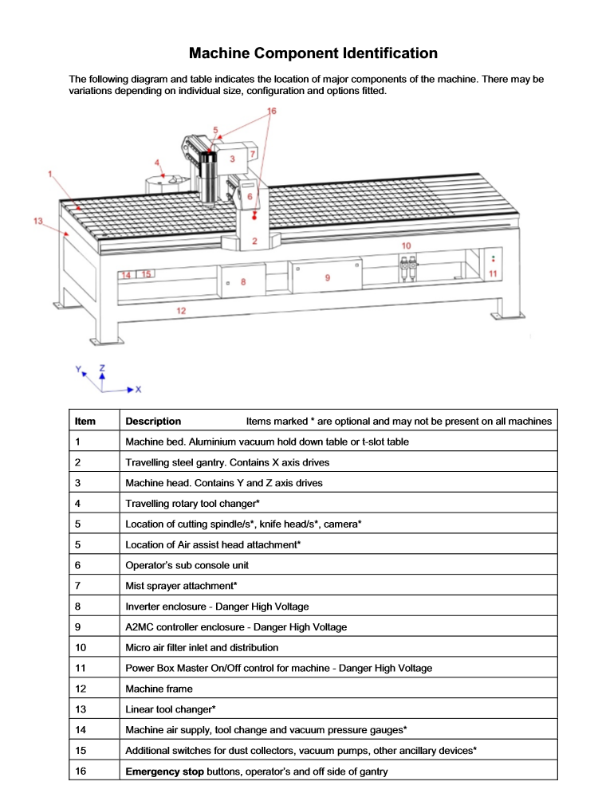

Safety
Safe Operation of Machines
Machine be used by trained people only
When machine is running, keep clear of any rotating or moving parts eg. the cutting bit, spindle moving gantry and head parts.
Do not lean on machine whilst in operation. No Person other than the operator or other authorized persons should be in the working area
Parts of the machine , particularly cutting bits, will get hot so you may need gloves when handling/ or changing tooling.
Maintain a clean workspace-check that the gantry and rails for tooling/materials left behind. Clean up as you work. the machine does the messy work for you to clean up!
Use the right tool for the job- explain different tooling pieces and how some have a specific purpose.
Wear enclosed footwear- They protect your feet and prevent slipping
No Kids under 12- high speed equipment, automated movement, very sharp tooling
Ask questions if you have doubts
Talk about parts of the machine
Emergency stop Buttons
Main parts on CNC machine
1)Machine bed-aluminium bed with vacuum hold down
2)Steel Gantry- X axis
5)Machine head- Contains Y and Z axis
Spindle-holds routing bits and collets spins at 16000rpm max
6)Controller panel- Manually control the gantry and load jobs from here
8/9)Inverter enclosure- DO NOT OPEN! High Voltage. Main on/off switch is located here
10)Vacuum Pumps- can be isolated for more vacuum pressure if not using full sheets

CNC Start up
Before starting the machine up make sure the workspace is tidy .
Make sure the compressor is on to blow away dust
Turn the main switch on.
CNC will ask "Find home position (G56)" -push Yes
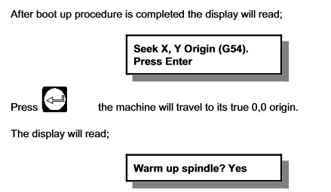

Note -Yes if machine hasn't been used that day.
Remove the waste cover board (2 person lift)
Check over the wasteboard for rough and uneven spots and sand down using scour pad
Use compressor to blow dust away.

Tool Pathes
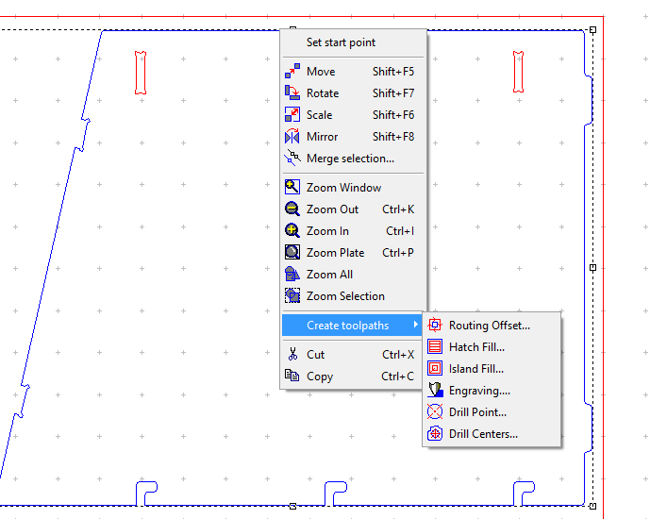
1) Right click on shape
2) Click Create toolpaths
3) Select routing type -
Routing offset-Internal, external paths
Island Fill/Island Hatch
Engrave Paths- engrave lines require qualified engrave bit
4)Set Feed, Speed and plunge rates - Feed rate = Number of cutting edges x chip per tooth x RPM
5) Click Save as.. if the tool path will be repeated or Ok when done
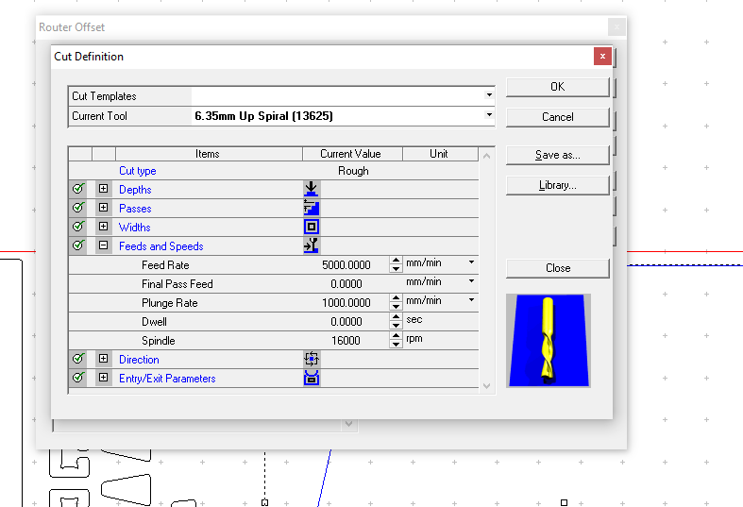

Moving Designs to Machine
When all the tool pathes are created, select the output button(G1). In this menu you will be able to choose the strategy in which the machine will operate

Output
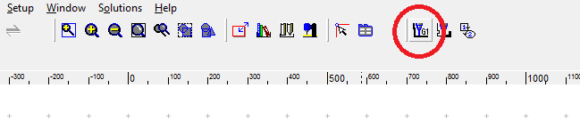
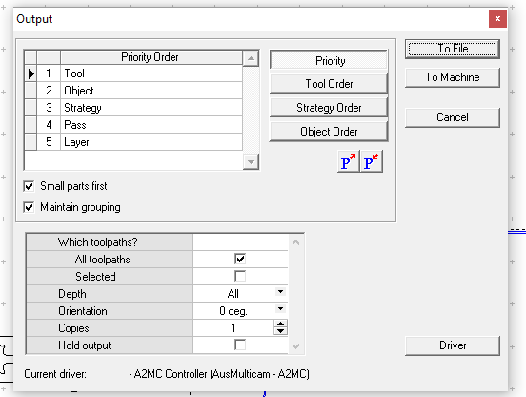

Priority-In this menu you will be able to choose the strategy in which the machine will operate as wel as user define the best way to operate the machine by adjust these options
Tool- If you are using multiple tool bits you can select the order in which the machine will cut first
Object- allows you to choose the order of objects cut depending on toolpath and location
Strategy- internal or external cuts first
Other options include small parts first and maintain groupings.
One complete click-> To File and save it

Open the Multi Cam App Manager
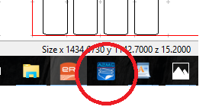

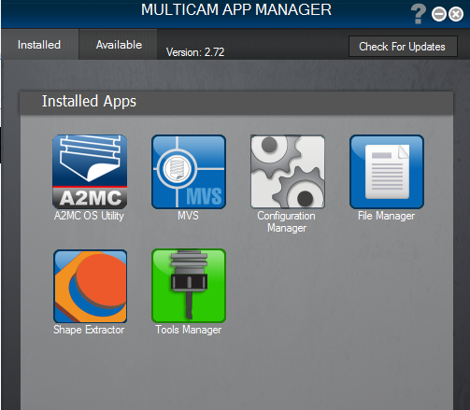

Select File Manager

select Connect -Note CNC Machine must be on to connect

Once connected ,select your saved job and select the arrow to move to machine
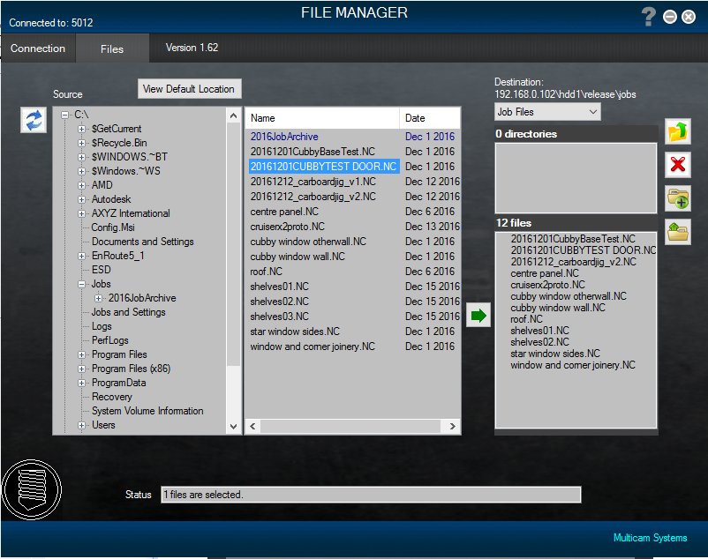

Loading a Tool
Go to Tab 6-Tooling mode
The Spindle will move over the to the tool loading section
Pick the appropriate tool and collet and insert into the spindle
Use the Collet Nut Wrench and Spanner to tighten -Note- Not too tight
Push the Qualify tab and select the tool from the list and press OK
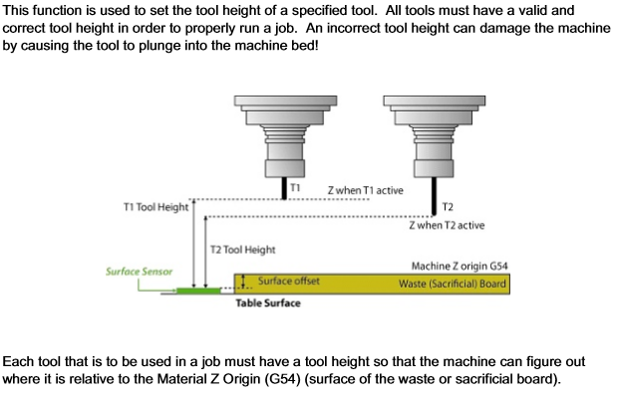
The machine will check tool by lowering onto the sensor pad to calculate the length of the bit.

Cutting on the CNC
Load material onto the waste board - Larger pieces can use the vacuum bed to hold material. Note - as the material is cut it will lose suction especially when cutting small objects. If the material is very bowed you can try laying the material with the high side in the middle and 2 people can push down. Alternatively, screws can be used but you will have to be aware that the tooling doesn’t hit them!
While machine is operating
Where PPE!!!!glasses ear protection
Observe the machine in operation
Use emergency stop if necessary. Note- if the machine is turned OFF mid operation, wait 1 minute to turn ON
