Select 8 empty cans, and attach them to the large wheel. Line up the bottom corner with the line, and zip tie them on using the holes provided.
Glue the round hub onto the smaller slot in the axle. Slide the wheel on, and glue it to the hub.
Then the handle (but do NOT glue it). Add a spacer if needed.
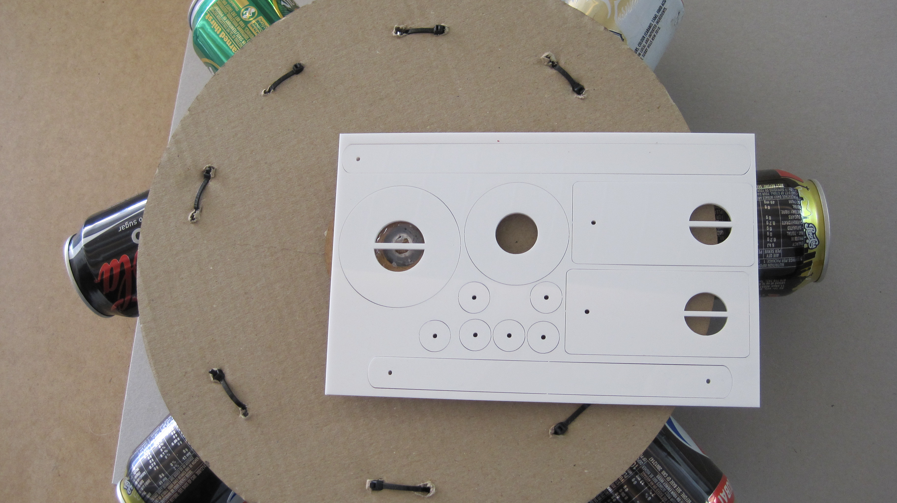
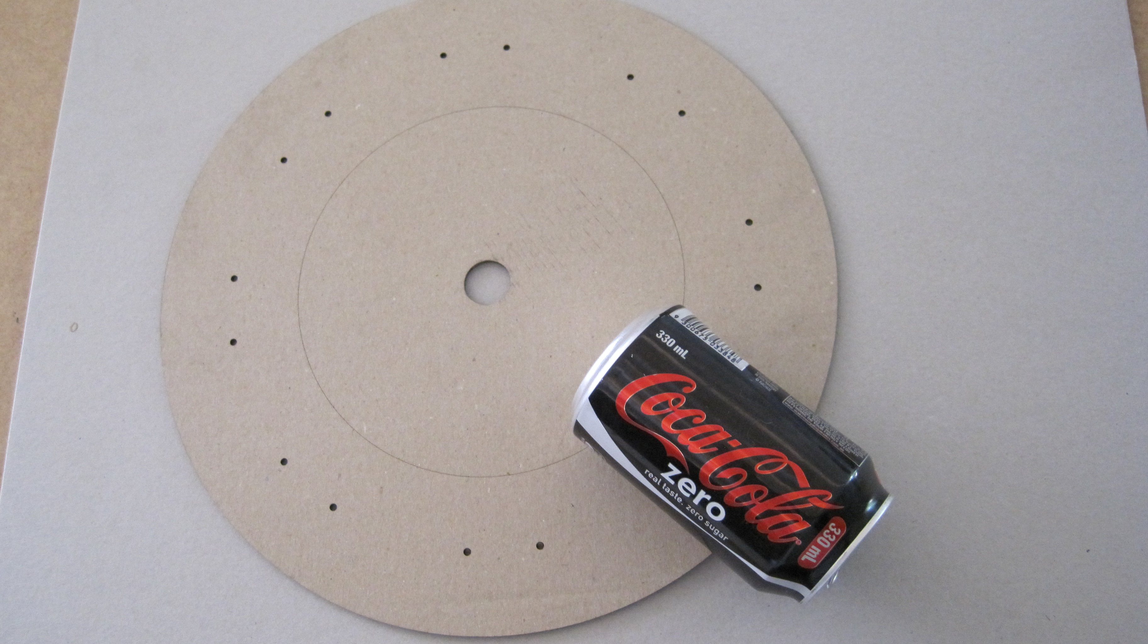

Glue the two rectangular driving hubs to the other end of the axle. Attach the short linkage, using a piece of wire with a small retainer glued on one end. When the linkage moves freely, glue the other retainer in place and trim wire if necessary.

Now glue the long linkage to the disk drive, with the hole towards the wheel. Lay the drive along the handle and join the linkages with another wire and retainer (don’t glue them together yet).
Slide the drive tray out to full extension and mark a line on the handle. Hold it there, and check that the tray can move in both directions freely, then screw it on to the handle.
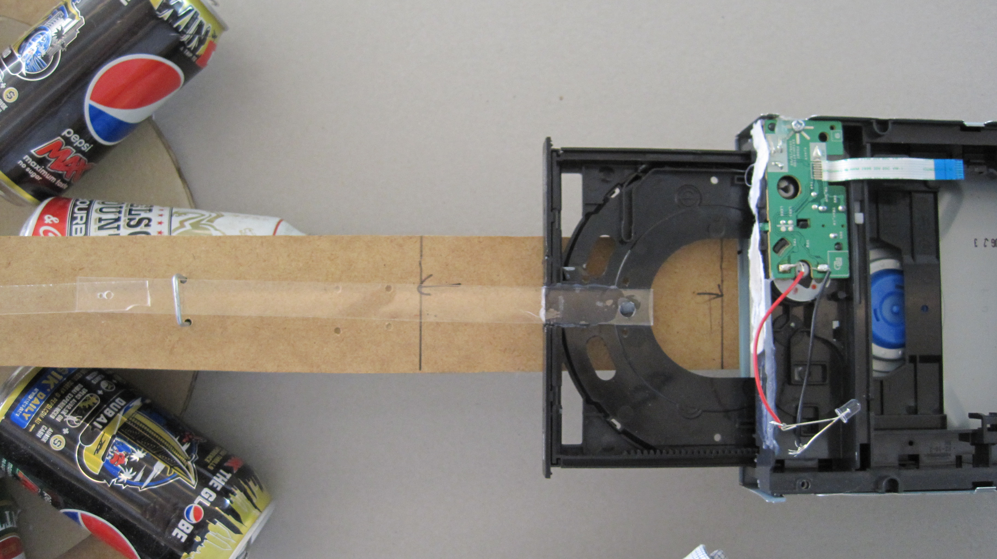

Attach the final retainer, fixing the linkages in place. Drill two holes next to the long linkage and add a U-shaped piece of wire pushed through the handle to keep the linkages aligned.
Join 3 LEDs in a line, and attach to the motor (colour to black, white to red). Join another 3, and attach the other way round (colour to red and white to black).
Push the wheel along, and the LEDS should flash alternately as the tray moves up and down

