Cubby House Workshop Plans
Introduction to workshop
00:00 -10:00 - Introduction by facilitator and participants. Describe what the course plan will be(Design a Cubby House using software, CNC induction)Ask about their experiences with using software to design or there experience with tools, and what they hope to gain from the workshop.
10:00 - 20:00 - Hand out paper with cubby template and sample designs for participants to sketch some ideas and come up with their own. Explain the limitations of the process eg. High detail routing takes a lot of time, using tabs when cutting small objects don’t cut too much material as it will alter its structural integrity
NOT TO SCALE!
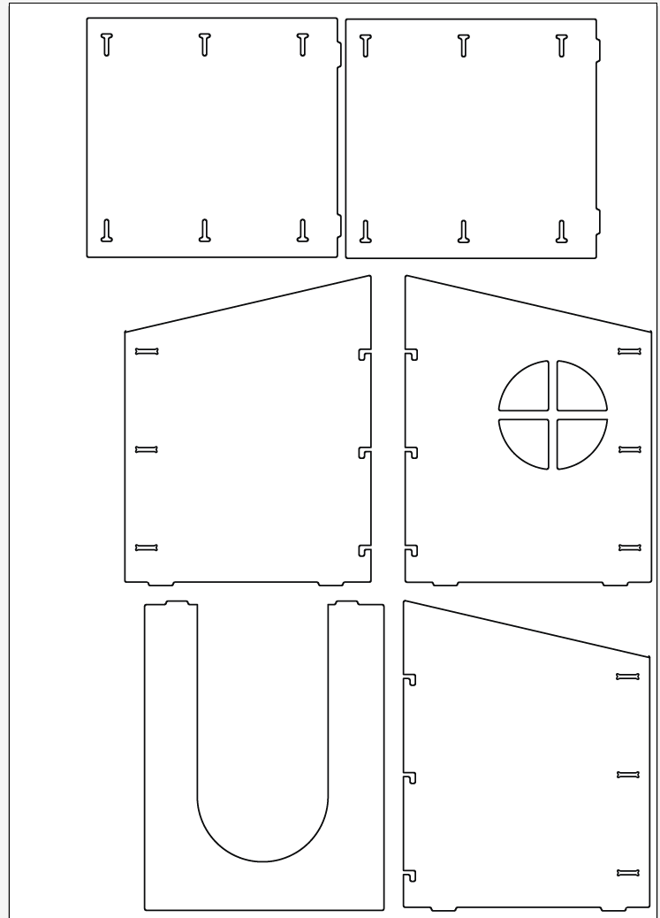
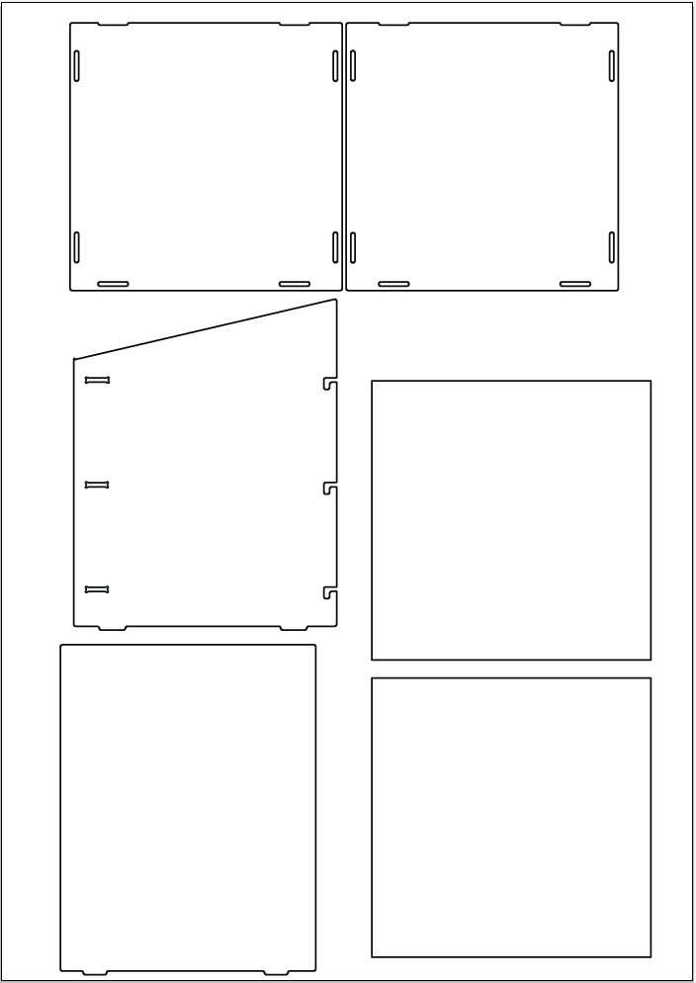

Job Design Considerations
20:00 - 30:00 - Open all templates in Illustrator and explain where each part is located for assembly. Demontrate the joinery/locking pieces.
30:00 - 1:00:00 - start transferring the sketched ideas to the templates.
Demonstrate basic Illustrator tools - selecting objects, grouping objects, joining lines. Assist people where needed and encourage those who finish early to assist
1:00:00 - 1:10:00 -Finalize Cubby design in Illustrator and save
1:10:00 - 1:40:00 - Open Illustrator files into enroute and discuss the layout process(Orientation of the bed in relation to the orientaion of design- Rotate button is explained
1:40:00 - 2:00:00 - Start running through CNC induction

CNC Induction
Give out induction Paperwork to participants and explain the function of a CNC machine and its uses.

Safety
Safe Operation Of Machines
Machine be used by trained people only
When machine is running keep clear of any rotating or moving parts eg. the cutting bit, spingle moving gantry and head parts.
Do not lean on machine whilst in operation. No Person other than the operator or other authorized persons should be in the working area
Parts of the machine , particulary cutting bits, will get hot so you may need gloves when handling/ or changing tooling.

Discuss the potential hazards when working with in a workshop and how to minimize them.
Eg. Correct personal protective equipment- safety glasses,ears muffs or earplugs, enclosed shoes and long hair/beard.s or loose clothing tucked in.

Maintain a clean workspace-check that the gantry and rails for tooling/materials left behind. Clean up as you work. the machine does the messy work for you to clean up!
Use the right tool for the job- explain different tooling pieces and how some have a specific purpose.
Wear enclosed footwear- They protect your feet and prevent slipping
No Kids under 12- high speed equipment, automated movement, very sharp tooling
Ask questions if you have doubts
Talk about parts of the machine
Demonstrate routing joinery pieces

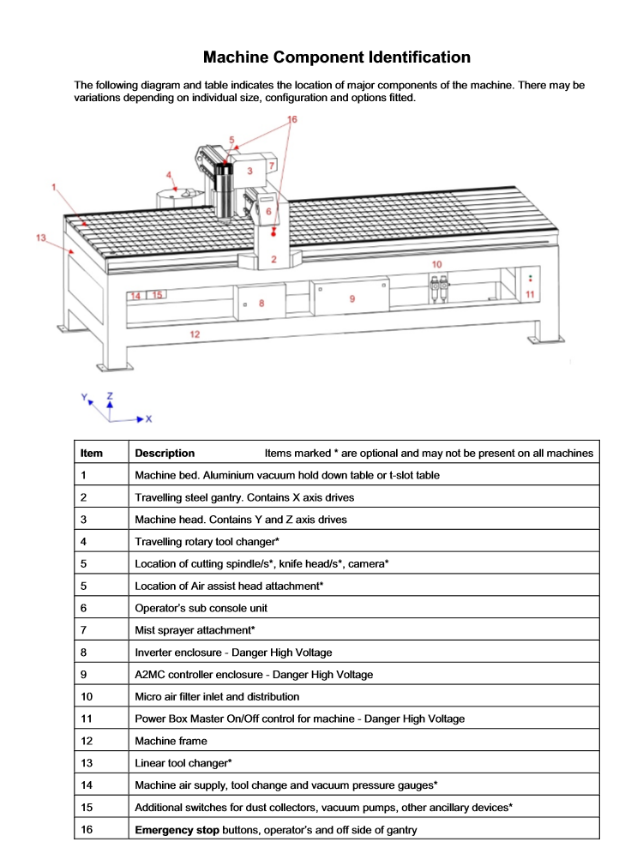

Emergency stop Buttons
Machine bed-aluminium bed with vacuum hold down
Steel Gantry- X axis
Machine head- Contains Y and Z axis
Spindle-holds routing bits and collets spins at 16000rpm max
Controller panel- Manually control the gantry and load jobs from here
inverter enclosure- DO NOT OPEN! High Voltage. Main on/off switch is located here
Vacuum Pumps- can be isolated for more vacuum pressure if not using full sheets

CNC Start up
Before starting the machine up make sure the workspace is tidy .
Make sure the compressor is on to blow away dust
Turn the main switch on.
CNC will ask "Find home position (G56)" -push Yes
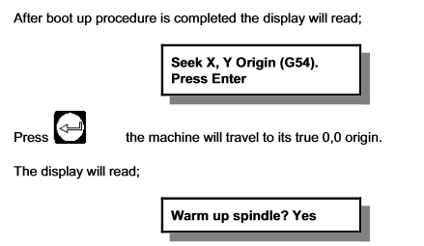

Note -Yes if machine hasn't been used that day.
Remove the waste cover board( 2 person lift)
Check over the wasteboard for rough and uneven spots and sand down using scour pad
Use compressor to blow dust away.

Tool Pathes
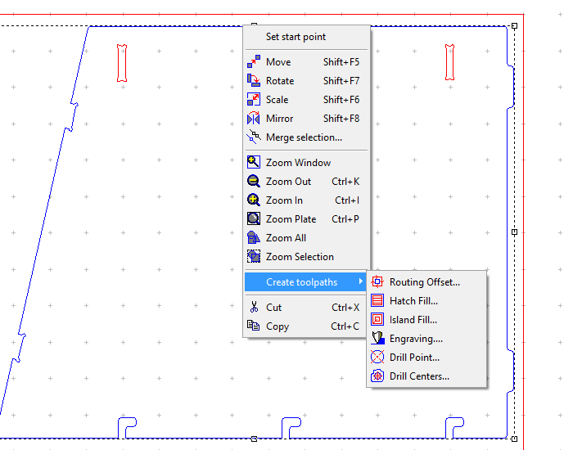

Creating tool pathes in enroute- Explain different path types
Routing offset-Internal, external pathes
Island Fill/Island Hatch
Engrave Paths
Explain Feed,Speed and plunge rates - Feed rate = Number of cutting edges x chip per tooth x RPM
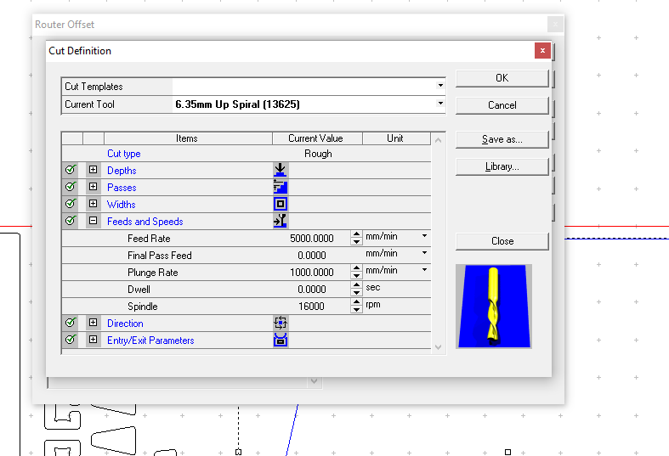

Demonstrate how to save toolpathes

Moving Designs to Machine
When all the tool pathes are created, select the output button(G1). In this menu you will be able to choose the strategy in which the machine will operate

Output
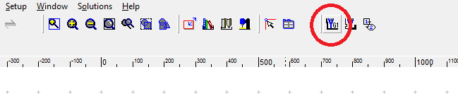
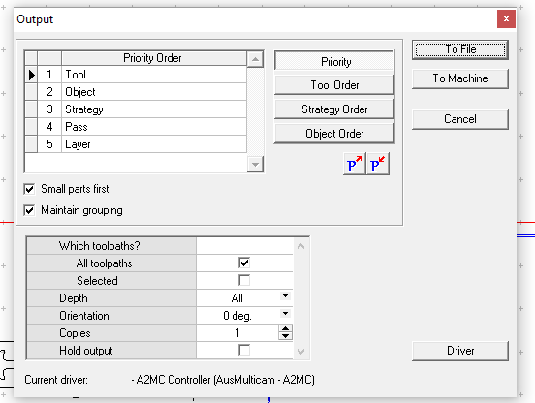

Priority-In this menu you will be able to choose the strategy in which the machine will operate as wel as user define the best way to operate the machine by adjust these options
tool- If you are using multipe tool bits you can select the order in which the machine will cut first
object- allows you to choose the order of objects cut depending on toolpath and location
Strategy- internal or external cuts first
other options include small parts first and maintin groupings.
One complete click-> To File and save it
Open the Multi Cam App Manager
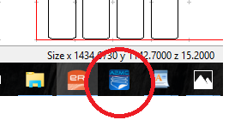

Select File Manager
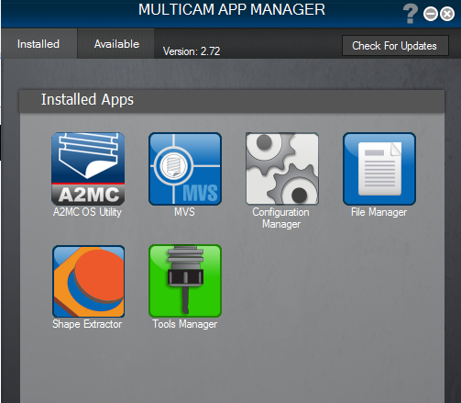

select Connect -Note CNC Machine must be on to connect

Once connected select your saved job and select the arrow to move to machine
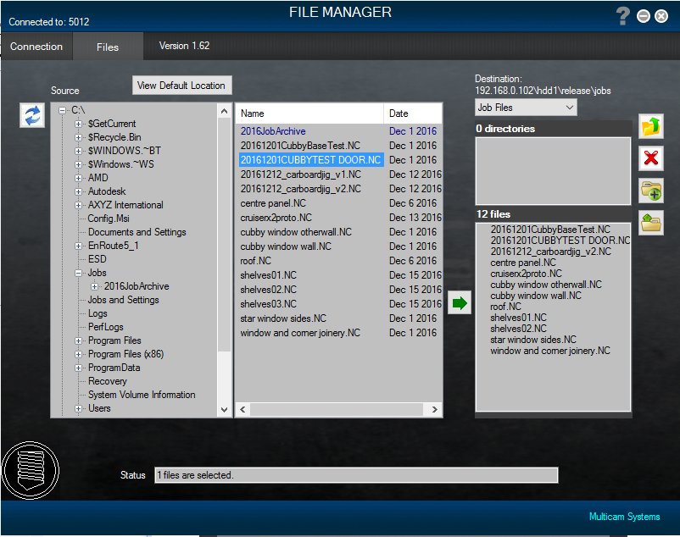

Loading a Tool
Go to Tab 6-Tooling mode
the Spindle will move over the to the tool loading section
Pick the appropriate tool and collett and insert into the spindle
Use the Collet Nut Wrench and Spanner to tighten -Note- Not too tight
push the Qualify tab and selct the tool from the list and press OK
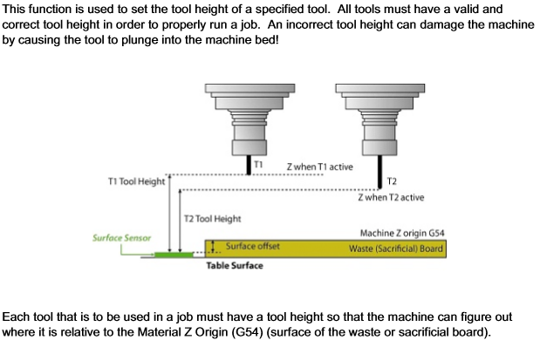
The machine will check tool by lowering onto the sensor pad to calculate the length of the bit.

Cutting on the CNC
Load material onto the wasteboard - Larger pieces can use the vacuum bed to hold material. Note - as the material is cut it will lose suction especially when cutting small objects. If the material is very bowed you can try laying the material with the high side in the middle and 2 people can push down. Alternatively screws, can be used but you will have to be aware of the tool path.
While machine is operating
Where PPE!!!!glasses ear protection
Observe the machine in operation
Use emergency stop if necessary. Note- if the machine is turned OFF mid operation, wait 1 minute to turn ON
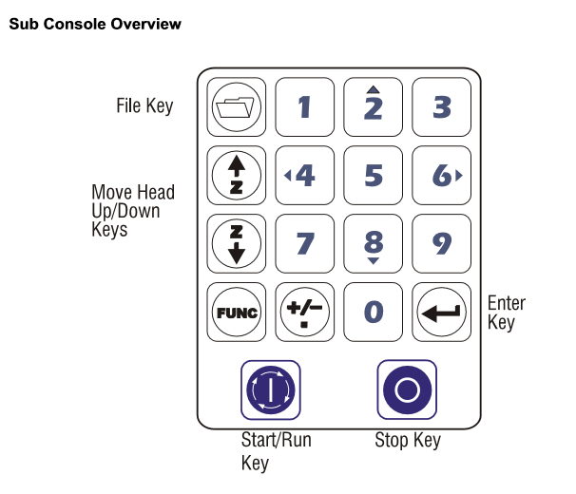

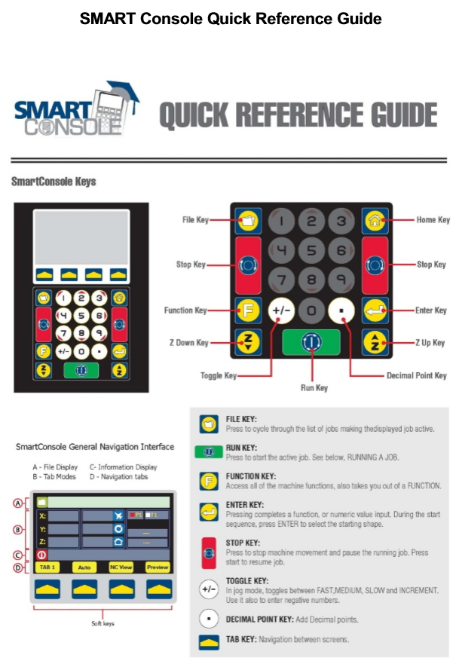

Assembly
