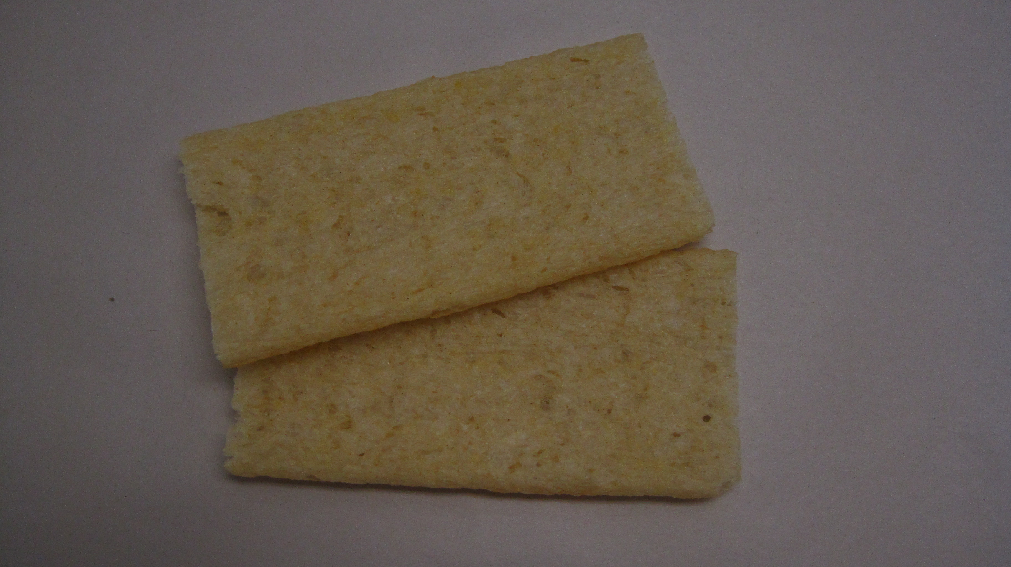

STEP 1:

Choose two cruskits that are reasonably flat:

STEP 2:
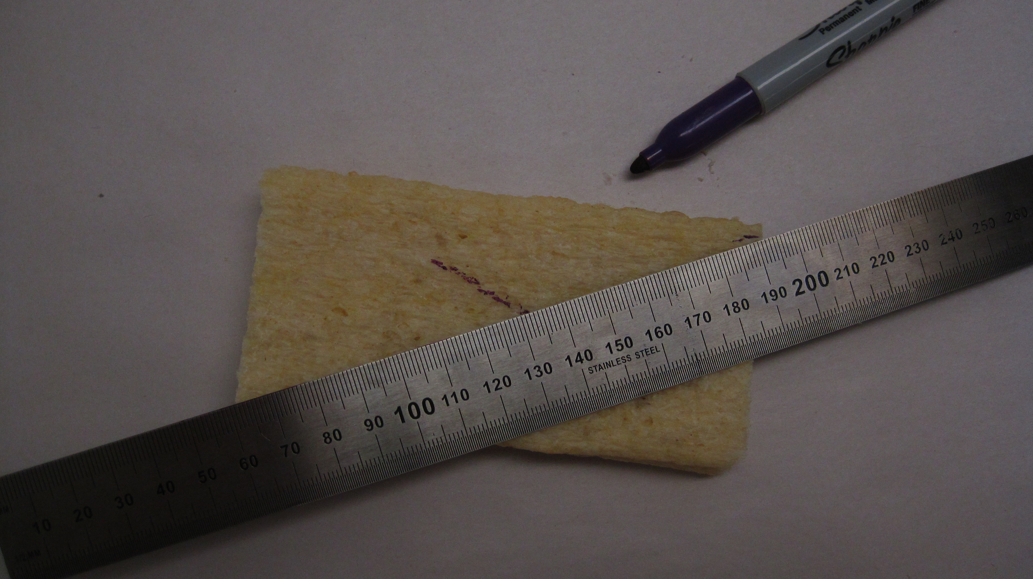

Use a ruler to find the centre of each piece
by drawing diagonal lines joining opposite corners.
(The centre is where the diagonals cross).
These pieces will be the sides of the box.

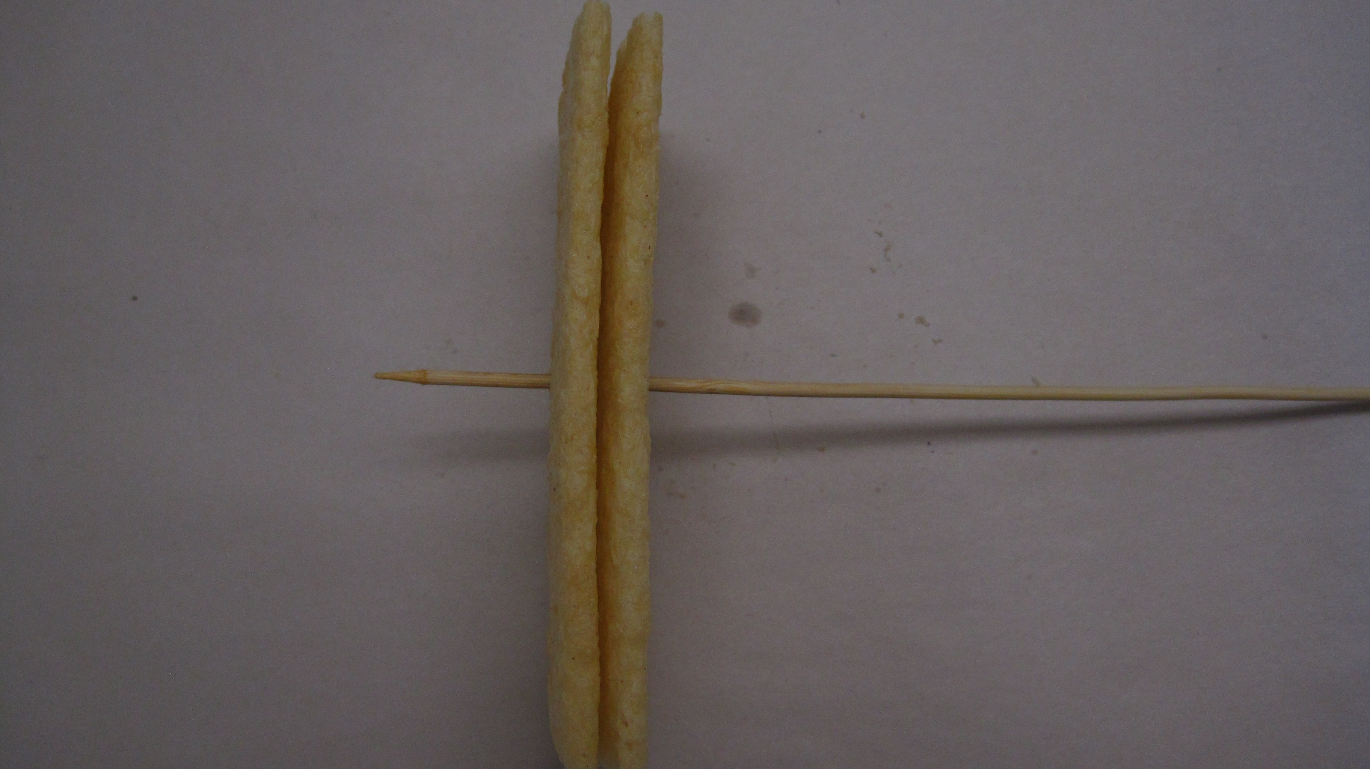
STEP 3:

Use a skewer to carefully bore a hole in each cruskit
at the centre point.
This will ensure the axle to go through will be level.

STEP 4:
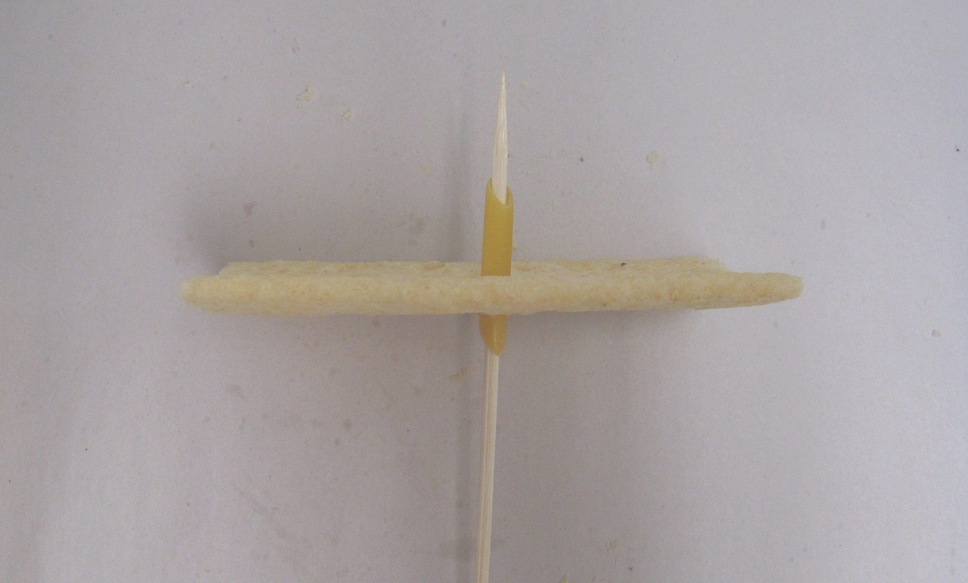

Enlarge the hole in each side by pushing a piece of
penne half way through, and glue it into place. This will
keep the axle straight, help support it and reduce
the friction.

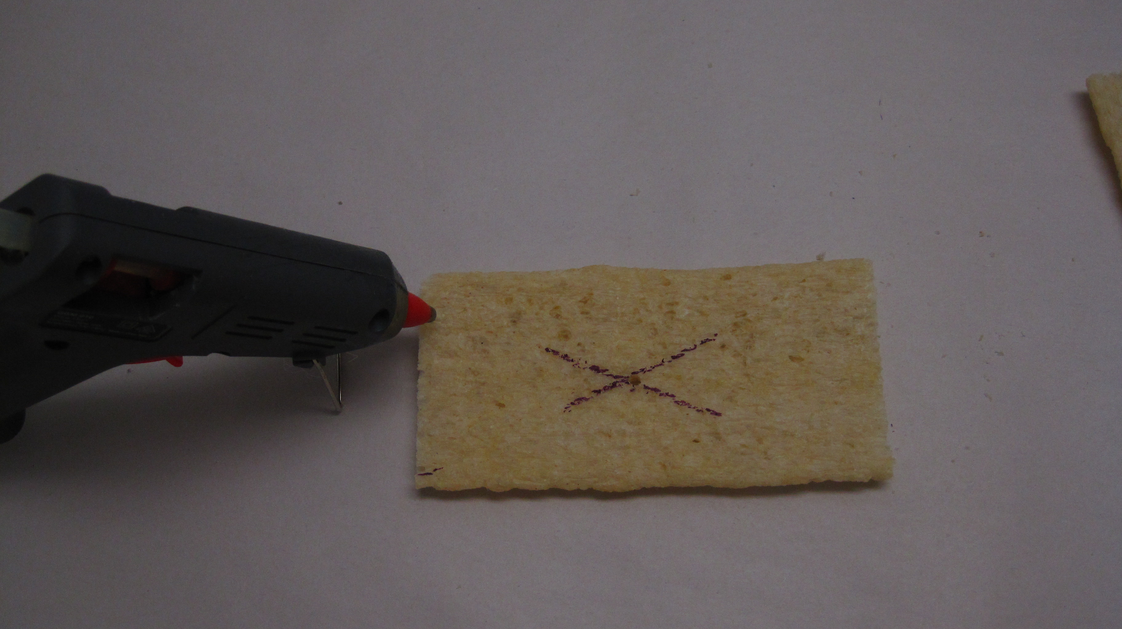
STEP 5:

Take another cruskit, and apply a liberal bead of hot glue
along the short edge of the cruskit. Apply the glue to the edge,
Glue goes here
not the face. This will be the base of the box.

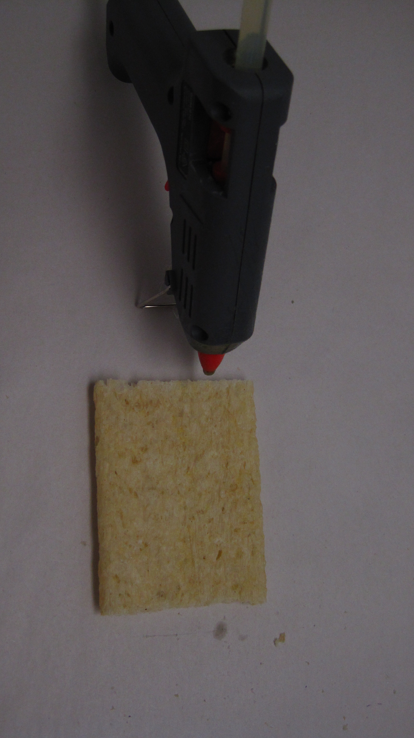
STEP 6:

Apply a bead of hot glue along the short edge
Glue goes here
of one of the cruskits with the penne. This time
apply the glue to the face rather than the edge (there is no
penne in this one, unlike yours, but you can see where to put
the glue).

STEP 7:
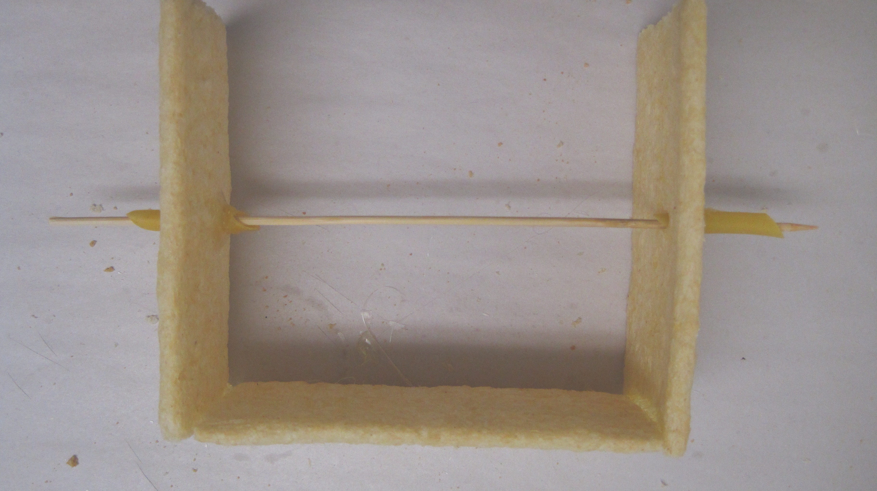

Press the two pieces of cruskit together at a 90 degree angle.
The edge of the base fits onto the face of the
side. Placing them horizontally on the table makes
it easier to maintain the angle while the glue sets. Do the same
at the other end with the other cruskit that has the penne
glued in. Adding a skewer helps keep things straight while
the glue sets.

STEP 8:

Use the diagonals method to locate the centre
of another cruskit, and make a hole
at the centre with a skewer. This will become the top
of the box.
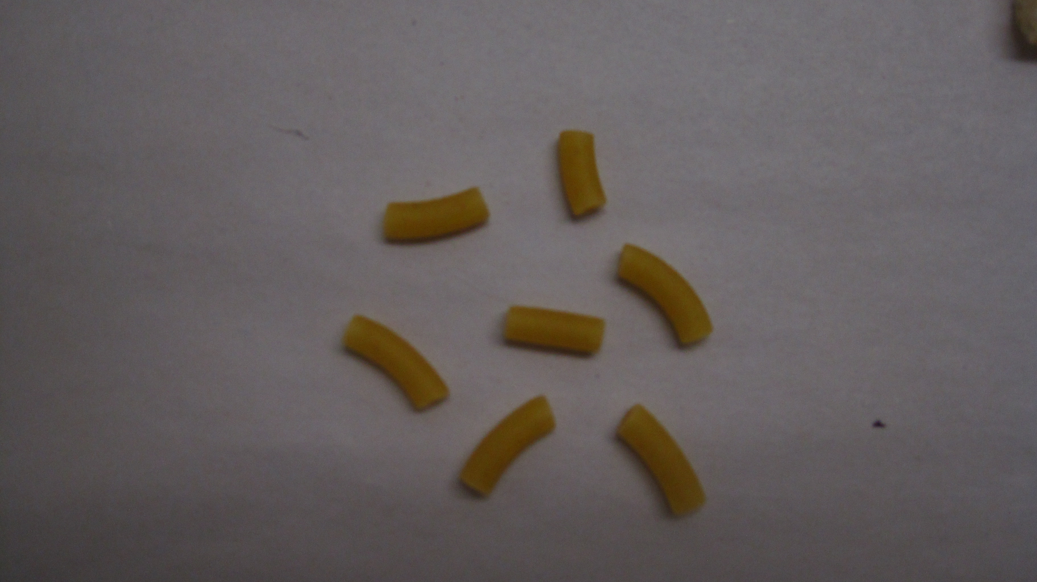

STEP 9:

Choose a relatively straight piece of thin macaroni.
The piece in the middle is about right.

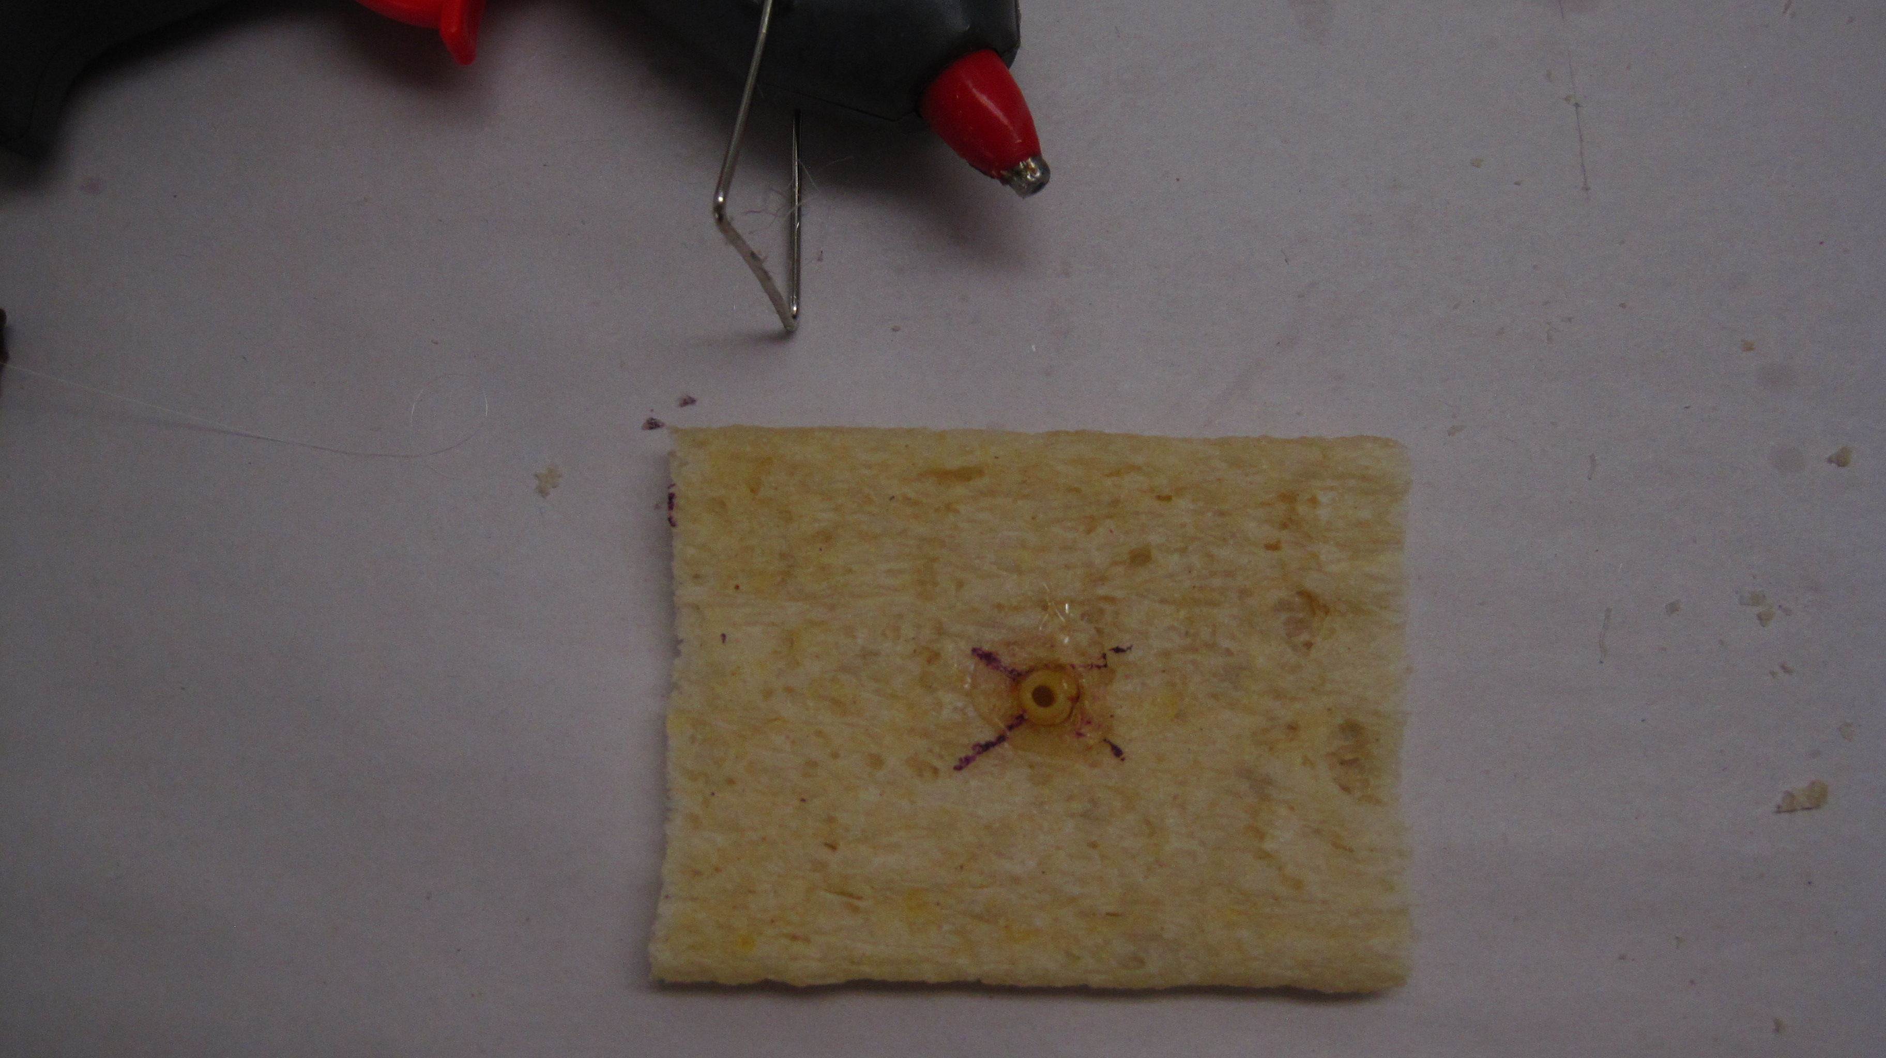
STEP 10:

Push the macaroni into the hole just made,
and secure in place with hot glue. Try to keep it
perpendicular to the face of the cruskit, and have it
protrude a few mm from both top and bottom. (this cruskit
is a bit small, but yours should be full sized)

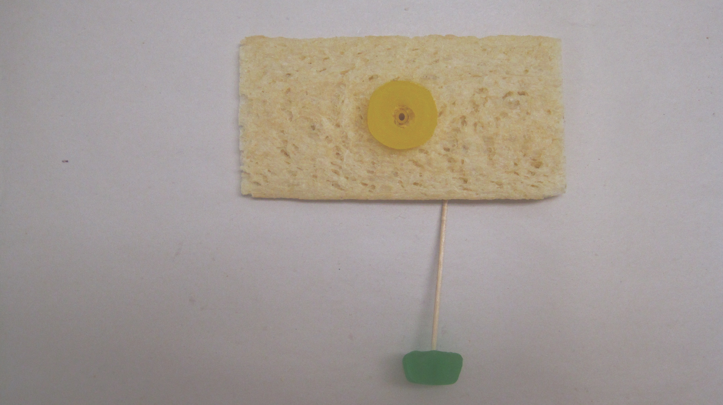
STEP 11:

Glue a lolly ring to the top, with the macaroni in
the middle. Take another jube, and insert a short piece of
spaghetti into the middle of it, but not all the way through.
The spaghetti should be about half the length of a cruskit.

STEP 12:
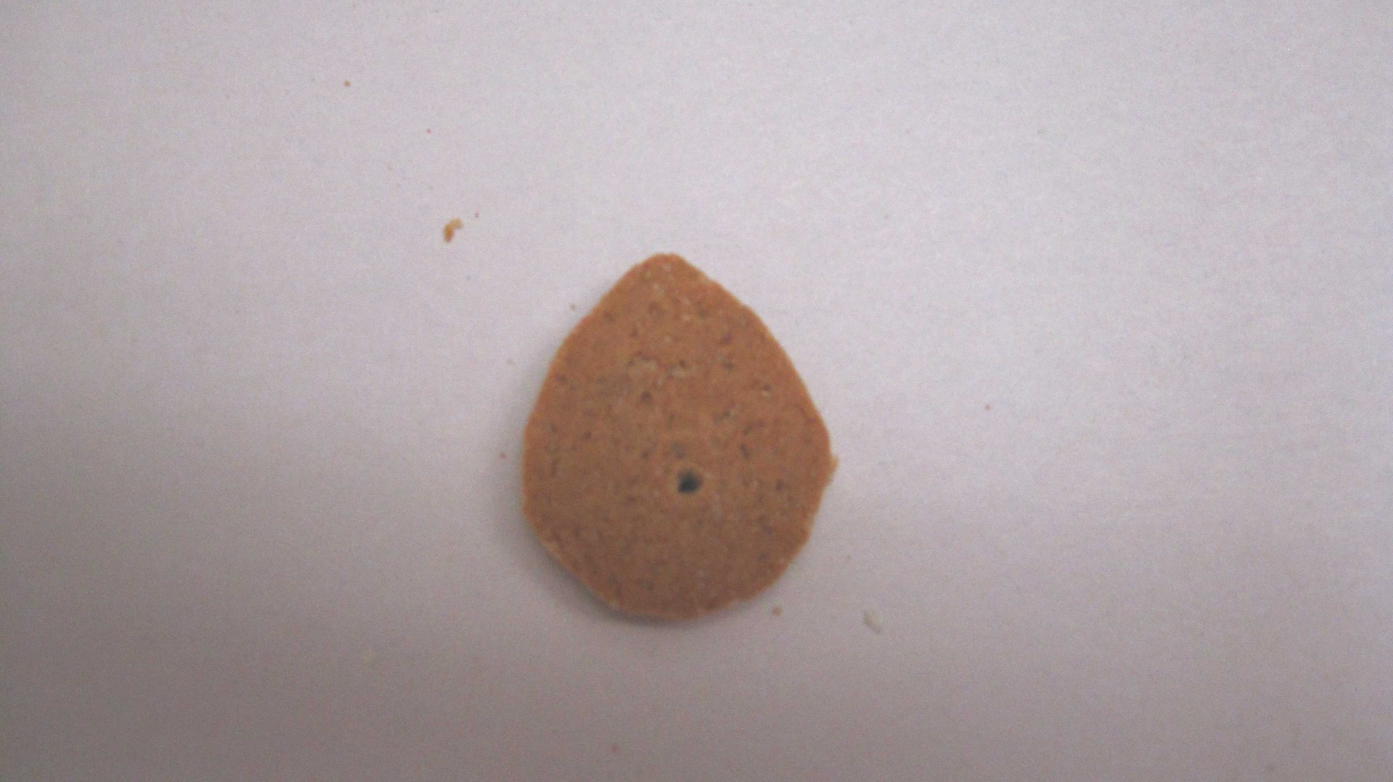

Use the craft knife to cut a gingernut biscuit into an egg-shape.
This is called a snail cam. It helps to make a hole first,
by gently drilling through with a sharp skewer. The one pictured
is about right, but you can adjust the shape later, if necessary.
The pointy end needs to be rounded, rather than too sharp.

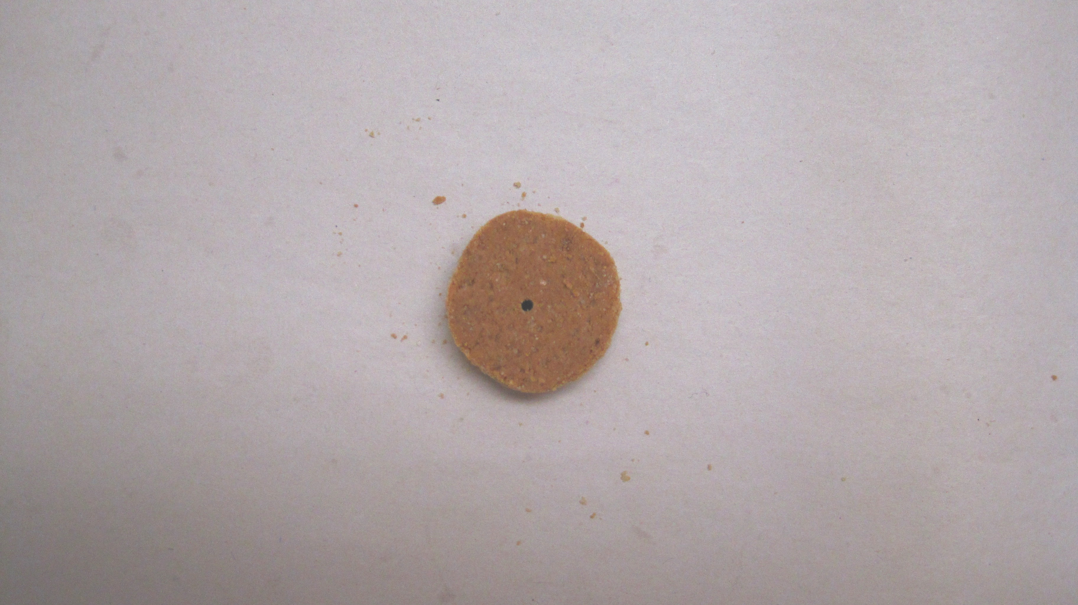

STEP 13:

Take another gingernut, and trim it down to make a circular
cam, about half the original diameter. Gently drill a hole in
the center using a sharp skewer.

STEP 14:
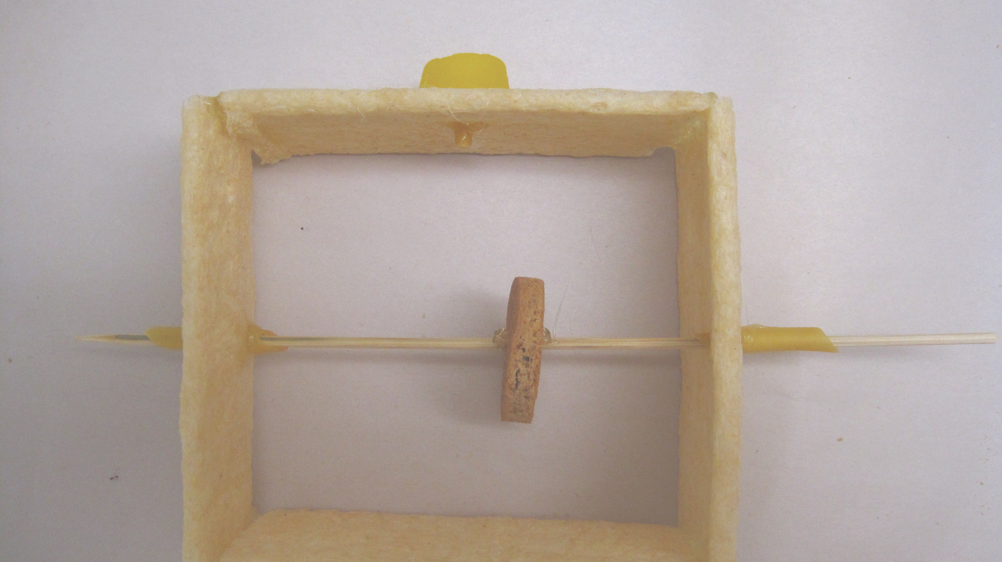

Glue the top onto the box, with the lolly ring on the outside.
Insert the axle through one side of the box,
then the EGG SHAPED biscuit, and gently push it through until it
comes out the other side. Rotate so the ‘egg’ points down.
When the biscuit is almost in the middle of the skewer,
glue it into place (you will have to do this while it is inside
the box).

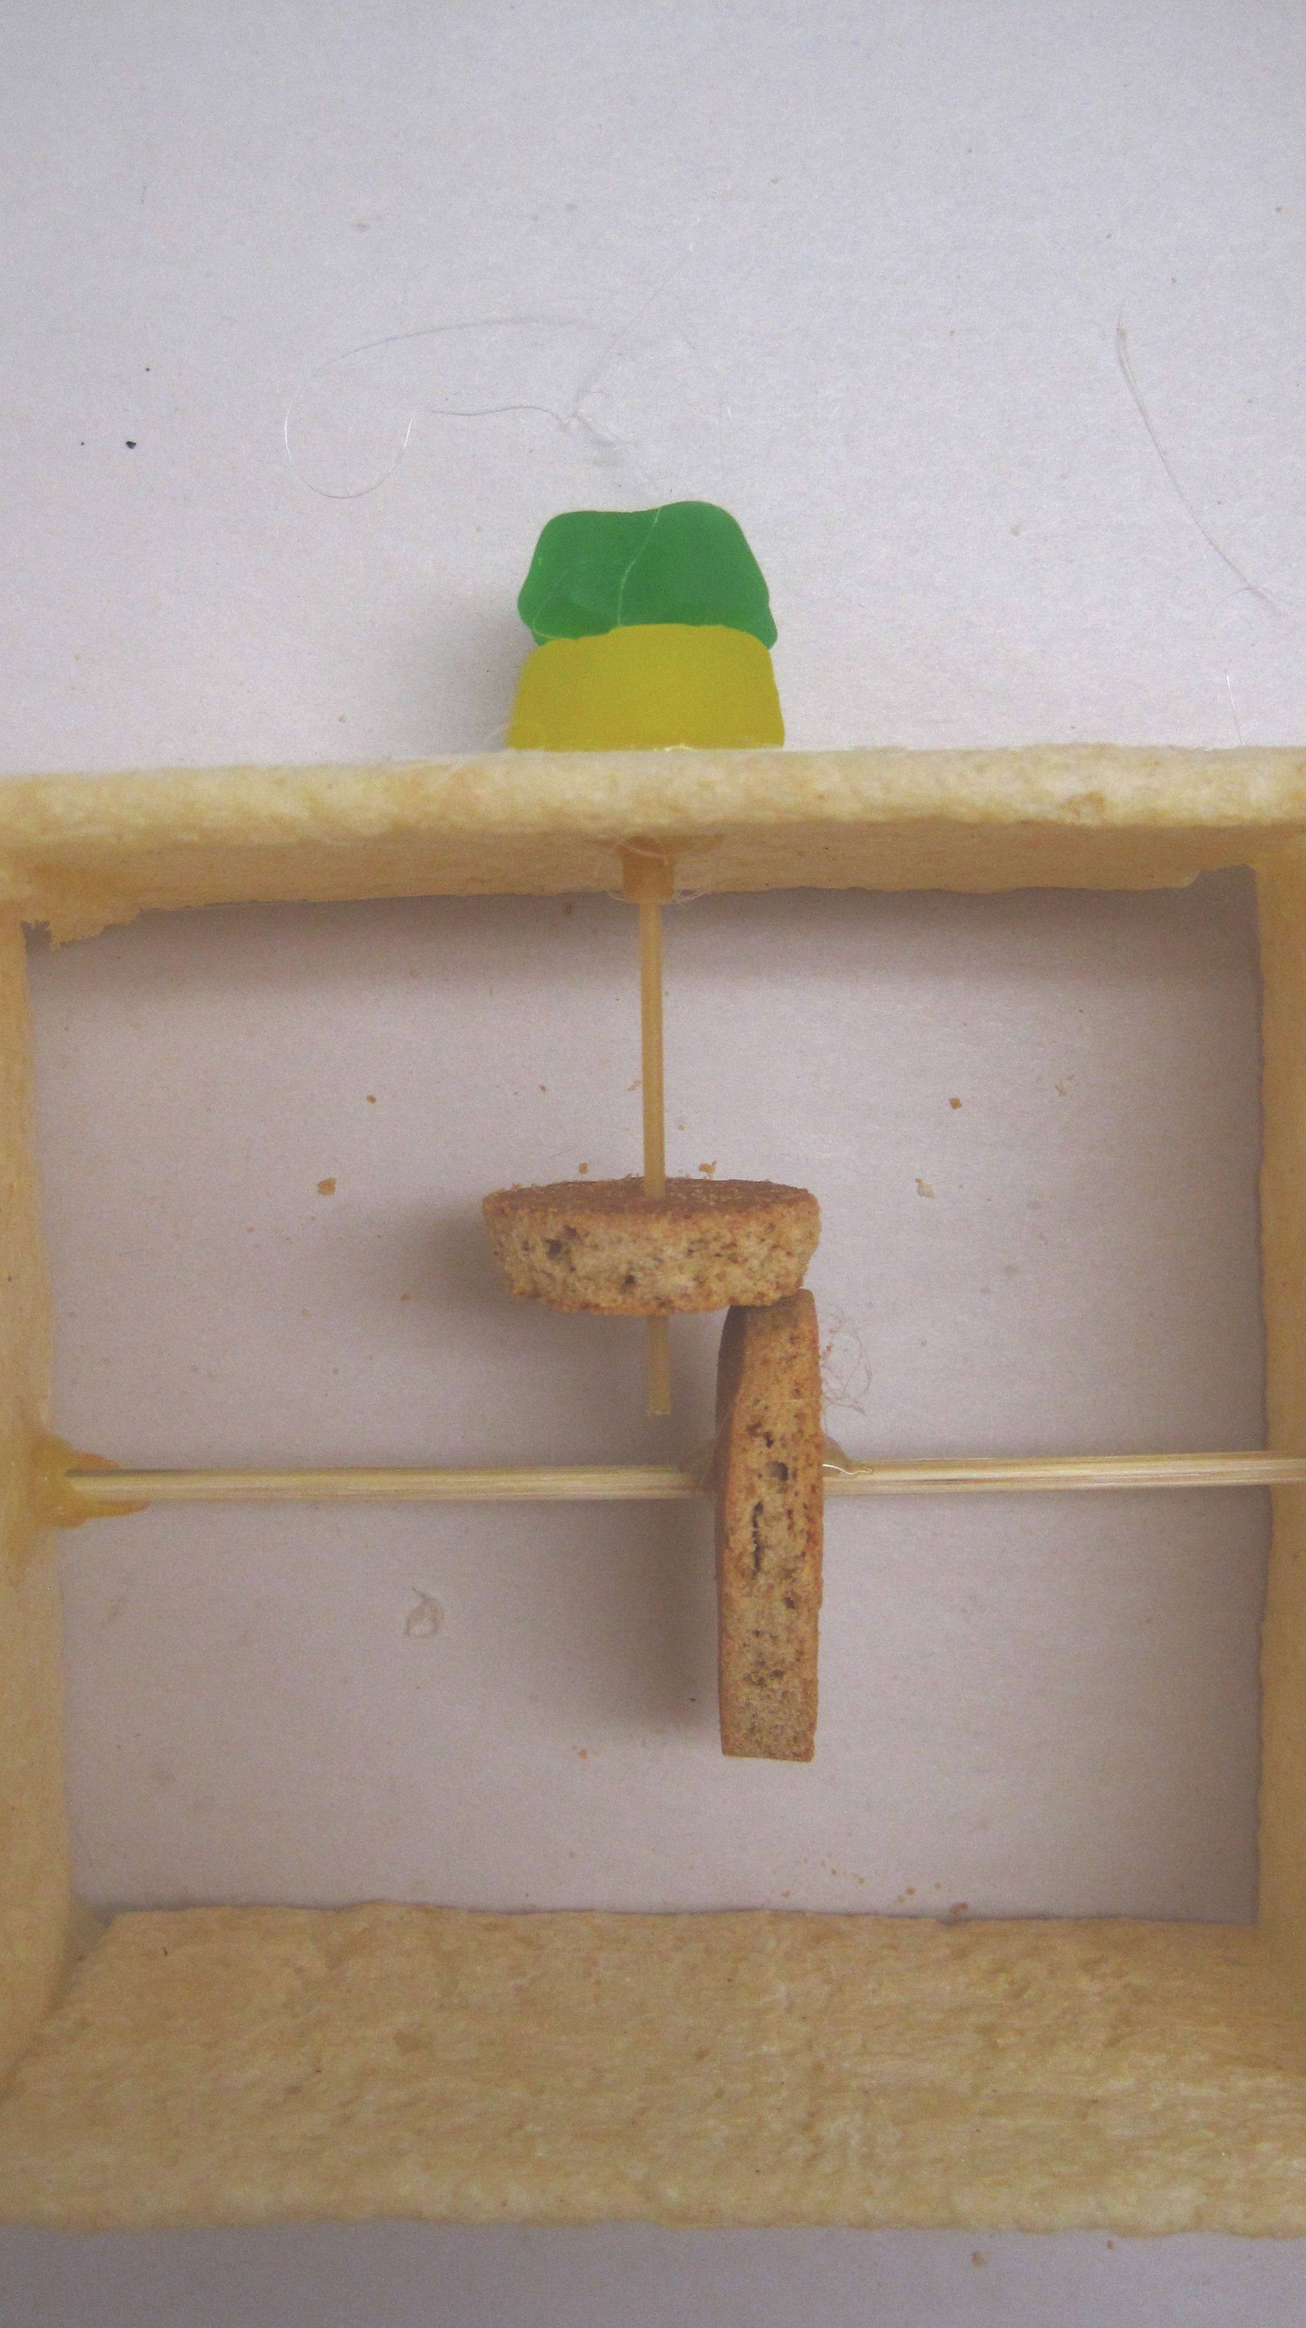

From the side, things
should look like this.
STEP 13:

Insert the spaghetti through the macaroni on the top of
the box, so the jube sits on the ring. As you do this, push
the spaghetti through the ROUND biscuit. Adjust so that the
two biscuits just touch when the longest axis of the snail cam
is pointing down, and the jube is sitting on the ring.
Glue the round biscuit to the spaghetti, making sure the bottom
of the spaghetti does not touch the axle
(snap a bit off if you need to).

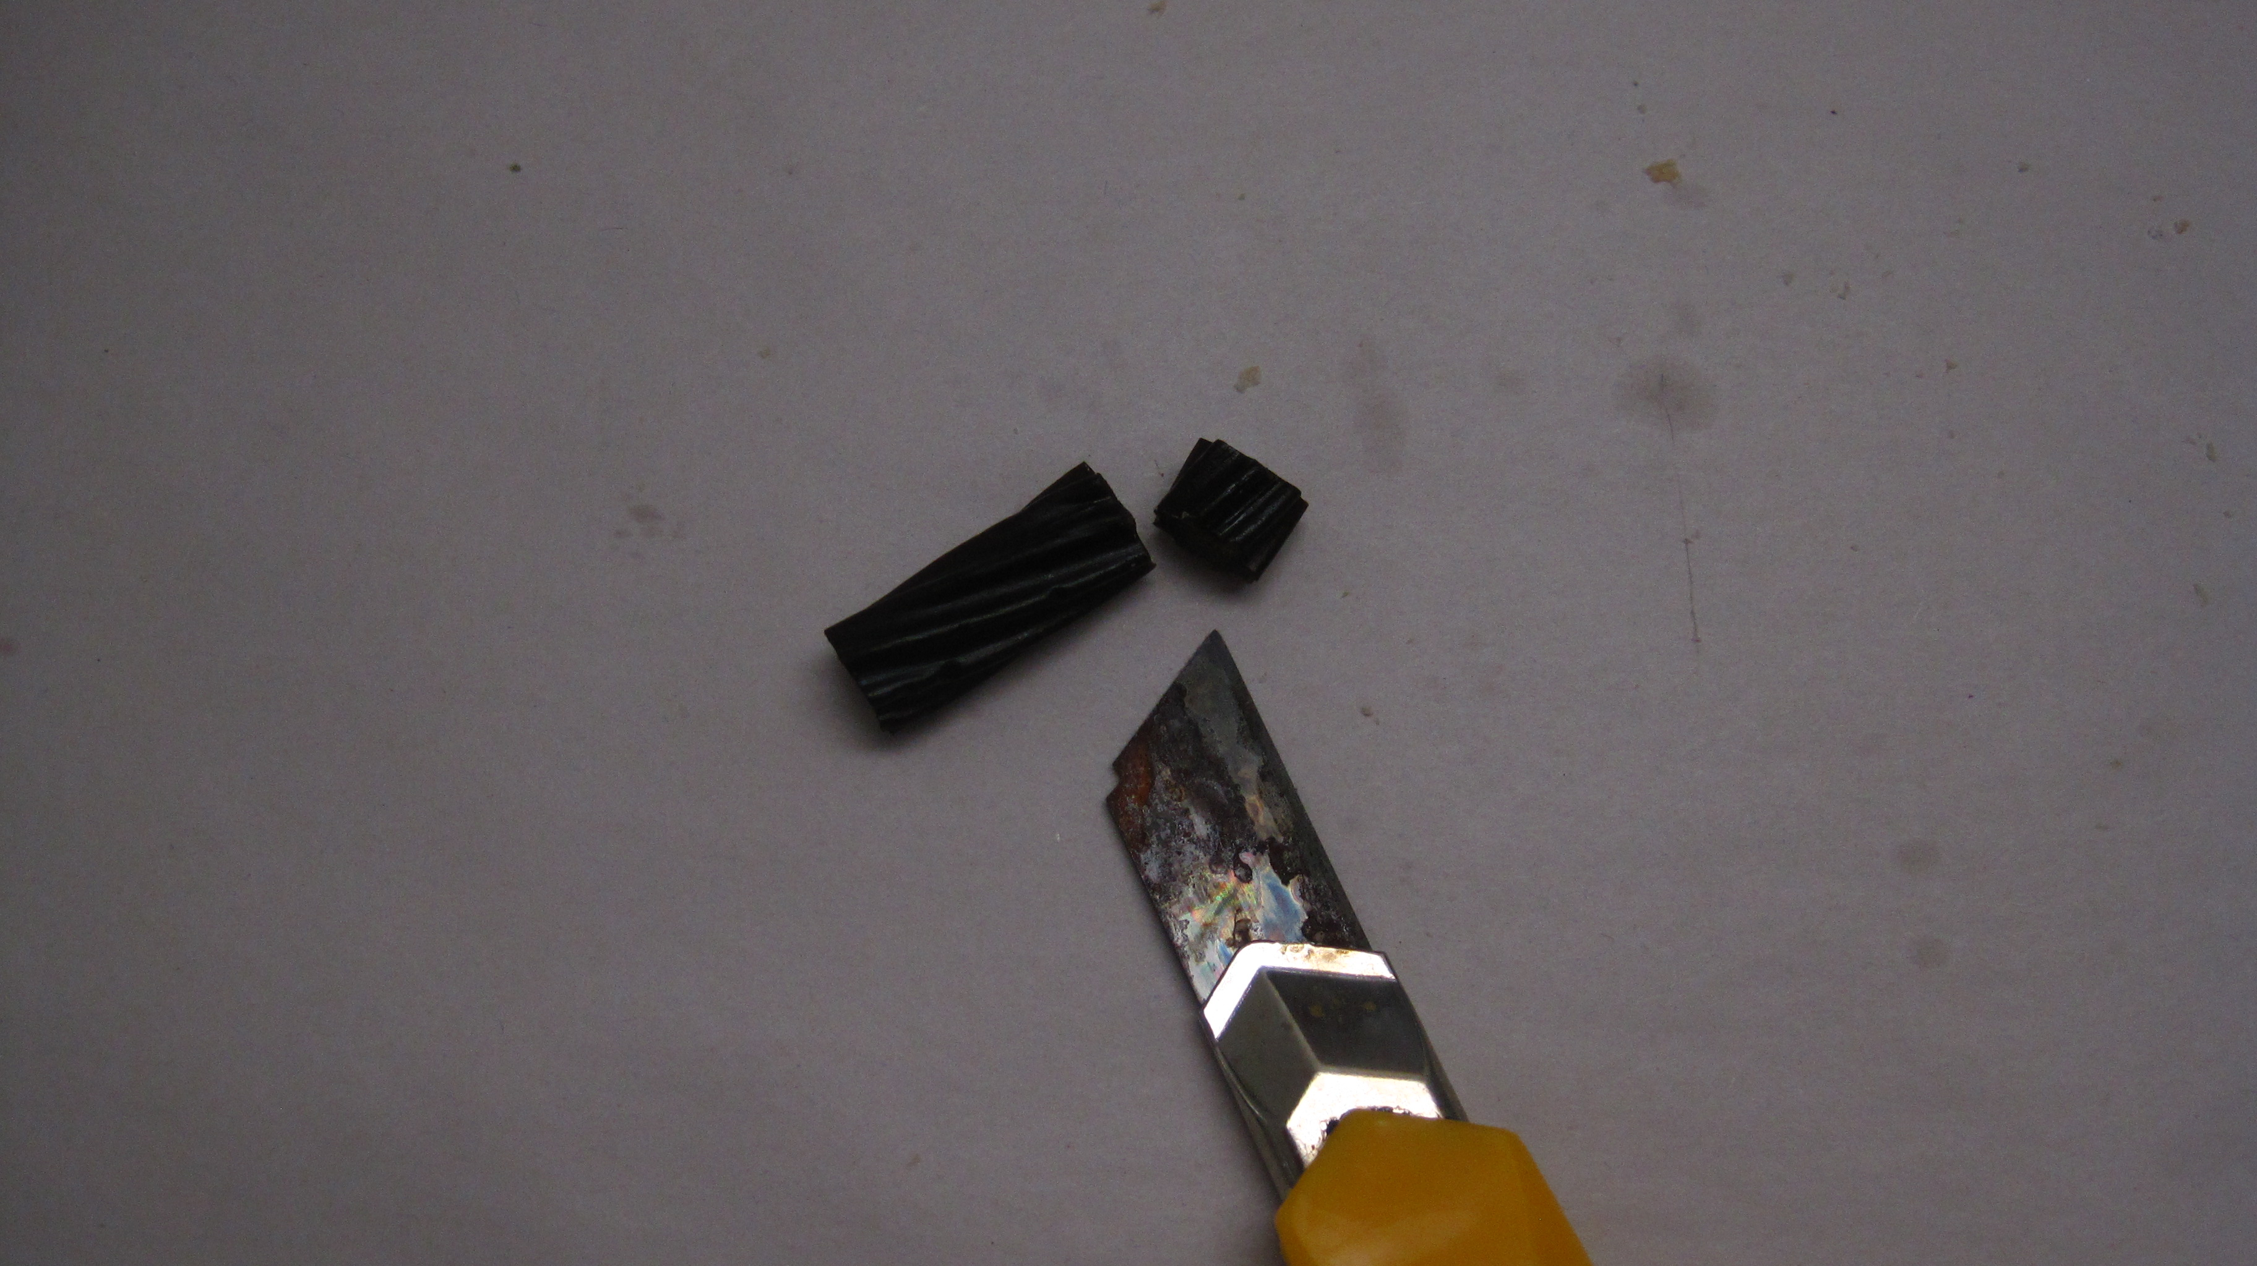
STEP 14:

Use the craft knife to cut a 1cm disc of
liquorice.

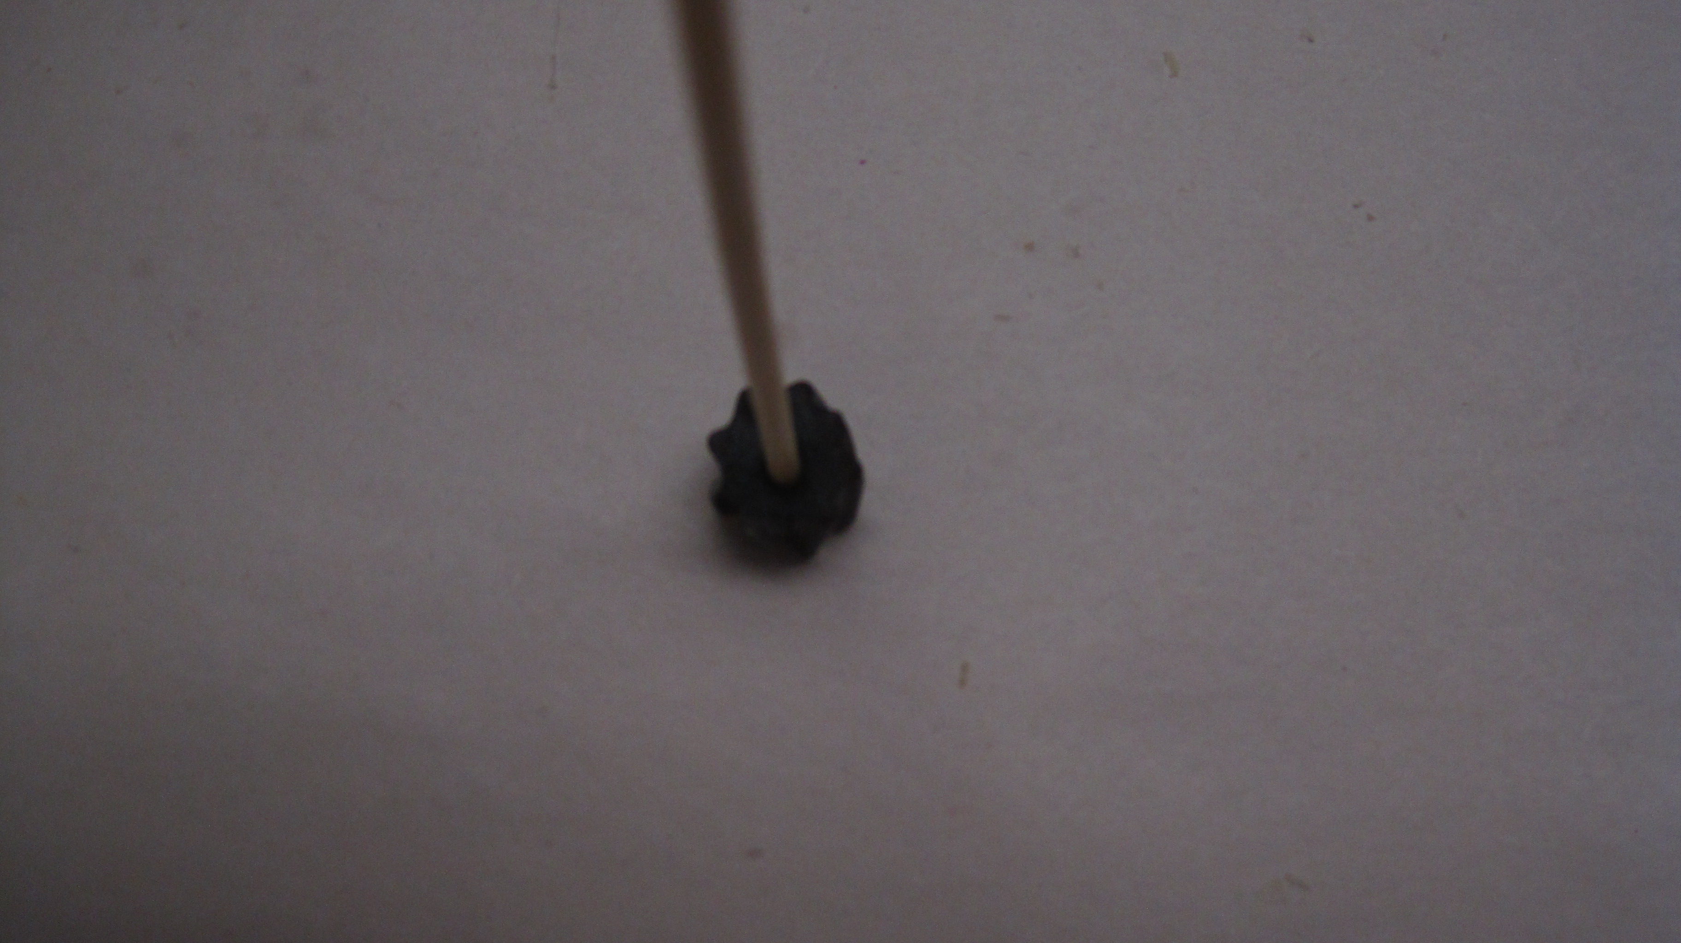

STEP 15:

Gently pierce a hole in the centre using
the skewer. Be careful to avoid splitting.

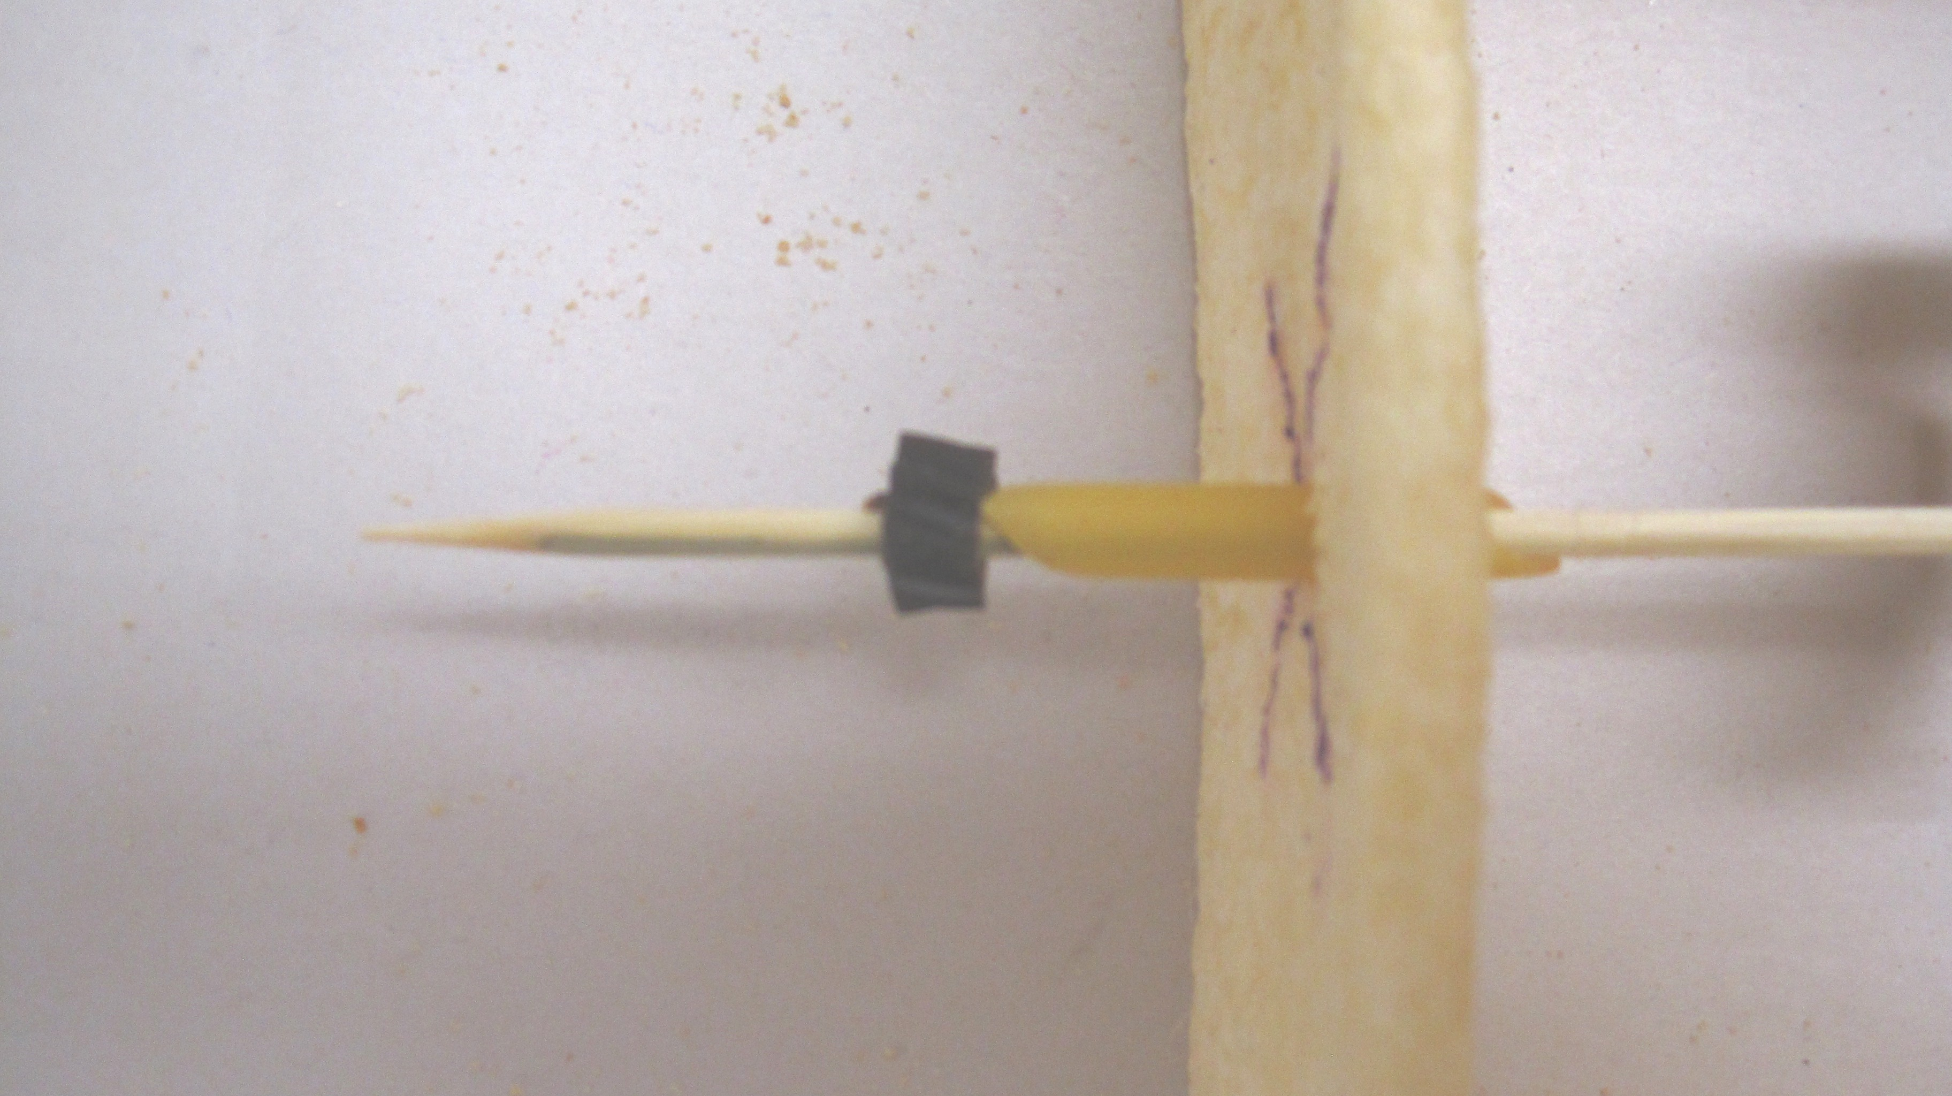
STEP 16:

Push the liquorice ring over the end of the axle on the outside
of the box, and slide it along to lock the cams in place.

STEP 17:
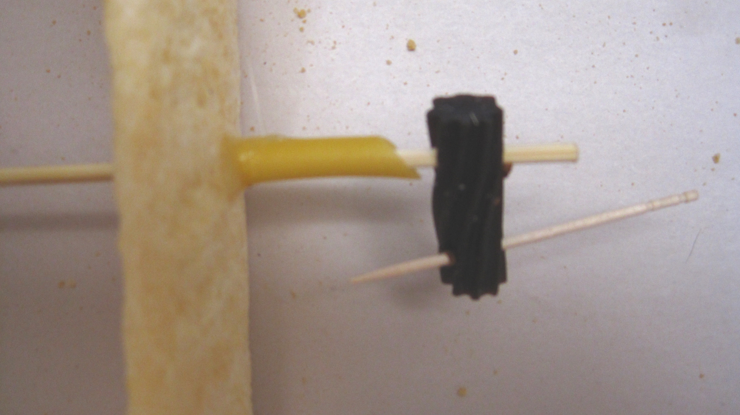

Holding a piece of liquorice at right angles to the other end
of the axle skewer, push the end of the skewer through the
liquorice about 1cm down. This will make a crank handle
for the mechanism inside the box.
Push a toothpick (or a piece of skewer) through
the liquorice to complete the crank.

STEP 18:
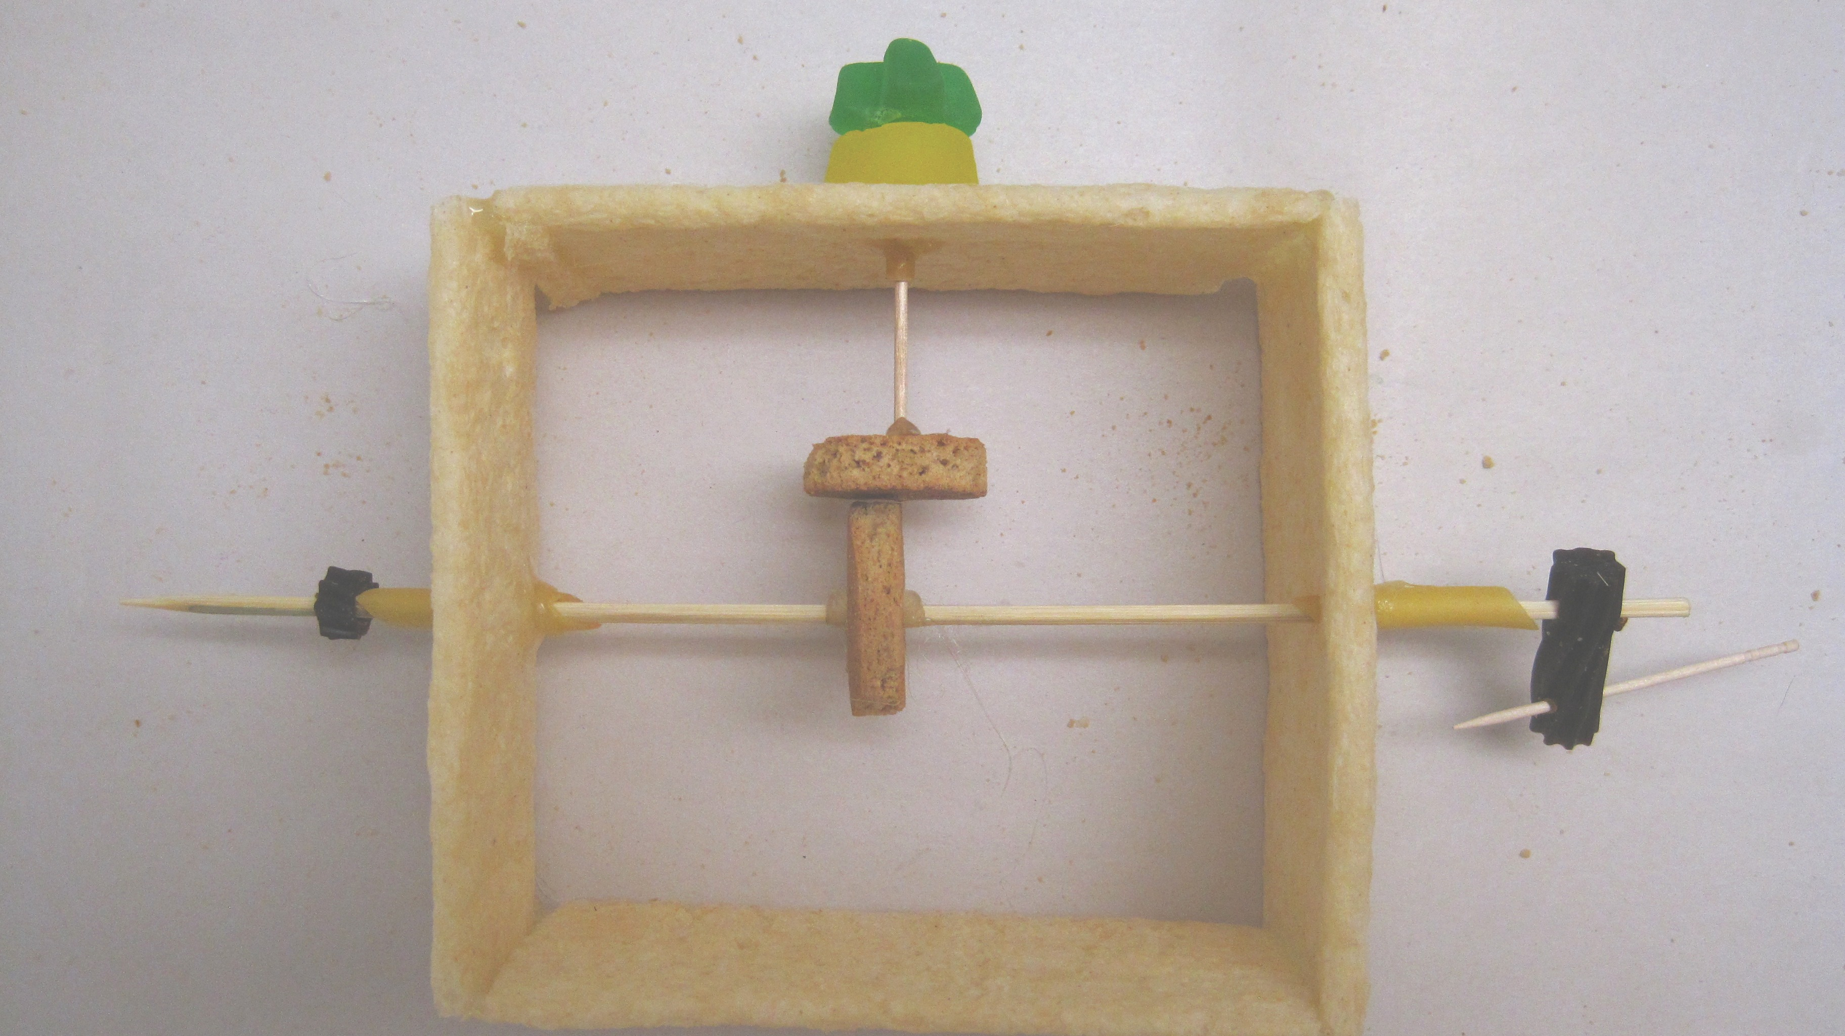

Your automaton is now complete. Adjust the location of the cams
so that they engage properly by sliding the liquorice along
the axle. You can artfully decorate the jube with nodding
pieces of rice vermicelli, if you wish.

STEP 19:

Turn the crank, and smile as the snail cam pushes against the follower, spinning the jube which also jumps up and down.
