Prusik Knot – tying the flying line to the bridle
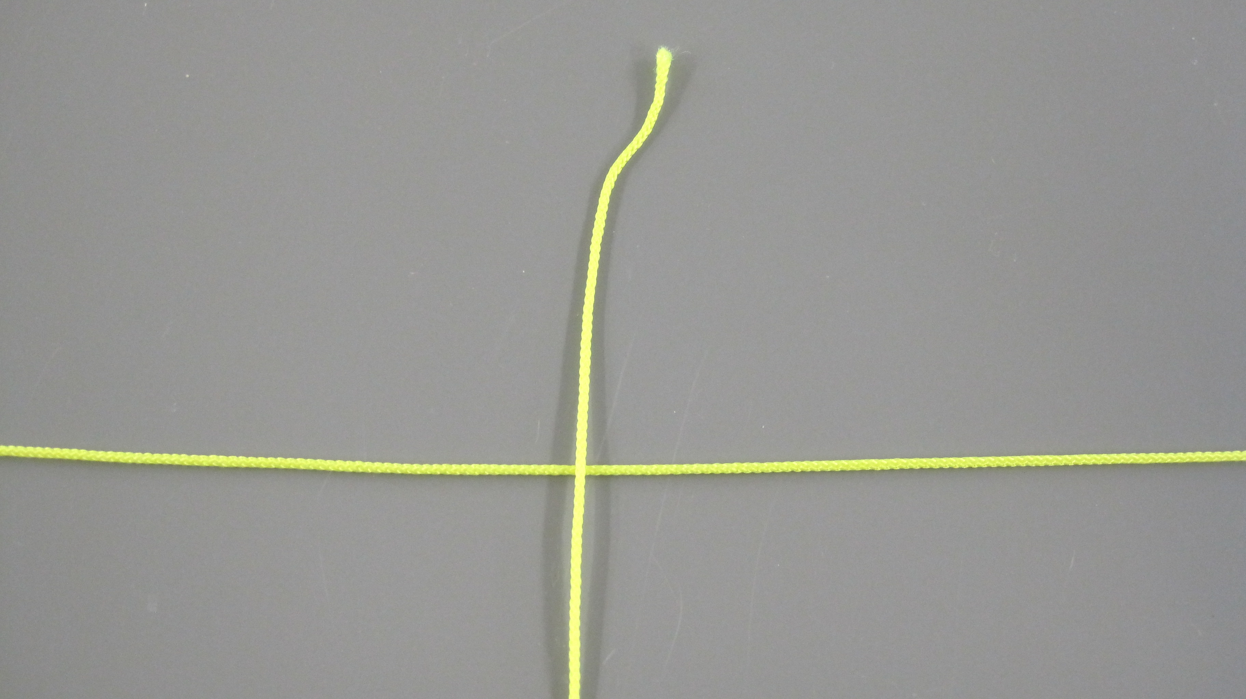
STEP 1: Pass the end of the flying line over the centre of the bridle

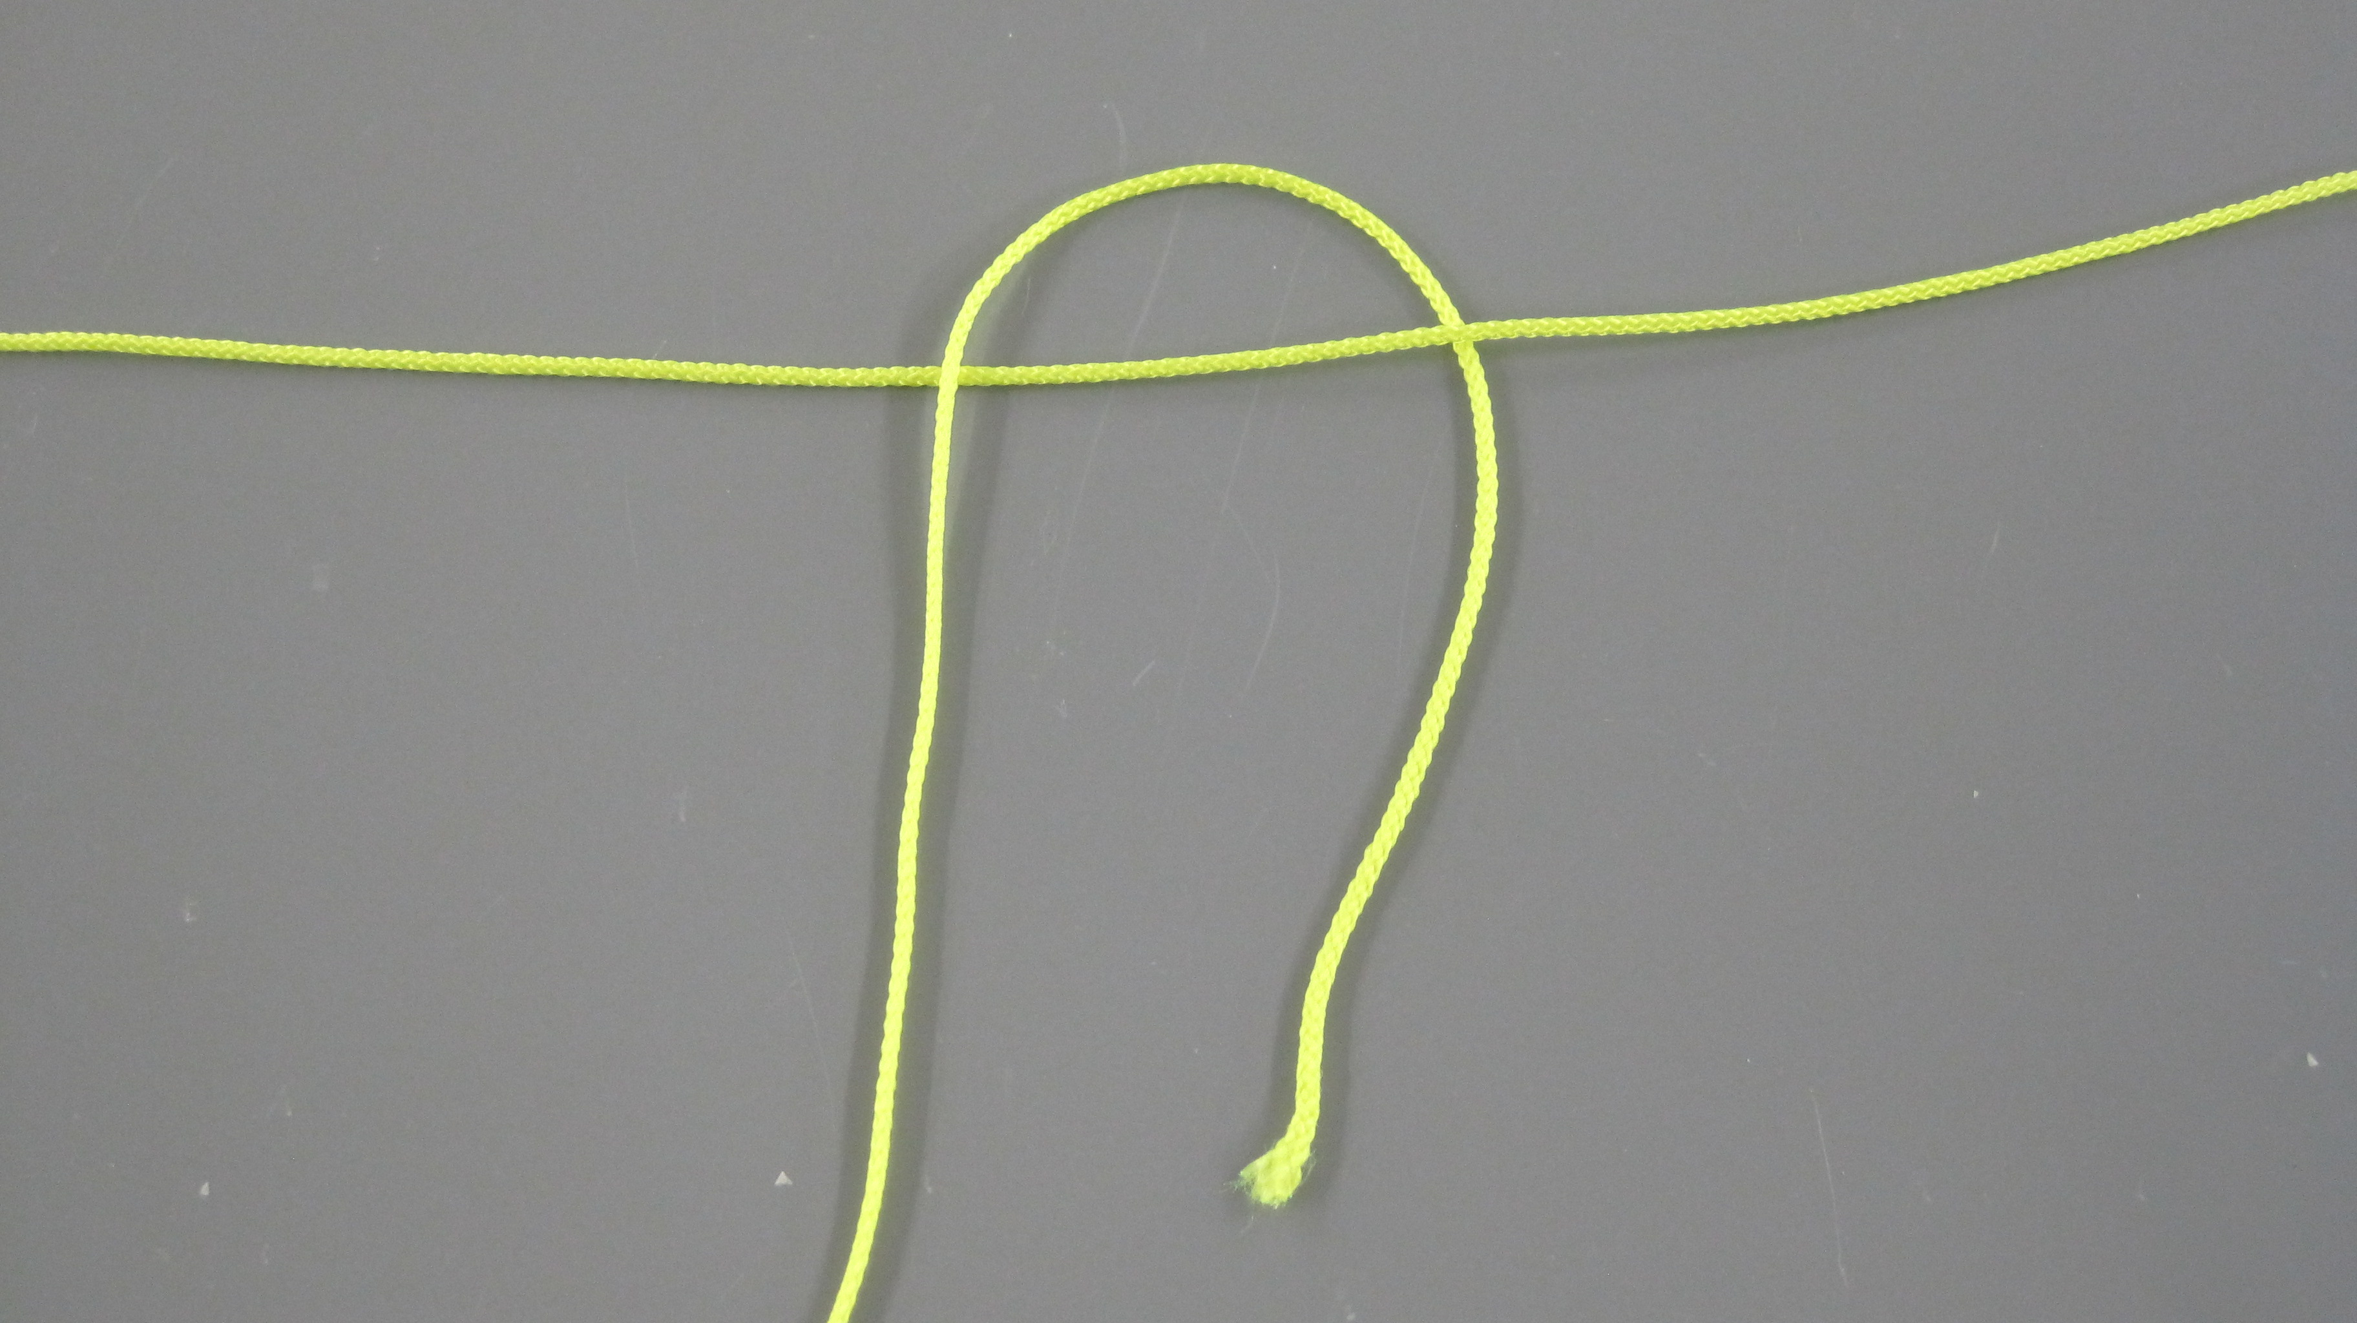
STEP 2: Bring the end down and under the b bridle line
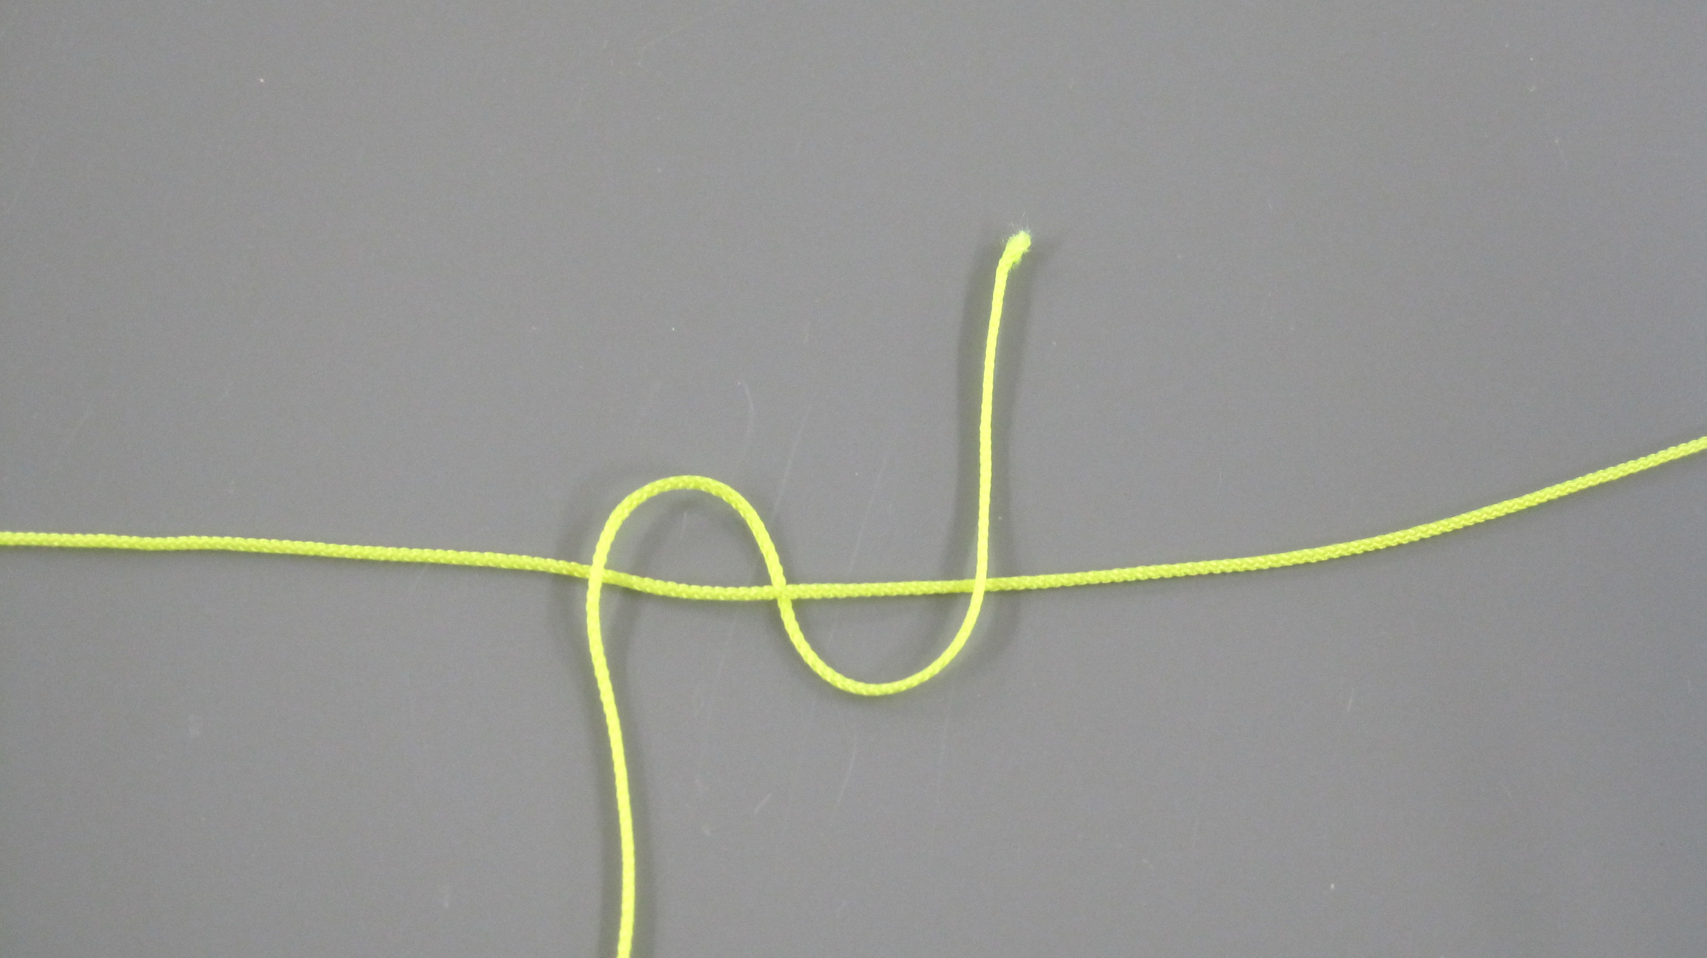

STEP 3: Now take the end over the bridle

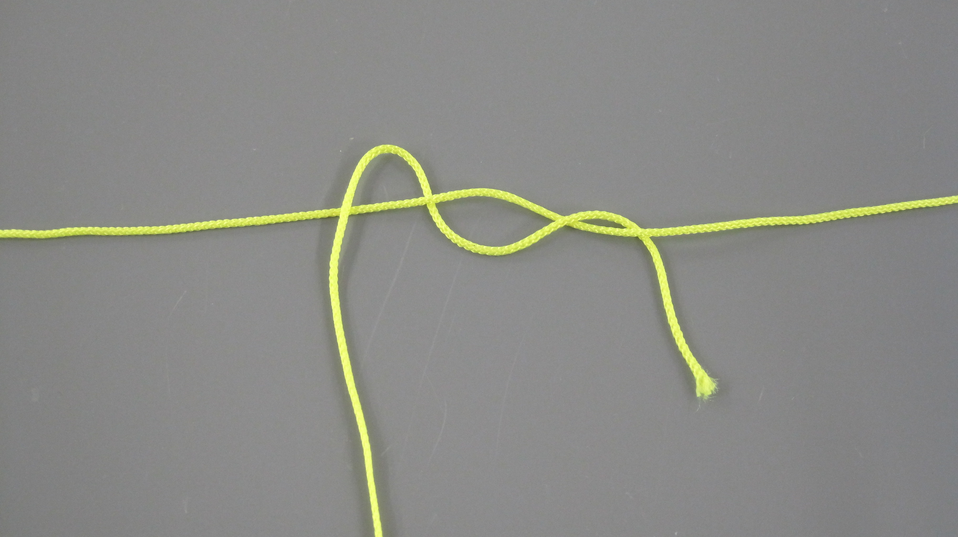
STEP 4: Bring the end under

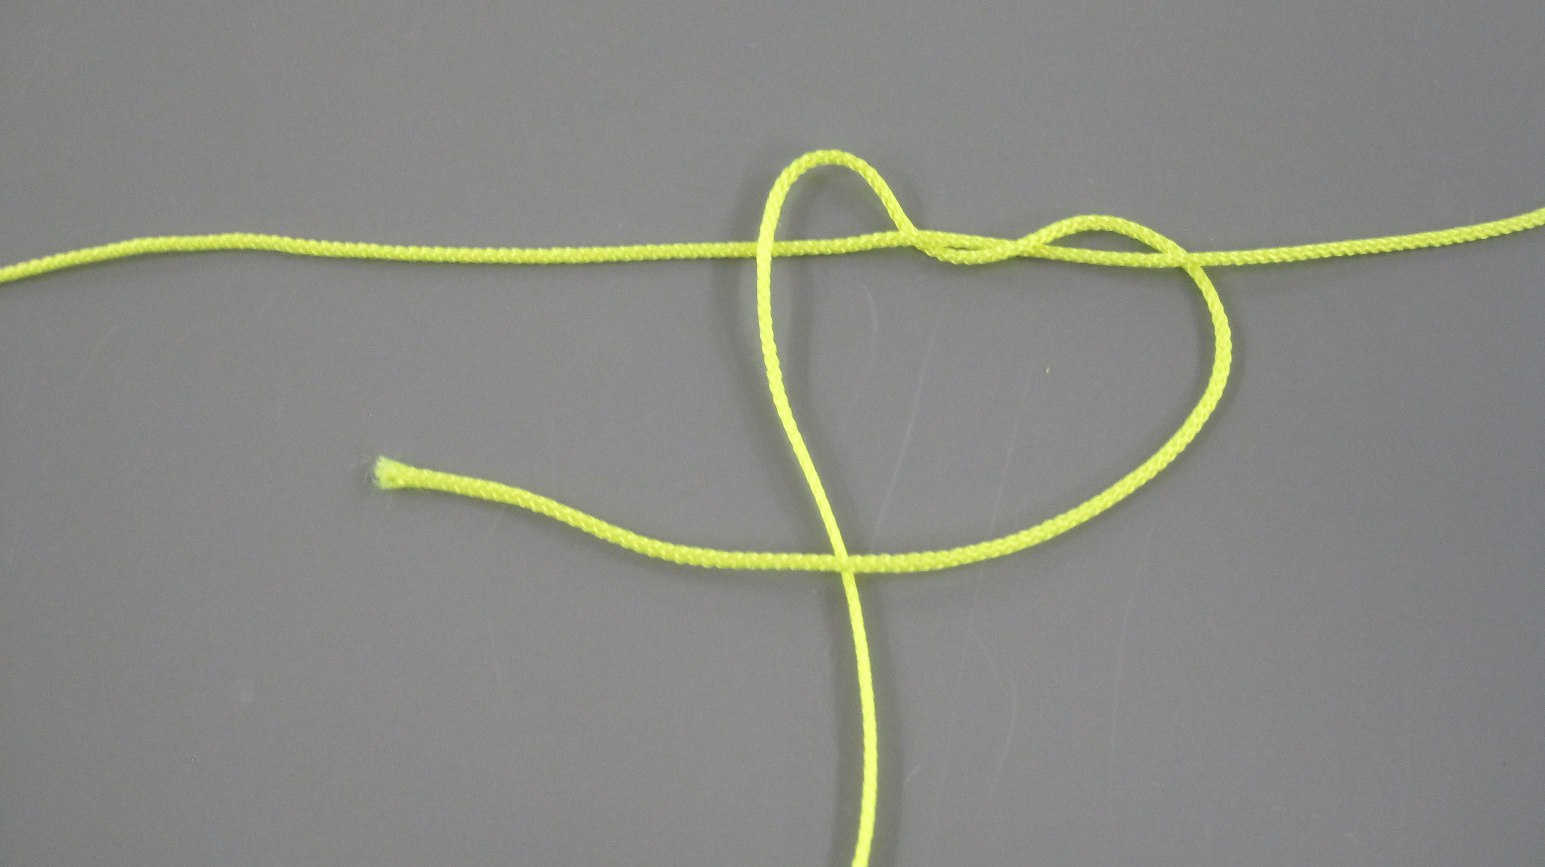

STEP 5: and then across and over rest of the flying line.

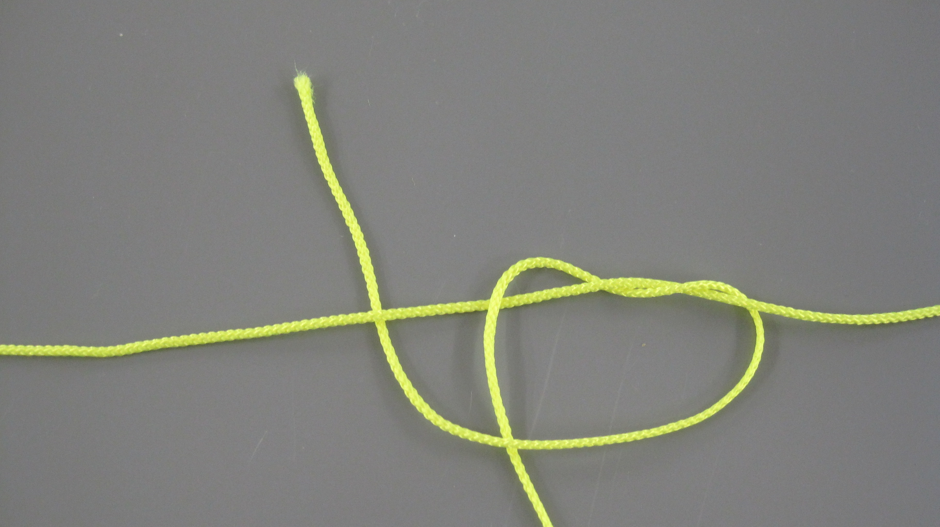
STEP 6: Bring the end under the bridle on the other side of the trailing flying line
STEP 7: Now the end comes over,
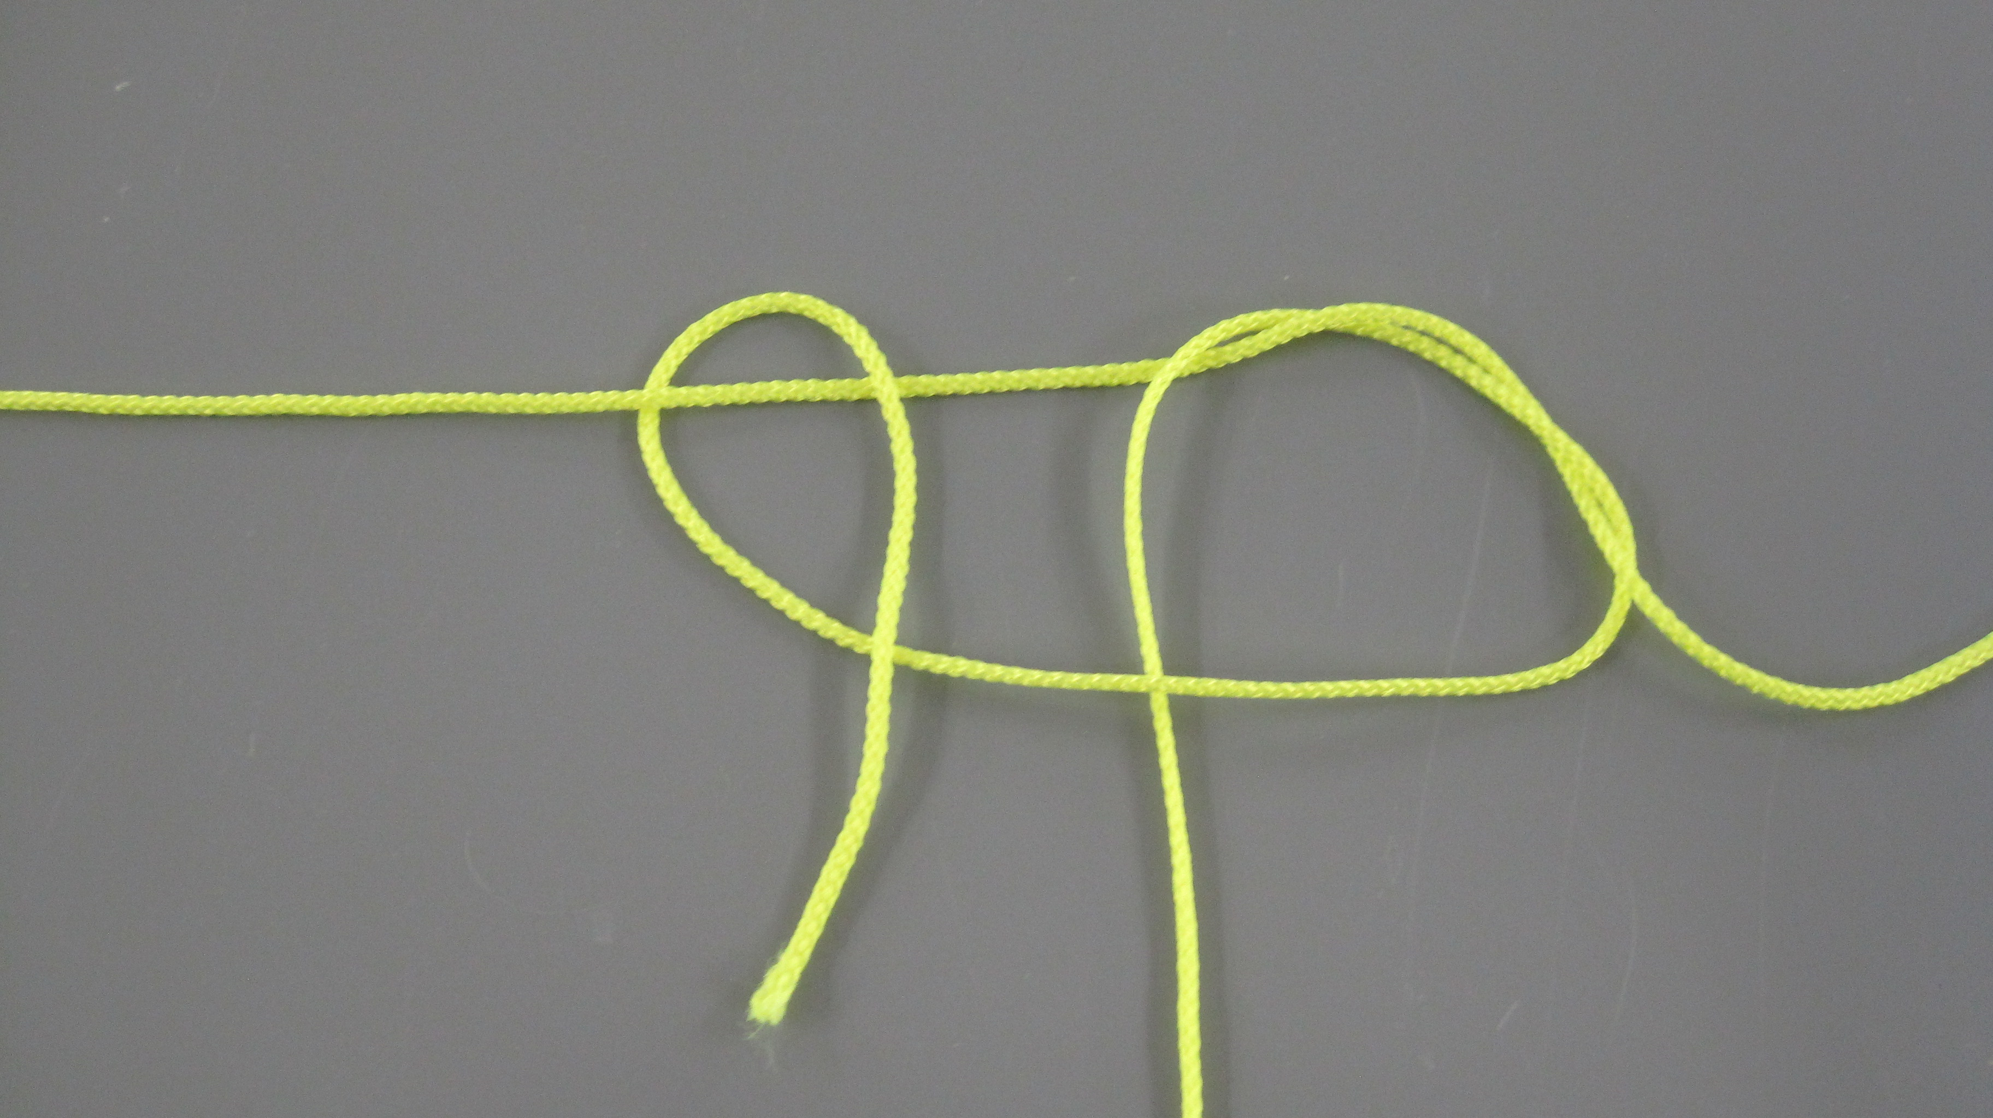

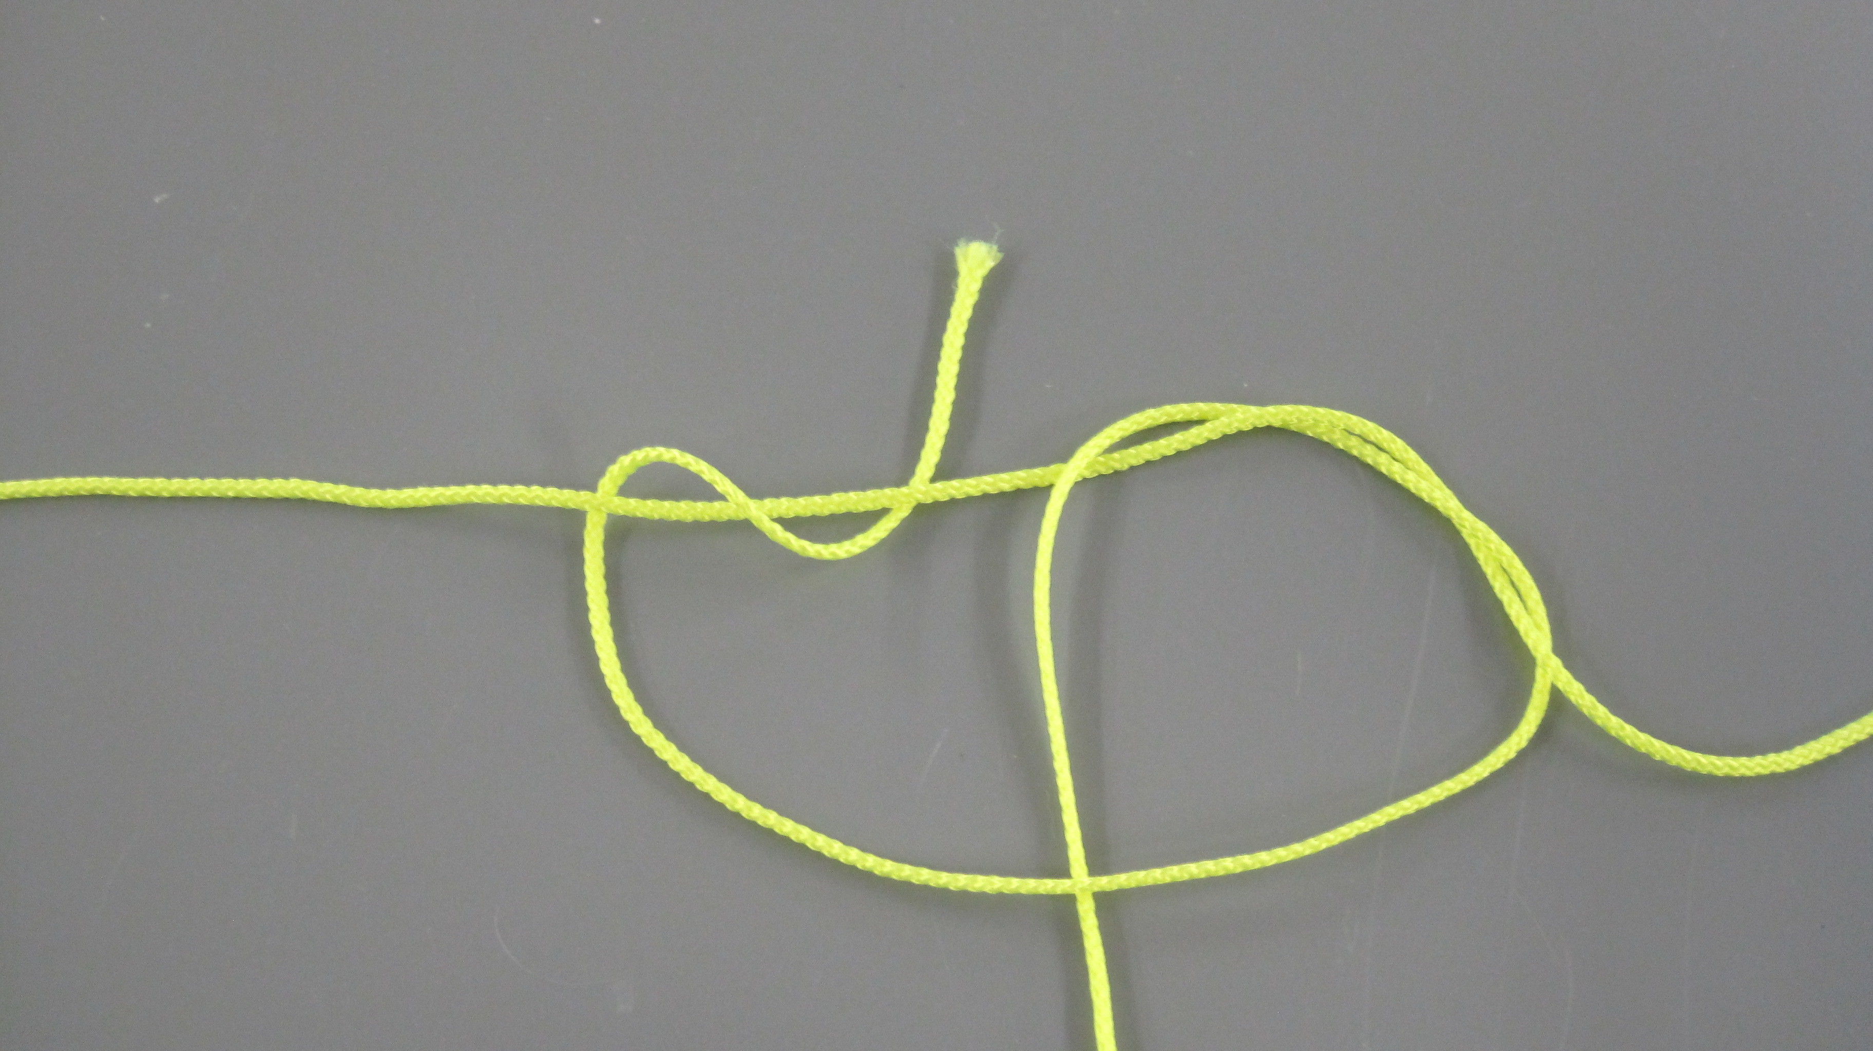
STEP 8: then under,

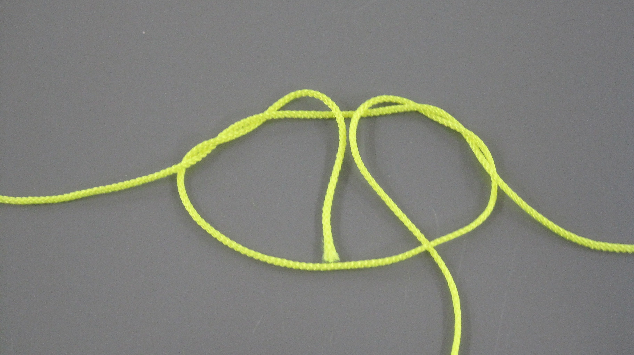
STEP 9: and finally over the bridle.

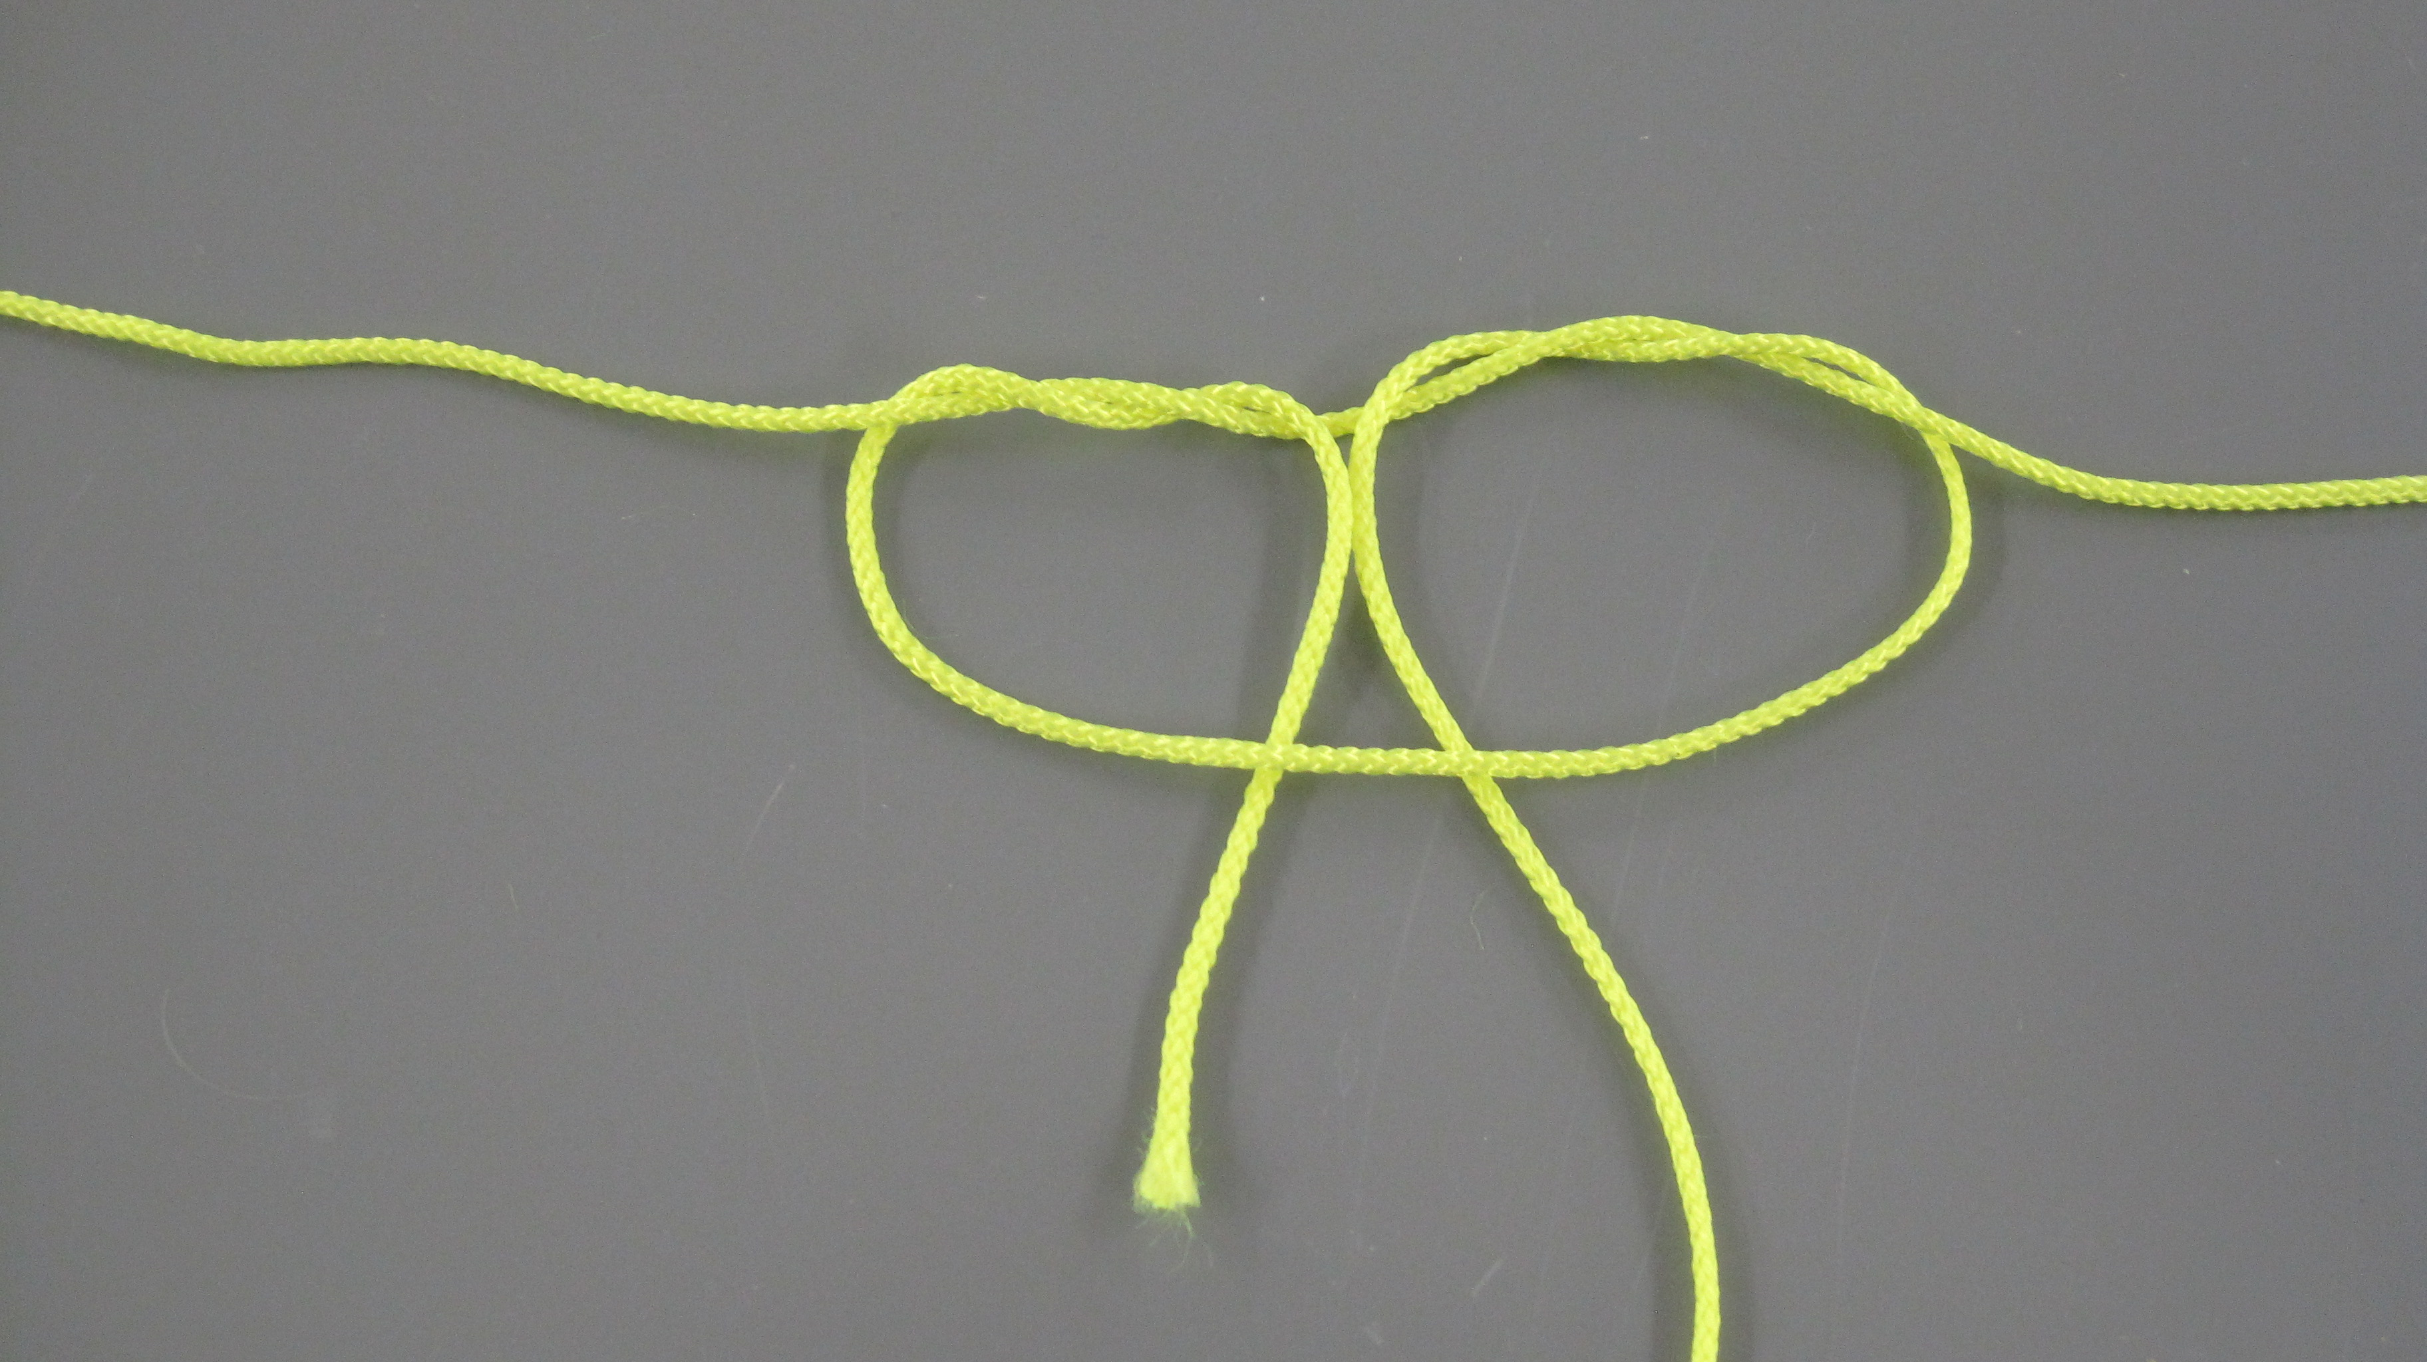
STEP 10: Pull the end through and under the hanging loop.

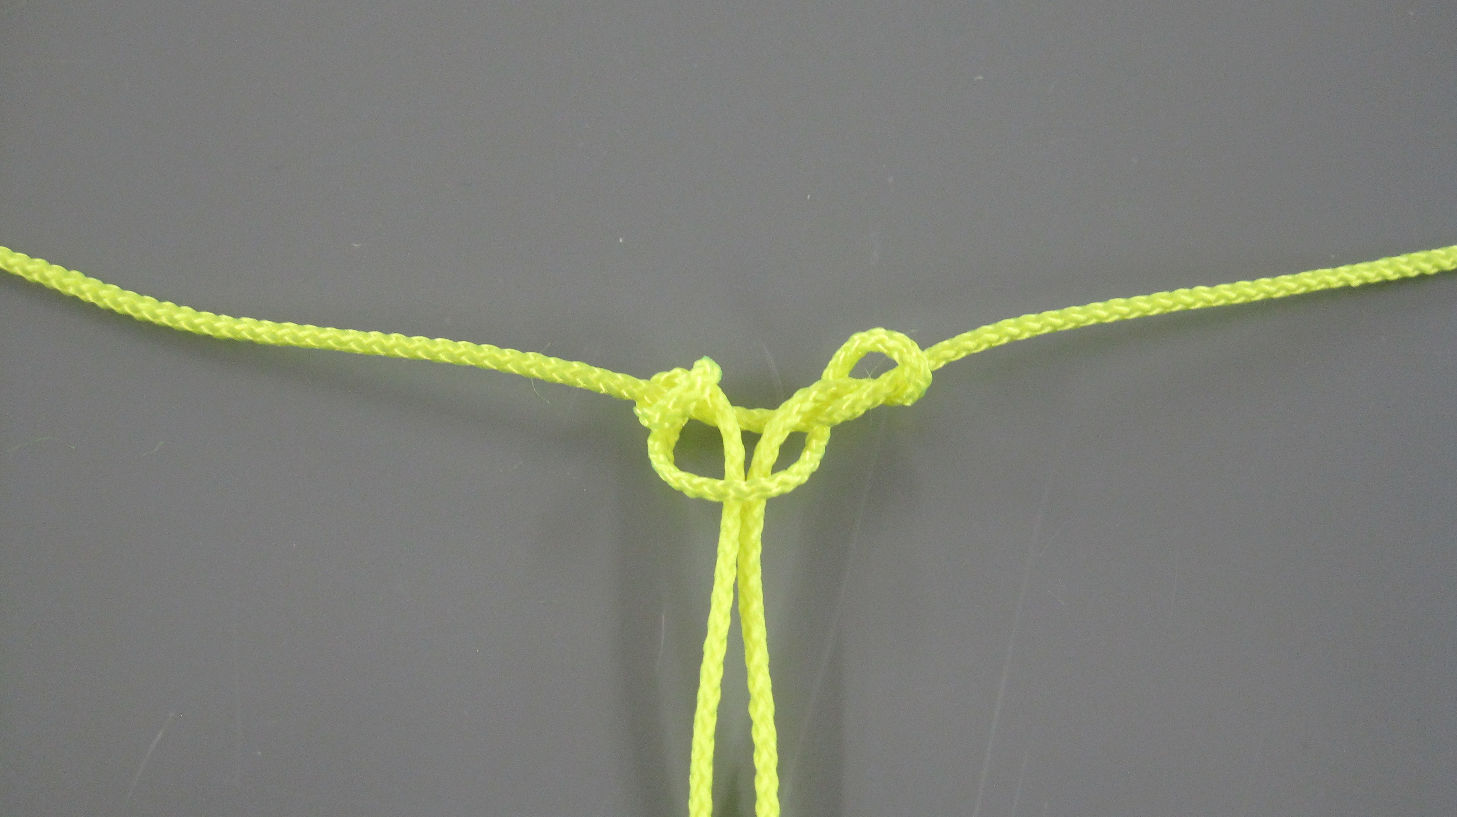
STEP 11: Tighten the knot by holding the ends of the flying line, and pulling.

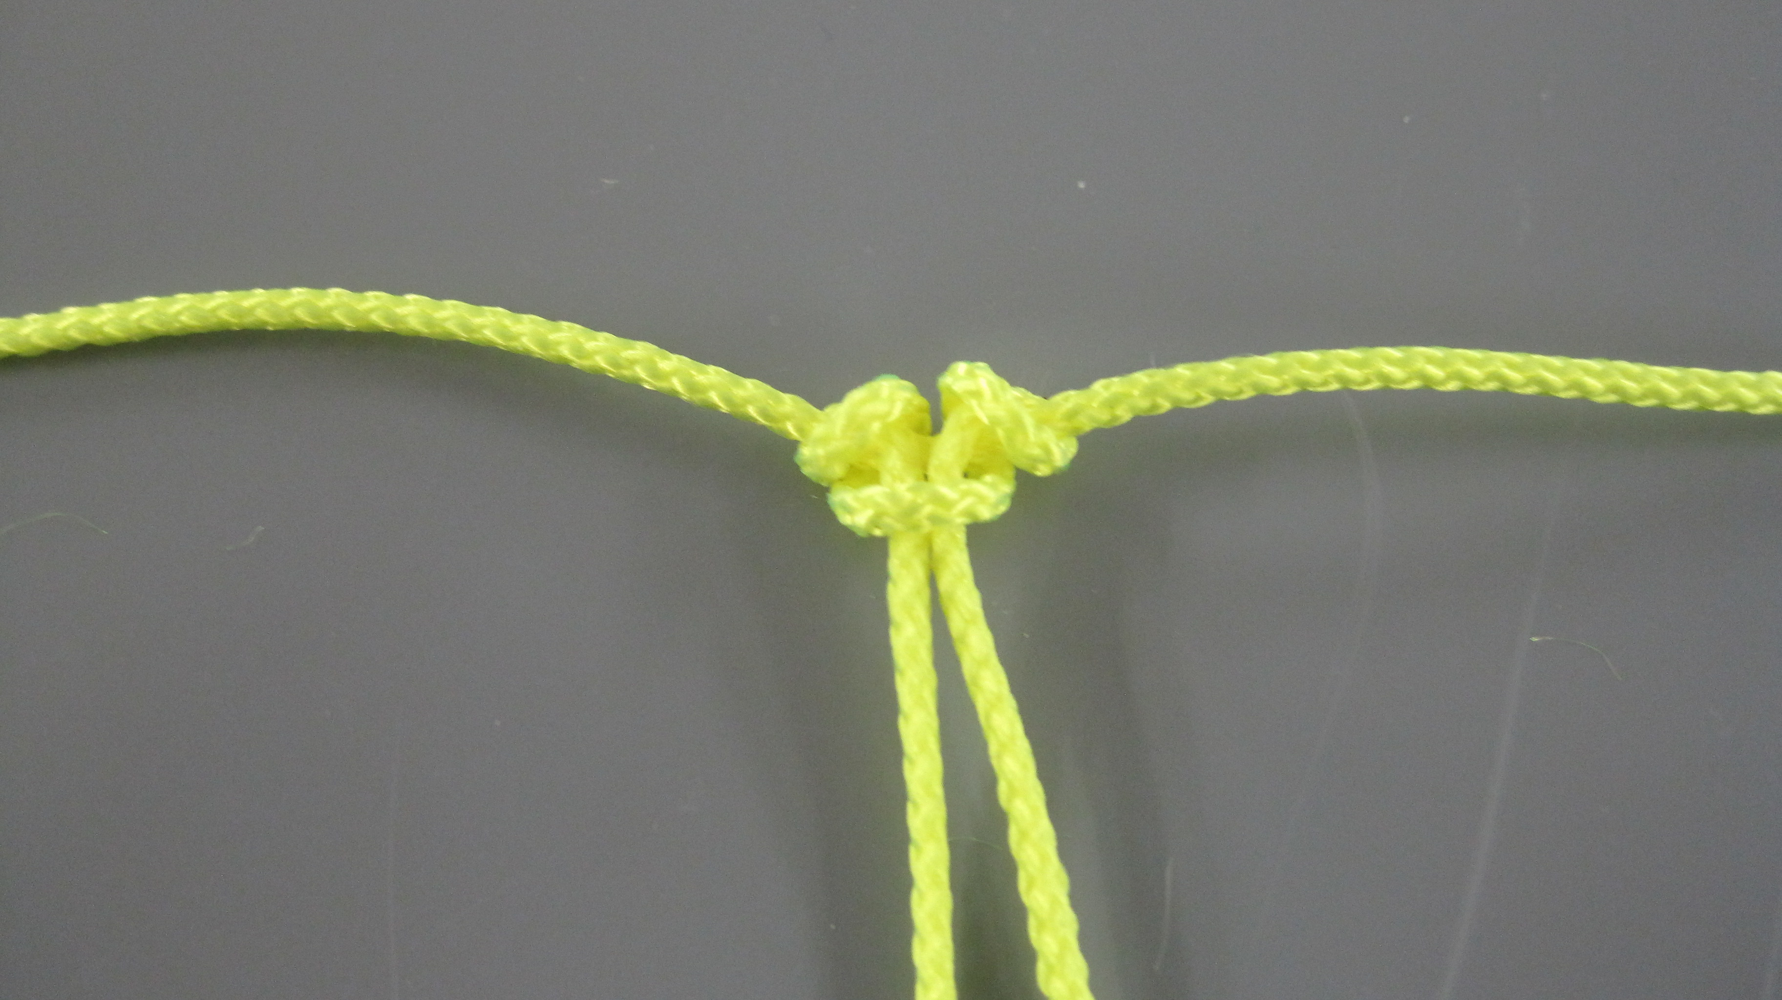
STEP12: When the knot is tight it can still slide along the bridle line for any necessary adjustments.
Loosen it if necessary by pulling the ends of the (vertical) flying line apart.

