How PC Fans Work
From: http://pcbheaven.com/wikipages/How_PC_Fans_Work/

The vast majority of PCs has at least one of them. They carry the heavy load to keep your PC cool and functional, either by providing fresh air in the box, or by forcing the hot air to leave a hot surface by pushing cool air. Read the following article to learn how the BLDC PC Fans operates...
What is inside a PC fan?

There are may types of PC fans that are assembled in different ways. In this article, i will explain the basic and most common fan type. The fan that i study is a 3-wire 4 coils 80mm fan rotating at 2200 rpm. Then i will explain some other common fans.
First of all i had to disassemble the fan. I am not the right person to disassemble something for the first time due to lack of patience. During the disassembling, i broke some parts of the housing and a fin. Still i did not find any way of easy disassembling. I suppose that the fan i chosen (and maybe many others) are NOT to be disassembled and re-assembled. Anyway, let's see what's inside a PC fan:

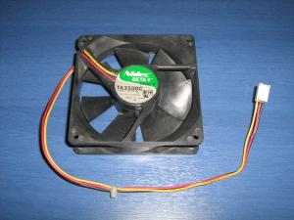 | 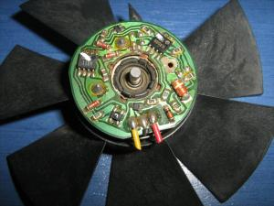 | 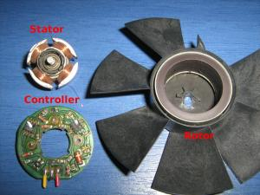
A victim in the name of science | Removing the fins from the housing, the controller is revealed | The rotor, the stator and the controller

It is more than obvious that the PC fan is not rotated from a simple DC motor. It has the permanent magnets fixed on the rotor, the stator carries the coils, there are no brushes, it has a controller... the sun is shining... it is of course a brushless motor. I have written a detailed theory about brushless motors. You can find it in the "Theory of operation of brushless motors" page.
Some different PC fan types

As long as the motor is concerned, i suppose that all PC fans use brushless motors. There are several reasons that a brushless motor should be used, among them is the reliability, the power efficiency and the rpm feedback. So the motor type would not be the proper way to categorize PC fans. Instead, i will categorize them with the most obvious characteristic: their connector.
There are actually 3 different types of PC fans. Those with a 2-pin connector, those with a 3-pin connector and those with a 4-pin connector. Let's see them one by one:
2-wire PC Fans

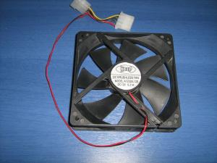
A 2-wire PC fan
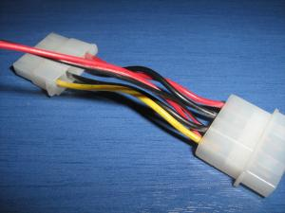
These fans have usually a male-female molex 4-pins connector from where their power supply is drawn.
These are the oldest and most simple PC fans. Only two wires comes out out of the fan controller, the positive and the negative. Giving power to the fan, it will rotate at full speed. The internal diagram of a typical two-wire fan is as follows:
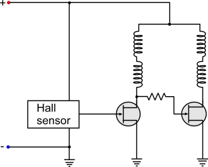
The connector of a 2-wire fan has a red and a black cable. The red cable goes to the positive of the power supply and the black to the negative. Usually, for more flexibility, they have a male-female 4-wire molex power connector. In one end of the connector the fan is connected in parallel with the 12V (YELLOW - BLACK). Therefore, the fan is powered normally and the cable of the PSU can be used to power another device.
3-wire PC Fans

A 3-wire PC fan
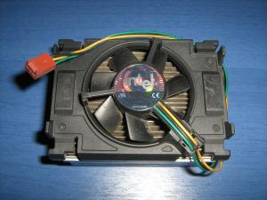
Yet another 3-wire PC fan with different wire colors
A very common type of PC fan. These fans introduced the "tacho" for the first time. The first two wires are the power supply of the fan. The third wire, comes directly from the output of the Hall sensor. This output generates 2 pulses per one revolution of a fan. The fan is then connected to the motherboard. From the third wire, the motherboard can "read" the tacho of the fan and see if the fan is running and with how many RPMs! It is a great innovation! If the motherboard sees no pulses or very low rpm, then the characteristic buzzer sounds to inform the operator that something is not ok. The internal diagram of a typical three-wire fan is as follows:
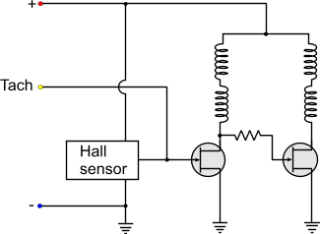
It seems that for once more, the manufacturers did not have the same wire provider, or their wire providers did not have the same colored-plastic provider... Two fans with 3-wire connectors may not have the same wire colors. Thus, instead of using the colors to distinguish the function, better go with the connector that is standard. No matter what color the cable has, it will be plugged in the same motherboard connector! So,as you look from the key-side of the connector, number 1 is the most left pin
:
- 1: Negative power supply
- 2: Positive power supply
- 3: Tacho

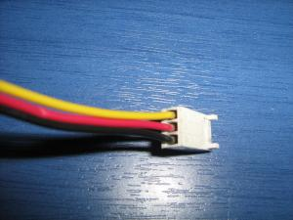 | 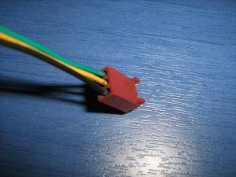
BLACK: Negative  RED: Positive  YELLOW: Tacho | BLACK: Negative  YELLOW: Positive  GREEN: Tacho
4-wire PC Fan

This is the most modern type of PC fan. This fan is designed to be controlled with a PWM signal and increase or decrease its RPM. All fans actually can be controlled with PWM, but this particular type can also provide tacho feedback simultaneously, something that the 3-wire fan cannot do -under normal circumstances. The 3-wire fan powers the Hall sensor and the controller from the same line that the coils are powered. Thus, if someone tries to send PWM pulses to the coils of a 3-wire fan, the same pulses will arrive at the controller. The controller will then malfunction, because it needs constant current to operate. As a result, the third wire will not provide correct readings.
Unlike the 3-wire fans, the 4-wire fans have a slight change that eliminates this problem. The controller and the Hall sensor are always powered with constant current. A transistor (fet) is placed before the coils. The base of the transistor is actually the fourth wire. So, the PWM pulses are driving the transistor. The coils receive these pulses through the transistor, but the controller along with the Hall sensor are not affected at all. This change can be seen in the internal diagram of a typical 4-wire fan:
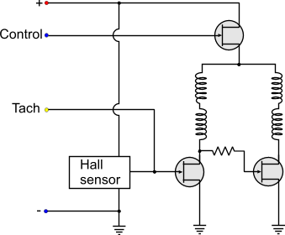
Usually, the diagram is more complicated than this. This is to give you an idea about the principle of operation of the PC PWM Fans (as used to be called). The controller actually checks the PWM input pulses and sends pulses to the transistor accordingly. If the PWM Duty cycle is bellow a threshold value, then the fan either shuts down, or it remains in a stable 'LOW" rpm. There are also fans that even with 0% duty cycle, they keep on running at this 'LOW' speed. This is usually done in critical applications that even if the external controller fails to operate, the internal fan controller will bypass the signal and will keep the fan running.
As for the pinout... Just do not trust the colors. As you look from the key-side of the connector, number 1 is the most left:

- 1: Negative power supply
- 2: Positive power supply
- 3: Tacho
- 4: PWM control

BLACK: Negative  YELLOW: Positive  GREEN: Tacho  BLUE: PWM Control | BLACK: Negative  RED: Positive  YELLOW: Tacho  BLUE: PWM Control
Can I connect a 3-wire fan to a 4-wire connector?

Yes you can. If you notice the pinout of the fans, the 3 first pins are the same for the 3 and 4 wire fans. Also, the keys are the same for both connectors. The 4-wire connector has smaller back-key to accept the smaller 3-wire fan connector keys. The fan will always run at full speed (as the control pin will not be used), but the rpm feedback (tacho) of the fan will operate normally and the motherboard will read the rpm normally.
Can I connect a 4-wire fan to a 3-wire connector?

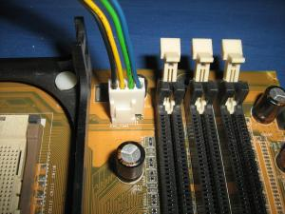
A 4-wire fan connected to a 3-wire connector. No problem!
Yes (and no) and Yes. Although the connector is larger, the keys of the 4-wire fan have the same distance as the 3-wire connector. The fan will operate at full speed all the time, as the 4th wire from the PWM control will be on air. The motherboard will normally read the rpm feedback from the fan tacho.
Now, i am not quite sure about the internal connectivity of the 4-wire fans. No matter how may fans i tested, and no matter how many sites i visited, i found no clue that this configuration will fail. This means that the PWM control line must have an internal pull-up resistor, so that when the pin is unconnected, the control FET will be kept always ON. There could be a manufacturer though that maybe felt like making something different, and either he removed this resistor or replaced the FET with different channel than normal. I do not know why anyone would do this! But i have not find anywhere a norm that declares if the fan MUST operate or not with the 4th wire unconnected. A site-reader sent me a link from Intel (click) which definitely shows that a 4-wire fan can be connected to a 3-pin connector, so i suppose that this is the norm i was looking for. Thanks a lot Mysteron347.
Anyway, what you only have to do is to test it. Either plug it in and see what happens, or give power yourself to the first 2 pins (negative and positive). If it rotates, then no problem!

