The Edge CNC Induction
Activity 1 - Key Safety Tips for Fabrication Lab
Draw a line to the safety tip with its explanation
Wear the right safety gear | It’s there for your protection
Clean up as you go | Accidents happen in untidy places
Correctly use the right tool for the job | Most injuries come from misusing tools
Always wear appropriate covered footwear | They protect your feet and prevent slipping
No kids under 12. Sorry | There is hazardous equipment and substances used in the Fabrication Lab
Ask questions if you have any doubts | It’s easy to ask and you could prevent an injury

Activity 2
Identify CNC components
- Vacuum bed
- Travelling Steel Gantry contains x axis
- Machine Head contains y and z axis
- NOT APPLICABLE
- Location of cutting spindles
- Operators Console
- NOT APPLICABLE
- Inverter enclosure- High Voltage
- A2MC Controller Enclosure-High Voltage
- Air Filter
- Power Box Master ON/OFF- High Voltage
- Machine Frame
- NOT APPLICABLE
- Air Supply for Vacuum pressure gauges
- Not applicable
- Emergency stop

Activity 3
Name these parts to check before starting
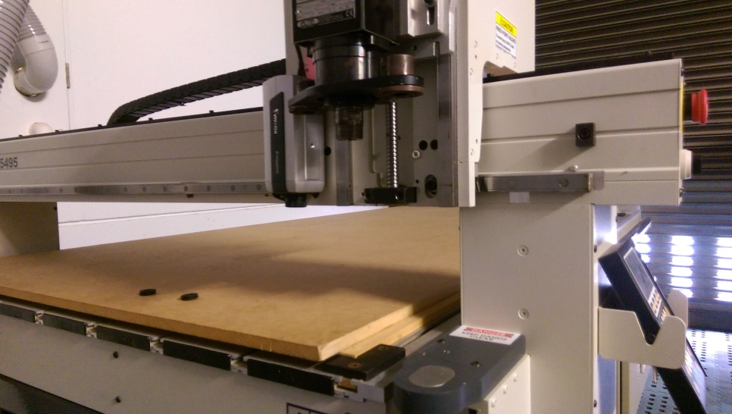

1-Threaded Spindle- check spindle for corrosion/rust and clean with steel wool
2-Waste board- check over waste board for flatness . Use scour pad to clean
3-x and y axis Gantry rails- check for dust and debris
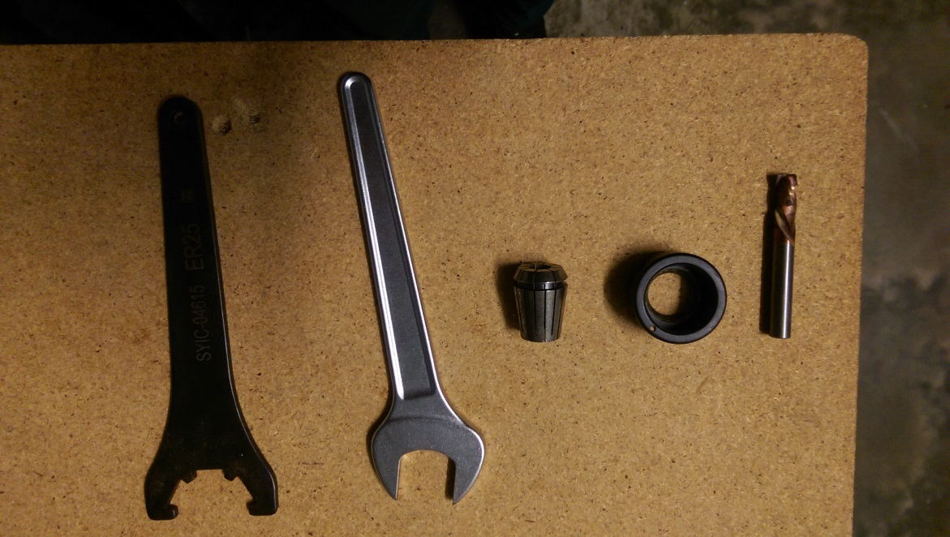

1-Collet wrenches | 2-Collet | 3-Collet Nut | 4-Routing Bit

Activity 4
We’ve identified the key stages in the CNC process. Each stage is listed below. Put each step in the correct order, by placing a number in the corresponding circle.
Preparing Your design
1. Design your model in and save as .dxf(can also import .ai and some CAD file types)
2. Import to Enroute
3.Set up orientation and Create a tool path
4 Send file to output and save
5 Open Multicam app manager and send file to machine

Preparing the CNC

- Remove waste board
- Turn on compressor to blow away dust
- Turn on CNC machine to run through its startup checks
- Open file on the CNC control
- Install and qualify required tool
- Load material onto bed and clamp accordingly(Vacuum, screw)
- Turn on dust extractor
- Press Start and observe until cutting is complete

Safety
Do’s and Don’ts when using CNC
Place these safety tips in the appropriate column
Do | Don’ts
Check tooling before use | Lean on Machine when its operating
Wear PPE when operating | Leave machine unattended
Check over your tool paths of your design before  cutting | Overtighten tooling
 | Lift material by yourself

