- ways to start a fire :Techniques

Fire plough

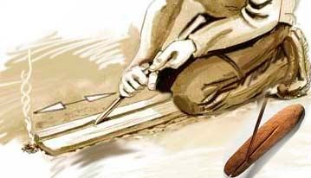

Pump drill[edit]
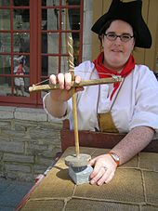
A pump drill
A pump drill is a simple tool used to make holes in light materials by hand and has been in use for centuries. The drill itself is composed of: the drill shaft, a narrow board with a hole through the center, a weight (usually a heavy disc) acting as a flywheel, and a length of cord. The weight is attached near the bottom of the shaft and the hole board is slipped over the top. The cordage is run through a hole near the top of the shaft and affixed to either end of the hole board so that it hangs just above the weight. The end of the shaft usually has a square hole made to fit certain sized auger bits or a simple triangular bit made to cut while rotating in both directions.^{[citation needed]}
To use, one hand is placed on the hole board while the other turns the shaft to wind the cord around its length, thus raising the hole board to near the top where the cord becomes taut. Placing the tip against the material to be drilled and held upright, a smooth downward pressure is exerted on the board, causing the drill to rapidly spin. Once the bottom is reached, the weight is relieved and the drill allowed to rebound re-winding the cord around the shaft and the process is repeated. It is a skill simple in concept, but takes some practice to master and greatly speeds up the process of making small holes.^{[original research?]}

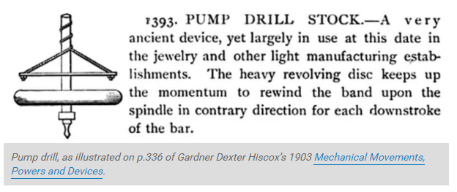

Hand drill[edit]
This section needs expansion. You can help by adding to it. (December 2012)
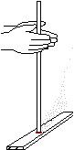
A hand drill with a hearthboard.
The hand drill is a similar tool, but uses a longer, thinner spindle; and instead of a bearing block and bow combination, the downward pressure and spinning is achieved by rubbing the hands together around the spindle.^{[citation needed]} As the hands move downward to the base, where the drill is pinched and the hands are brought quickly to the top one at a time. This can be made unnecessary by cutting a nock at the top of the drill, tying a cord through this, and then putting your thumbs through loops in the cord. However, skilled operators can either maintain pressure with their hands almost stationary vertically; or, in a movement comparable to floating, can "float" their hands back to the top of the drill. There is a more limited choice of materials to use with this method, needing much softer materials, such as mullein, yucca, cattail, and root wood.^{[original research?]}

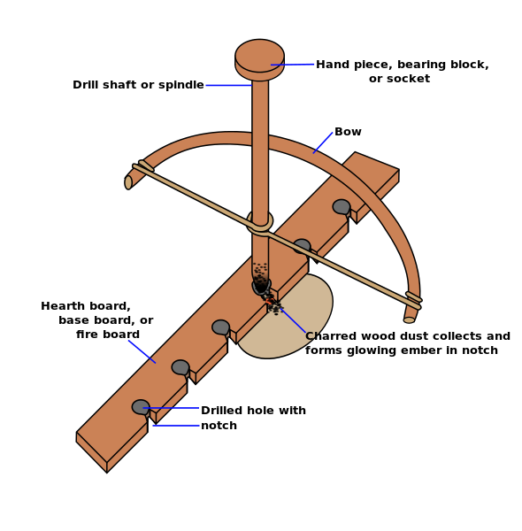
The drill offers an ancient method of starting fire without matches or a lighter, a method that applies friction to generate heat. The heat eventually produces an ember in the burnt sawdust. The ember is tiny, smaller than the head of a cigarette, and fragile. Once the ember is formed it is carefully placed into a "tinder bundle" (a bird's type nest of stringy, fluffy, and combustible material). Once the ember is in the tinder bundle it is then carefully nurtured and coaxed into flame. Once the tinder bundle bursts into flame, it is placed into the fuel that has been assembled ready for ignition.
The spindle, carved to reduce friction at one end and maximize it at the other, is held in a hole in the bottom of the bearing block, and at the other by the base board (which also is known variously as the hearth, hearth board, or fireboard). The string of the bow is wrapped once around it, so that it is tight enough not to slip during operation. A variation on this is called the "Egyptian Bow Drill", which attaches the string by wrapping it around multiple times, or actually tying it to the drill or through a hole through the drill shaft, then wrapping it.
The usual position that a person assumes whilst operating the bow drill is as follows: the right knee is placed on the ground (assuming a right-handed operator) and the arch of the left foot is on the board, pinning it in place. The left wrist, holding the handhold, is hooked around the left shin and locked in place to keep it steady so it can generate enough downward pressure and speed; achieved by pushing down with the handhold and spinning the drill. The heat of the friction between the hearth and the spindle both creates charred, fuzzy dust and causes it to ignite - forming a coal or ember. The handhold is lubricated and the spindle is carved to about thumb thickness, usually 6 to 8 inches (150 to 200 mm) long. Another option to practice is to make the "handhold" into a "mouth-hold" piece, so it's held down by pressure from the chin/mouth, leaving both hands free.
An indentation and a "v" notch into the center of the dent is made into the fireboard and the spindle is placed on it. The notch allows a place for the dust collect while it is being abraded off the spindle and the hearth. Eventually, the friction generates heat to ignite the dust, which can be used to light tinder.
Whilst a "v" is most common, other methods to create a cavity to contain the dust whilst it is being ignited can be used. For example, drilling part-way into a hearth made by lashing two sticks together from one side, and then drilling from the other side to meet this hole; or using the area where two branches separate. This is to keep the coal off wet or snow-covered ground.^{[citation needed]}
The hearth and spindle can both be constructed from any medium-soft, dry, non-resinous wood, and work best when both are made from the same piece of wood; however, with practice almost any wood combination can be used provided the parts contain little or no resin or moisture. The most important factor is whether the wood is dry enough to ignite, as wet wood will not work; yucca, aspen, white cedar, basswood, buckeye and most willows all work very well. Combinations such as hazel and poplar also work well. The bow should be stiff but slightly limber and around the distance from the users armpit to their fingertips. The bearing block (handhold) can be made of anything that is harder than the spindle. Bone, antler, shell and stone work best, as they can be easily greased, do not create as much friction, and do not burn; however, hard woods such as maple and tulip and red cedar are quite serviceable and often easier to find and work. Some effective materials used to grease the bearing block include sebum, animal and plant oils, or even moist vegetation.^{[original research?]}

Fire piston
A fire piston consists of a hollow cylinder ranging in length from about 3 to 6 inches (7.5 to 15 cm), having a bore about 0.25 inch (6-7mm) in diameter, sealed at one end and open at the other. A piston with an airtight circular seal is fitted into the cylinder. The piston has a handle on the end to allow a firm grip to be applied to it, or a large enough surface area to strike it sharply without causing pain while the cylinder is braced against a hard surface, and it can be completely withdrawn from the cylinder. The piston generally has a notch or recess on or in its face, into which a piece of tinder is placed.
The compression of the air when the piston is quickly rammed into the cylinder causes the interior temperature to rise sharply to 500 °F (260 °C)^{[citation needed]}. This is hot enough for the tinder on or in the piston face to ignite with a visible flash that can be seen if the cylinder is made of translucent or transparent material. The piston is then quickly withdrawn, before the now-burning tinder depletes the available oxygen inside the cylinder. The smouldering tinder can then be removed from the face of the piston and transferred to a larger nest of fine tinder material. The ember is then fanned or blown upon vigorously to create a flame, at which time various stages of larger kindling can be added until built into a proper fire.
Ancient and modern versions of fire pistons have been made from wood, animal horns, antlers, bamboo, or lead. Other metals have also been used in modern versions.
Fire pistons have a compression ratio of about 25 to 1. This compares with about 20:1 for a modern diesel engine and 7:1 - 11.5:1 for a gasoline engine. The fire piston is made deliberately narrow so that the force on the piston is not so great as to make it impossible for unaided human strength to compress the air in the cylinder to its fullest extent. To achieve the compression ratio, the final compressed volume of the tinder and air must be small relative to that of the length of the piston tube. These two factors together mean that only a tiny amount of tinder can be lit by a fire piston, but this is sufficient to light other tinder, and then to light a larger fire.
Easily combustible materials such as char cloth or amadou work well as tinder in the fire piston. The tinders that work best in the fire piston combust at a very low temperature. Cotton fibres for example combust at 455 °F (235 °C) and will light in fire pistons.

Firepiston
How does it work?
Air gets very hot when it is compressed under high pressure. A classic example would be the heat that is created when one uses a bicycle pump. But when the air is compressed in a firepiston it is done so quickly and efficiently that it can reach a temperature in excess of 800 degrees Fahrenheit. This is hot enough to ignite the tinder that is placed in the end of the piston which has been hollowed out to accept it.
Ancient examples of the tube itself are of hardwood, bamboo, or even horn. It is closed on one end, very smooth inside and accurately bored. Equal care is taken in the creation of the associated piston. A "gasket" of wound thread, fiber, or sometimes leather insures a proper seal for successfully creating the compression. This gasket is "greased" to help with the seal and to allow free travel of the piston. The walls of the bore must be perfectly straight and polished smooth.
Fire piston
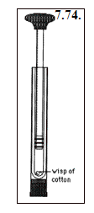
http://www.brynmawr.edu/chemistry/Chem/sburgmay/chem104/7genProbs.htm#_msocom_2
Tinder:

Amadou
Amadou is a spongy material derived from Fomes fomentarius fungi that grow on the bark of coniferous and angiosperm trees, and have the appearance of a horse's hoof (thus the name "horse fungus"). It is also known as the "tinder fungus" and is useful for starting slow-burning fires. The fungus must be removed from the tree, the hard outer layer scraped off, and then thin strips of the inner spongy layer cut for use as tinder.
Amadou was a precious resource to ancient people, allowing them to start a fire by catching sparks from flint struck against iron pyrites. Remarkable evidence for this is provided by the discovery of the 5,000-year-old remains of "Ötzi the Iceman", who carried it on a cross-alpine excursion before his death and subsequent ice-entombment.^{[1]} Amadou has great water-absorbing abilities. It is used in fly fishing for drying out dry flies that have become wet.^{[2][3]} Another use is for forming a felt-like fabric used in the making of hats and other items.^{[4][5]}
Before such uses, amadou needs to be prepared by being pounded flat, and boiled or soaked in a solution of nitre (potassium nitrate). One method of preparation starts by soaking a slice in washing soda for a week, beating it gently from time to time. After that it has to be dried; when dry it is initially hard and has to be pounded with a blunt object to soften it up and flatten it out.^{[3]}

Char cloth
Char cloth (or charcloth) – also called charpaper – is a swatch of fabric made from vegetable fiber (such as linen, cotton or jute) that has been converted via pyrolysis into a slow-burning fuel of very low ignition temperature. It can be ignited by a single spark that can in turn be used to ignite a tinder bundle to start a fire.^{[1][2]} It is sometimes manufactured at home for use as the initial tinder when cooking or camping and historically usually provided the "tinder" component of a tinderbox. It is often made by putting cloth into an almost airtight tin with a small hole in it, and cooking it in campfire coals until the smoking slows and the cloth is properly charred.
Char cloth ignites with even the smallest spark, and is therefore commonly used with a flint and steel.

Oakum is made from jute fibers, the same stuff gunnysacks are made of. It is normally pounded into the seams of a wooden boat as sort of a primitive caulking. A little bit of oakum is easily fluffed into a small nest, which can accept your char cloth once it carries a spark. It’s available on-line in many places; a pound will cost you about $7.00 and will last years.

Making char cloth:

First, I cut up an old black 100% cotton tee shirt. The squares were roughly 2" square, but I didn't take time to measure accurately. I initially cut up about 100 of them, but only used about 50. I needed to test two different sized cans so I used an old peach can for one test batch, and an old tuna fish can for the second. In the photo you can see that I divided up my batch of cotton squares onto the 2 aluminum foil pieces that will cover the lids. The batch of extra squares (I didn't use) are behind the 2 cans. I packed them into the cans loosely. That is, I didn't "jam" them down in. I dropped them in, and where they hit was where they stayed. I should have used a white tee shirt for this test. I couldn't tell if they turned black (like they're supposed to) since they started out black in color. I found out later...
I used two cans (cleaned, of course) and covered them both with heavy duty aluminum foil. Use a sharp pin and punch ONE hole in the top of the aluminum foil. You don't need to use different sized cans. I did just for this test.
I took the grate off of the grill and set the cans into the still very hot charcoal briquettes. You can pile the half-burned briquettes around the cans if you want. The whole idea is to get the cans very hot, very fast.
I left the cans on for about 6 minutes. Yes, you can see the smoke escape, both from the pin hole, and the aluminum foil that evidentially was not sealed perfectly tight.
The smoke from the charring cotton is flammable. Another test as to when it is ready to come off the coals is to light the smoke...yes, it burns. When it stops burning, it is ready to come off.
I ate a hurried dinner (or at least part of it) while I waited...checking it twice during the 6 minutes. The smoke did stop at 6 minutes. Interestingly, both cans stopped smoking at the exact same time. If in doubt, leave it for 10 minutes, but no more. Using the tongs shown, I carefully removed the two cans from the charcoal and set them off to the side. I left them there until I went back inside and finished my dinner.
About 15 minutes later, I checked the cans and found the tops cool enough to handle without tools.
It was dark outside by the time I finished, so I brought the two cans inside and set them on two hot pads. I removed the aluminum foil and found that, at least as far as I could see, there was little or no change...but there was. The (black) cotton was still black, but the texture had changed, and now felt more like satin than cotton. You could still make out the texture of each thread, only now it was charcoal, not cotton. It was REALLY COOL.
took one piece out at first, put it into an ashtray, and lit it. It started to burn, but slowly, and without flame. When I blew on it, instead of going out, it got hotter. I know that if I had a bunch of tinder on top of this thing it would have caught fire and flamed up.
I then added two or three more pieces, and they lit off the already burning piece of char cloth, even through there still was no flame. Then, like a dummy, I picked up the glass ashtray with my hand, and found it was VERY HOT.
My test pieces (3 in all, now) burned for about 3 to 4 minutes, even with me blowing on them intermittently. I found that even if I did not blow on the char cloth, it kept burning slowly from one side of the cloth to the other. There was virtually no smell. It only took a small spark to light off the Char Cloth. It held the fire for a short period of time that would have allowed me to add more dry tinder and make the fire larger. I am really pleased with the ease of making this "free" fire starter. This would be great stuff to use with flint and steel or a friction-type fire bow.

Fire striker
A fire striker (or fire steel) is a piece of carbon steel from which sparks are struck by the sharp edge of flint, chert or similar rock
Besides using flint with the steel, many other hard, non-porous rocks can be used, that can take a sharp edge, such as chert, jasper or chalcedony.^{[2]}
The sharp edge of the flint is used to strike the fire steel at an acute angle. With practice, small pieces of steel are shaved off the fire steel. The friction of shaving the steel off the fire steel and the pyrophoricity of the steel heats the pieces to a molten state.

Rock Striker
An ideal tool for starting a spark-based fire, the striker should be made of flint for best results. If you can't find flint, look for quartzite, which is much more common and is hard enough to strike sparks from steel.
Step One Identify quartzite by the many crescent-shaped fractures on the surface.
Step Two Choose a quartzite boulder that is flat or discus-shaped and drop it against a larger rock to chip off an edge. Round or oval rocks are more difficult to break.
Step Three A flake broken from the quartzite boulder is usually sharp enough to use as a striker or knife. If you can't find one to your liking, break the boulder again.
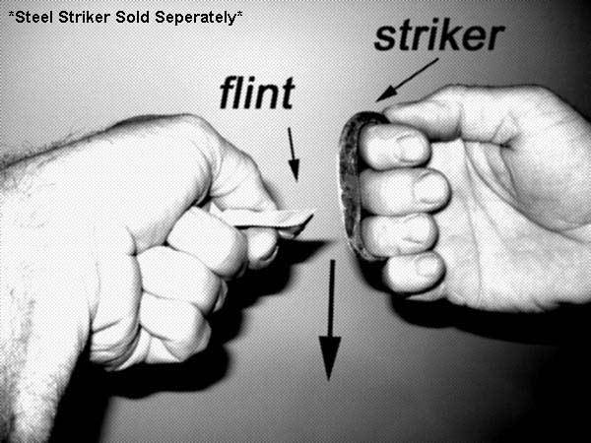
http://www.goknapping.com/

Fire Plough

.

Fire Plough
This produces its own tinder by pushing out particles of wood ahead of the friction. Step One Cut a groove in the softwood fireboard, then plough or rub the tip of a slightly harder shaft up and down the groove. The friction will push out dusty particles of the fireboard, which will ignite as the temperature increases

Polished aluminium can reflector

Ok, let's get to it...
The can....
The key to this is the bottom of the coke can (by the way, any pop can will do), which is ideal for reflecting and concentrating the sun's light and energy.
Here is a photo of a coke can bottom. Note that it has a slightly dull finish. In its present condition it is not shiny enough to concentrate the sun's rays enough to ignite tinder.
That's where the chocolate bar comes in ....

The chocolate bar....
The can bottom is not shiny enough to function as a good reflector and concentrator of sunlight. It needs polishing. The chocolate does an excellent job of this. So, simply break off a piece of chocolate and use it to polish up the can bottom!
P.S. Any type of chocolate will do. Probably the purer it is, the better. In that case, maybe a Toblerone bar isn't so great, as it has nuts and honey in it.

This is a close-up of the surface of an un-polished can's bottom. Note the fine straight lines in the aluminum.
These fine lines on the unpolished can are actually the grain of the aluminum roll stock from which the can is made, indicating a small degree of surface roughness which limits the can's reflectivity. These scatter the sun's rays, and prevent them from being focused together into a single bright point.
This is why the can needs polishing.
Compare this to the picture below of a polished can bottom.

Here is a close-up of a polished can bottom.
Compare this to the picture above of an un-polished can bottom. There's a big difference.
How can you tell when it's polished enough? What you are looking for is a "mirror" finish. An object placed near the bottom of the can should produce a clear (although distorted) image.

A note from A. Robinson, via email:
"DO NOT eat the chocolate after you have used it to polish the can! It will pick up aluminum from the can, which is toxic. I've done metalwork with aluminum, and you're actually supposed to handle it with gloves, since it leaves a black toxic residue on your skin. Once it has been exposed to air for a few hours, aluminum is safe to handle because it forms an oxide layer on the surface which is non-toxic. But polishing it will remove the oxide layer and expose bare metal, and the chocolate will definitely pick up some aluminum. Not a mortal danger, but not the best thing in the world to eat!"
Polishing the bottom of the can.
Note: For polishing the can, one needs to use the wrapper (or something else) in the process. Just rubbing chocolate on the bottom of the can won't do too much. The process is to smear some chocolate on the bottom, then use the wrapper (or whatever) as a "cloth" to do the polishing. Every now and then, one needs to add a bit more of the "abrasive." As a reference point, it will probably take ½-1 hour or more to finish the process.
Toothpaste also works as a good polish.
Using the chocolate bar holds to the initial challenge - but using fine steel wool, some sort of cleanser or other polishing compound gives much more rapid results. Jeweller's rouge will get the bottom of the can to a mirror finish in a few minutes. Chocolate at best would take an hour!

All polished and shiny.
Note that other polishing agents will work as well, such as toothpaste, powder cleansers, etc.

How to actually make fire...
On a sunny day (yes, you do need sunlight!), Hold a piece of suitable tinder, such as a fragment of tinder fungus, at the focal point of the can bottom -- about 1 - 1.25" away from the center of the "bowl".
One doesn't need to use tinder fungus. To keep to the core of the challenge, one can use pieces of the chocolate wrapper to get a coal. If the chocolate bar has a black paper insert, this is of course the best due to the dark colour. It takes a bit longer with the wrapper - but, as with a magnifying glass, many things can be used.

It is important to orient the bottom of the can towards the sun. If the bottom of the can is "off-axis"
from the sun, then the the light gathering will be less optimal.
To make sure that you are finding the optimal focal point, try using some black newspaper. Take a small strip, and move it towards the focal point. As you move the paper in and out, you should be able to see the light converge to a small point. At this time, the newspaper should start to smoke. Wearing sunglasses is suggested. It protects the eyes and also reduces the intensity of the light so that it is easier to identify the sharpest focus. CLICK HERE for more info and photos of how to do this.
Holding the small piece of tinder fungus is easier with a long thin stick with a small split in the end, such as is shown in this photos.
Other materials can be used as tinder.
Eye safety tip:
Stand facing away from the sun (facing your shadow) and hold the can above your head so that you are looking at the bottom of the tinder and the side of the can instead of the top of the tinder and the mirror. Move the tinder to find the brightest spot. (Thanks to Thomas for this tip)

After a very short time (only a few seconds in the bright sun), the tinder fungus will be smouldering. Then transfer it to a tinder bundle and blow it into flame (if you're using a large enough piece of tinder fungus). If you're using a very small piece, then transfer the ember to a larger piece by holding the two pieces together and blowing on them.
Alternatively, you could use a small bundle of very volatile tinder.
For more info about Tinder, click here.

http://www.wildwoodsurvival.com/survival/fire/cokeandchocolatebar/index.html

Ice lens:
http://www.wildwoodsurvival.com/survival/fire/ice/rb/rbfirefromice3a.html

Fire From Water
Text, photos, and demonstration by Rob Bicevskis
Photo and demo by Ron Bicevskis | The basic idea is to take a piece of plastic wrap (Saran or otherwise) and form it into a "pocket", i.e. bring the four corners together.  The pocket is then filled with water.  The corners are then grouped together and twisted until the whole assembly resembles a sphere. This creates a makeshift lens.  It was pretty easy to start a fire using cedar bark tinder.  Using tinder fungus would of course made things even easier.  This first picture shows the basic setup. Notice the upside-down foot in the "lens."

Photo and demo by Ron Bicevskis | Smoke...

Photo and demo by Ron Bicevskis | Another view.  Notice the magnified leg in this picture.

Photo and demo by Ron Bicevskis | Success!  Fire from Water

http://www.wildwoodsurvival.com/survival/fire/water/index.html

PVC and leather fire piston
http://www.wildwoodsurvival.com/survival/fire/firepiston/rw1/index.html

Cotton and linseed oil (takes 5 hours)
http://www.wildwoodsurvival.com/survival/fire/spontaneouscombustion/rbjul05/index.html
ELECTRICAL TECHNIQUES

- Battery and steel wool

- Static and flammable vapour

CHEMICAL TECHNIQUES
- Glycerol and permanganate

- Chlorine and brake fluid

- Linseed oil and cotton cloth (delayed)

- Super glue and cotton cloth

- Safety matches (red phosphorus potassium chlorate and sulphur)

The striking surface on modern matchboxes is typically composed of 25% powdered glass or other abrasive material, 50% red phosphorus, 5% neutralizer, 4% carbon black, and 16% binder; and the match head is typically composed of 45–55% potassium chlorate, with a little sulfur and starch, a neutralizer (ZnO or CaCO
3), 20–40% of siliceous filler, diatomite, and glue.^{[36]}

INADVISABLE TECHNIQUES
- Volcanic ignition (active lava flows)
- Nuclear ignition

