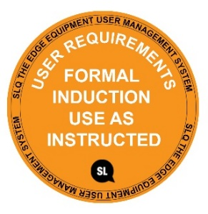
SAFE OPERATING PROCEDURE
VACUUM FORMER
DO NOT use this equipment unless the Supervisor has instructed you is it safe to use and has given you permission
Approved safety glasses must be worn at all times. | A suitable protective workshop apron is encouraged.

Appropriate protective footwear with substantial uppers must be worn.

DO NOT use faulty equipment – report this immediately to the Supervisor.

PRE-OPERATIONAL SAFETY CHECKS
- Ensure this machine has a suitable, safe work area.
- Check the general condition of the former.
- Ensure that all clamping arrangements are adequate, secure and correctly adjusted.
- Before switching on the power, ensure all controls are in their correct positions.
- Have your teacher check all adjustments i.e. heat settings and air pressures, before attempting to vacuum form an article.
- Ensure no other students are in the surrounding area.

OPERATIONAL SAFETY CHECKS
- Take particular care when vacuum forming very hot thermoplastic materials. High air pressures are also used in this forming process.
- Familiarise yourself with all machine operations and controls. If in doubt, ask for assistance.
- Always handle heated plastic material with suitable gloves.
- Keep hands clear of the plastic area to be heated.
- Take care to ensure to ensure that the heat gun is moved away from the plastics material before the vacuum forming process begins.
- Do not use the compressed air to cool down an article or to clean down the work area.
Caution – Hot equipment and plastics

HOUSEKEEPING
- Ensure all equipment is switched off and cooled down.
- Leave the work area in a safe, clean and tidy condition.

POTENTIAL HAZARDS
Hot machine parts Electricity Burns Eye injuries
This SOP does not necessarily cover all possible hazards associated with the tool and should be used in conjunction with other references. It is designed to be used as an adjunct to teaching Safety Procedures and to act as a reminder to users prior to tool use.

© State of Queensland (State Library of Queensland) 2020

This policy is licensed under a Creative Commons Attribution 3.0 Australia licence. You are free to copy, communicate and adapt this work, so long as you attribute the State Library of Queensland.

For more information see http://creativecommons.org/licenses/by/3.0/au

