SAFE OPERATING PROCEDURE
VACUUM CHAMBER
DO NOT use vacuum chamber unless the Supervisor has instructed you it is safe to use and has given you permission
Safety glasses must be worn at all times in work areas. |   Long and loose hair must be contained or restrained.
  Appropriate protective footwear with substantial uppers must be worn. | 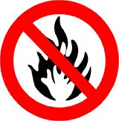  Ensure all flammable materials are safety stored away from the unit.
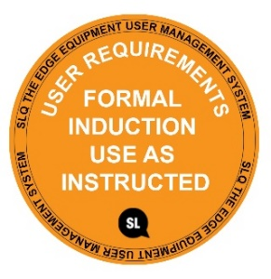
MAXAMIUM VACUUM 29 Hg

PRE-OPERATIONAL SAFETY CHECKS
- Ensure no slip/trip hazards are present in workspaces and walkways.
- Mix your materials according to the manufacturer’s directions.
- Use a container that holds at least four times the amount of material you are vacuuming to allow for the expansion of the material.
- Check the condition of all hoses and fittings. Hoses that are damaged or in poor condition should not be used.
- Faulty equipment must not be used. Immediately report suspect equipment.

OPERATIONAL SAFETY CHECKS
1. Place the material into the chamber and place the lid on top ensuring the rubber seal lines up around the edges of the chamber.
2. Close the petcock lever and switch on the vacuum pump.
3. Once your vacuum chamber reaches 29-inches of mercury (resembling foam) wait for one or two minutes.
4. When the material falls it will plateau and not rise any more. You will want to continue operating the vacuum chamber for another 2-3 minutes to make certain all of the air has been removed from your material.
5. Turn off the vacuum pump and open the petcock of your vacuum chamber to allow air inside. Once the gauge reads zero remove your material from the vacuum chamber.

HOUSEKEEPING
1. Return vacuum chamber to the correct storage location.
3. Leave the equipment and work area in a safe, clean and tidy state after job is completed.

POTENTIAL HAZARDS
Air under vacuum High noise levels
Eye injuries Flying debris

This SOP does not necessarily cover all possible hazards associated with the tool and should be used in conjunction with other references. It is designed to be used as an adjunct to teaching Safety Procedures and to act as a reminder to users prior to tool use.

© State of Queensland (State Library of Queensland) 2020

This policy is licensed under a Creative Commons Attribution 3.0 Australia licence. You are free to copy, communicate and adapt this work, so long as you attribute the State Library of Queensland.

For more information see http://creativecommons.org/licenses/by/3.0/au

