SAFE OPERATING PROCEDURE
SPRAY BOOTH
DO NOT use spray cans unless it is safe to use and a supervisor has given you permission
Safety glasses must be worn at all times in work areas. |   A suitable P2 or P3 filter mask must be worn whenever excess fumes are created.
  Appropriate protective footwear with substantial uppers must be worn. |   Protective clothing or a workshop apron is encouraged.

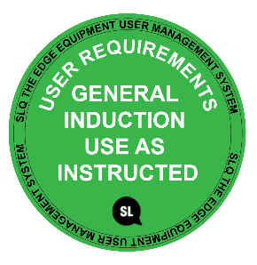
PRE-OPERATIONAL SAFETY CHECKS
- Ensure no slip/trip hazards are present in workspaces and walkways.
- Visually check that the spray booth filters are in a sound, clean condition.
- Ensure that the fume extraction unit is ON and operating efficiently.
- Faulty equipment must not be used. Immediately report suspect machinery.

OPERATIONAL SAFETY CHECKS
- Ensure the workpiece fits properly into the spray booth.
- Place the workpiece in an appropriate position where the operator always has the spray directed between themselves and the exhaust filter. Spray away from the body.
- NEVER direct a paint stream onto the body or towards others.
- ALWAYS use a compliant mask when using paints and solvents.
- Read and comprehend the safety data sheet information supplied for all paints and solvents.

HOUSEKEEPING
- Switch off the fume extraction system.
- Ensure all solvents, paints, etc. are returned to storage.
- Leave the booth and work area in a safe, clean and tidy state.

POTENTIAL HAZARDS

Hazardous chemicals Toxic fumes Fire and explosions

This SOP does not necessarily cover all possible hazards associated with the tool and should be used in conjunction with other references. It is designed to be used as an adjunct to teaching Safety Procedures and to act as a reminder to users prior to tool use.

© State of Queensland (State Library of Queensland) 2020

This policy is licensed under a Creative Commons Attribution 3.0 Australia licence. You are free to copy, communicate and adapt this work, so long as you attribute the State Library of Queensland.

For more information see http://creativecommons.org/licenses/by/3.0/au

