
[enter name of equipment]

[Choose one from below: delete other AND THIS TEXT]
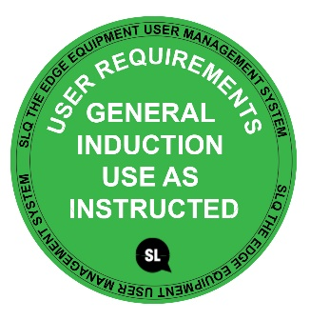 | DO NOT use this equipment unless the Supervisor has instructed you in its safe to operation and has given permission.
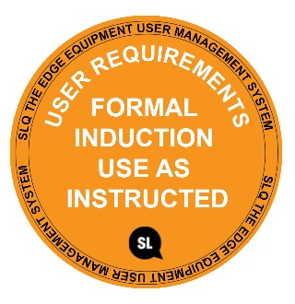 | DO NOT use this machine unless you have completed the induction and a supervisor has given you permission.
 | DO NOT use this machine unless you have completed the induction and you are under supervision.

[Delete non -appropriate icons below:]
Safety glasses must be worn at all times in work areas. |   Long and loose hair must be contained or restrained.
  Appropriate footwear with substantial uppers must be worn. |   Close fitting, protective clothing or a workshop apron is encouraged.
  Hearing protection must be worn when noise levels are excessive. |   A mask must be worn when excessive airborne dust is created.

PRE-OPERATIONAL SAFETY CHECKS [modify the information to reflect the item of equipment – refer to ‘operator manual’]
- Ensure a suitable safe work area.
- Make sure...
- Examine the power lead and plug for obvious damage.
- Check...
- Plan…

OPERATIONAL SAFETY CHECKS [modify the information to reflect the item of equipment – refer to ‘operator manual’]
- Examine the material to be used…
- Ensure the material is secure and well supported.
- Ensure the power cord is well clear of any cutting surfaces…
- Check the…
- Allow the…
- Keep hands away from…
- Do not apply excessive…
- Take care when…
- If the…
- Do not allow waste to accumulate…
- On completion…
- If the… stop immediately. Switch the machine off and report it to…

HOUSEKEEPING [modify the information to reflect the equipment]
- Return this equipment to the appropriate storage cupboard.
- Leave the work area in a safe, clean and tidy condition.

POTENTIAL HAZARDS [modify the information to reflect the equipment]
Noise Flying debris Dust Vibration Burns from exhaust
This SOP does not necessarily cover all possible hazards associated with the tool and should be used in conjunction with other references. It is designed to be used as an adjunct to teaching Safety Procedures and to act as a reminder to users prior to tool use.

© State of Queensland (State Library of Queensland) 2020
This policy is licensed under a Creative Commons Attribution 3.0 Australia licence. You are free to copy, communicate and adapt this work, so long as you attribute the State Library of Queensland.

For more information see http://creativecommons.org/licenses/by/3.0/au

