SAFE OPERATING PROCEDURE
PRESSURE CHAMBER
DO NOT use this equipment unless the Supervisor has instructed you in its safe use and operation and has given permission
Safety glasses must be worn at all times in work areas. |   Long and loose hair must be contained or restrained.
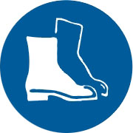  Appropriate protective footwear with substantial uppers must be worn. | 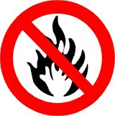  Ensure all flammable materials are safety stored away from the unit.
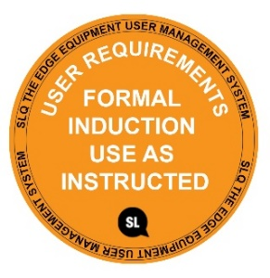
MAXAMIUM PRESSURE 60 PSI - DO NOT EXCESSED

PRE-OPERATIONAL SAFETY CHECKS
- Ensure no slip/trip hazards are present in workspaces and walkways.
- Ensure the pressure gauge reads zero PSI. Turn the air lever to the open position before releasing the clamps
- Check the condition of all hoses and fittings. Hoses that are damaged or in poor condition should not be used.
- Listen for any air leaks from any flexible airlines and immediately report if any leaks are found.
- Air hoses should be kept free of grease and oil to reduce the possibility of deterioration.
- Only standard air fittings should be used on air lines.
- Faulty equipment must not be used. Immediately report suspect equipment.

OPERATIONAL SAFETY CHECKS
1. Air hoses should not be placed where they will create tripping hazards.
2. Never direct compressed air in the direction of bystanders.
3. Never try to catch whipping airline (keep clear and turn off at source).
4. Ensure all clamps are tighten evenly and the lever is in the closed position before attaching the air hose.
5. Open the lever and watch the gauge carefully. Close the lever when the PSI reaches the desired pressure. Do NOT EXCESSED 60 PSI.
6. Release pressure by slowly opening the lever. Ensure you or any bystander are not directly in front of the releasing compressed air outlet.

HOUSEKEEPING
1. Store the Pressure Chamber is a safety location away from traffic areas.
2. Return airline and fixtures to the correct storage location.
3. Leave the equipment and work area in a safe, clean and tidy state after job is completed.

POTENTIAL HAZARDS
Air under pressure High noise levels
Eye injuries Flying debris

This SOP does not necessarily cover all possible hazards associated with the tool and should be used in conjunction with other references. It is designed to be used as an adjunct to teaching Safety Procedures and to act as a reminder to users prior to tool use.

© State of Queensland (State Library of Queensland) 2020

This policy is licensed under a Creative Commons Attribution 3.0 Australia licence. You are free to copy, communicate and adapt this work, so long as you attribute the State Library of Queensland.

For more information see http://creativecommons.org/licenses/by/3.0/au

