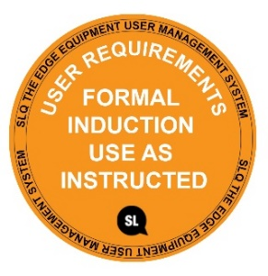
SAFE OPERATING PROCEDURE
INJECTION MOULDER
DO NOT use this machine unless you have completed an induction and the Supervisor and has given permission
Safety glasses must be worn at all times in work areas. |   Long and loose hair must be contained or restrained.
  Appropriate protective footwear with uppers must be worn. |   Gloves (heat resistance) must be worn.
  Rings and jewellery must not be worn. |   A mask may be needed when excessive fumes are created.

PRE-OPERATIONAL SAFETY CHECKS
- Ensure no slip/trip hazards are present in workspaces.
- Be aware of other people in the immediate vicinity
- Check that all safety guards are in position and are operational.
- Familiarise yourself with and check all machine operations and controls.
- Faulty equipment must not be used. Immediately report suspect equipment.

OPERATIONAL SAFETY CHECKS
- Keep clear of moving plugger handle
- Pre heat the injection moulder to be sure the machine has reached the required temperature.
- Never try to extrude screw until the machine is up to proper operating
- temperature.
- Never over fill the hopper with shredded materials
- Never leave the machine’s heaters on for any extended length of time when the machine
- is not being operated.
- Never leave the machine unattended.
- Before making adjustments of cleaning switch off the machine.

HOUSEKEEPING
- Switch off the machine when work has been completed.
- Leave the work area in a safe, clean and tidy condition.

POTENTIAL HAZARDS
Hot machine parts and materials Crush points fumes Eye injury Manual handling

This SOP does not necessarily cover all possible hazards associated with the tool and should be used in conjunction with other references. It is designed to be used as an adjunct to teaching Safety Procedures and to act as a reminder to users prior to tool use.

© State of Queensland (State Library of Queensland) 2020
This policy is licensed under a Creative Commons Attribution 3.0 Australia licence. You are free to copy, communicate and adapt this work, so long as you attribute the State Library of Queensland.

For more information see http://creativecommons.org/licenses/by/3.0/au

