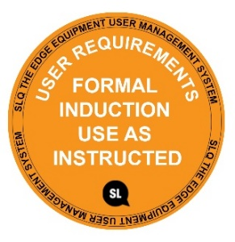
SAFE OPERATING PROCEDURE
MIG WELDER
DO NOT use this machine unless you have completed the induction and a supervisor has given you permission

Safety glasses must be worn at all times in addition to welding mask. |   Long and loose hair must be contained or restrained.
  Appropriate protective footwear with substantial uppers must be worn. |   Close fitting protective clothing to cover arms and legs must be worn.
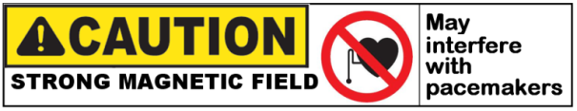 |   Oil free leather gloves and spats must be worn when welding.
  Rings and jewellery must not be worn. | A welding mask with correct grade lens for GMAW must be worn.  

PRE-OPERATIONAL SAFETY CHECKS
- Ensure no slip/trip hazards are present in workspaces and walkways.
- Ensure the work area is clean and clear of grease, oil, and any flammable materials.
- Keep the welding equipment, work area and gloves dry to avoid electric shocks.
- Ensure the gloves, welding gun and work leads are in good condition.
- Ensure others are protected by closing UV curtains or erecting UV safety screens.
- Ensure fume extraction or ventilation system is on before beginning welding operation.
- Ensure the work leads do not create a tripping hazard.

DO NOT use faulty equipment - Report this immediately

OPERATIONAL SAFETY CHECKS
- Ensure machine is correctly set up for current, voltage, wire feed and gas flow.
- Ensure work return cables make firm contact to provide a good electrical connection.
- Never leave the welder running unattended.
- Take care to avoid welding flashes. Erect UV safety curtains as required.

HOUSEKEEPING
- Switch off the machine and fume extraction.
- Close gas cylinder valve.
- Hang up welding gun and welding cables.
- Leave the work area in a safe, clean and tidy state.

POTENTIAL HAZARDS
Electric shock Fume UV & IR radiation burns to eyes and body
Body burns due to hot or molten material Flying sparks Fire

This SOP does not necessarily cover all possible hazards associated with the tool and should be used in conjunction with other references. It is designed to be used as an adjunct to teaching Safety Procedures and to act as a reminder to users prior to tool use.

© State of Queensland (State Library of Queensland) 2020
This policy is licensed under a Creative Commons Attribution 3.0 Australia licence. You are free to copy, communicate and adapt this work, so long as you attribute the State Library of Queensland.

For more information see http://creativecommons.org/licenses/by/3.0/au

