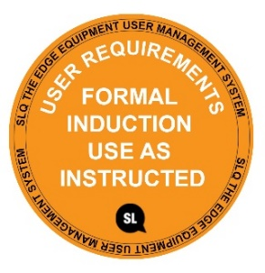
SAFE OPERATING PROCEDURE
METAL DROP SAW
DO NOT use this machine unless you have completed the induction and a supervisor has given you permission
Safety glasses must be worn at all times in work areas. |   Long and loose hair must be contained or restrained.
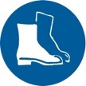  Appropriate protective footwear with uppers must be worn. |   Coveralls, protective clothing or a workshop apron is encouraged.
  Rings and jewellery must not be worn. |   Hearing protection will be required when operating this machinery.

PRE-OPERATIONAL SAFETY CHECKS
- Check workspaces and walkways to ensure that no slip/trip hazards are present.
- Ensure saw blade is in good condition.
- Locate and check the operation of the ON/OFF starter.
- Check that all safety guards are in working order.
- Check the operation of the work vice.
- Faulty equipment must not be used. Immediately report suspect equipment.

OPERATIONAL SAFETY CHECKS

- Ensure that the work piece is securely held in the work vice.
- Support overhanging work and signpost if it presents a hazard.
- NEVER attempt to cut very small items or to cut materials other than metals.
- Never leave the machine running unattended.
- Attention must be paid to unusual noises during the sawing process.
- Never force the saw into the workpiece. Use a slow and even feed rate.
- Before making adjustments or before cleaning swarf accumulations switch off and bring the machine to a complete standstill.
- Be aware of flying sparks. Ensure that sparks fly away from you, other people and don’t work near flammable materials.

HOUSEKEEPING
- Switch off the machine.
2. Leave the machine in a safe, clean and tidy state.

POTENTIAL HAZARDS
Possible burns from hot material Eye injuries Sharp edges and burrs Noise

This SOP does not necessarily cover all possible hazards associated with the tool and should be used in conjunction with other references. It is designed to be used as an adjunct to teaching Safety Procedures and to act as a reminder to users prior to tool use.

© State of Queensland (State Library of Queensland) 2020
This policy is licensed under a Creative Commons Attribution 3.0 Australia licence. You are free to copy, communicate and adapt this work, so long as you attribute the State Library of Queensland.

For more information see http://creativecommons.org/licenses/by/3.0/au

