SAFE OPERATING PROCEDURE
CORDLESS DRILL
DO NOT use this machine unless you have completed an induction and the Supervisor has given permission

Approved safety glasses must be worn at all times in work areas. | Hearing protection must be worn when noise levels are identified as excessive.
  Appropriate protective footwear with substantial uppers must be worn. | Protective clothing or a suitable workshop apron is encouraged.
A mask must be worn when excessive airborne dust is created. | Contain or restrain long and loose hair and remove exposed rings or jewellery.
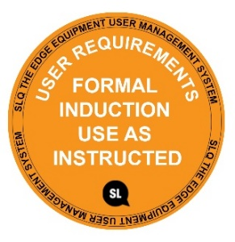

Always secure material before drilling

PRE-OPERATIONAL SAFETY CHECKS
- Ensure this power tool has a suitable safe work area.
- Ensure the battery is suitably charged.
- Do not use dull or damaged drill bits.
- Check the selected drill bit is correctly fitted.

OPERATIONAL SAFETY CHECKS
- Do not connect the battery until all adjustments have been made.
- Examine the material to be drilled for splits, loose knots and nails, etc.
- Select the correct sized drill bit. Tighten securely in the chuck.
- Ensure the work piece is secure and well supported in a convenient position for drilling.
- The power drill must be held firmly with both hands to control operational accuracy and the rotational torque.
- Keep hands and fingers well clear of moving parts. Avoid blocking and covering the motor ventilation slots with your hands.
- Allow the drill to reach operating speed, then apply load gradually. Do not apply excessive force.
- Back the drill bit out to clear away all waste.
- Avoid prolonged use as this could overheat the motor.
- Do not place the drill down until the bit has stopped rotating.

HOUSEKEEPING
- Return the drill bit and return this tool to the appropriate location.
- Leave the work area in a safe, clean and tidy condition.

POTENTIAL HAZARDS
  - Moving, rotating and sharp parts Electricity Eye injuries
  - Burns (friction) Noise Excessive dust
This SOP does not necessarily cover all possible hazards associated with the tool and should be used in conjunction with other references. It is designed to be used as an adjunct to teaching Safety Procedures and to act as a reminder to users prior to tool use.

© State of Queensland (State Library of Queensland) 2020
This policy is licensed under a Creative Commons Attribution 3.0 Australia licence. You are free to copy, communicate and adapt this work, so long as you attribute the State Library of Queensland.

For more information see http://creativecommons.org/licenses/by/3.0/au

