Keys
W | Walk Forward | E | Inventory | 1  -  9 | Select Hotbar Slot
S | Walk Backward | Q | Drop Item | SpaceW | Jump  (Twice to fly)
A | Strafe Left | T | Chat Window | Left Shift | Fly Down
D | Strafe Right |  |  | Left Ctrl | Sprint
 | Delete Block |  | Add Block

Minecraft Blocks
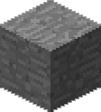 | Stone | 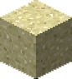 | Sand | 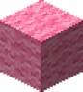 | Pink Wool
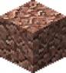 | Granite | 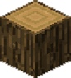 | Oak Wood | 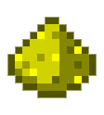 | Glowstone
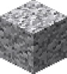 | Diorite | 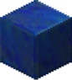 | Lapis Lazuli |  | Bone Meal
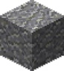 | Andesite | 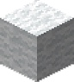 | White Wool
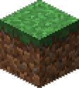 | Grass | 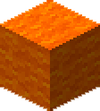 | Orange Wool
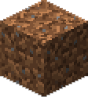 | Dirt | 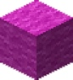 | Magenta Wool
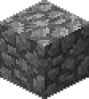 | Cobblestone |  | Light Blue Wool
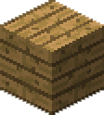 | Oak Wood Planks | 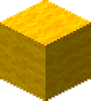 | Yellow Wool
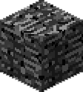 | Bedrock | 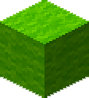 | Lime Wool

Adding a block to your hotbar

- Press E to open the inventory
- Find the block you want and drag it down to the hotbar within the inventory
- Press ESC to close the inventory

Removing a block from your hotbar

- Press 1-9 to select the block to remove from your hotbar
- Press Q to drop the block into the world

Growing a tree

- Place a tree on the ground
- Add Bone Meal to your hotbar and select it
- New right-click on the tree you placed earlier

Making a block glow

- Press the / character and type addlight enable and press enter
- Add a glowstone to your hotbar and select it
- Now left click on any block in the world to set it as a light

