Tech Byte
6 Shot sequence (Pocket Cinema)
Description | Follow the “Book Search Storyboard” and learn filming techniques
Duration | 1 hour
What You’ll Need | - iPads with Camera app and iMovie installed  - iPad tripod (if available)  - The “Book Search” storyboard (see below)
Purpose | This is a technical filming exercise to practice visual continuity and shot composition through a simple six-shot sequence. Participants will learn about camera placement, movement, and perspective, using a single, static-camera setup.

Session Outline
Stage | Activities
1. Welcome & Setup | - Welcome participants.  - Separate into groups of 2  - Explain the exercise.
2. Plan and practice the shots | - Use the Book Search Storyboard and do a practice run before you start recording each shot.  - The camera stays in place – the character walks in and out of the field of view. Use a tripod if you have one.
3. Record your clips | - Open the Camera app and film the 6 scenes, as close to the storyboard as possible  - Each shot should run for 6 seconds (you can shorten them in the editing stage)
4. Edit the movie using iMovie | - Open iMovie and start a new project.  - Import your clips by tapping the + button.  - Arrange them to match the storyboard.  - Shorten or reshoot clips as appropriate  - Add a title (tap T and type your movie’s name).  - Add background music (tap Audio to select a soundtrack).
5. Preview and share | - Tap Play to watch your movie.  - If you’re happy with it, share it on the IKC interactive screen (if available).

Staff Notes
- Promote the session through the Digital and You app.
- Set up at least four iPads, plus paper and pens for planning.
- Follow the storyboard as closely as possible. This session is teaching technique.
- Sit with participants to guide them through the apps and troubleshoot issues.
- Offer praise and positive feedback throughout.

Six Shot Sequence – Book search
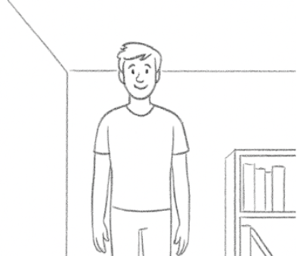 | 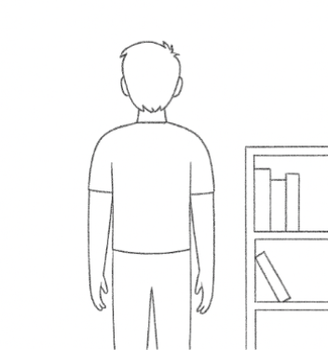
Start with the actor walking towards the camera | This screen starts with the camera almost touching the back of the actor as they walk away towards the bookshelf
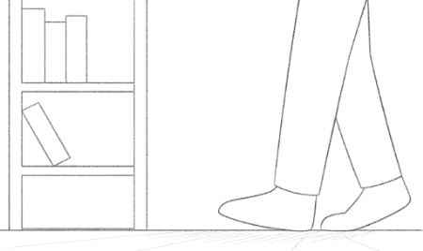 | 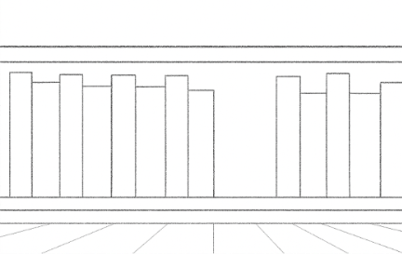
Creative angle shot – the camera is low down and the actors feet walk to and stop at the book shelf | POV – the camera is stationary, but pans slowly across the bookshelf.
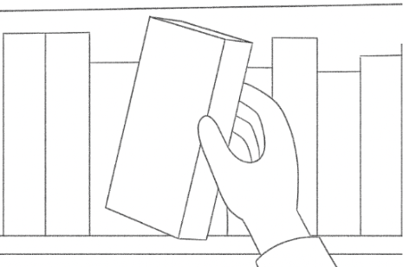 | 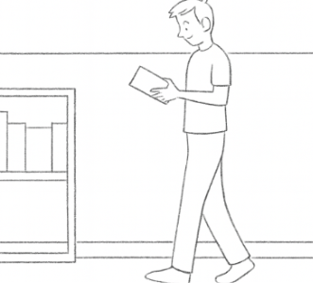
Close up shot of the actor reaching for and pulling a book from the shelf | Wide shot of the actor looking at the book and then walking out of frame. Sequence the shot with the previous frame

