Mod Your Space: Laser Cut your own Costume Props
~~HERO-IMAGE 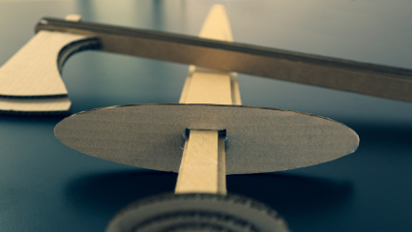~~ ~~HERO-SUBTITLE Fantasy, Sci-Fi or historical items, anything can be created with cardboard~~

Summary
As part of the Summer Festival 2020 this workshop was developed to teach participants how to quickly design and create props for their next cosplay or costume. Using digital design software and access to the laser cutter, props can be made within minutes, from idea to reality. Using corrugated cardboard is cheap and is an environmentally friendly material which allows for multiple iterations of designs and creative experimentation.
The workshop will cover:
- Basic Design workflow in Corel Draw
- Basic understanding how a laser cutter works
- Basic Prototyping/Product development skills
- Cross-disciplinary, Arts and Technology

Activity Summary
- Introduction
- Safety Brief (safe usage of tools and materials)
- Intro to Corel Draw
- How to design for the laser cutter
- Designing / Cutting
- Decoration / Paint / Assembly

Materials
Material | Quantity | Cost | Supplier
Corrugated Cardboard 3-6mm | 1 sheet | $2 | Boxfactory.come.au
Braided Elastic | 1 box | $5.30 | Spotlight
Hook & Loop | 5m | $530 | Bunnings Warehouse
SUGAR Spray paint | * | $8/can | Ironlak
Hot Glue Sticks | * | * | RS Electronics
 | TOTAL: | $10

Tools & Equipment
- Laser Cutter (and qualified operator)
- Hot Glue guns
- Scissors
- Stanley Knives

Instructions

Step Zero: Before the workshop
- Make sure you have enough cardboard for the workshop, preferably cut up to match the size of the laser bed. This allows for maximum prop size!
- Have a few examples of both files and props to demonstrate (or images to inspire)

Step One: Introduction

References

Files

