Mechanical Cabaret (Woodford version)
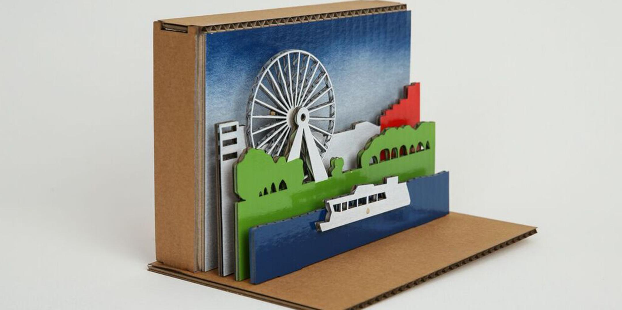
Developed by Daniel Flood

Summary
This workshop will go live in prototype form at The Planting 2017 and will graduate to a workshop for Woodford Folk Festival 2017/18 (much like the lock did). Participants will construct a simple mechanical toy/kinetic sculpture. The intention is to use recycled plastic as the primary material to build these out of. Ideally the Steampunk LED workshop could plug into this unit, providing an extension activity that would integrate electricity into the design. Aim it to provide each participant with a box or parts, a base design and space to innovate on what they construct with some optional bits and pieces. Workshop should not run more than 90 minutes in a controlled environment, which hopefully gives us scope to complete in two hours it we're practised at it.
This will be the first TryIt off the rank this year too. Time to get developing.

Activity Summary
Describe the activity being proposed and the engagement, skills and knowledge development value of this type of activity.

Materials

Tools

Instructions
Rename the steps as you like, use italics or bold for emphasis

Step Zero:

Step One:

Step Two:

Step Three:

Step Four:

Step Five: Troubleshooting

Step Six: References

Production notes

Critical Success Factors
Which of the critical success factors does this Prototype target? For more details see SLQ-Strategic-Plan-2016-20

Enable Access

Engage Community

Build Capability

Delivering of The Edge Promises
Aside from the SLQ Strategic Plan, there is The Edge's commitments to the community and the lens we look at it through. Here are a few more check boxes for you to answer

This empowers creative experimentation across...

It will inspire...

Feedback
1. Feedback:
Solution:
2. Feedback:
Solution:
3. Feedback:
Solution:
4. Other observations:

References

Files
Reference book about Cabaret Mechanical Movement. There is print up of this somewhere near my desk.

