Dungeons and Dollhouses
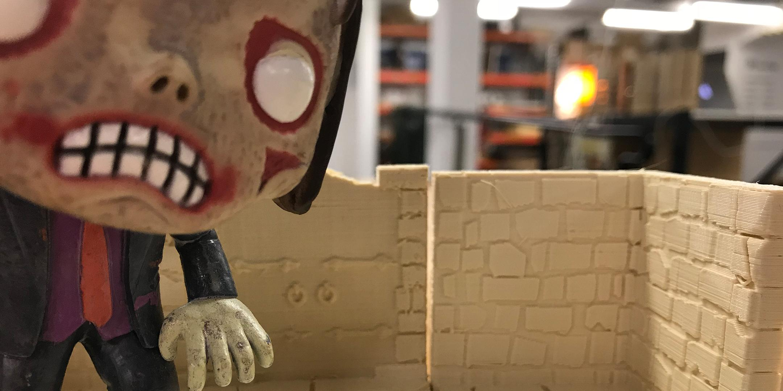

What??
Castle Greyskull and Malibu Barbie's playhouse are ingrained cultural objects of most 40+ year old Australian's. There would be equivalents in todays young people but I have no idea what they would be (lacking young children and all). In an effort to stop people being straight up consumers and turn them into makers, this is a workshop where participant will design and fabricate their person Dungeons and Dollhouses.
We are not being proscriptive as to boys making dungeons and girls making dollhouses; GI Joes need somewhere to live too and that would be an awesome dollhouse. It introduces the participants to the fabrication lab and will be designed to be an open ended engagement that extends beyond the scope of the workshop.
The idea for this workshop came from a conversation had in 2015 from Indianapolis and Chicago. I was coming back from GenCon and the person sitting next to me from the National Dollhouse Convention (they'd been happening at the same time). We discussed how old school practises could be adapted to new school technologies. It seemed obvious but not done a lot.
This is the response to that.
By Dungeon I am meaning any terrain for gaming; war-gaming, RPG, board gaming etc. Depending on the project, there might be an opportunity to get some gaming in and tie it to the One Last Apocalypse project.
The focus needs to be on learning some stuff, having fun with some stuff and taking it home. Low cost materials (making stuff out of corrugated card and pointing to how it could be transitioned to ply/MDF etc), tricks that have been learnt from doing this stuff. It's all about showing people what they can do with some time and determination.

Activity Summary
We're looking at two workshops and lots of open lab time. It will use the laser and 3D printers, maybe the vinyl cutter and small form CNC. It assumes that people have an interest in these practises before they come in the door. It people don't then we'll leverage off of other people for some peer-to-peer learning.
There will be a couple of example files/models for people to play with and a suite of pre-designed parts to work with. The idea is that the participant can modify the existing designs or go off in a completely different tangent, depending on their need making this process as easy or as difficult as possible.
They will also be provided with a lift of other resources that can be used.

Materials
These materials are per participant if not specified otherwise.

Tools
Tools required during the workshop. It is not required that one of each is supplied for participants but one tool per two participants is preferred.

Instructions
Rename the steps as you like, use italics or bold for emphasis

Step Zero:

Step One:

Step Two:

Step Three:

Step Four:

Step Five: Troubleshooting

Step Six: References

TryIt and Feedback
1. Feedback:
Solution:
2. Feedback:
Solution:
3. Feedback:
Solution:
4. Other observations:

References
This were you put external links like LED generator

Files
This is where you put files for laser cutting etc..

Critical Success Factors
Which of the critical success factors does this Prototype target? For more details see SLQ-Strategic-Plan-2016-20

Enable Access

Engage Community

Build Capability

Delivering of The Edge Promises
Aside from the SLQ Strategic Plan, there is The Edge's commitments to the community and the lens we look at it through. Here are a few more check boxes for you to answer

This empowers creative experimentation across...

It will inspire...

