Workshops
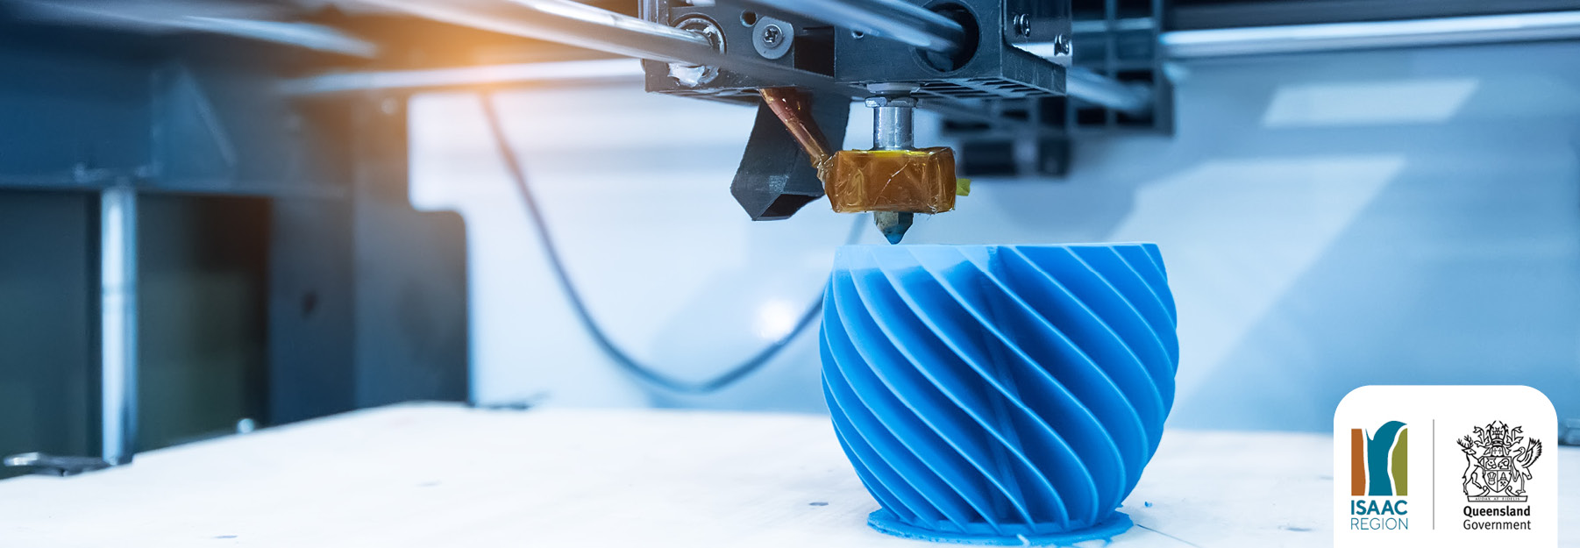  3D PRINTING WORKSHOP - Here you find material complementing the 3D printing workshop touring the Isaac Region. | 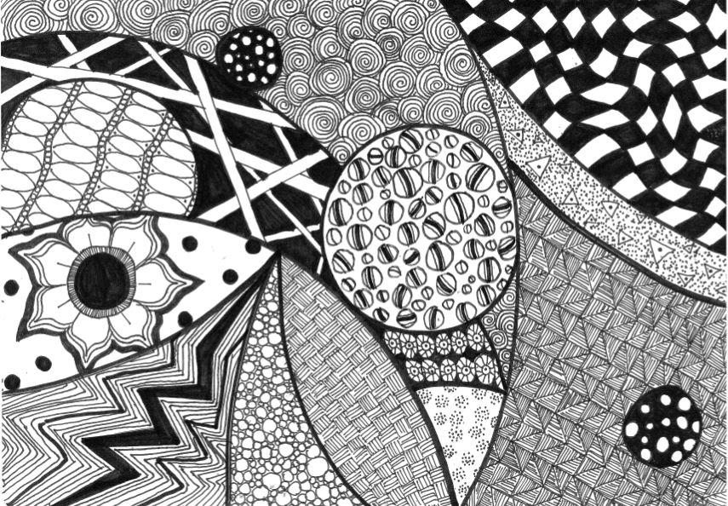  ZENTANGLES TUTORIAL - Here you'll find a tutorial video and resources to create your very own zentangles artwork.

