SCRATCH

What is Scratch?
Scratch is an online platform where you can program your own interactive stories, games and animations - and share your creations with others in the online community. This is a coding based program with easy to follow practices that helps young people to learn to think creatively, reason systematically, and work collaboratively.

What is Scratch Jr?
Scratch Jr is a more introductory program that enables younger aged children to create their own interactive stories and games. In doing this they piece together programming blocks to make characters move, jump, dance, and sing.

Scratch Programming
The following links will lead you to some of the program's created by staff in the Isaac region. Feel free to give them a go and use them as a starting point to develop your own Scratch coding.
- Scratch Jr Program's
- Scratch Program's

Scratch with Makey Makey
In simple terms the Makey Makey is a simple circuit board that you can use to create your own keyboard and connect it to any keyboard. In doing this you are able to connect everyday conducive objects (such as banana’s, paperclips, donuts etc) to your computer and use them as a keyboard.
These can be used alongside Scratch.
- Makey Makey's
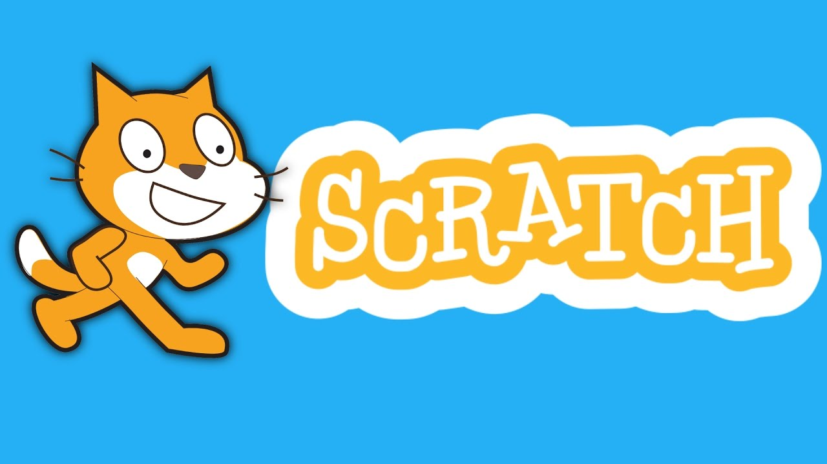
~~HERO-IMAGE ~~
Back to IRC Wiki

