Resources
  F5F TIPS & MESSAGING | 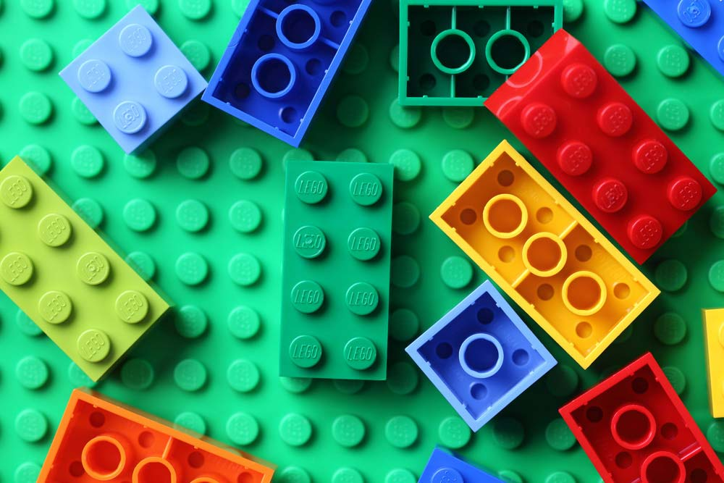  LEGO BUILDER - Program ideas for engaging sessions with Lego for the ages 6+.
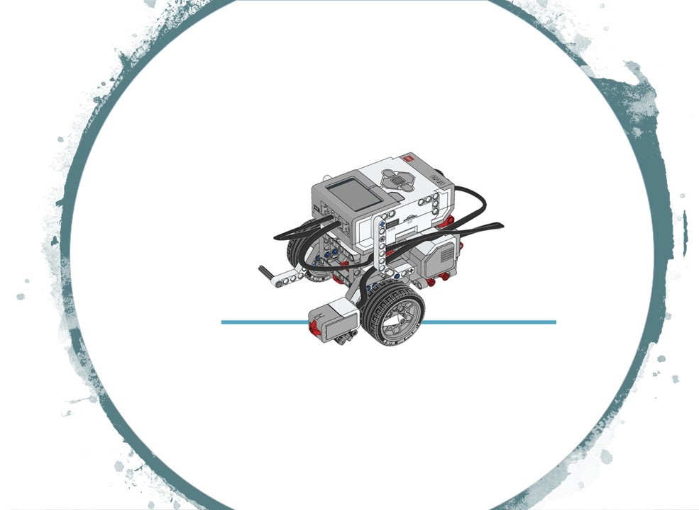  LEGO ROBOTICS - The Lego Robotics workshops with EV3 and Mindstorms. |   OSMO - Program ideas for engaging sessions with Osmo's for the ages 6+.
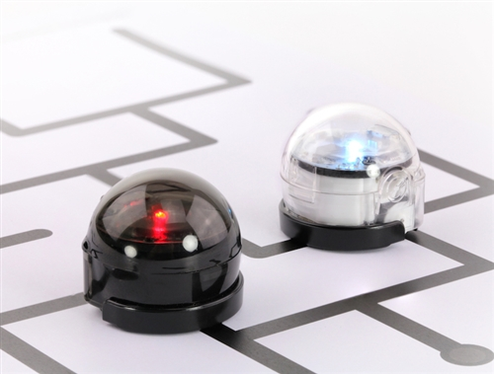  OZOBOT - Program ideas for engaging sessions with Ozobots for the ages 9+. | 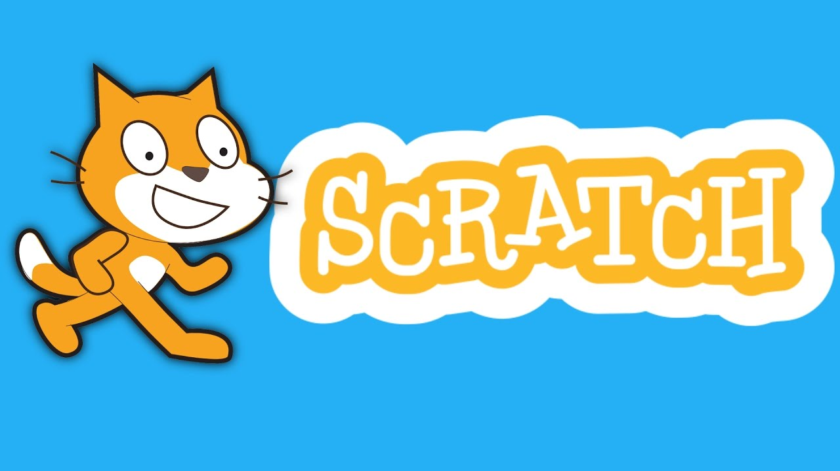  SCRATCH - Program ideas for engaging sessions with Scratch for the ages 9+ including the use of Makey Makey's. | 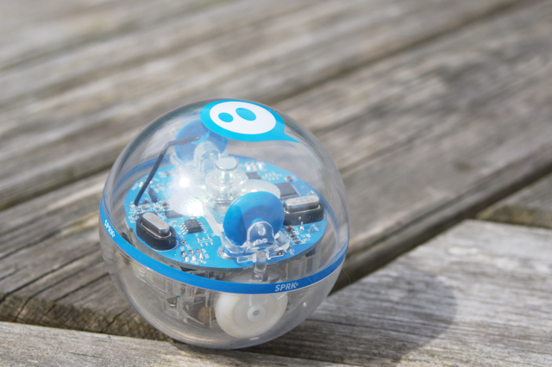  SPHERO - Program ideas for engaging sessions with Sphero's for the ages 9+. | 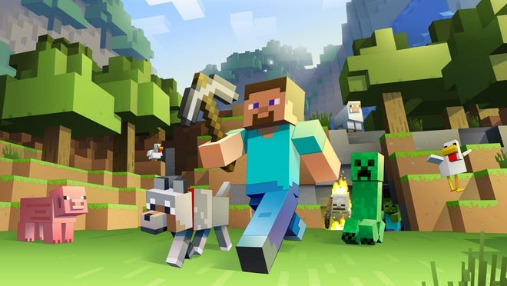  MINECRAFT - This is a site for our Isaac Master Builders.

