BSSSC Session Plan - 15 Sep

BSSSC Session Plan - 15 Sep
15 September 2021 (9am – 1.10pm) Online Zoom
Facilitator: Michelle Brown / QUT Assistant: Owen Green
Time | What | Who
9-9.15am | Check in and Revisit what we did last time (well exploring, solo writing, group writing, dreaming, maybe get groups to show again) | SLQ
9.15 – 9.30am- | Design Brief  Fabrication  - Offsite fabrication  - Working as a client  - Key considerations – concept vs design vs fabrication readiness  - Recap timelines  relief_projection_wall1  Design – Digital Tools  - Explore digital fabrication technology  * What they are?  * How they can be used in this instance?  - Explore design constraints and opportunities presented as a part of the project process  * Splitting into elements for later assemblage  * Safety considerations for Wall Relief  * Considerations of cardboard as a technology  * Consideration of adhesion technologies; glues, tapes etc  Design – Digital Projection  - Space and Scope for digital projection mapping | SLQ
9.30-10am | Concept Selection  Discuss what other groups are doing and how that impacts what we choose.  As this is a community project, there are some already chosen Imagined things that affect us: #5 Shark Komododragon, #21 Mask God, #50 Thing.  The Designed Well  Let's look at what we ended up with last session.  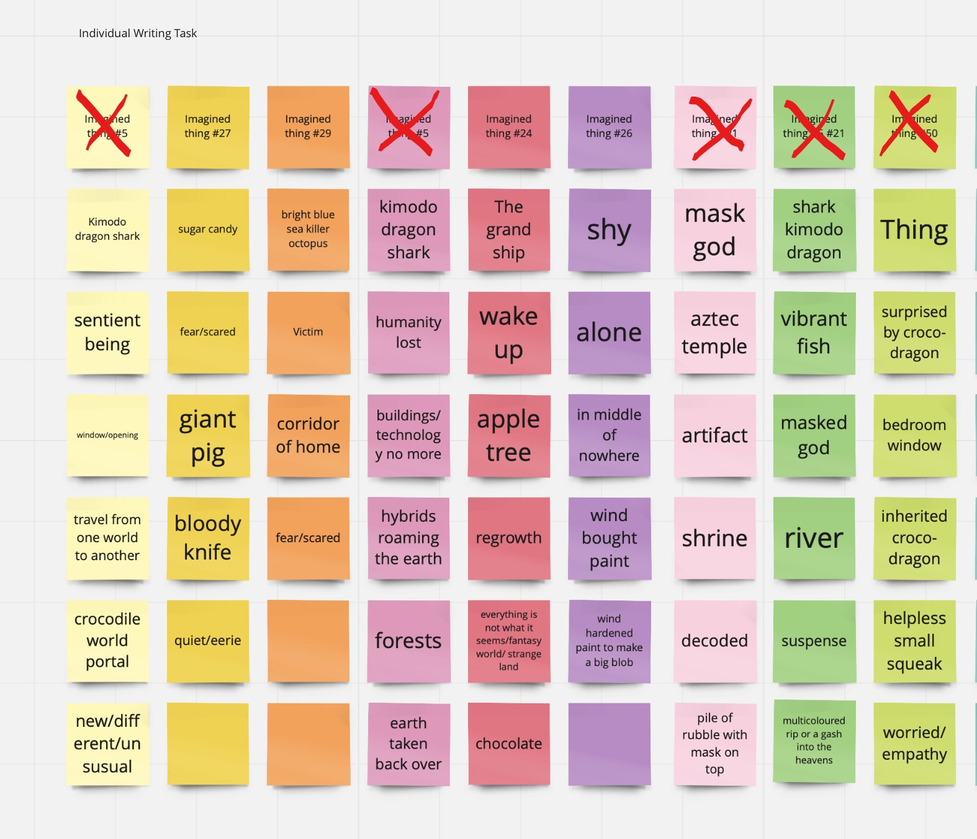  The 3 main themes from our first session were:  - Group 1: a forest with Hybrids  - Group 2: Forest and River, a summoning place  - Group 3: Labyrinth, giant house or map  We still have #24 The Grand Ship, #26 Shy, #27 Sugar Candy and #29 Viperson to play with!  With this in mind, we want to focus the selection for our project further, we may want to focus the discussion about the ‘world’ in which our Imagined Thing lives rather than the Creature itself similar to our first session. | SLQ
10-10.30am | Concept Selection Cont.  Group decision making around which Imagined thing to choose and which World ideas to focus on.  Maybe extract themes and dream up Labyrinth possibilities for each of #52 Hybrid, #24 The Grand Ship, #26 Shy, #27 Sugar Candy and #29 Viperson to help make the decision | SLQ/BSSSC
10.30am – 10.40am | Refine and break down concept into 3 groups for design;  - Digital Design  - Sketching  - Modelling (with flat cardboard sheets or paper)  Show some shadow paper techniques - https://www.pinterest.com.au/Thebadlament/grumpus/wall-relief-ideas/ | SLQ/BSSSC
 | Refine Design Group Time  Split into groups and take an element of the idea.  Sketch (by hand or digitally) out the elements of the design (for prototyping).  Design time (paper/card cutting, we will have lots more next session).  May need some instruction on programs. | BSSSC
11.10am – 12pm Break
12-12.45pm | Design – Digital Projection  - Story ideas/Imagery – what has come out throughout the day, significant stories of our wall relief  - Themes – major themes of the concept  - Sound ideas | SLQ/BSSSC
12.45-1.10pm | Pack up, Documentation & Communication  Documentation the session (SLQ Wiki)  Check out | SLQ

