74. ROCU from a Logged Forest - Chosen Thing
HERE LIES THE ENTRY FOR AN IMAGINED THING
This is a thing imagined by Bronte, aged , on Thursday July 8
The full name of this thing is: ROCU
It can be found in: A logged forest
It is known that: The skeleton is all that is left of him after the loss of his forest. He is concerned by anger of his loss but is sad - regrets his actions. Rocu has the power to create but needs a strong reason for doing so.
This thing has three important features: Skeleton, Bones, and Plants

An image of ROCU can be found here:
upload_image_file_2400 upload_image_file_3400 upload_image_file_4400 upload_image_file_5400
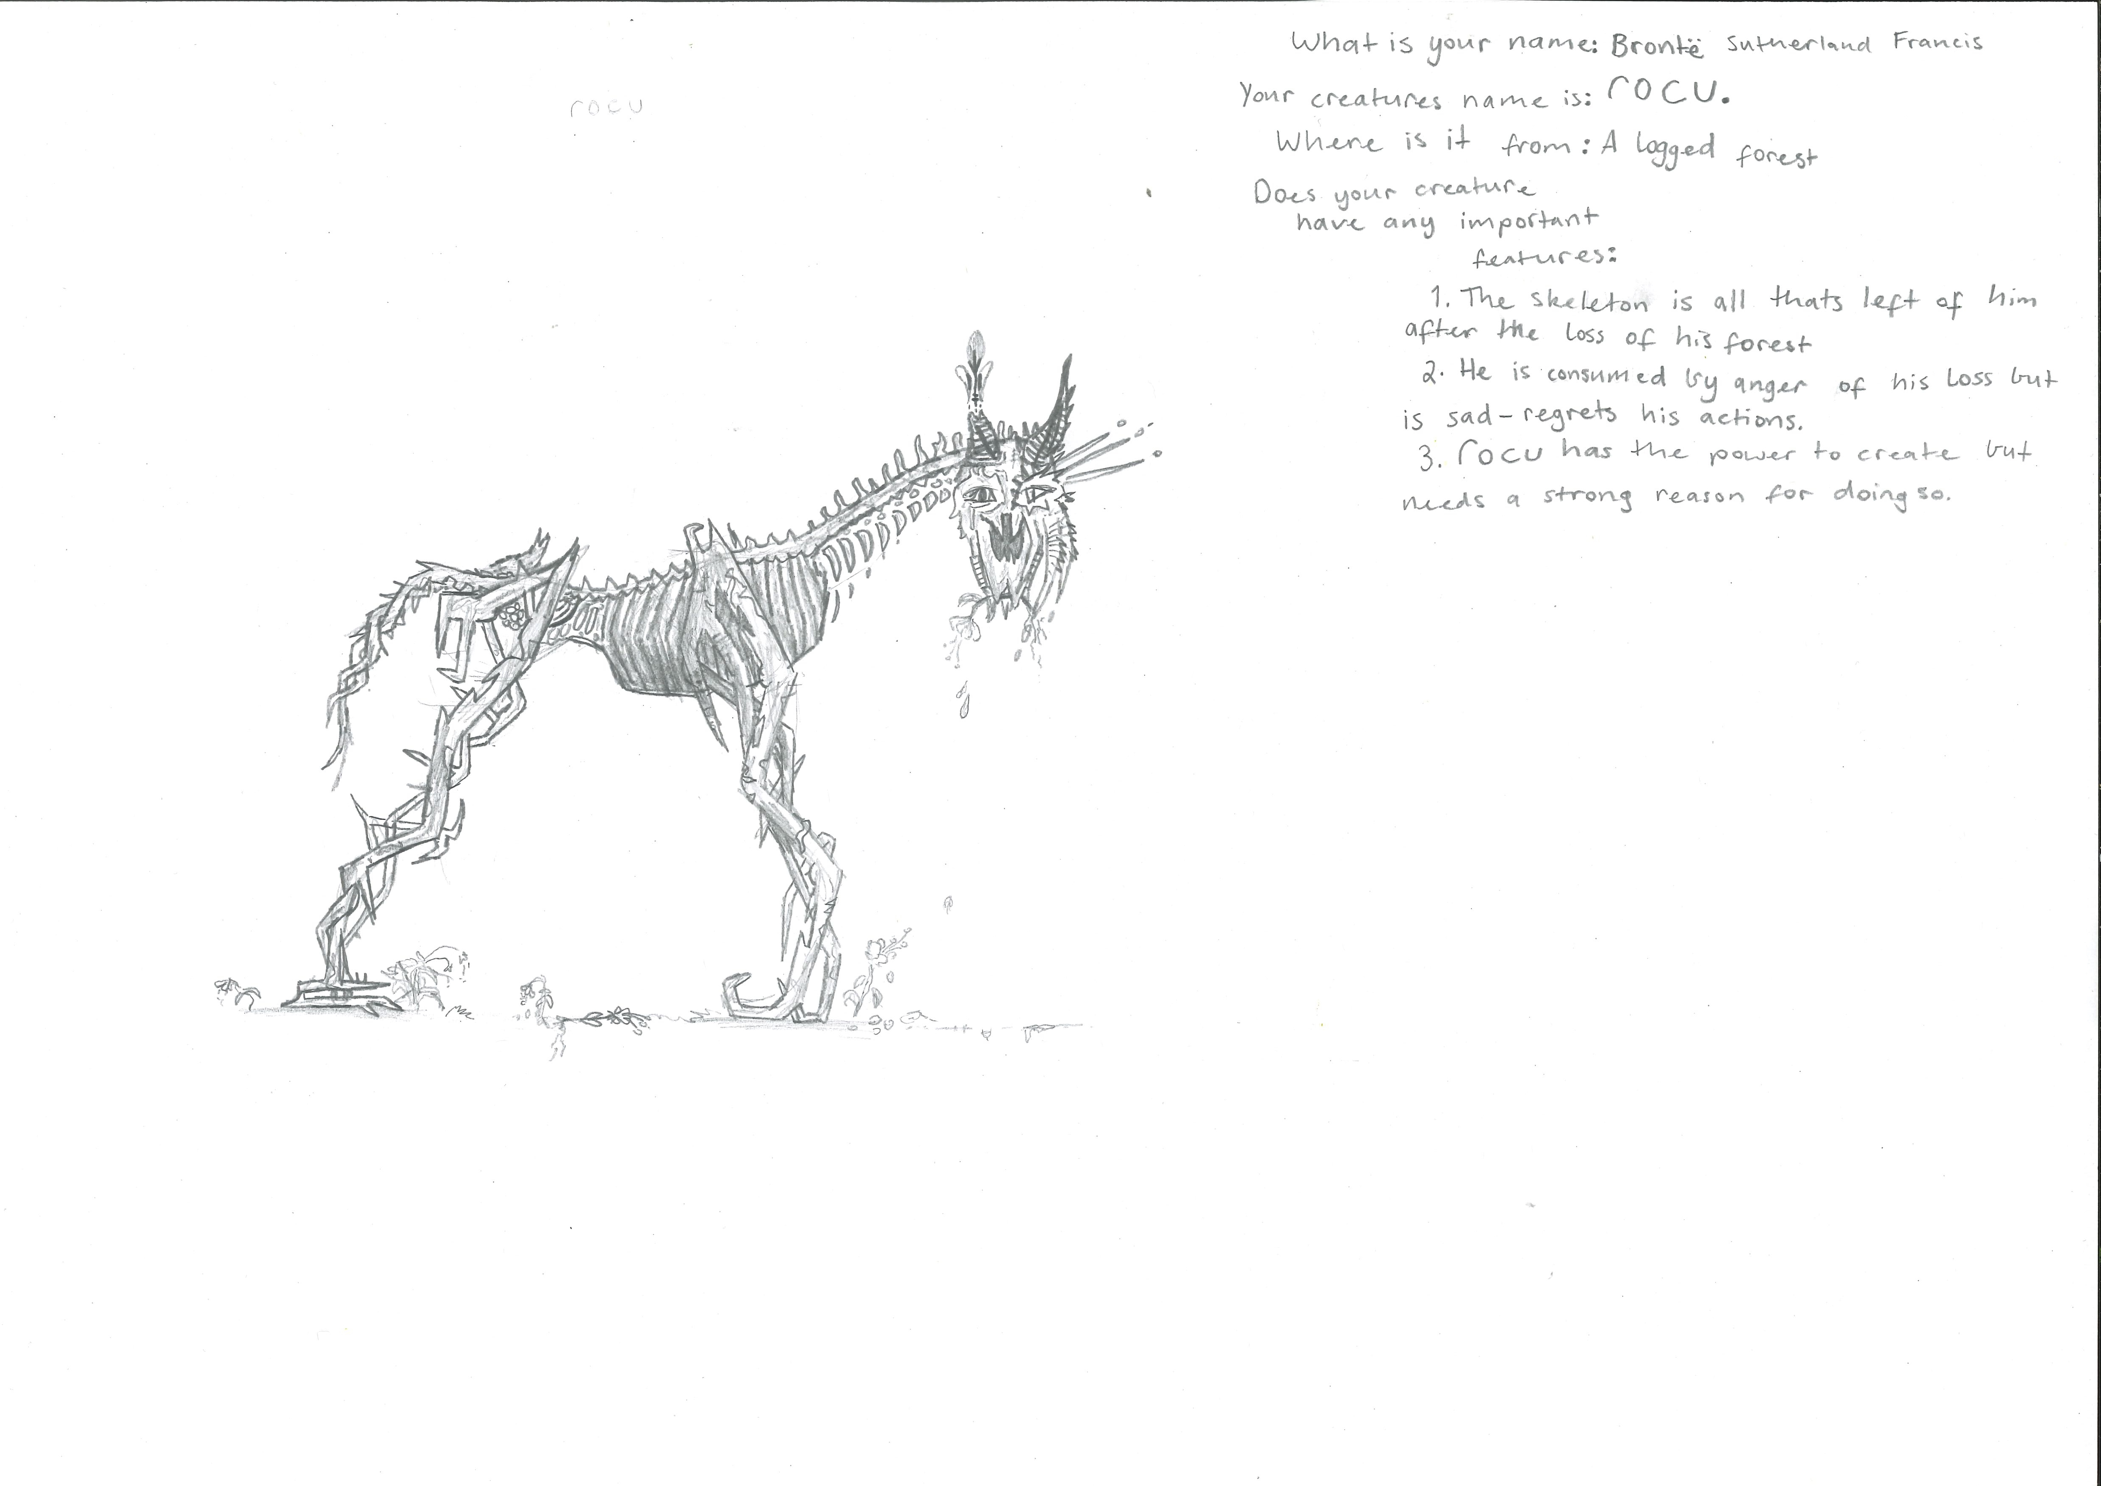400

A recording ROCU can be found here:
upload_your_audio_file400

This is the unique QR code for this Imagined Thing. Right click it to save then share it, so you and others can find your way back to here to this point of The Well.

IT IS KNOWN! HUZZAH FOR THE GREAT & GRAND RUMPUS!

