72. Giant Hedgehog Dinosaur
HERE LIES THE ENTRY FOR AN IMAGINED THING
This is a thing imagined by Natalie, aged , on Thursday July 8
The full name of this thing is: Giant Hedgehog Dinosaur
It can be found in: World where it is sunny, no rain, lots of nature
It is known that: NA
This thing has three important features: Feet, round eyes and nose, and whiskers

An image of Giant Hedgehog Dinosaur can be found here:
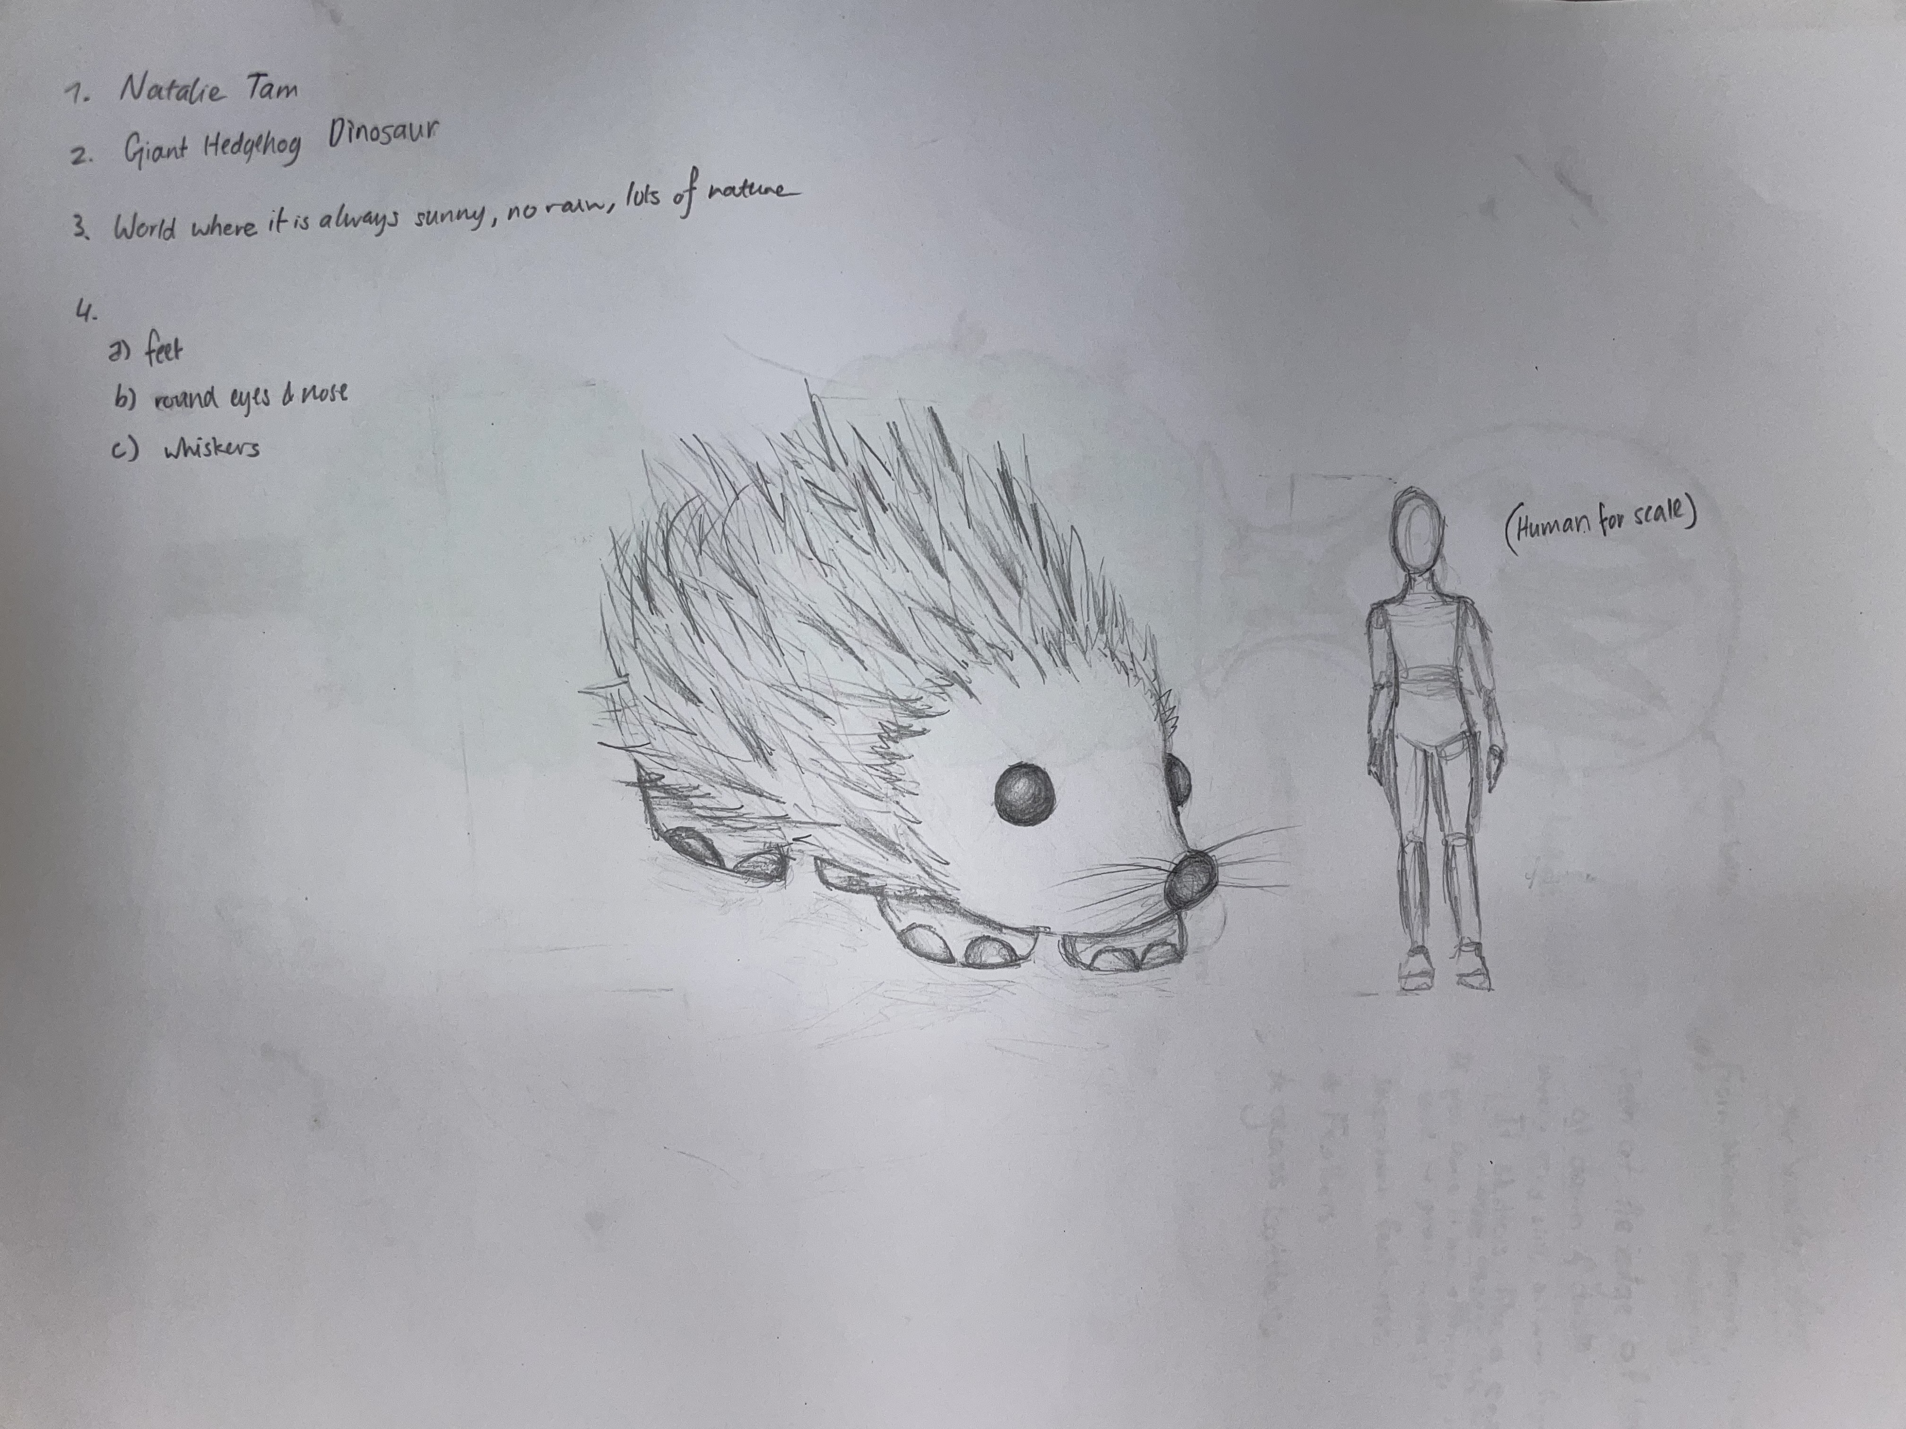

A recording Giant Hedgehog Dinosaur can be found here:
upload_your_audio_file400

This is the unique QR code for this Imagined Thing. Right click it to save then share it, so you and others can find your way back to here to this point of The Well.

IT IS KNOWN! HUZZAH FOR THE GREAT & GRAND RUMPUS!

