71. The Water Tree
HERE LIES THE ENTRY FOR AN IMAGINED THING
This is a thing imagined by Matilda, aged , on Thursday July 8
The full name of this thing is: The Water Tree
It can be found in: Nobody knows, it's a mystery
It is known that: Seen at edge of lakes at dawn or dusk. Usually very still, but when frightened it skitters like a crab deeper into the lake. If you leave it an offering, it is said to grant wishes.
This thing has three important features: Feathers and Glass bottle

An image of The Water Tree can be found here:
upload_image_file_2400 upload_image_file_3400 upload_image_file_4400 upload_image_file_5400
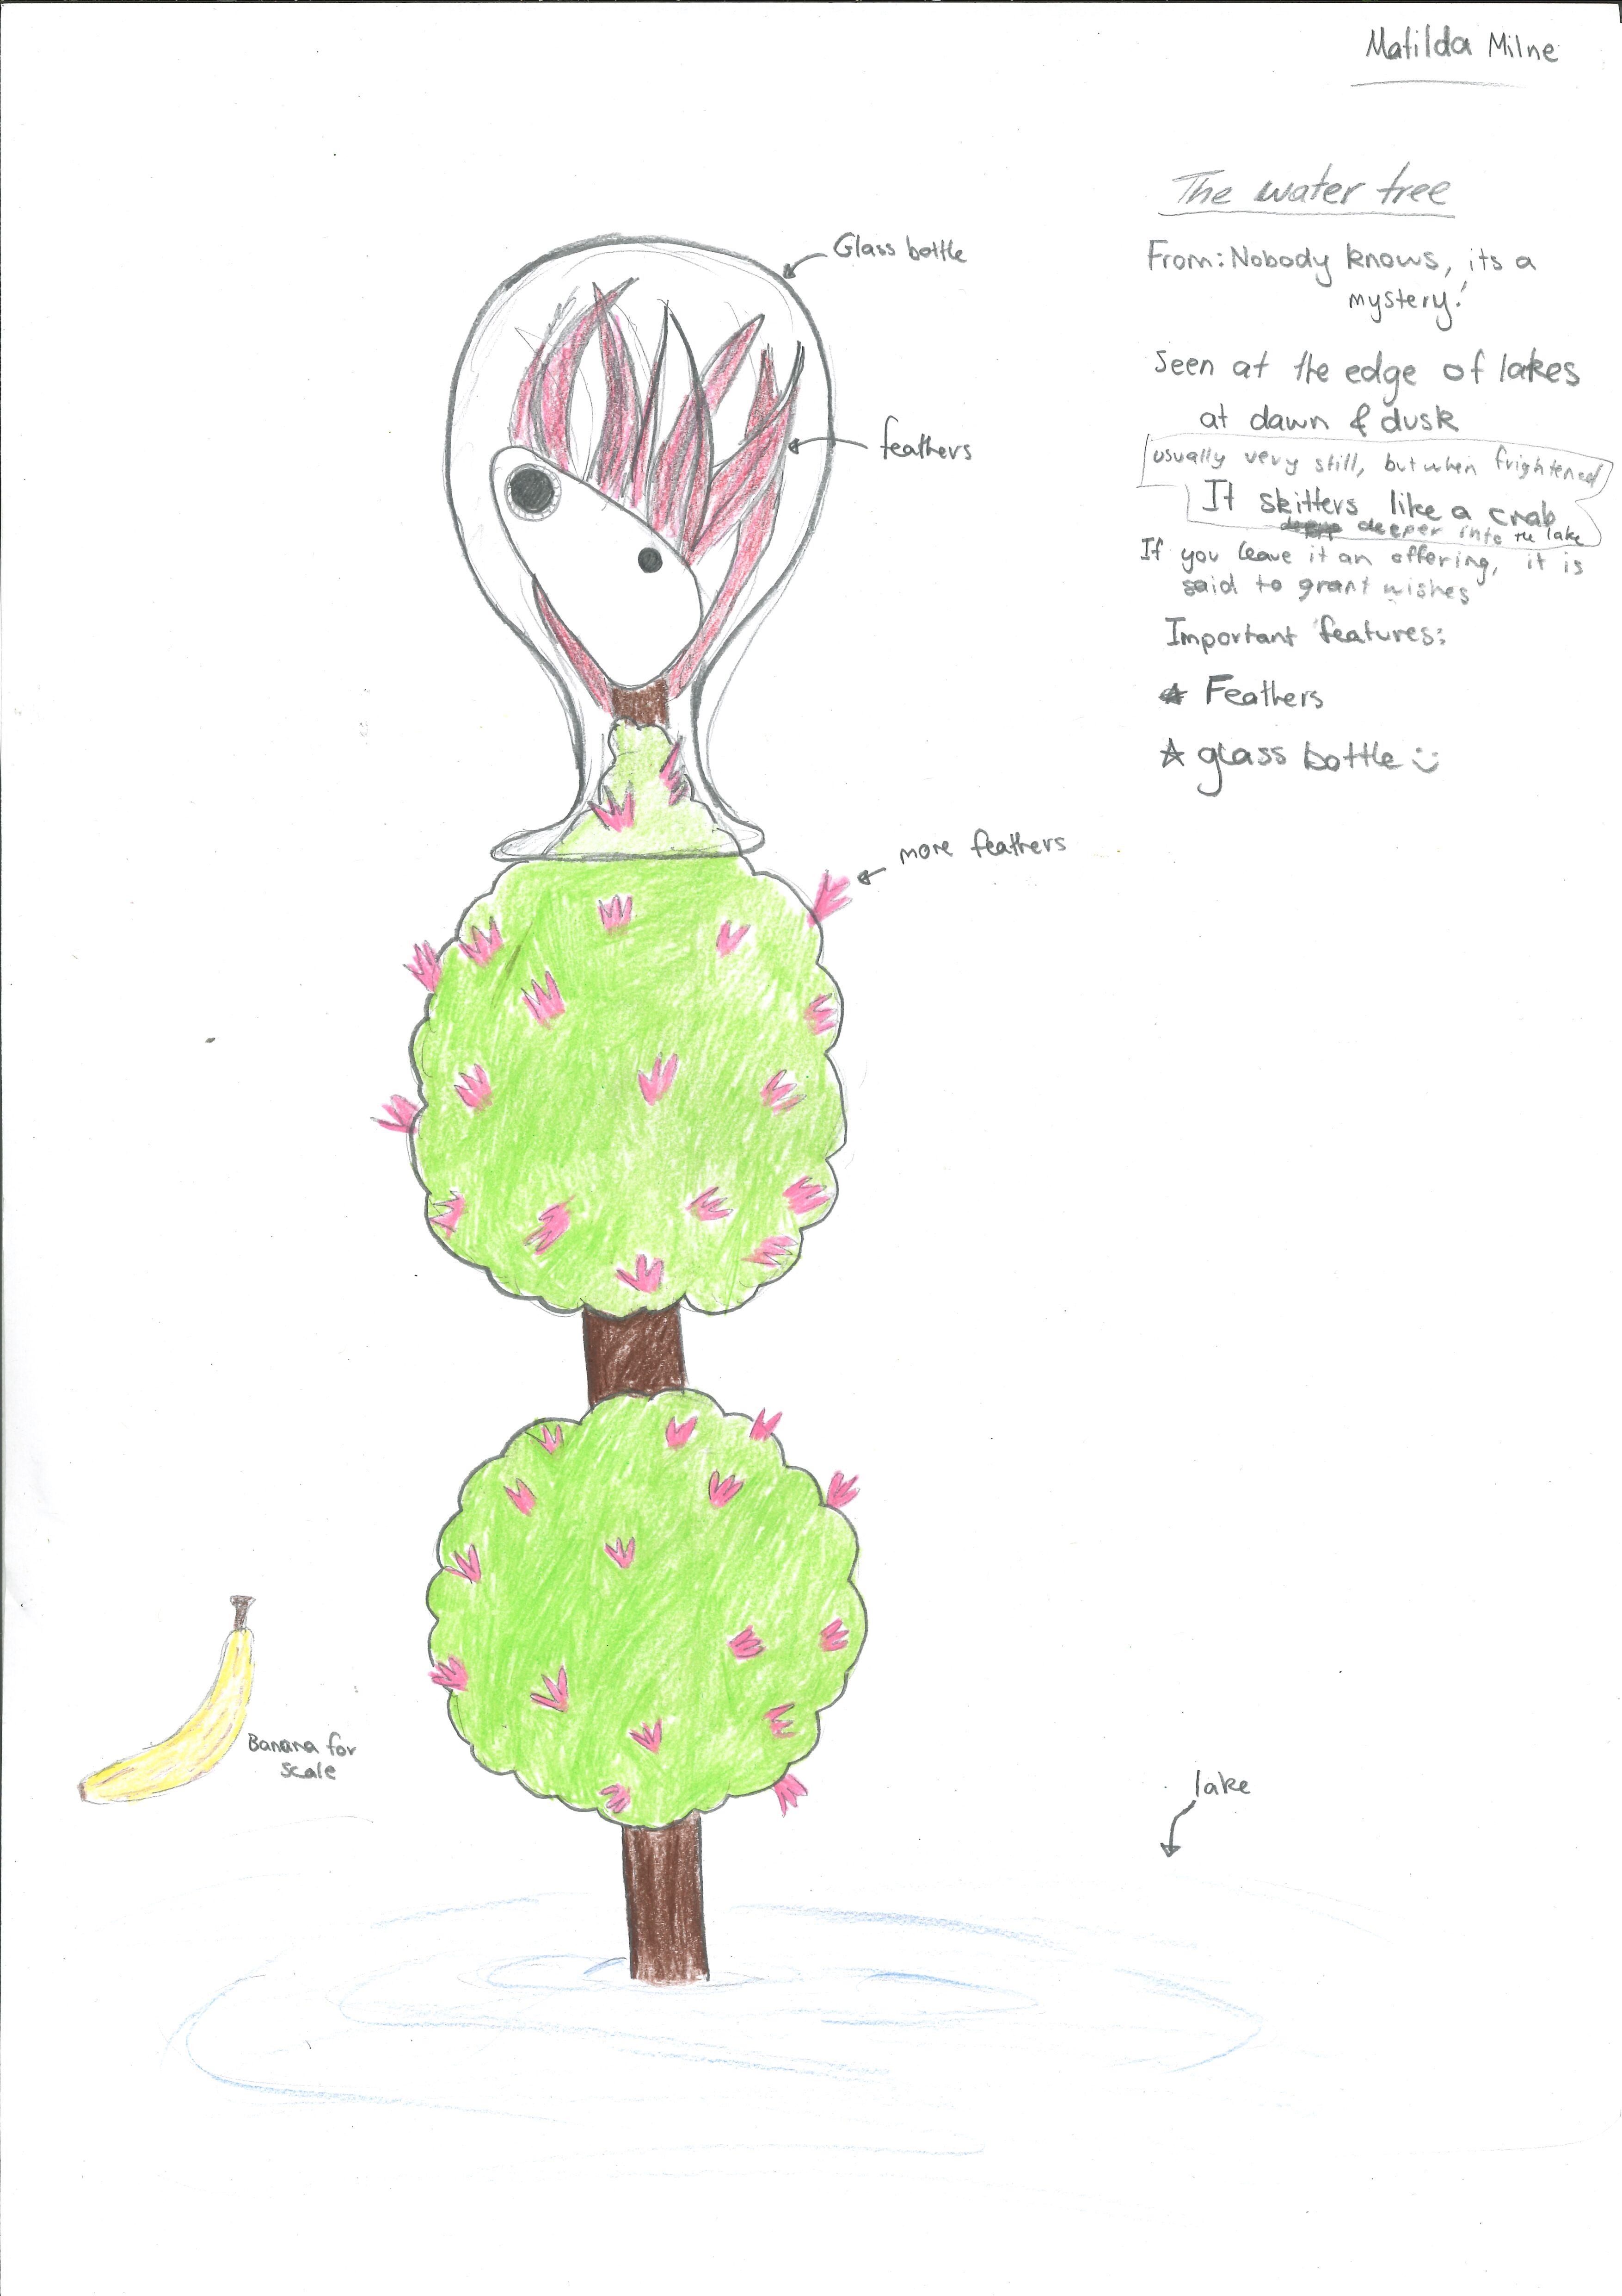400

A recording The Water Tree can be found here:
upload_your_audio_file400

This is the unique QR code for this Imagined Thing. Right click it to save then share it, so you and others can find your way back to here to this point of The Well.

IT IS KNOWN! HUZZAH FOR THE GREAT & GRAND RUMPUS!

