41. Crystal Warrior
HERE LIES THE ENTRY FOR AN IMAGINED THING
This is a thing imagined by Shahram, aged 11, on Tuesday May 11
The full name of this thing is: crystal warrior
It can be found in: its from a place just underground where other crystal monsters are.
It is known that: when it was born he didn't want to be a normal crystal monster. He wanted to be a warrior and he did. But the one thing he needed was an owner for him. He was looking for a companion. Then he found one person, and that is me.
This thing has three important features: He shoots crystal to protect his arm. , He is some sort of fury monster but he is not. , and He has orange around him to protect him from getting hurt.

An image of crystal warrior can be found here:
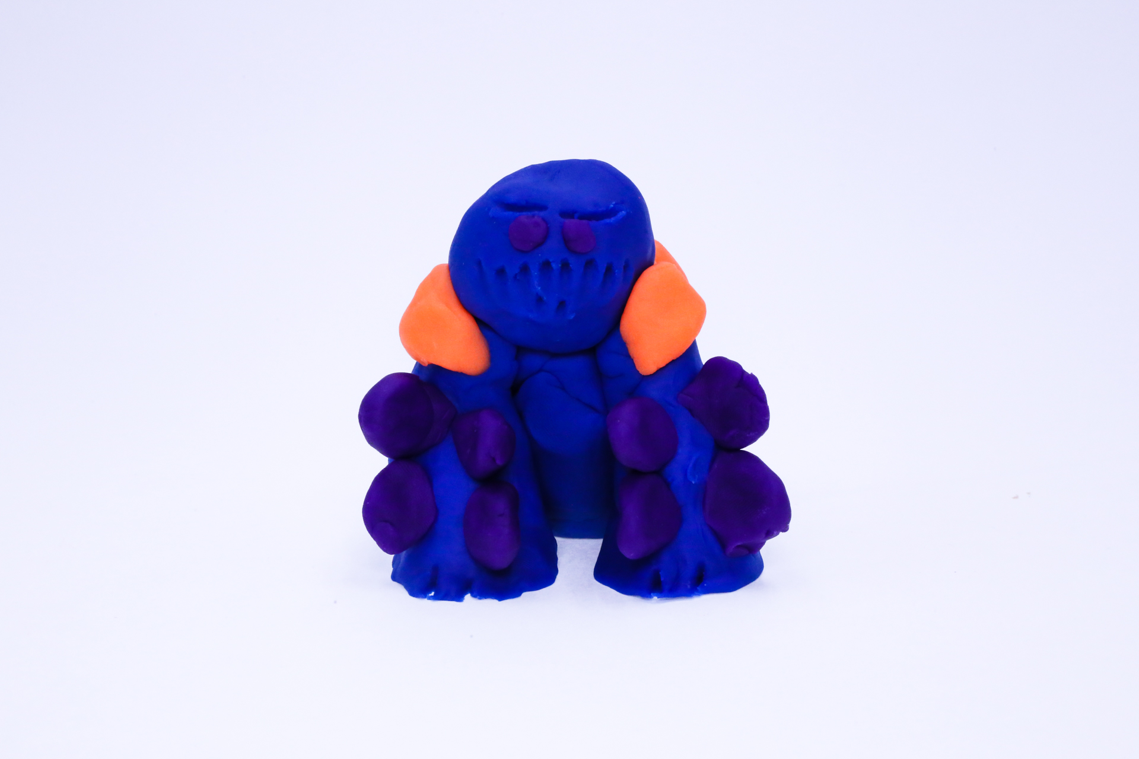400
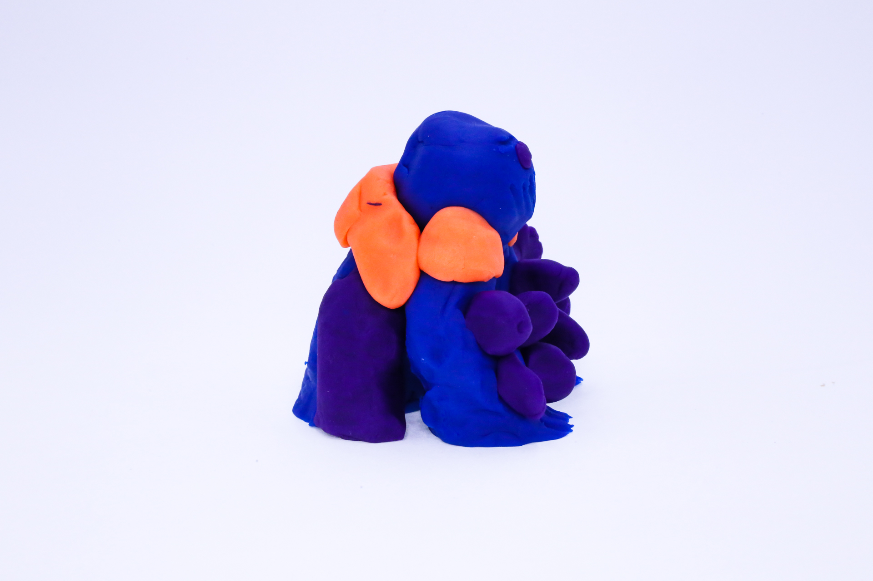400
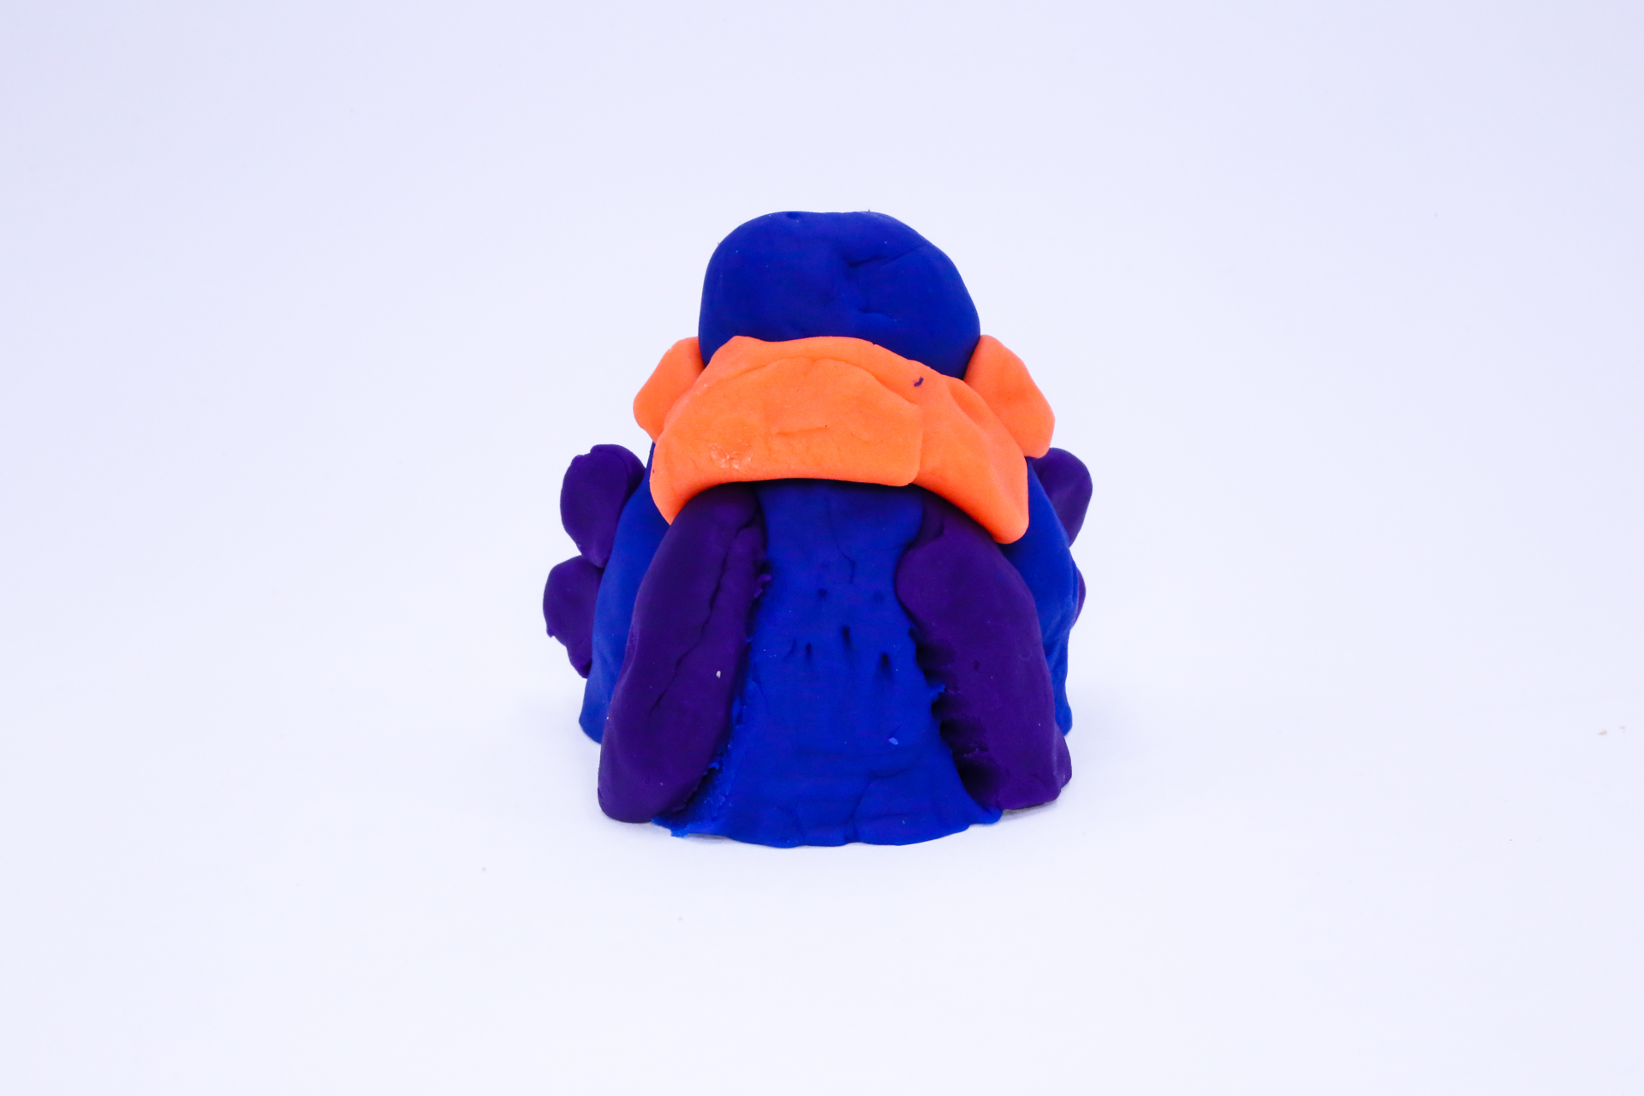400
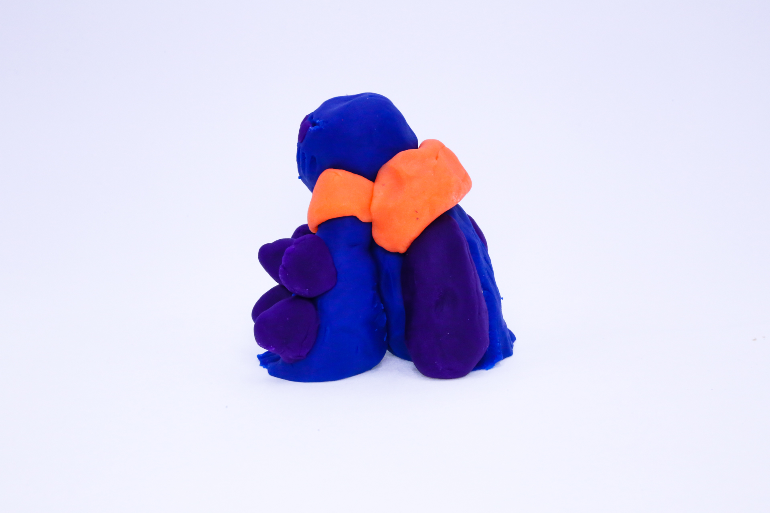400
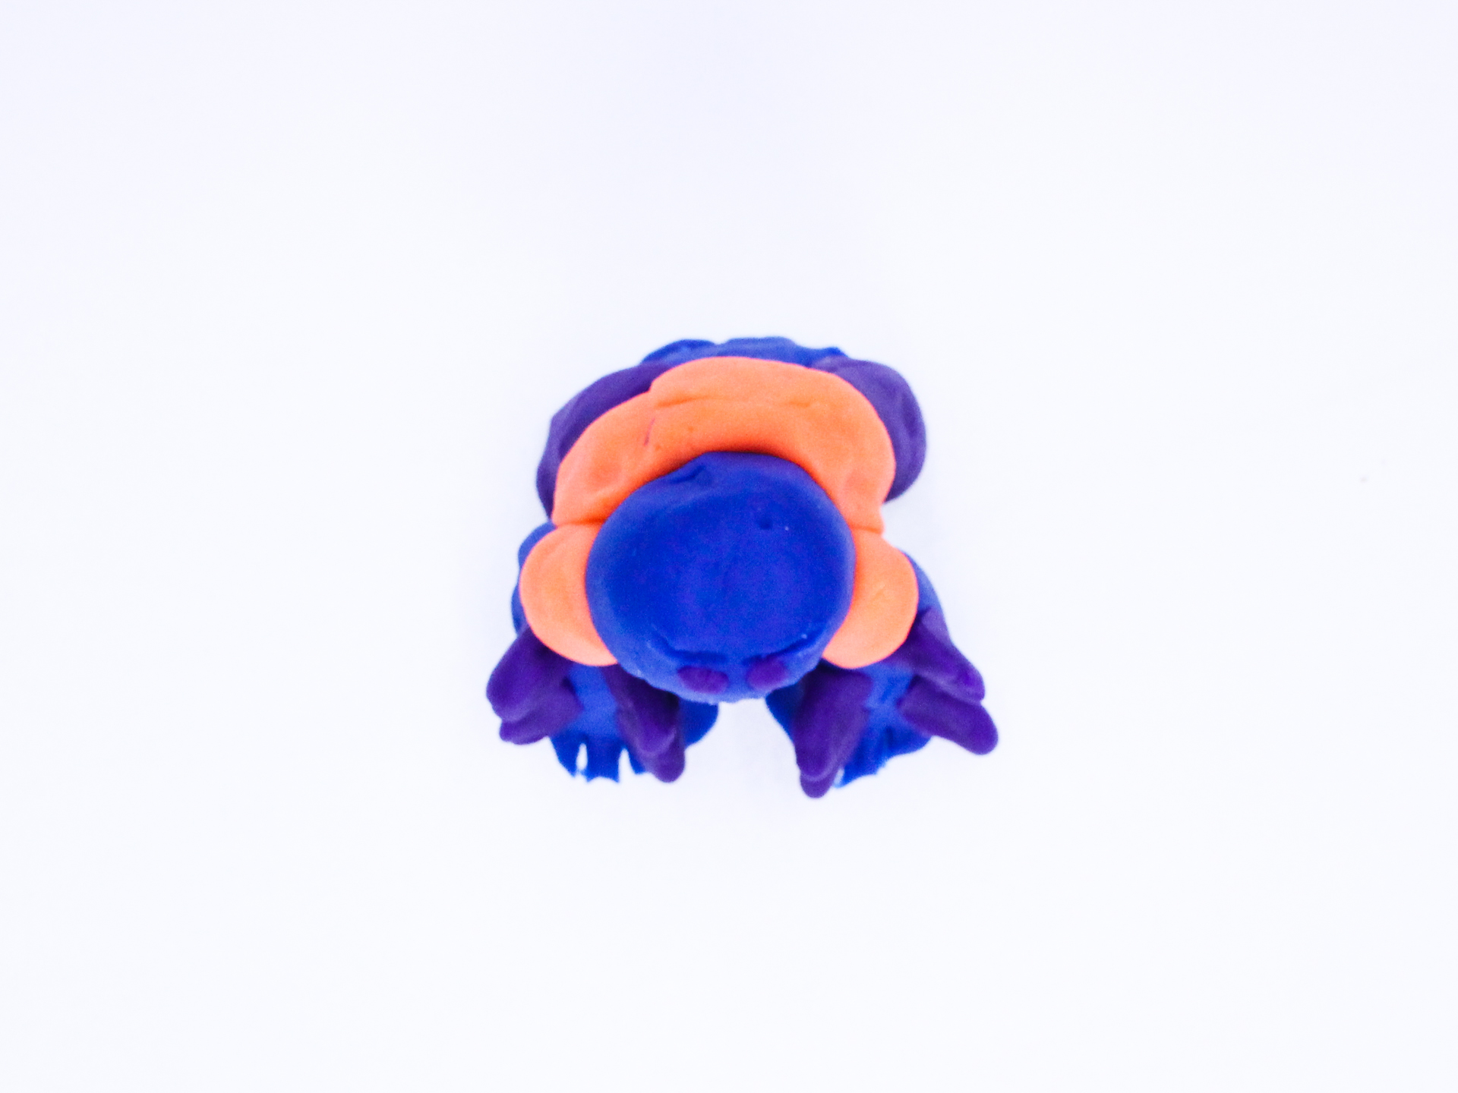400

A recording crystal warrior can be found here:
400

This is the unique QR code for this Imagined Thing. Right click it to save then share it, so you and others can find your way back to here to this point of The Well.

IT IS KNOWN! HUZZAH FOR THE GREAT & GRAND RUMPUS!

