11. Hypnotiser
HERE LIES THE ENTRY FOR AN IMAGINED THING
This is a thing imagined by Liam, aged 10, on Wednesday April 21
The full name of this thing is: hypnotiser
It can be found in: My thing is from a planet and the planet is the sun.
It is known that: I went to the sun but I am indistructible so I flew to the sun with my flying and I can fly and I found a hypnotiser and my hypnotiser can hypnotise anyone or thing.
This thing has three important features: get a eye, get a big fake volcano, and get a stactue to put the eye on and put the volcano under the tower

An image of hypnotiser can be found here:
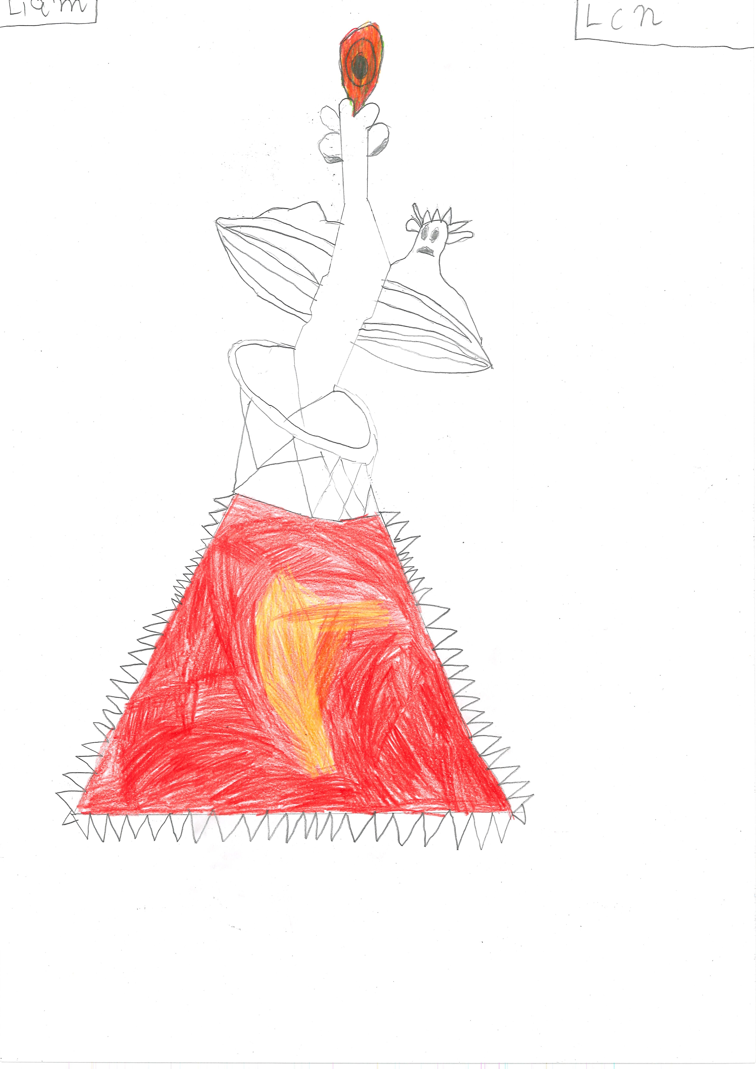400

A recording hypnotiser can be found here:
upload_your_audio_file400

This is the unique QR code for this Imagined Thing. Right click it to save then share it, so you and others can find your way back to here to this point of The Well.

IT IS KNOWN! HUZZAH FOR THE GREAT & GRAND RUMPUS!

