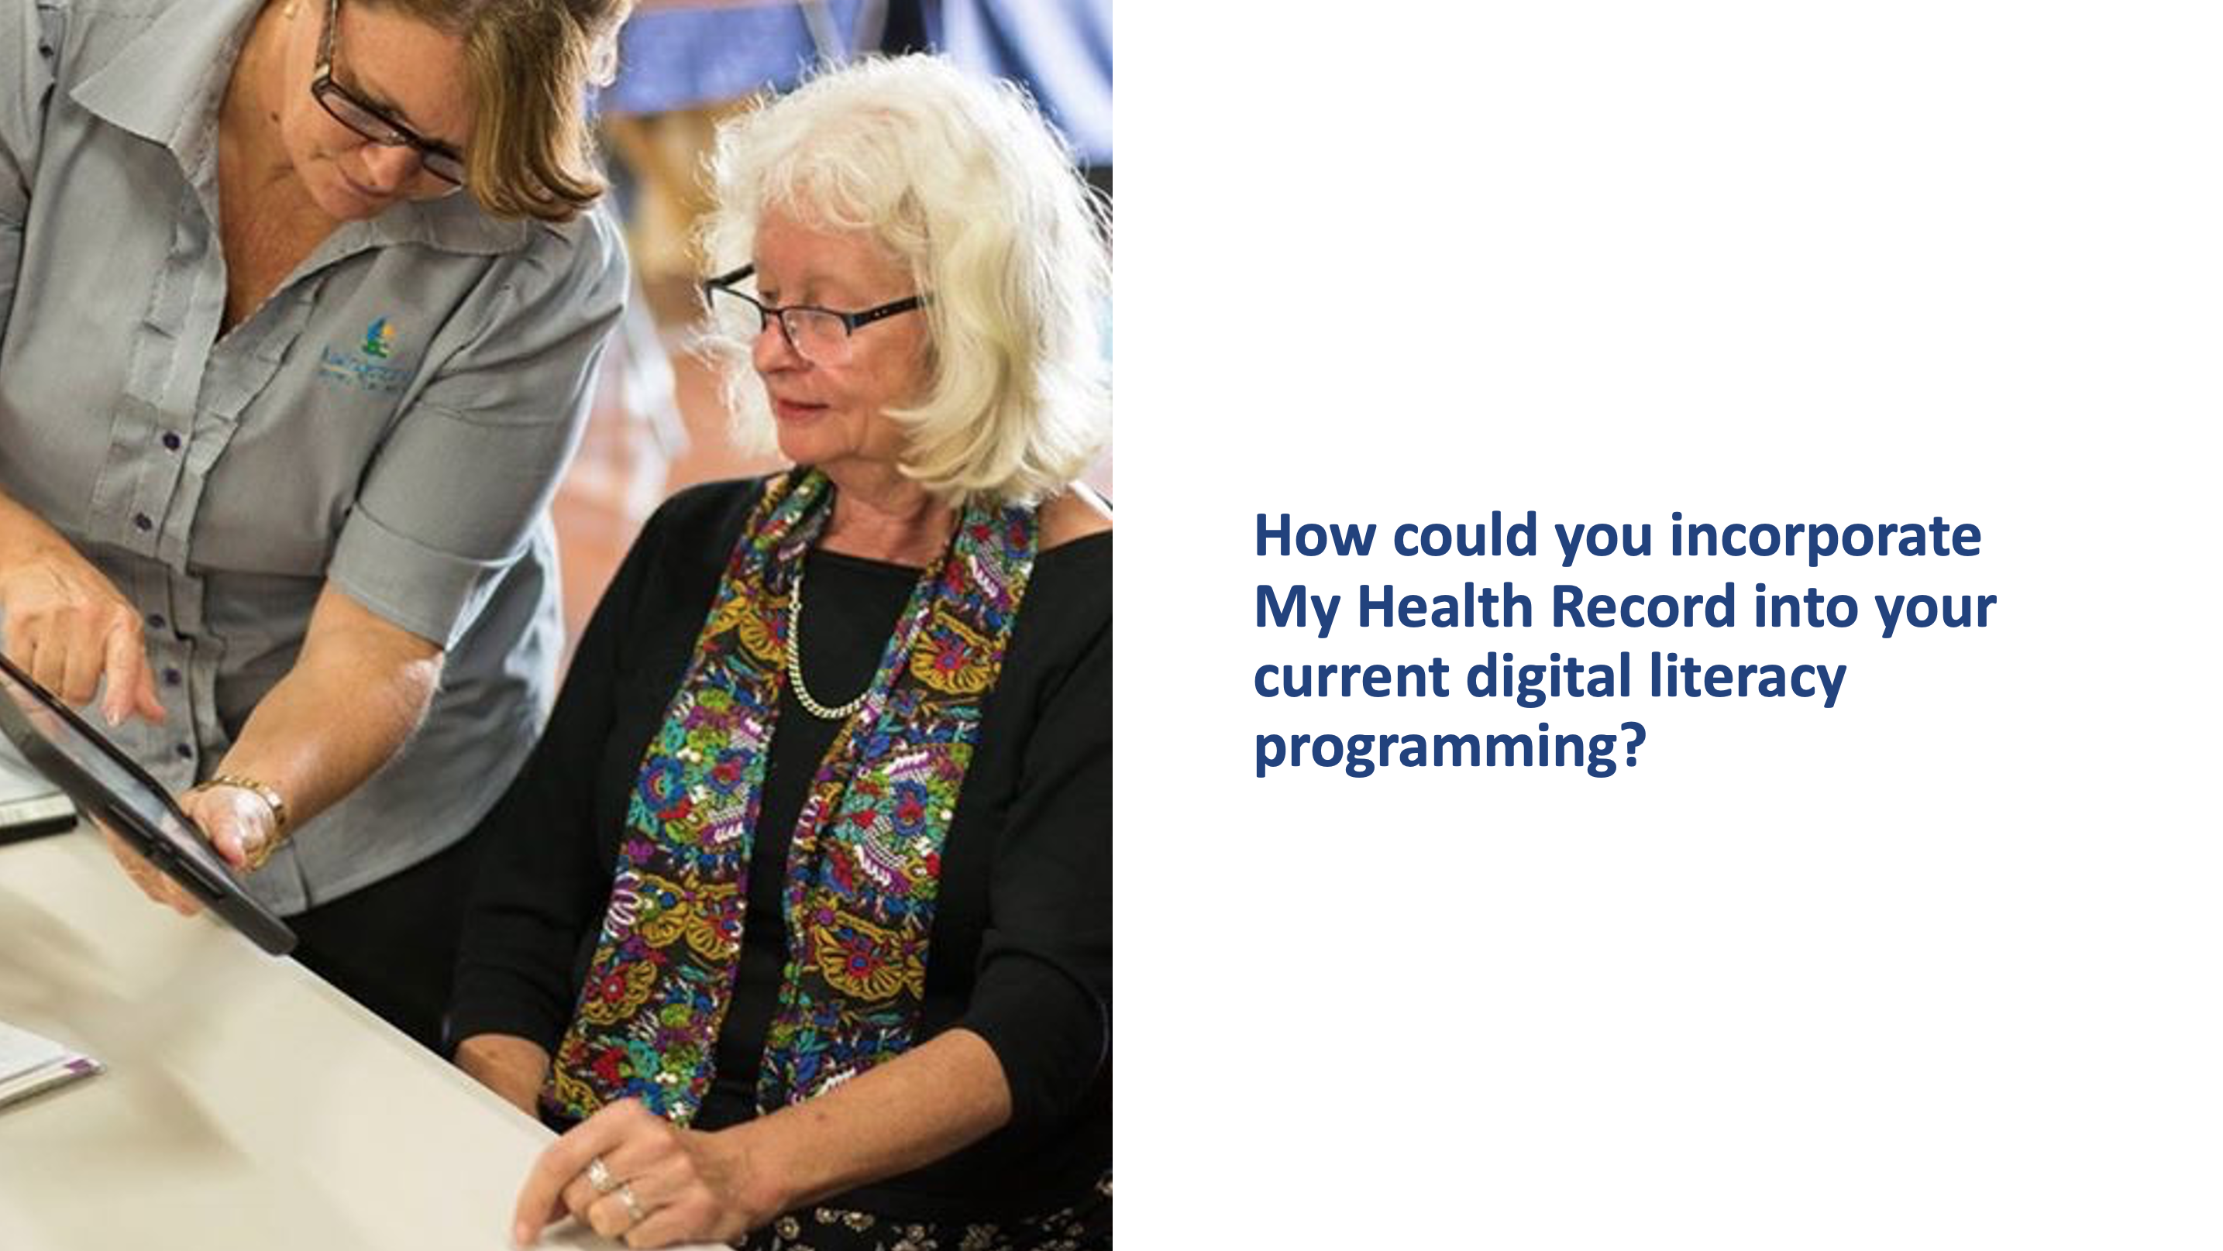
Could you incorporate My Health Record and wider health literacy into your existing library programming? if so, how might you do it? Contribute 2-3 ideas to the discussion forum below. Please feel free to comment on or reply to any other contributions.

Idea sharing - Health literacy in library programming.
~~HERO-COLORS #20407F #FFF #FFF #FFF #FFF~~

