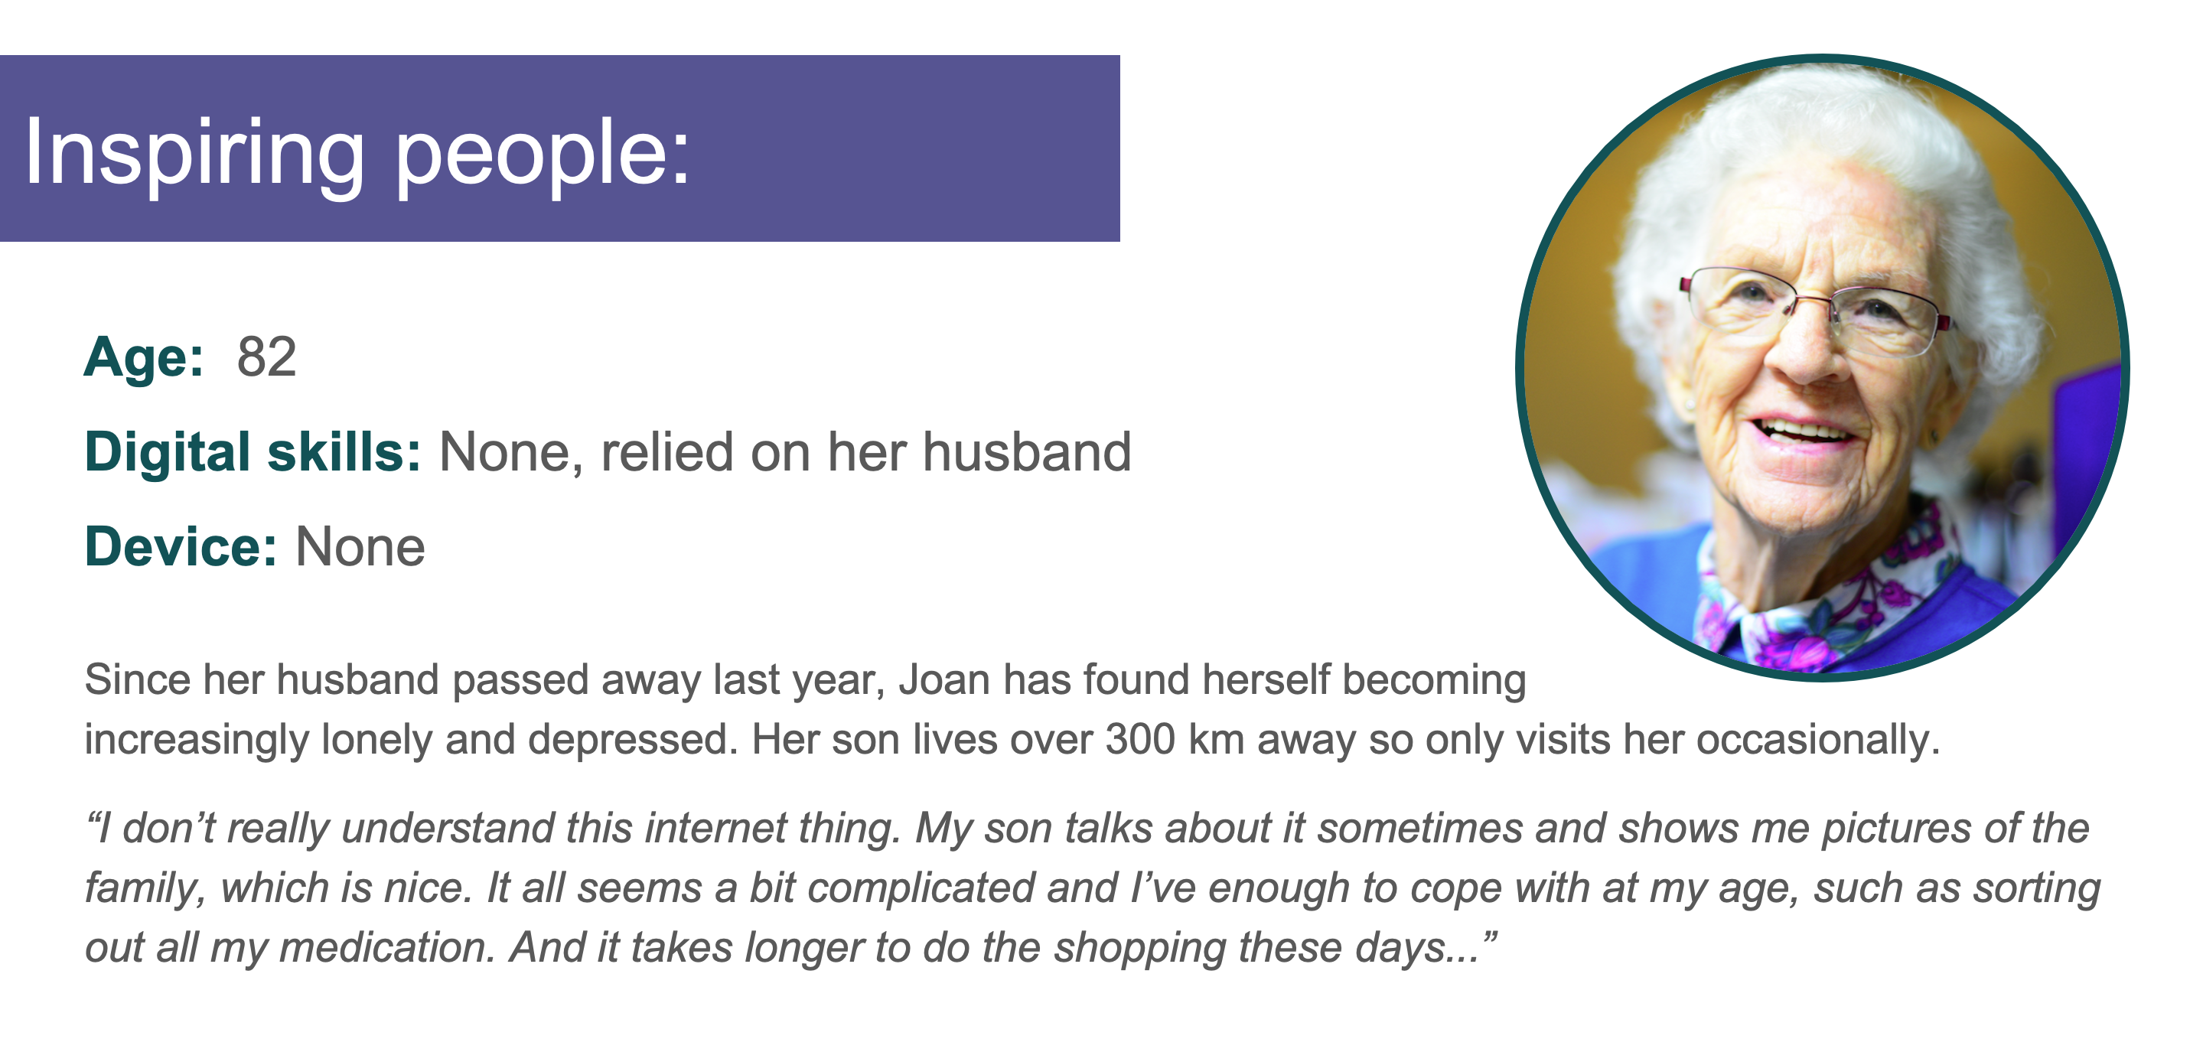

Inspiring Joan
Based on Joan's profile above, suggest some ways you could inspire her to get interested in getting online!
Please feel free to comment on or reply to any other contributions.
~~HERO-COLORS #A60991 #FFF rgba(255,255,255,0.8) #FFF #FFF~~

