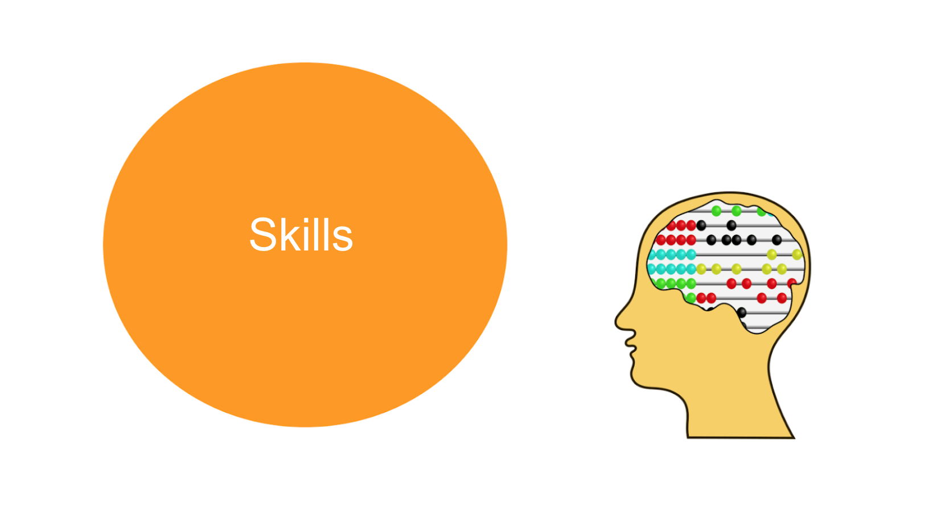

Idea sharing
What skills do you think a digital mentor would need?
Contribute your thoughts to the discussion forum below and see what others have said. Please feel free to comment on or reply to any other contributions.
~~HERO-COLORS #A60991 #FFF rgba(255,255,255,0.8) #FFF #FFF~~

