LEGO Spike
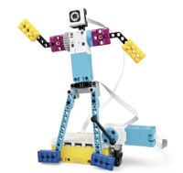
LEGO Spike is a junior version of the LEGO MindStorms kit, allowing children to learn the construction and coding of simple challenges to complex problems.
Similar to LEGO MindStorms, the kit contains motors and sensors and hundreds of LEGO pieces to build whatever you can imagine.
Recommended Ages | Year 4+ (ages 10+)
Product Cost | Core Set $600
Where to Purchase | Can be purchased from larger toy/educational stores or Modern Teaching Aids

Product Requirements
- A Computer or Tablet with Bluetooth capabilities is required

Loanable Kits
State Library does not have kits of this item available for loan to libraries.

Resources

Replacement Parts
Replacement parts can be ordered directly from LEGO at http://service.lego.com/en-us/replacementparts. You will require either the LEGO set number or the individual LEGO brick part number.
LEGO Set numbers can be found on the original LEGO box while brick part numbers are embossed on each brick. You can also use the website http://bricklink.com/ to search for set/part numbers.

