STORY LAB: DIGITAL DIROAMAS WORKSHOP
A workshop for participants aged 8-16.
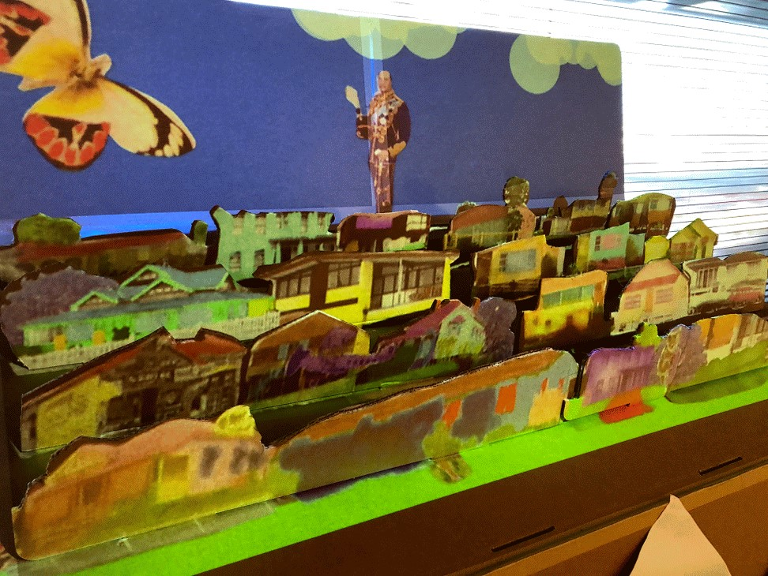
This workshop was created by the Young People and Families team for State Library of Queensland’s Summer Festival: Art + Stories + Play program in January 2019.

DESCRIPTION
Using the Sketches app for iPad, re-colour and remix photography featured in the Home: a suburban obsession exhibition along with other digital materials from State Library’s collections. Then, using the Tagtool app, arrange and animate a digital diorama.

OUTCOMES
- Introductory understanding of Sketches app, and how it can be used as a tool for digital editing.
- Introductory understanding of the Tagtool App and how it can be used as an animation tool.
- Engagement in collaborative design process.
- A serious amount of fun

PARTICIPANTS
- Maximum 15 people aged 8-12 or 12-16.
- Participants work independently.

DURATION
5 hours, including a 30 minute and 15 minute break.

FACILITATOR EXPERIENCE REQUIRED
Facilitation of this workshop requires
- A working understanding of Sketches Pro app.
- A working understanding of the Tagtool app.
- A working understanding of the iOS operating system on iPad.
- A working understanding of Google Drive.
Completing this workshop resource in full yourself as preparation for the workshop will act as adequate training for all of the above.

MATERIAL REQUIREMENTS
- 15 iPads (participants)
- iPad (presenter)
- Apple TV
- HDMI Cable
- Music stand
- Projector
- 15 Stylus
- 5 Scissors
- 5 Pencils
- Digitised collection materials (saved on Google Drive)

VENUE REQUIREMENTS
- Flat floor workshop room or auditorium, minimum 7m x 12m minimum floor space
- 5 x Workshops Tables with chairs
- Large projection or LED screen.
- Audio playback and speakers.

SETUP

STEP 1:

