Story Lab Workshops
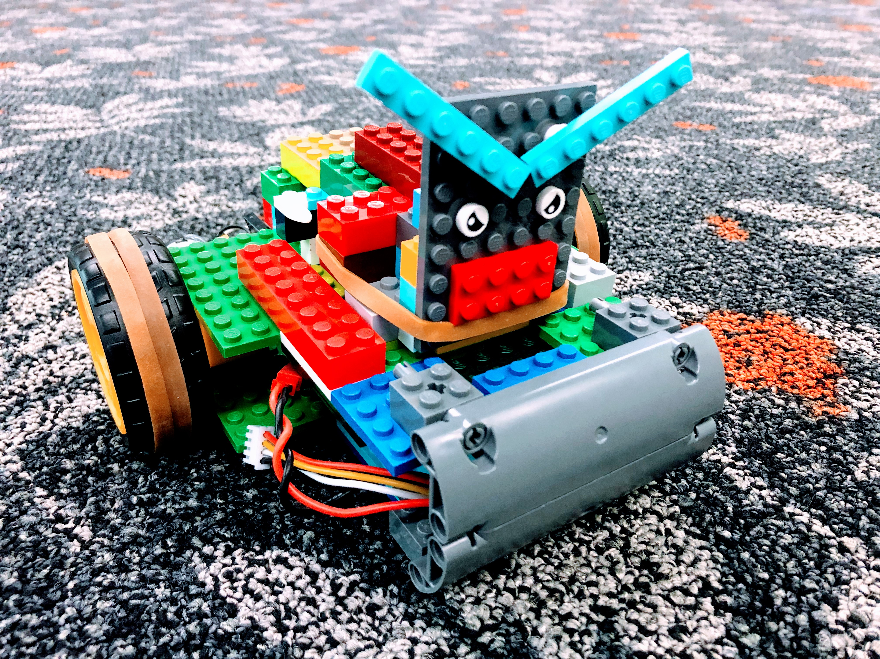
Robot Racers Workshop
Using a custom-made robotics kit designed and produced by volunteers at The Edge Fabrication Lab, participants can engineer a robot racer using Arduino controllers, motors, and Lego. Once their racers are complete, they design and fabricate a large scale race track. Then ready, set, race to compete for good times and glory.
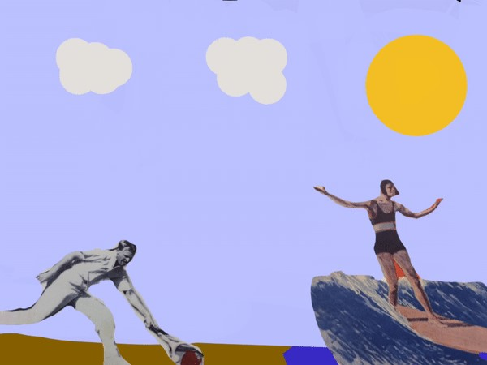
App Animation Mash Up Workshop
Remix free-use digital images to create loop-based animations with your fingertips. Using the live animation and VJ* app ‘Tag Tool’ it’s easy to manipulate and re-contextualize historical images and illustrations, combined with your own drawn creations, to create visual mash-ups that can be exported and shared.

